anton@AntonTiHP:~$ cat > cat > "Домашние животные"

Собаки

Кошки

Хомяки

anton@AntonTiHP:~$ cat > "Вьючные животные"

Лошади

Верблюды

Ослы

anton@AntonTiHP:~$ cat "Домашние животные" "Вьючные животные" > Animals

anton@AntonTiHP:~$ cat Animals

Собаки

Кошки

Хомяки

Лошади

Верблюды

Ослы

anton@AntonTiHP:~$ mv "Animals" "Друзья человека"

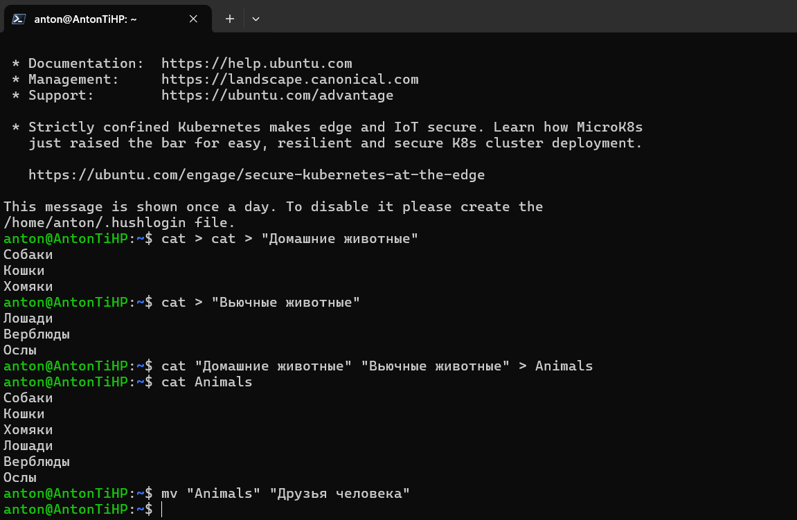

anton@AntonTiHP:~$ mkdir folder_for_attestation

anton@AntonTiHP:~$ mv 'Друзья человека' folder_for_attestation/

anton@AntonTiHP:~$ ls

cat docker-compose.yml folder_for_attestation 'Вьючные животные' 'Домашние животные'

anton@AntonTiHP:~$ cd folder_for_attestation/

anton@AntonTiHP:~/folder_for_attestation$ ls

'Друзья человека'

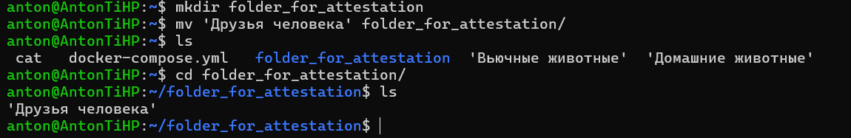

anton@AntonTiHP:~/folder_for_attestation$ sudo apt-get update

[sudo] password for anton:

Sorry, try again.

[sudo] password for anton:

Sorry, try again.

[sudo] password for anton:

Get:1 http://security.ubuntu.com/ubuntu jammy-security InRelease [110 kB]

Hit:2 http://archive.ubuntu.com/ubuntu jammy InRelease

Get:3 http://archive.ubuntu.com/ubuntu jammy-updates InRelease [119 kB]

Get:4 http://security.ubuntu.com/ubuntu jammy-security/main amd64 Packages [1392 kB]

Hit:5 http://archive.ubuntu.com/ubuntu jammy-backports InRelease

Get:6 http://archive.ubuntu.com/ubuntu jammy-updates/main amd64 Packages [1608 kB]

Get:7 http://archive.ubuntu.com/ubuntu jammy-updates/main Translation-en [303 kB]

Get:8 http://archive.ubuntu.com/ubuntu jammy-updates/restricted amd64 Packages [1826 kB]

Get:9 http://archive.ubuntu.com/ubuntu jammy-updates/restricted Translation-en [310 kB]

Get:10 http://archive.ubuntu.com/ubuntu jammy-updates/universe amd64 Packages [1070 kB]

Get:11 http://archive.ubuntu.com/ubuntu jammy-updates/universe Translation-en [244 kB]

Get:12 http://archive.ubuntu.com/ubuntu jammy-updates/multiverse amd64 Packages [42.7 kB]

Get:13 http://archive.ubuntu.com/ubuntu jammy-updates/multiverse Translation-en [10.4 kB]

Get:14 http://security.ubuntu.com/ubuntu jammy-security/main Translation-en [243 kB]

Get:15 http://security.ubuntu.com/ubuntu jammy-security/restricted amd64 Packages [1768 kB]

Get:16 http://security.ubuntu.com/ubuntu jammy-security/restricted Translation-en [299 kB]

Get:17 http://security.ubuntu.com/ubuntu jammy-security/universe amd64 Packages [848 kB]

Get:18 http://security.ubuntu.com/ubuntu jammy-security/universe Translation-en [162 kB]

Get:19 http://security.ubuntu.com/ubuntu jammy-security/multiverse amd64 Packages [37.2 kB]

Get:20 http://security.ubuntu.com/ubuntu jammy-security/multiverse Translation-en [7588 B]

Get:21 https://download.docker.com/linux/ubuntu jammy InRelease [48.8 kB]

Get:22 https://download.docker.com/linux/ubuntu jammy/stable amd64 Packages [31.1 kB]

Fetched 10.5 MB in 4s (2734 kB/s)

Reading package lists... Done

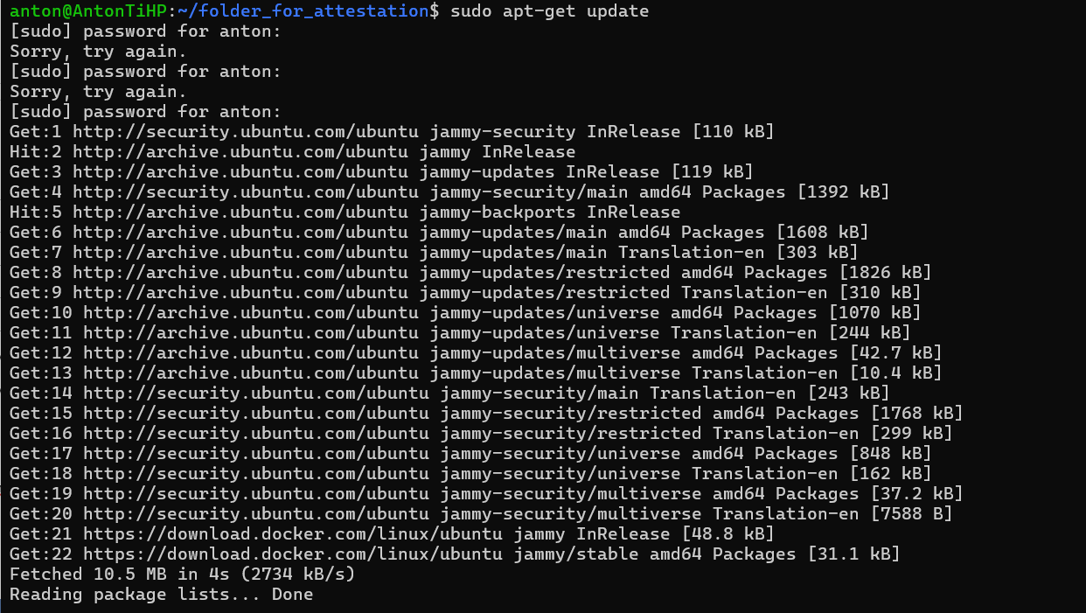

anton@AntonTiHP:~/folder_for_attestation$ sudo apt update

Hit:1 http://security.ubuntu.com/ubuntu jammy-security InRelease

Hit:2 https://download.docker.com/linux/ubuntu jammy InRelease

Hit:3 http://archive.ubuntu.com/ubuntu jammy InRelease

Hit:4 http://archive.ubuntu.com/ubuntu jammy-updates InRelease

Hit:5 http://archive.ubuntu.com/ubuntu jammy-backports InRelease

Reading package lists... Done

Building dependency tree... Done

Reading state information... Done

104 packages can be upgraded. Run 'apt list --upgradable' to see them.

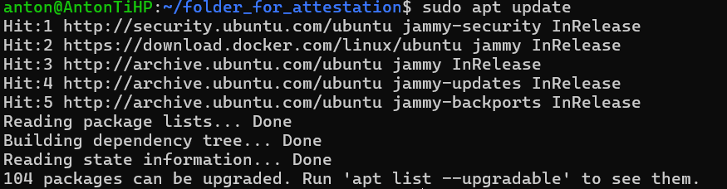

anton@AntonTiHP:~/folder_for_attestation$ sudo apt install mysql

Reading package lists... Done

Building dependency tree... Done

Reading state information... Done

E: Unable to locate package mysql

anton@AntonTiHP:~/folder_for_attestation$ sudo apt install mysql-server

Reading package lists... Done

Building dependency tree... Done

Reading state information... Done

The following additional packages will be installed:

libaio1 libcgi-fast-perl libcgi-pm-perl libclone-perl libencode-locale-perl libevent-pthreads-2.1-7 libfcgi-bin

libfcgi-perl libfcgi0ldbl libhtml-parser-perl libhtml-tagset-perl libhtml-template-perl libhttp-date-perl

libhttp-message-perl libio-html-perl liblwp-mediatypes-perl libmecab2 libprotobuf-lite23 libtimedate-perl

liburi-perl mecab-ipadic mecab-ipadic-utf8 mecab-utils mysql-client-8.0 mysql-client-core-8.0 mysql-common

mysql-server-8.0 mysql-server-core-8.0

Suggested packages:

libdata-dump-perl libipc-sharedcache-perl libbusiness-isbn-perl libwww-perl mailx tinyca

The following NEW packages will be installed:

libaio1 libcgi-fast-perl libcgi-pm-perl libclone-perl libencode-locale-perl libevent-pthreads-2.1-7 libfcgi-bin

libfcgi-perl libfcgi0ldbl libhtml-parser-perl libhtml-tagset-perl libhtml-template-perl libhttp-date-perl

libhttp-message-perl libio-html-perl liblwp-mediatypes-perl libmecab2 libprotobuf-lite23 libtimedate-perl

liburi-perl mecab-ipadic mecab-ipadic-utf8 mecab-utils mysql-client-8.0 mysql-client-core-8.0 mysql-common

mysql-server mysql-server-8.0 mysql-server-core-8.0

0 upgraded, 29 newly installed, 0 to remove and 104 not upgraded.

Need to get 29.5 MB of archives.

After this operation, 243 MB of additional disk space will be used.

Do you want to continue? [Y/n] Y

Get:1 http://archive.ubuntu.com/ubuntu jammy/main amd64 mysql-common all 5.8+1.0.8 [7212 B]

Get:2 http://archive.ubuntu.com/ubuntu jammy-updates/main amd64 mysql-client-core-8.0 amd64 8.0.36-0ubuntu0.22.04.1 [2692 kB]

Get:3 http://archive.ubuntu.com/ubuntu jammy-updates/main amd64 mysql-client-8.0 amd64 8.0.36-0ubuntu0.22.04.1 [22.7 kB]

Get:4 http://archive.ubuntu.com/ubuntu jammy/main amd64 libaio1 amd64 0.3.112-13build1 [7176 B]

Get:5 http://archive.ubuntu.com/ubuntu jammy/main amd64 libevent-pthreads-2.1-7 amd64 2.1.12-stable-1build3 [7642 B]

Get:6 http://archive.ubuntu.com/ubuntu jammy/main amd64 libmecab2 amd64 0.996-14build9 [199 kB]

Get:7 http://archive.ubuntu.com/ubuntu jammy-updates/main amd64 libprotobuf-lite23 amd64 3.12.4-1ubuntu7.22.04.1 [209 kB]

Get:8 http://archive.ubuntu.com/ubuntu jammy-updates/main amd64 mysql-server-core-8.0 amd64 8.0.36-0ubuntu0.22.04.1 [17.5 MB]

Get:9 http://archive.ubuntu.com/ubuntu jammy-updates/main amd64 mysql-server-8.0 amd64 8.0.36-0ubuntu0.22.04.1 [1437 kB]

Get:10 http://archive.ubuntu.com/ubuntu jammy/main amd64 libhtml-tagset-perl all 3.20-4 [12.5 kB]

Get:11 http://archive.ubuntu.com/ubuntu jammy/main amd64 liburi-perl all 5.10-1 [78.8 kB]

Get:12 http://archive.ubuntu.com/ubuntu jammy/main amd64 libhtml-parser-perl amd64 3.76-1build2 [88.4 kB]

Get:13 http://archive.ubuntu.com/ubuntu jammy/main amd64 libcgi-pm-perl all 4.54-1 [188 kB]

Get:14 http://archive.ubuntu.com/ubuntu jammy/main amd64 libfcgi0ldbl amd64 2.4.2-2build2 [28.0 kB]

Get:15 http://archive.ubuntu.com/ubuntu jammy/main amd64 libfcgi-perl amd64 0.82+ds-1build1 [22.8 kB]

Get:16 http://archive.ubuntu.com/ubuntu jammy/main amd64 libcgi-fast-perl all 1:2.15-1 [10.5 kB]

Get:17 http://archive.ubuntu.com/ubuntu jammy/main amd64 libclone-perl amd64 0.45-1build3 [11.0 kB]

Get:18 http://archive.ubuntu.com/ubuntu jammy/main amd64 libencode-locale-perl all 1.05-1.1 [11.8 kB]

Get:19 http://archive.ubuntu.com/ubuntu jammy/main amd64 libfcgi-bin amd64 2.4.2-2build2 [11.2 kB]

Get:20 http://archive.ubuntu.com/ubuntu jammy/main amd64 libhtml-template-perl all 2.97-1.1 [59.1 kB]

Get:21 http://archive.ubuntu.com/ubuntu jammy/main amd64 libtimedate-perl all 2.3300-2 [34.0 kB]

Get:22 http://archive.ubuntu.com/ubuntu jammy/main amd64 libhttp-date-perl all 6.05-1 [9920 B]

Get:23 http://archive.ubuntu.com/ubuntu jammy/main amd64 libio-html-perl all 1.004-2 [15.4 kB]

Get:24 http://archive.ubuntu.com/ubuntu jammy/main amd64 liblwp-mediatypes-perl all 6.04-1 [19.5 kB]

Get:25 http://archive.ubuntu.com/ubuntu jammy/main amd64 libhttp-message-perl all 6.36-1 [76.8 kB]

Get:26 http://archive.ubuntu.com/ubuntu jammy/main amd64 mecab-utils amd64 0.996-14build9 [4850 B]

Get:27 http://archive.ubuntu.com/ubuntu jammy/main amd64 mecab-ipadic all 2.7.0-20070801+main-3 [6718 kB]

Get:28 http://archive.ubuntu.com/ubuntu jammy/main amd64 mecab-ipadic-utf8 all 2.7.0-20070801+main-3 [4384 B]

Get:29 http://archive.ubuntu.com/ubuntu jammy-updates/main amd64 mysql-server all 8.0.36-0ubuntu0.22.04.1 [9460 B]

Fetched 29.5 MB in 7s (4130 kB/s)

Preconfiguring packages ...

Selecting previously unselected package mysql-common.

(Reading database ... 28358 files and directories currently installed.)

Preparing to unpack .../0-mysql-common_5.8+1.0.8_all.deb ...

Unpacking mysql-common (5.8+1.0.8) ...

Selecting previously unselected package mysql-client-core-8.0.

Preparing to unpack .../1-mysql-client-core-8.0_8.0.36-0ubuntu0.22.04.1_amd64.deb ...

Unpacking mysql-client-core-8.0 (8.0.36-0ubuntu0.22.04.1) ...

Selecting previously unselected package mysql-client-8.0.

Preparing to unpack .../2-mysql-client-8.0_8.0.36-0ubuntu0.22.04.1_amd64.deb ...

Unpacking mysql-client-8.0 (8.0.36-0ubuntu0.22.04.1) ...

Selecting previously unselected package libaio1:amd64.

Preparing to unpack .../3-libaio1_0.3.112-13build1_amd64.deb ...

Unpacking libaio1:amd64 (0.3.112-13build1) ...

Selecting previously unselected package libevent-pthreads-2.1-7:amd64.

Preparing to unpack .../4-libevent-pthreads-2.1-7_2.1.12-stable-1build3_amd64.deb ...

Unpacking libevent-pthreads-2.1-7:amd64 (2.1.12-stable-1build3) ...

Selecting previously unselected package libmecab2:amd64.

Preparing to unpack .../5-libmecab2_0.996-14build9_amd64.deb ...

Unpacking libmecab2:amd64 (0.996-14build9) ...

Selecting previously unselected package libprotobuf-lite23:amd64.

Preparing to unpack .../6-libprotobuf-lite23_3.12.4-1ubuntu7.22.04.1_amd64.deb ...

Unpacking libprotobuf-lite23:amd64 (3.12.4-1ubuntu7.22.04.1) ...

Selecting previously unselected package mysql-server-core-8.0.

Preparing to unpack .../7-mysql-server-core-8.0_8.0.36-0ubuntu0.22.04.1_amd64.deb ...

Unpacking mysql-server-core-8.0 (8.0.36-0ubuntu0.22.04.1) ...

Setting up mysql-common (5.8+1.0.8) ...

update-alternatives: using /etc/mysql/my.cnf.fallback to provide /etc/mysql/my.cnf (my.cnf) in auto mode

Selecting previously unselected package mysql-server-8.0.

(Reading database ... 28577 files and directories currently installed.)

Preparing to unpack .../00-mysql-server-8.0_8.0.36-0ubuntu0.22.04.1_amd64.deb ...

Unpacking mysql-server-8.0 (8.0.36-0ubuntu0.22.04.1) ...

Selecting previously unselected package libhtml-tagset-perl.

Preparing to unpack .../01-libhtml-tagset-perl_3.20-4_all.deb ...

Unpacking libhtml-tagset-perl (3.20-4) ...

Selecting previously unselected package liburi-perl.

Preparing to unpack .../02-liburi-perl_5.10-1_all.deb ...

Unpacking liburi-perl (5.10-1) ...

Selecting previously unselected package libhtml-parser-perl:amd64.

Preparing to unpack .../03-libhtml-parser-perl_3.76-1build2_amd64.deb ...

Unpacking libhtml-parser-perl:amd64 (3.76-1build2) ...

Selecting previously unselected package libcgi-pm-perl.

Preparing to unpack .../04-libcgi-pm-perl_4.54-1_all.deb ...

Unpacking libcgi-pm-perl (4.54-1) ...

Selecting previously unselected package libfcgi0ldbl:amd64.

Preparing to unpack .../05-libfcgi0ldbl_2.4.2-2build2_amd64.deb ...

Unpacking libfcgi0ldbl:amd64 (2.4.2-2build2) ...

Selecting previously unselected package libfcgi-perl:amd64.

Preparing to unpack .../06-libfcgi-perl_0.82+ds-1build1_amd64.deb ...

Unpacking libfcgi-perl:amd64 (0.82+ds-1build1) ...

Selecting previously unselected package libcgi-fast-perl.

Preparing to unpack .../07-libcgi-fast-perl_1%3a2.15-1_all.deb ...

Unpacking libcgi-fast-perl (1:2.15-1) ...

Selecting previously unselected package libclone-perl.

Preparing to unpack .../08-libclone-perl_0.45-1build3_amd64.deb ...

Unpacking libclone-perl (0.45-1build3) ...

Selecting previously unselected package libencode-locale-perl.

Preparing to unpack .../09-libencode-locale-perl_1.05-1.1_all.deb ...

Unpacking libencode-locale-perl (1.05-1.1) ...

Selecting previously unselected package libfcgi-bin.

Preparing to unpack .../10-libfcgi-bin_2.4.2-2build2_amd64.deb ...

Unpacking libfcgi-bin (2.4.2-2build2) ...

Selecting previously unselected package libhtml-template-perl.

Preparing to unpack .../11-libhtml-template-perl_2.97-1.1_all.deb ...

Unpacking libhtml-template-perl (2.97-1.1) ...

Selecting previously unselected package libtimedate-perl.

Preparing to unpack .../12-libtimedate-perl_2.3300-2_all.deb ...

Unpacking libtimedate-perl (2.3300-2) ...

Selecting previously unselected package libhttp-date-perl.

Preparing to unpack .../13-libhttp-date-perl_6.05-1_all.deb ...

Unpacking libhttp-date-perl (6.05-1) ...

Selecting previously unselected package libio-html-perl.

Preparing to unpack .../14-libio-html-perl_1.004-2_all.deb ...

Unpacking libio-html-perl (1.004-2) ...

Selecting previously unselected package liblwp-mediatypes-perl.

Preparing to unpack .../15-liblwp-mediatypes-perl_6.04-1_all.deb ...

Unpacking liblwp-mediatypes-perl (6.04-1) ...

Selecting previously unselected package libhttp-message-perl.

Preparing to unpack .../16-libhttp-message-perl_6.36-1_all.deb ...

Unpacking libhttp-message-perl (6.36-1) ...

Selecting previously unselected package mecab-utils.

Preparing to unpack .../17-mecab-utils_0.996-14build9_amd64.deb ...

Unpacking mecab-utils (0.996-14build9) ...

Selecting previously unselected package mecab-ipadic.

Preparing to unpack .../18-mecab-ipadic_2.7.0-20070801+main-3_all.deb ...

Unpacking mecab-ipadic (2.7.0-20070801+main-3) ...

Selecting previously unselected package mecab-ipadic-utf8.

Preparing to unpack .../19-mecab-ipadic-utf8_2.7.0-20070801+main-3_all.deb ...

Unpacking mecab-ipadic-utf8 (2.7.0-20070801+main-3) ...

Selecting previously unselected package mysql-server.

Preparing to unpack .../20-mysql-server_8.0.36-0ubuntu0.22.04.1_all.deb ...

Unpacking mysql-server (8.0.36-0ubuntu0.22.04.1) ...

Setting up libmecab2:amd64 (0.996-14build9) ...

Setting up mysql-client-core-8.0 (8.0.36-0ubuntu0.22.04.1) ...

Setting up libfcgi0ldbl:amd64 (2.4.2-2build2) ...

Setting up libclone-perl (0.45-1build3) ...

Setting up libhtml-tagset-perl (3.20-4) ...

Setting up liblwp-mediatypes-perl (6.04-1) ...

Setting up libfcgi-bin (2.4.2-2build2) ...

Setting up libencode-locale-perl (1.05-1.1) ...

Setting up libprotobuf-lite23:amd64 (3.12.4-1ubuntu7.22.04.1) ...

Setting up mecab-utils (0.996-14build9) ...

Setting up libio-html-perl (1.004-2) ...

Setting up libtimedate-perl (2.3300-2) ...

Setting up mysql-client-8.0 (8.0.36-0ubuntu0.22.04.1) ...

Setting up libfcgi-perl:amd64 (0.82+ds-1build1) ...

Setting up libaio1:amd64 (0.3.112-13build1) ...

Setting up liburi-perl (5.10-1) ...

Setting up libevent-pthreads-2.1-7:amd64 (2.1.12-stable-1build3) ...

Setting up libhttp-date-perl (6.05-1) ...

Setting up mecab-ipadic (2.7.0-20070801+main-3) ...

Compiling IPA dictionary for Mecab. This takes long time...

reading /usr/share/mecab/dic/ipadic/unk.def ... 40

emitting double-array: 100% |###########################################|

/usr/share/mecab/dic/ipadic/model.def is not found. skipped.

reading /usr/share/mecab/dic/ipadic/Verb.csv ... 130750

reading /usr/share/mecab/dic/ipadic/Noun.adjv.csv ... 3328

reading /usr/share/mecab/dic/ipadic/Noun.nai.csv ... 42

reading /usr/share/mecab/dic/ipadic/Noun.csv ... 60477

reading /usr/share/mecab/dic/ipadic/Suffix.csv ... 1393

reading /usr/share/mecab/dic/ipadic/Symbol.csv ... 208

reading /usr/share/mecab/dic/ipadic/Noun.adverbal.csv ... 795

reading /usr/share/mecab/dic/ipadic/Noun.org.csv ... 16668

reading /usr/share/mecab/dic/ipadic/Noun.proper.csv ... 27328

reading /usr/share/mecab/dic/ipadic/Interjection.csv ... 252

reading /usr/share/mecab/dic/ipadic/Postp.csv ... 146

reading /usr/share/mecab/dic/ipadic/Noun.number.csv ... 42

reading /usr/share/mecab/dic/ipadic/Others.csv ... 2

reading /usr/share/mecab/dic/ipadic/Postp-col.csv ... 91

reading /usr/share/mecab/dic/ipadic/Filler.csv ... 19

reading /usr/share/mecab/dic/ipadic/Noun.place.csv ... 72999

reading /usr/share/mecab/dic/ipadic/Adverb.csv ... 3032

reading /usr/share/mecab/dic/ipadic/Noun.others.csv ... 151

reading /usr/share/mecab/dic/ipadic/Noun.demonst.csv ... 120

reading /usr/share/mecab/dic/ipadic/Conjunction.csv ... 171

reading /usr/share/mecab/dic/ipadic/Prefix.csv ... 221

reading /usr/share/mecab/dic/ipadic/Noun.verbal.csv ... 12146

reading /usr/share/mecab/dic/ipadic/Adj.csv ... 27210

reading /usr/share/mecab/dic/ipadic/Adnominal.csv ... 135

reading /usr/share/mecab/dic/ipadic/Noun.name.csv ... 34202

reading /usr/share/mecab/dic/ipadic/Auxil.csv ... 199

emitting double-array: 100% |###########################################|

reading /usr/share/mecab/dic/ipadic/matrix.def ... 1316x1316

emitting matrix : 100% |###########################################|

done!

update-alternatives: using /var/lib/mecab/dic/ipadic to provide /var/lib/mecab/dic/debian (mecab-dictionary) in auto mod

e

Setting up mysql-server-core-8.0 (8.0.36-0ubuntu0.22.04.1) ...

Setting up mecab-ipadic-utf8 (2.7.0-20070801+main-3) ...

Compiling IPA dictionary for Mecab. This takes long time...

reading /usr/share/mecab/dic/ipadic/unk.def ... 40

emitting double-array: 100% |###########################################|

/usr/share/mecab/dic/ipadic/model.def is not found. skipped.

reading /usr/share/mecab/dic/ipadic/Verb.csv ... 130750

reading /usr/share/mecab/dic/ipadic/Noun.adjv.csv ... 3328

reading /usr/share/mecab/dic/ipadic/Noun.nai.csv ... 42

reading /usr/share/mecab/dic/ipadic/Noun.csv ... 60477

reading /usr/share/mecab/dic/ipadic/Suffix.csv ... 1393

reading /usr/share/mecab/dic/ipadic/Symbol.csv ... 208

reading /usr/share/mecab/dic/ipadic/Noun.adverbal.csv ... 795

reading /usr/share/mecab/dic/ipadic/Noun.org.csv ... 16668

reading /usr/share/mecab/dic/ipadic/Noun.proper.csv ... 27328

reading /usr/share/mecab/dic/ipadic/Interjection.csv ... 252

reading /usr/share/mecab/dic/ipadic/Postp.csv ... 146

reading /usr/share/mecab/dic/ipadic/Noun.number.csv ... 42

reading /usr/share/mecab/dic/ipadic/Others.csv ... 2

reading /usr/share/mecab/dic/ipadic/Postp-col.csv ... 91

reading /usr/share/mecab/dic/ipadic/Filler.csv ... 19

reading /usr/share/mecab/dic/ipadic/Noun.place.csv ... 72999

reading /usr/share/mecab/dic/ipadic/Adverb.csv ... 3032

reading /usr/share/mecab/dic/ipadic/Noun.others.csv ... 151

reading /usr/share/mecab/dic/ipadic/Noun.demonst.csv ... 120

reading /usr/share/mecab/dic/ipadic/Conjunction.csv ... 171

reading /usr/share/mecab/dic/ipadic/Prefix.csv ... 221

reading /usr/share/mecab/dic/ipadic/Noun.verbal.csv ... 12146

reading /usr/share/mecab/dic/ipadic/Adj.csv ... 27210

reading /usr/share/mecab/dic/ipadic/Adnominal.csv ... 135

reading /usr/share/mecab/dic/ipadic/Noun.name.csv ... 34202

reading /usr/share/mecab/dic/ipadic/Auxil.csv ... 199

emitting double-array: 100% |###########################################|

reading /usr/share/mecab/dic/ipadic/matrix.def ... 1316x1316

emitting matrix : 100% |###########################################|

done!

update-alternatives: using /var/lib/mecab/dic/ipadic-utf8 to provide /var/lib/mecab/dic/debian (mecab-dictionary) in aut

o mode

Setting up libhtml-parser-perl:amd64 (3.76-1build2) ...

Setting up libhttp-message-perl (6.36-1) ...

Setting up mysql-server-8.0 (8.0.36-0ubuntu0.22.04.1) ...

update-alternatives: using /etc/mysql/mysql.cnf to provide /etc/mysql/my.cnf (my.cnf) in auto mode

Renaming removed key_buffer and myisam-recover options (if present)

mysqld will log errors to /var/log/mysql/error.log

mysqld is running as pid 4749

Created symlink /etc/systemd/system/multi-user.target.wants/mysql.service → /lib/systemd/system/mysql.service.

Setting up libcgi-pm-perl (4.54-1) ...

Setting up libhtml-template-perl (2.97-1.1) ...

Setting up mysql-server (8.0.36-0ubuntu0.22.04.1) ...

Setting up libcgi-fast-perl (1:2.15-1) ...

Processing triggers for man-db (2.10.2-1) ...

Processing triggers for libc-bin (2.35-0ubuntu3.4) ...

/sbin/ldconfig.real: /usr/lib/wsl/lib/libcuda.so.1 is not a symbolic link

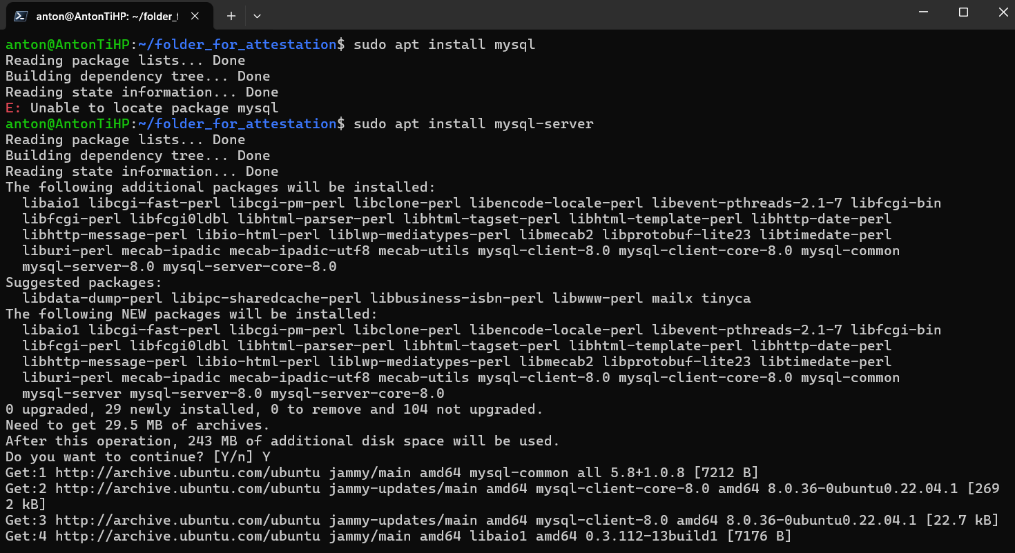

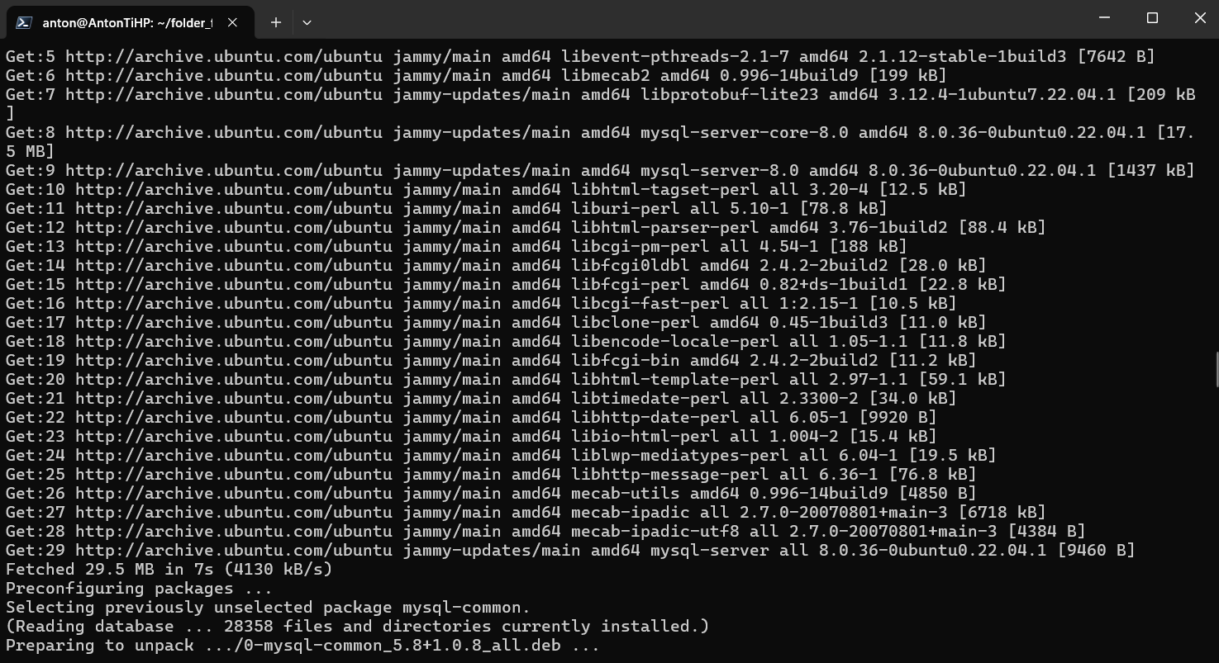

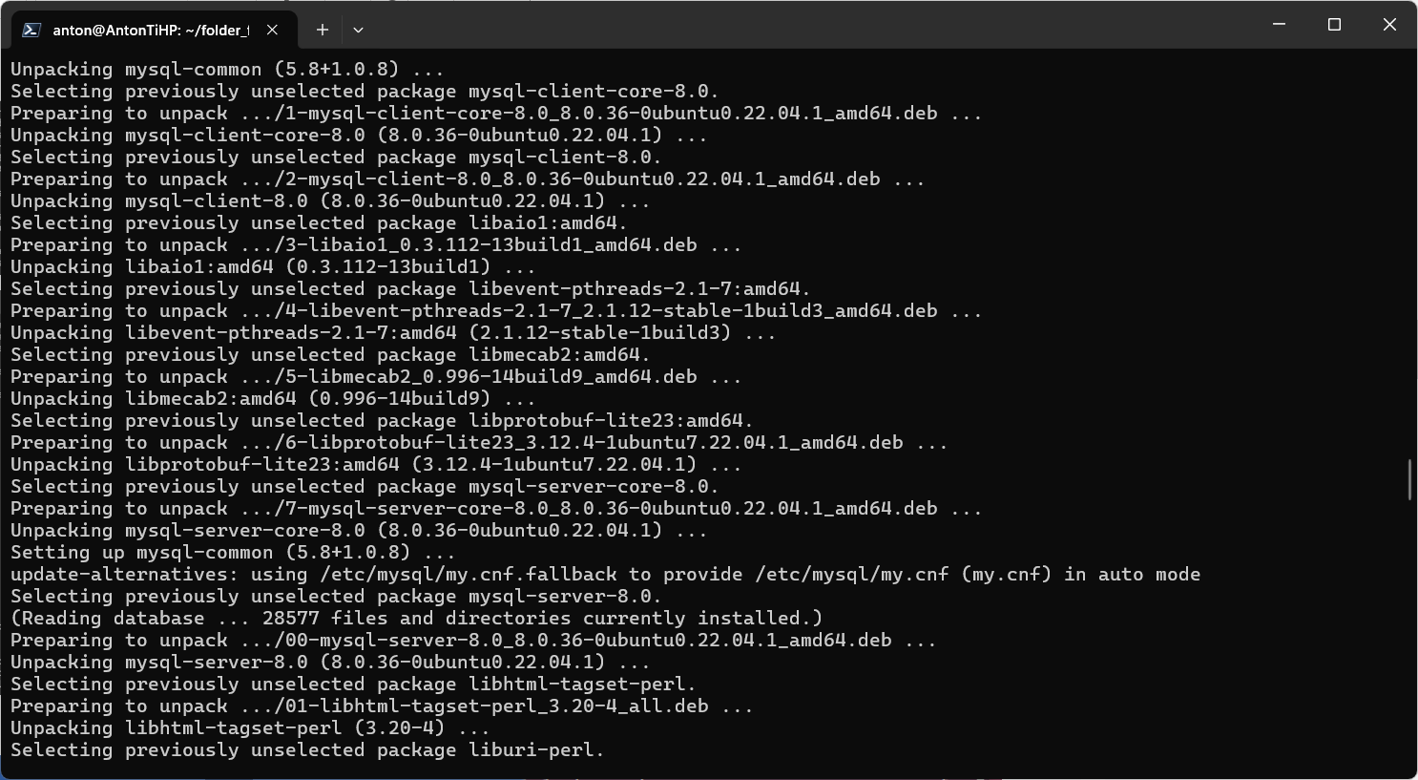

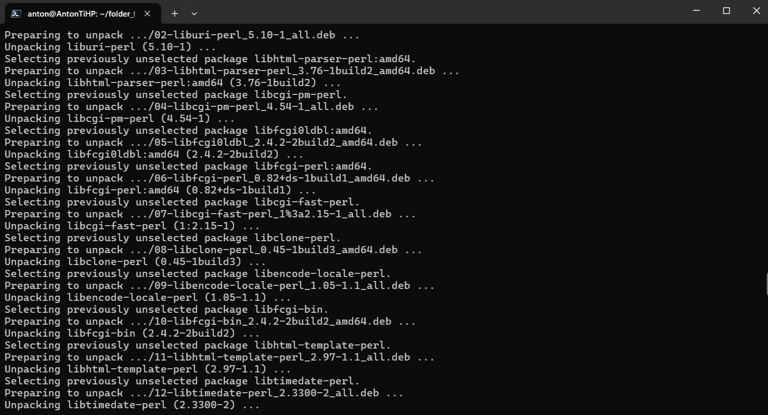

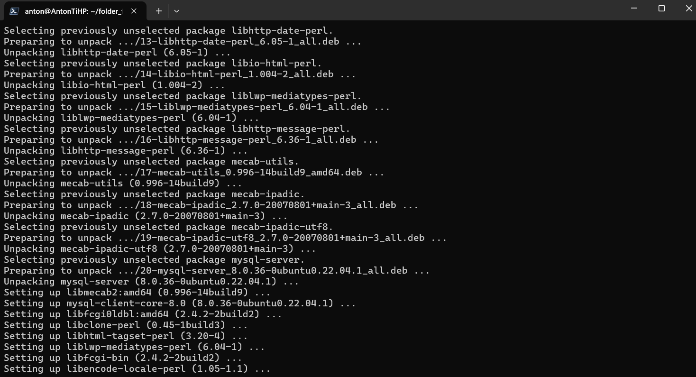

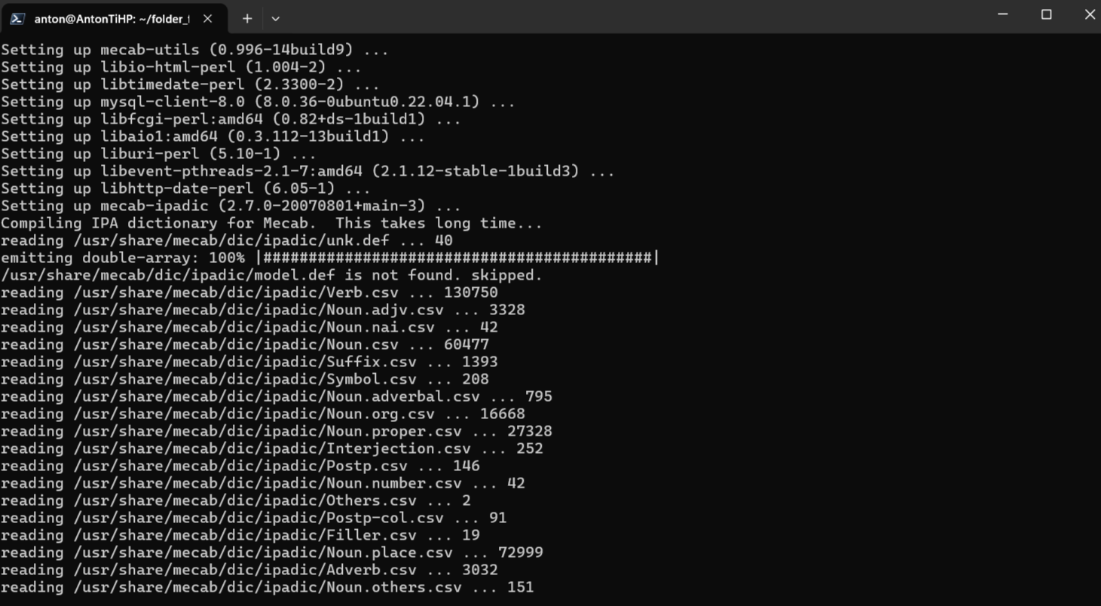

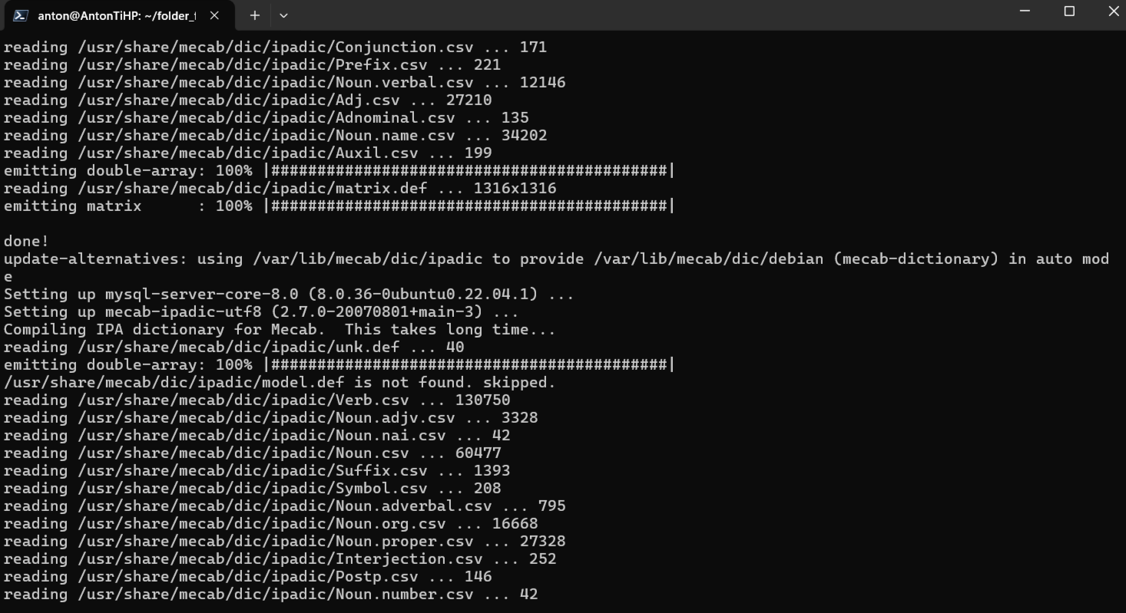

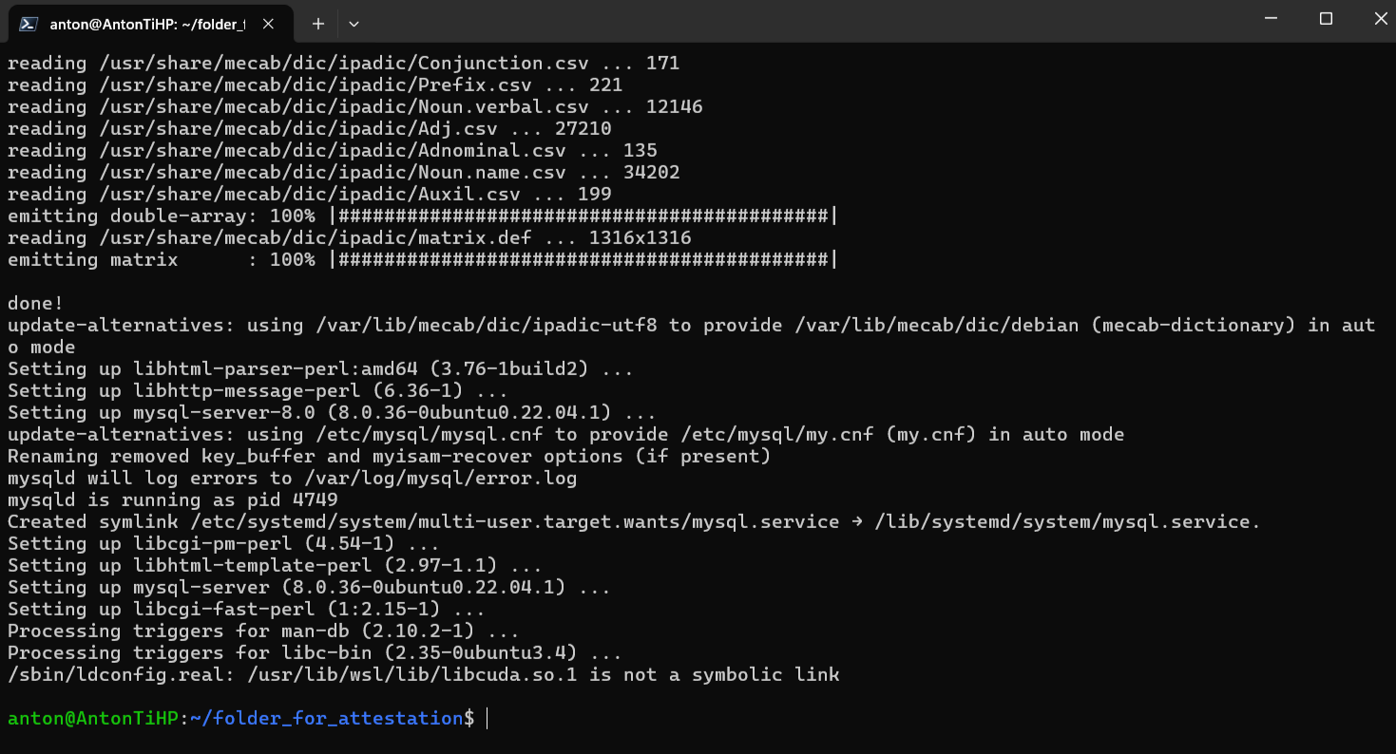

anton@AntonTiHP:~/folder_for_attestation$ sudo service mysql status

● mysql.service - MySQL Community Server

Loaded: loaded (/lib/systemd/system/mysql.service; enabled; vendor preset: enabled)

Active: active (running) since Tue 2024-04-23 23:13:33 EET; 4min 50s ago

Process: 4947 ExecStartPre=/usr/share/mysql/mysql-systemd-start pre (code=exited, status=0/SUCCESS)

Main PID: 4972 (mysqld)

Status: "Server is operational"

Tasks: 37 (limit: 9393)

Memory: 384.8M

CGroup: /system.slice/mysql.service

└─4972 /usr/sbin/mysqld

Apr 23 23:13:33 AntonTiHP systemd[1]: Starting MySQL Community Server...

Apr 23 23:13:33 AntonTiHP systemd[1]: Started MySQL Community Server.

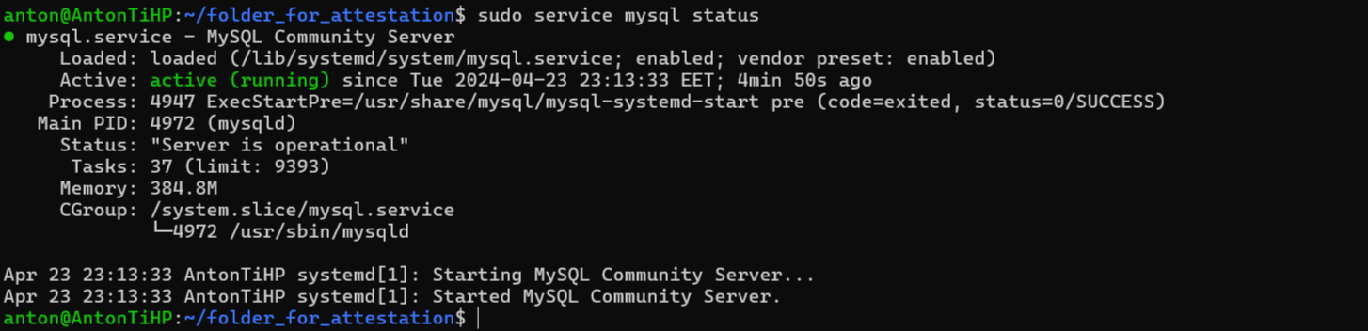

anton@AntonTiHP:~/folder_for_attestation$ wget http://ftp.us.debian.org/debian/pool/main/s/sl/sl_5.02-1_amd64.deb

--2024-04-23 23:19:37-- http://ftp.us.debian.org/debian/pool/main/s/sl/sl_5.02-1_amd64.deb

Resolving ftp.us.debian.org (ftp.us.debian.org)... 208.80.154.139, 64.50.236.52, 64.50.233.100, ...

Connecting to ftp.us.debian.org (ftp.us.debian.org)|208.80.154.139|:80... connected.

HTTP request sent, awaiting response... 200 OK

Length: 12916 (13K) [application/vnd.debian.binary-package]

Saving to: ‘sl_5.02-1_amd64.deb’

sl_5.02-1_amd64.deb 100%[=================================================>] 12.61K --.-KB/s in 0s

2024-04-23 23:19:37 (218 MB/s) - ‘sl_5.02-1_amd64.deb’ saved [12916/12916]

anton@AntonTiHP:~/folder_for_attestation$ sudo dpkg -i sl_5.02-1_amd64.deb

Selecting previously unselected package sl.

(Reading database ... 28965 files and directories currently installed.)

Preparing to unpack sl_5.02-1_amd64.deb ...

Unpacking sl (5.02-1) ...

Setting up sl (5.02-1) ...

Processing triggers for man-db (2.10.2-1) ...

anton@AntonTiHP:~/folder_for_attestation$ sudo dpkg -r sl

(Reading database ... 28988 files and directories currently installed.)

Removing sl (5.02-1) ...

Processing triggers for man-db (2.10.2-1) ...

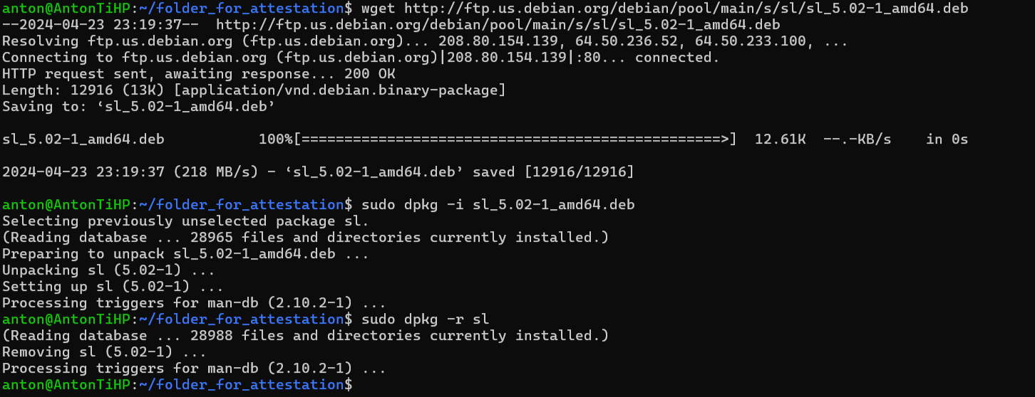

102 cat > cat > "Домашние животные"

103 cat > "Вьючные животные"

104 cat "Домашние животные" "Вьючные животные" > Animals

105 cat Animals

106 mv "Animals" "Друзья человека"

107 mkdir folder_for_attestation

108 mv 'Друзья человека' folder_for_attestation/

109 ls

110 cd folder_for_attestation/

111 ls

112 sudo apt-get update

113 sudo apt update

114 apt list --upgradable

115 sudo apt install mysql

116 sudo apt install mysql-server

117 sudo service mysql status

118 wget http://ftp.us.debian.org/debian/pool/main/s/sl/sl_5.02-1_amd64.deb

119 sudo dpkg -i sl_5.02-1_amd64.deb

120 sudo dpkg -r sl

121 clear

122 history

