 | MIDDLE GROUP CALENDAR  CALENDAR 2026-2027  Lessons on Tuesday, 4:45 - 5:45pm and Wednesday, 4:45 - 5:45pm

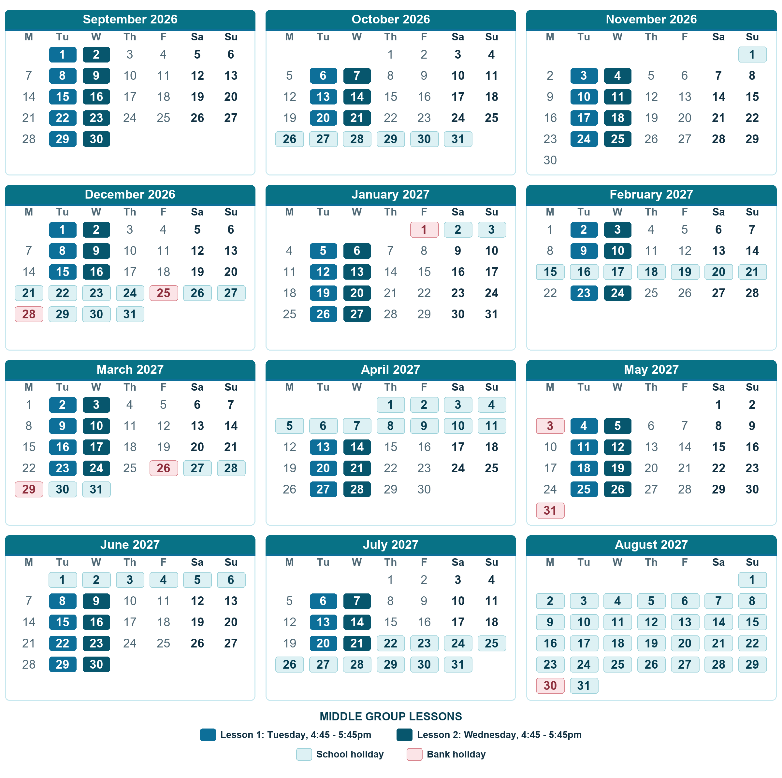
SCHOOL TERMS | SCHOOL HOLIDAYS
   | Autumn Term | 15 WEEKS  1 Sep 2026 - 18 Dec 2026
   | Autumn Half Term | 26 Oct 2026 - 1 Nov 2026  Christmas Holidays | 21 Dec 2026 - 3 Jan 2027
   | Spring Term | 11 WEEKS  4 Jan 2027 - 25 Mar 2027
   | Spring Half Term | 15 Feb 2027 - 21 Feb 2027  Easter Holidays | 26 Mar 2027 - 11 Apr 2027
   | Summer Term | 14 WEEKS  12 Apr 2027 - 21 Jul 2027
   | Summer Half Term | 31 May 2027 - 6 Jun 2027  Summer Holidays | From 22 Jul 2027

CONTACT VOLNA SCHOOL
For questions, enquiries or help with classes, please use the contact details below:
EMAIL  info@volnaschool.com | WEBSITE  www.volnaschool.com | PHONE  07881764892

