**ECSE 403 Lab 6 Report – Pole Placement for Inverted Pendulum**

*Question 1*

To get the state space model of the system we used the linearized version of the equations we derived in Lab 4. Specifically, assuming a small angle θ we set sinθ = θ and cosθ = 1. The resulting state space is shown below.

$$A= \left[\begin{matrix}0 & 1 & 1 & 1 \\ 0 & -\frac{B^{2}}{m_{c}R_{a}} & -\frac{m_{p}g}{m_{c}} & 0 \\ 0 & 0 & 0 & 1 \\ 0 & \frac{B^{2}}{m_{c}l_{p}R_{a}} & \frac{\left(m_{c}m_{p}\right)g}{m_{c}l_{p}} & 0\end{matrix}\right]= \left[\begin{matrix}0 & 1 & 1 & 1 \\ 0 & -14.49 & -1.98 & 0 \\ 0 & 0 & 0 & 1 \\ 0 & 86.25 & 70.25 & 0\end{matrix}\right]$$

$$B= \left[\begin{matrix}0 \\ \frac{B}{m_{c}R_{a}} \\ 0 \\ \frac{-B}{m_{c}l_{p}R_{a}}\end{matrix}\right]= \left[\begin{matrix}0 \\ 3.26 \\ 0 \\ -19.38\end{matrix}\right]$$

$$C= \left[\begin{matrix}1 & 0 & 0 & 0 \\ 0 & 0 & 1 & 0\end{matrix}\right]$$

$$D={\left[\begin{matrix}0 & 0 & 0 & 0\end{matrix}\right]}^{T}$$

Note: The for the values of the constants in A & B please see the code in appendix where they are defined. The values of A and B are slightly different to those shown if the long pole is used.

*Question 2*

Using the MIMO tf command in MATLAB we get the transfer function for x and θ.

$$x= \frac{3.255s^{2}-1.56s-190.3}{s^{4}+14.49s^{3}-70.25s^{2}-847.2s}$$

$$θ= \frac{3.255s^{2}-1.56s-190.3}{s^{3}+14.49s^{2}-70.25s-847.2}$$

*Question 3*

The pzmap command gives us the pole zero map of the system dynamics matrix A.

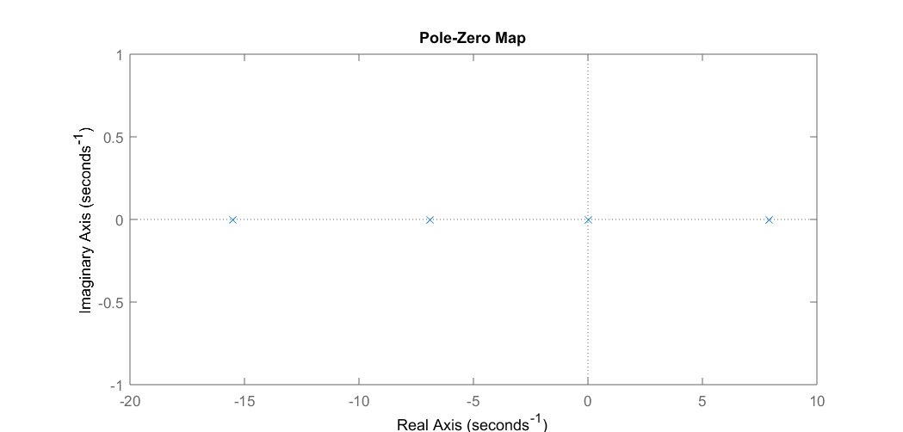

Figure 1: Pole zero map of system dynamics matrix A.

*Question 4*

Using command *eig(A)* the eigenvalues of matrix A were found to be $-15.5, -6.9, 0 and 7.9$. This can be verified from the answer to the previous question.

*Question 5*

Using the command ctrb(A, B) the controllability matrix of our system was obtained. Then, using the inv command the inverse controllability matrix was calculated. Since the inverse exists this means that the determinant is non-zero, hence the matrix is full rank, and the system is controllable.

*Question 6*

The system is fully observable since we have direct access to the values of each state from the sensors. As such, using the observability condition is redundant.

*Question 7*

Using the following design equations, we decided to design based on the two dominant poles for a 12.5% overshoot and a 2.1 second settling time.

$$t_{s}=\frac{3.9}{ζω_{n}}$$

$$ζ= \sqrt{\frac{{ln⁡(M_{p})}^{2}}{π^{2}+ {ln⁡(M_{p})}^{2}}}$$

$$P_{D_{1}, D_{2}}=ζω_{n}± ω_{n}\sqrt{1-ζ^{2}}$$

*Question 8*

We then moved the two non-dominant poles have ten times the magnitude of the dominant to move them away from the origin. This made their effect negligible. The resulting pole allocation was this one: [-20+20i, -20-20i, -1.5 + 2.25i, -1.5 - 2.25i].

*Question 9*

To generate the feedback, we used the place command. This gave us the following feedback:

K = [-30.7387 -18.5992 -56.6509 -4.5962] for the short bar

K = [ -61.4774 -32.7469 -120.6124 -13.9459] for the long bar

*Question 10*

With the gain set to K as shown above we implemented a controller using Simulink. We pass the derivative measurements of the position and angle system measurements through a low pass filter $\left(\frac{50}{s+50}\right)$ to remove high frequency noise.

*Question 11*

For safety reasons, and to operate inside the range where our linearized model is a good approximation, we set the threshold for operation of the model to within 10 degrees of the vertical. If the sensor detects that the angle is further than that it then sets all input to zero and lets the pendulum fall.

*Question 12 & 13*

The simulated system was able to stabilize the pendulum from the start. However, the physical system did not behave in the same way that the simulation predicted. While the pendulum was stabilized in our experiments, we found that manually tuning the parameters through trial and error helped us improve the performance.

Optimal Gain for short pole is (-54.65, -24, -63.03, -5.56)

with parameters:

RiseTime: 0.4854

SettlingTime: 1.6205

SettlingMin: 0.0713

SettlingMax: 0.0864

Overshoot: 12.3046

Undershoot: 0

Peak: 0.0864

PeakTime: 1.0362

Optimal Gain for tall pole is (-61.4774 -32.7469 -120.6124 -13.9459)

with parameters

RiseTime: 0.6473

SettlingTime: 2.1607

SettlingMin: 0.1267

SettlingMax: 0.1536

Overshoot: 12.3046

Undershoot: 0

Peak: 0.1536

PeakTime: 1.3816

*Question 14*

The following plots show the system response using the gain K shown above.

For the long pole:

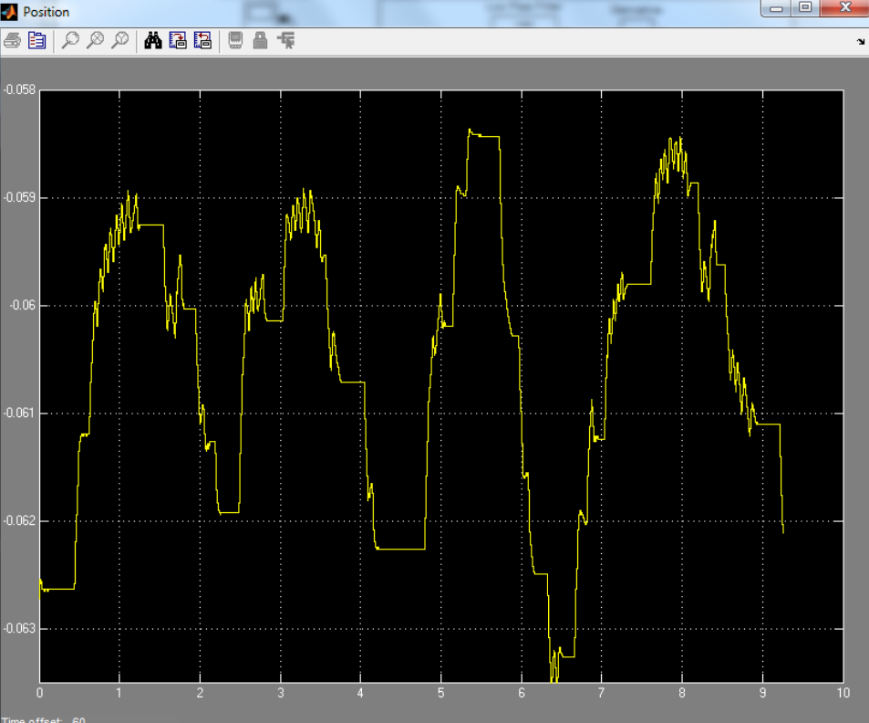

Figure 2: Position.

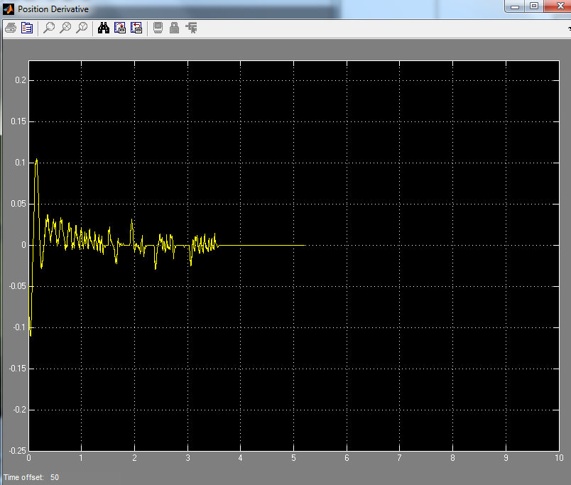

Figure 3: Position derivative.

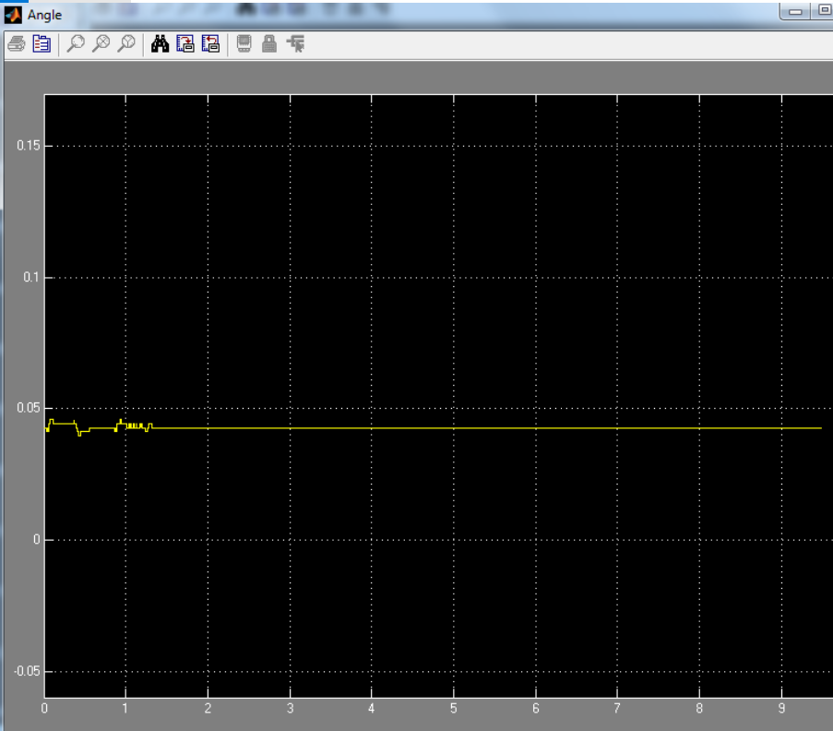

Figure 4: Theta.

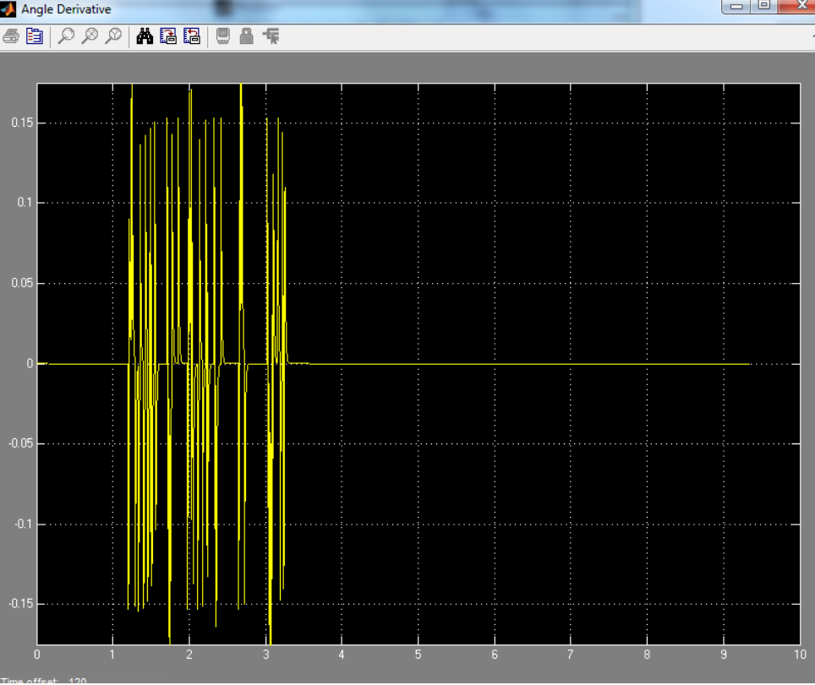

Figure 4: Theta derivative.

For the long pole:



Figure 5: Position.

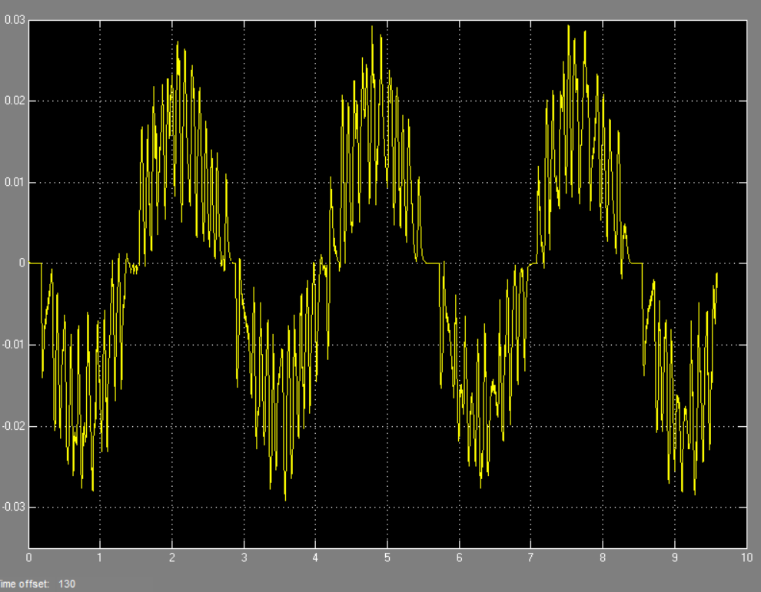

Figure 6: Position derivative

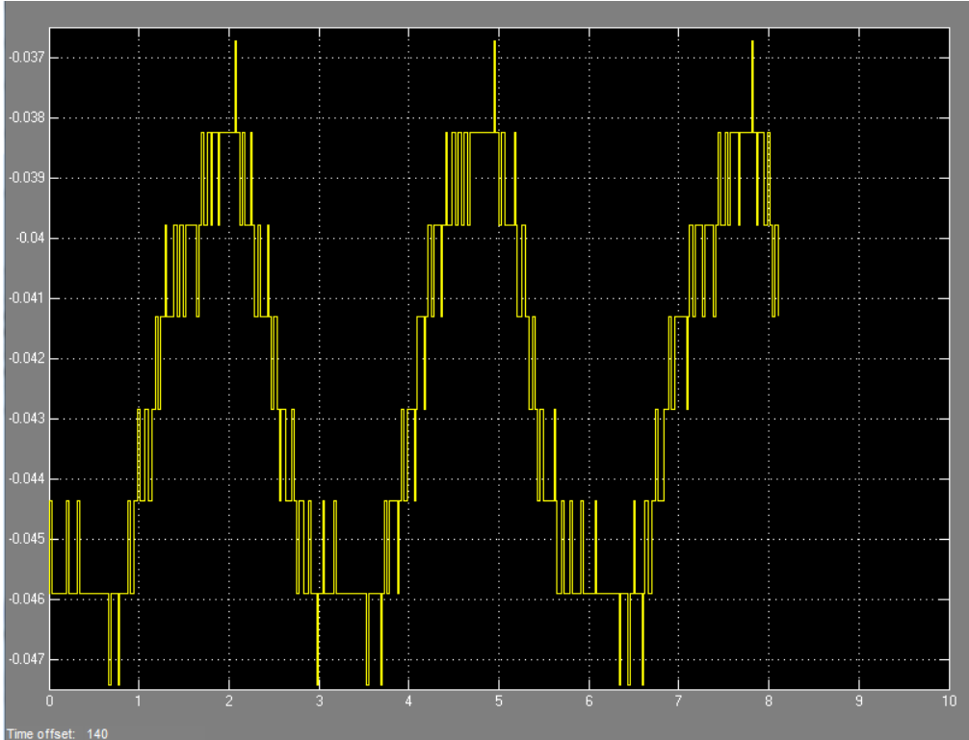

Figure 7: Angle

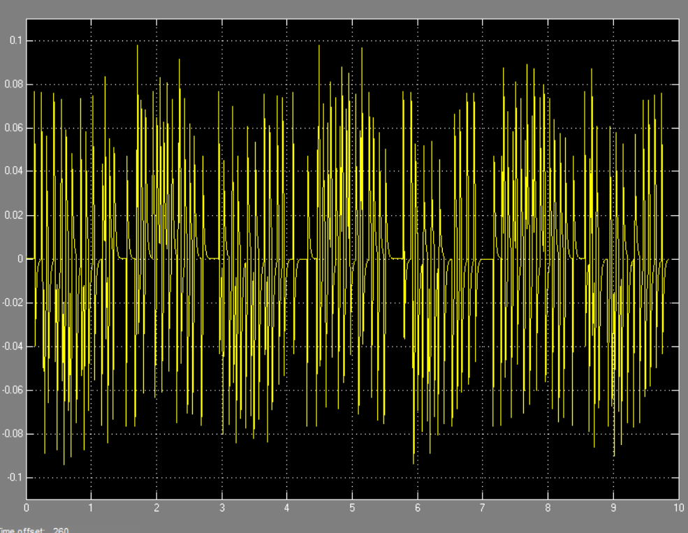

Figure 8: Angle derivative

*Question 15*

Increasing K1, increases position frequency also increases amplitudes and maximum angle deviation from 10 degrees.

Increasing K2 increases speed of the controller and allows it to move the cart faster to correct position. This in turn creates a lower frequency of position and at some points and almost no amplitude and goes completely flat.

Increasing K3, increases the importance of angle, so the angle error is decreased.

Increasing K4, increases the speed of correction of the angle.