1. **Design a state feedback controller based on dominant poles technique for the longer bar**

The steps we followed in lab 6 were repeated here but we made adjustments to the values of $m_{p}$ and $l_{p}$ to match the system of the longer bar.

1. **Define your problem as an LQR problem and define proper Q, R matrices.**

We defined the problem as an LQR problem, this meant fine tuning values for our Q and R matrices. The R matrix controls the cost on our input. Since we know that our input is almost free we set a relatively low value on this. Our Q matrix is defined as a diagonal matrix with the cost of the states on the diagonal.

$$Q=\left[ \begin{matrix}80 & 0 & 0 & 0 \\ 0 & 50 & 0 & 0 \\ 0 & 0 & 1000 & 0 \\ 0 & 0 & 0 & 20\end{matrix}\right]$$

$$R= \left[0.08\right]$$

1. **Describe intuitively how you chose the costs for each of the parameters to stabilize the system.**

Intuitively, we knew that the most important thing was to stabilize the angle of the system. That being said, given the physical limitations of the system, we knew we had to ensure that we also placed importance on the position of the cart. The cost for velocity parameter was set quite low as if we are able to correctly stabilize position velocity would not be a major problem. It is also important to note that our system was linearized around the zero degree point and if we allowed a lower value on our angle state, we would potentially no longer have a linear system. We also chose not to penalize angular velocity very highly as if we are able to effectively control the angle we can in turn control the angular velocity.

1. **Using *lqr* command, find proper gains for state feedback controller**

Using the lqr command, the gains we are able to achieve that would give us the desired system dynamics are these: K = [-23.0940 -35.3638 -131.7392 -17.7032]

1. **Try to stabilize the pendulum, if your gains are not working properly, redefine your cost function and design your controller again.**

We were able to achieve a very good performance with the system states we selected, however fine tuning to increase robustness of the system was required. We primarily fine tuned our weights corresponding to the position and angle of the system. This was done repeatedly through testing to ensure we achieve the most stable system possible. To test robustness of the system, we would tap the pendulum with a rod and measure the response on all states. The figures of the stable system are shown below for all four states:

Position Plot: Position dot:

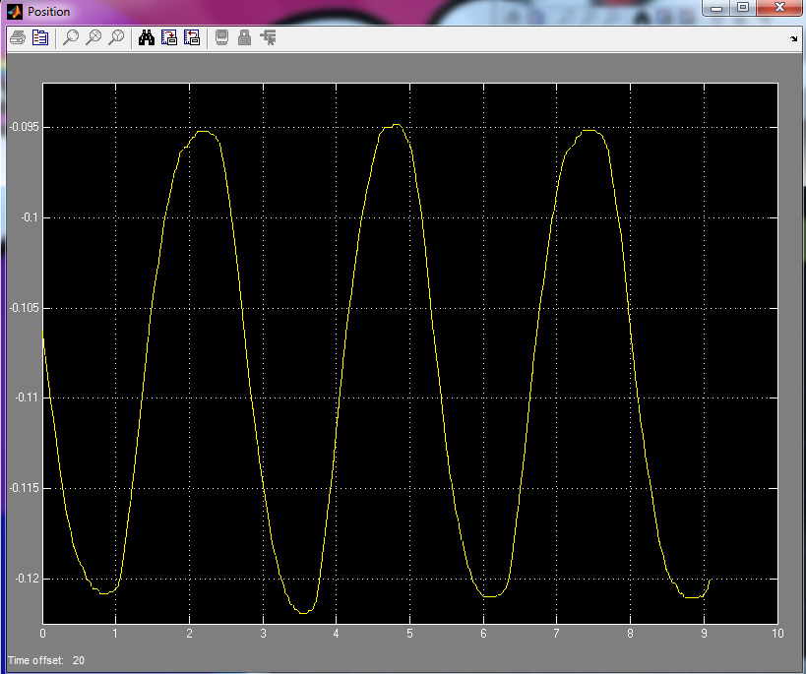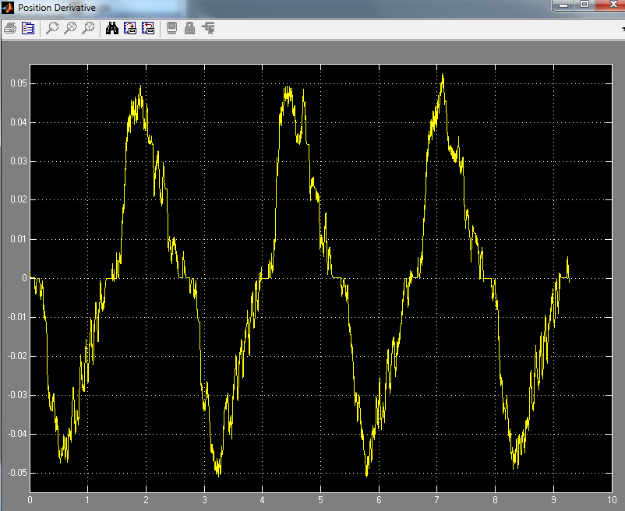

Angle: Angle dot:

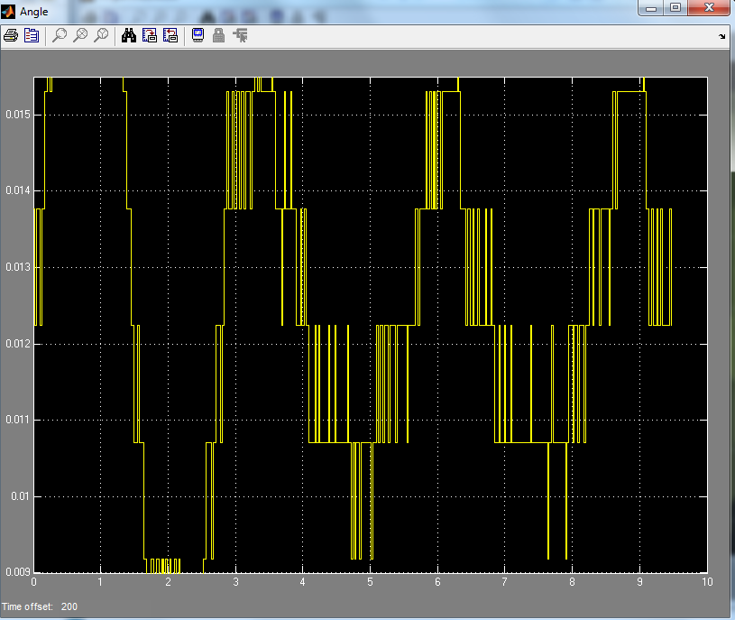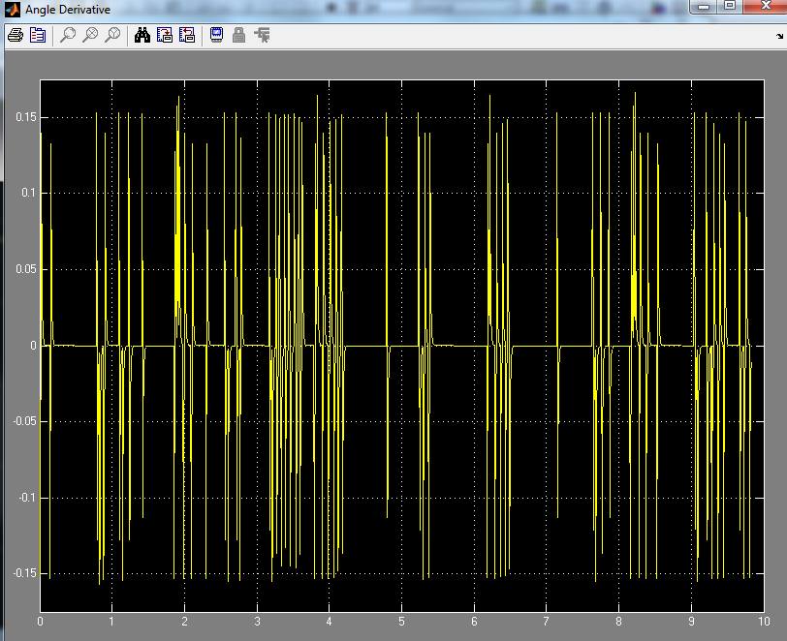

1. **Try to stabilize the pendulum, if your gains are not working properly, redefine your cost function and design your controller again.**

We were able to stabilize the pendulum with the LQR control. We however were able to determine that the gain effects to be as follows.

Increasing K1, increases position frequency also increases amplitudes and maximum angle deviation from 10 degrees.

Increasing K2 increases speed of the controller and allows it to move the cart faster to correct position. This in turn creates a lower frequency of position and at some points and almost no amplitude and goes completely flat.

Increasing K3, increases the importance of angle, so the angle error is decreased.

Increasing K4, increases the speed of correction of the angle.

1. **Repeat questions 2-6 for the longer bar**

We repeated questions 2-6 for the longer bar and got the following Q and R matrices as well as K matrix for our gain: Q same as the short pole case discussed in page 1, R = 0.15. R became higher because we need to more energy to control the big pole.

The state response of the system with a longer bar is seen below:

Position: Position dot:

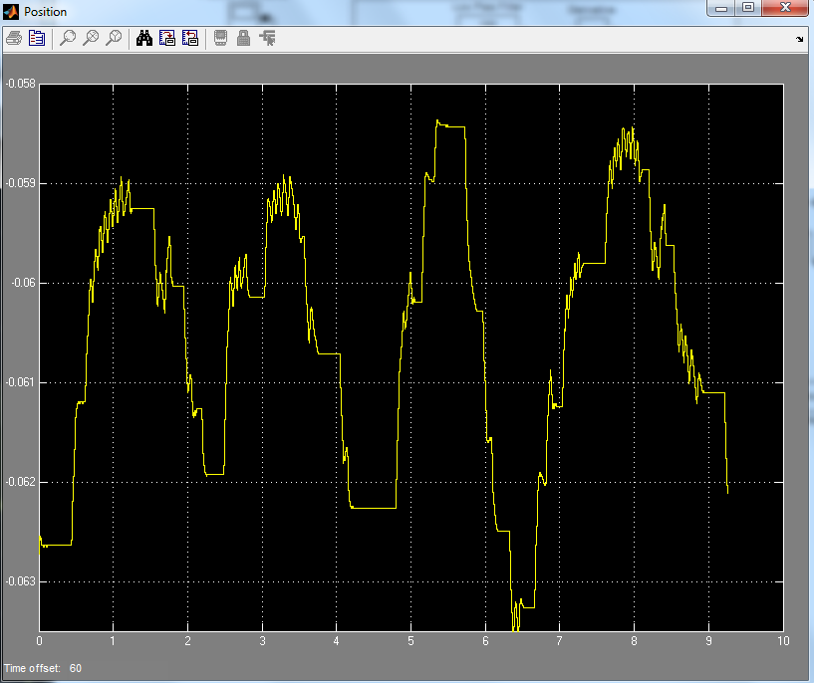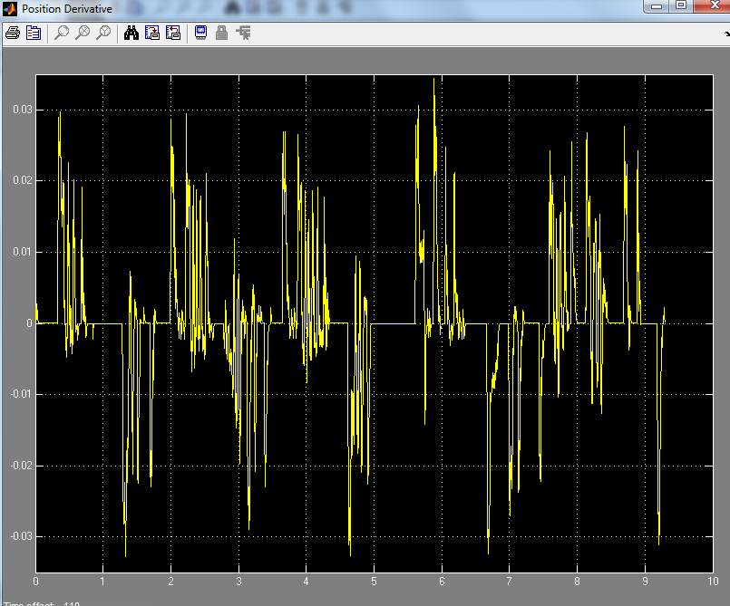

Angle: Angle dot:



1. **Include the costs you chose along with state feedback gains:**

Short bar:

Our K gain matrix was:

K = -23.0940 -35.3638 -131.7392 -17.7032

Our Q and R matrices were:

$$Q=\left[ \begin{matrix}80 & 0 & 0 & 0 \\ 0 & 50 & 0 & 0 \\ 0 & 0 & 1000 & 0 \\ 0 & 0 & 0 & 20\end{matrix}\right]$$

$$R= \left[0.08\right]$$

Long bar:

Our K gain matrix was:

K = -23.0940 -36.3798 -145.9253 -24.9310

Our Q and R matrices were:

$$Q=\left[ \begin{matrix}80 & 0 & 0 & 0 \\ 0 & 50 & 0 & 0 \\ 0 & 0 & 1000 & 0 \\ 0 & 0 & 0 & 20\end{matrix}\right]$$

$$R= \left[0.15\right]$$