# Index

## Company Name**:** …………………………………………………………………………………. page 2

## **Goal:** ……………………………………………………………………………………………………. page 2

## **Objective:** …………………………………………………………………………………….......... page 2

## **Target Audience:** …………………………………………………………………………………. page 2

## Site Structure: ……………………………………………………………………………………… page 2

## Wireframes: …………………………………………………………………………………………. page 3

## Home-page and Artindex.html: …………………………………………………………. page 3

## definition.html and history.html: ……………………………………………………... page 4

## Styles.html and Howindex.html: ………………………………………………………. page 5

## Selplant.html and Selstyle.html: ………………………………………………………… page 6

## Selpot.html and Maintain.html: ………………………………………………………… page 7

## Tsindex.html and Shears.html (x9): …………………………………………………… page 8

## Resindex.html and Glossary.html: …………………………………………………… page 9

## Links.html and Galleryindex.html: ………………………………………………………page 10

## Elm.html(x6) and Contactindex.html: …………………………………………………page 11

## Email.html and Feedback.html: …………………………………………………………page 12

## Colours: ……………………………………………………………………………………………. page 13

## Fonts and Sizes: ……………………………………………………………………………………. page 14-15

## Inventory of Images: ………………………………………………………………………. page 16-20

## Inventory of text: ……………………………………………………………………………. page 21-31

Company Name:Bonsaihut

Goal:ThatPeople learn to cultivate and care Bonsais.

Objective:Build a 33-page desktop website in given timeframe. Create clean, customizable html + css.

Target Audience:Adults and every person passionate for Bonsai art.

# Site Structure:

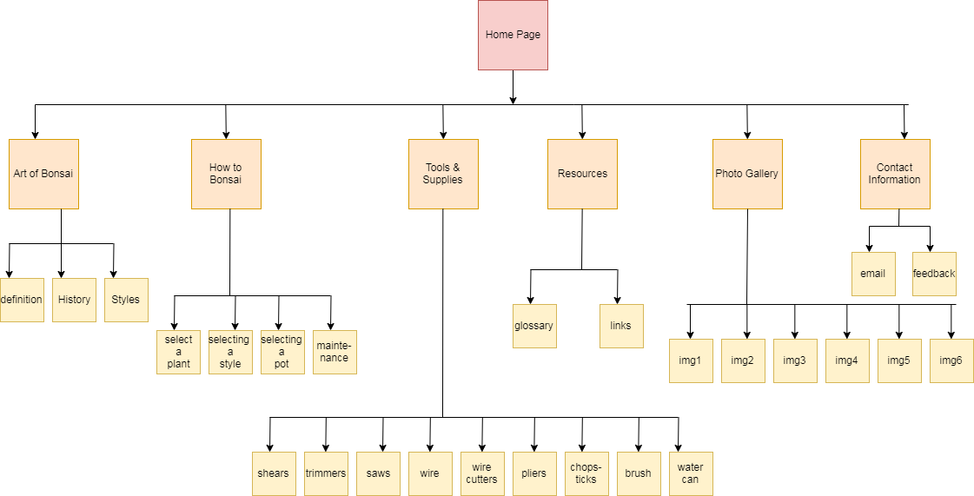

# Wireframes:

## Home-page

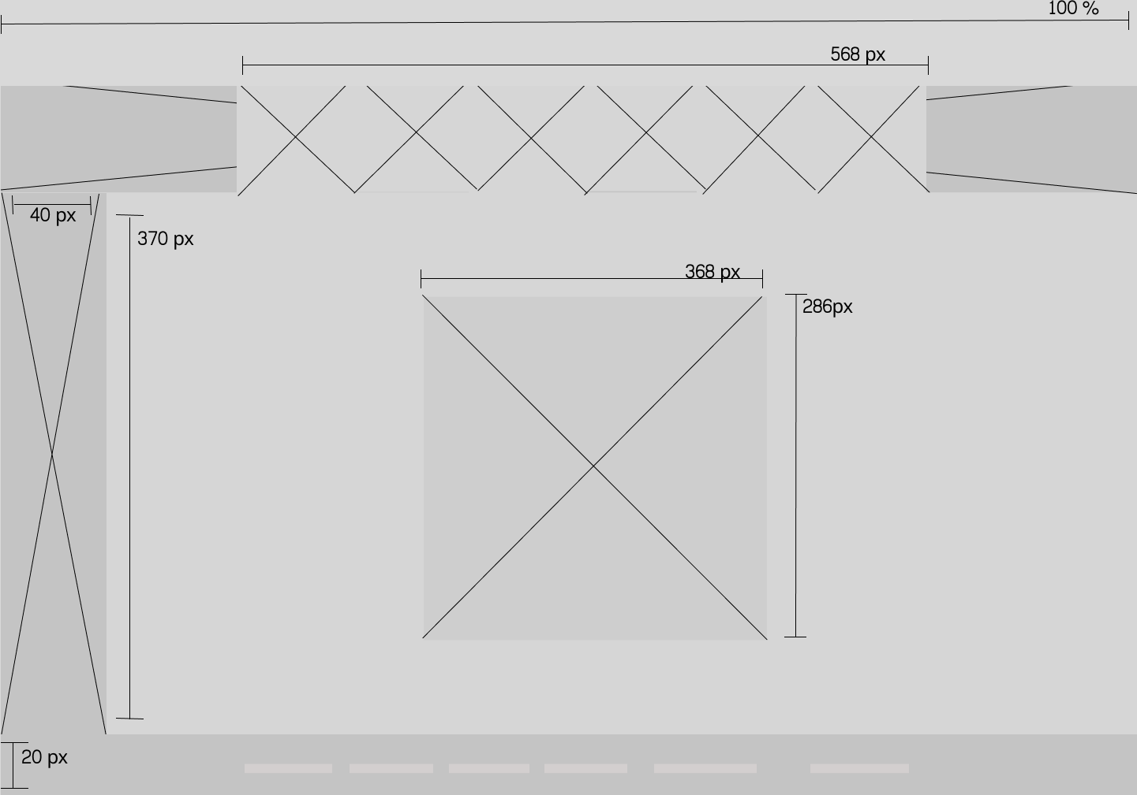

## Artindex.html

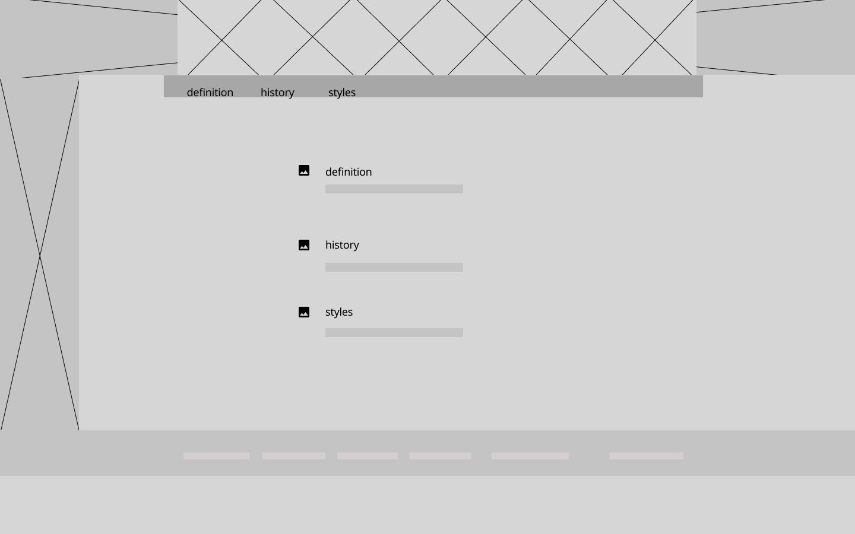

## definition.html

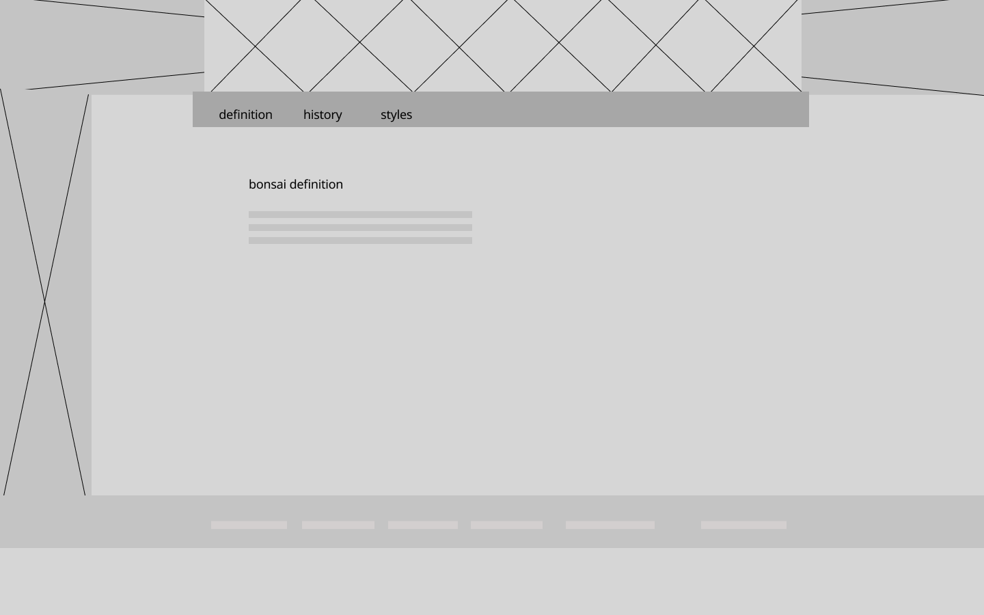

## history.html

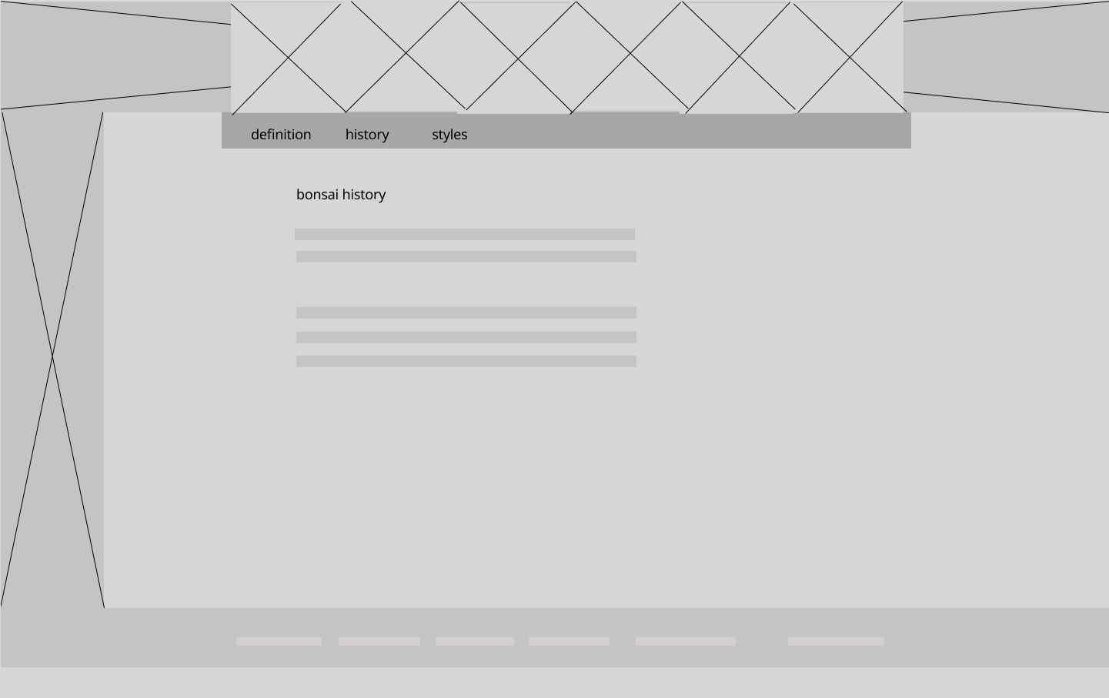

## Styles.html

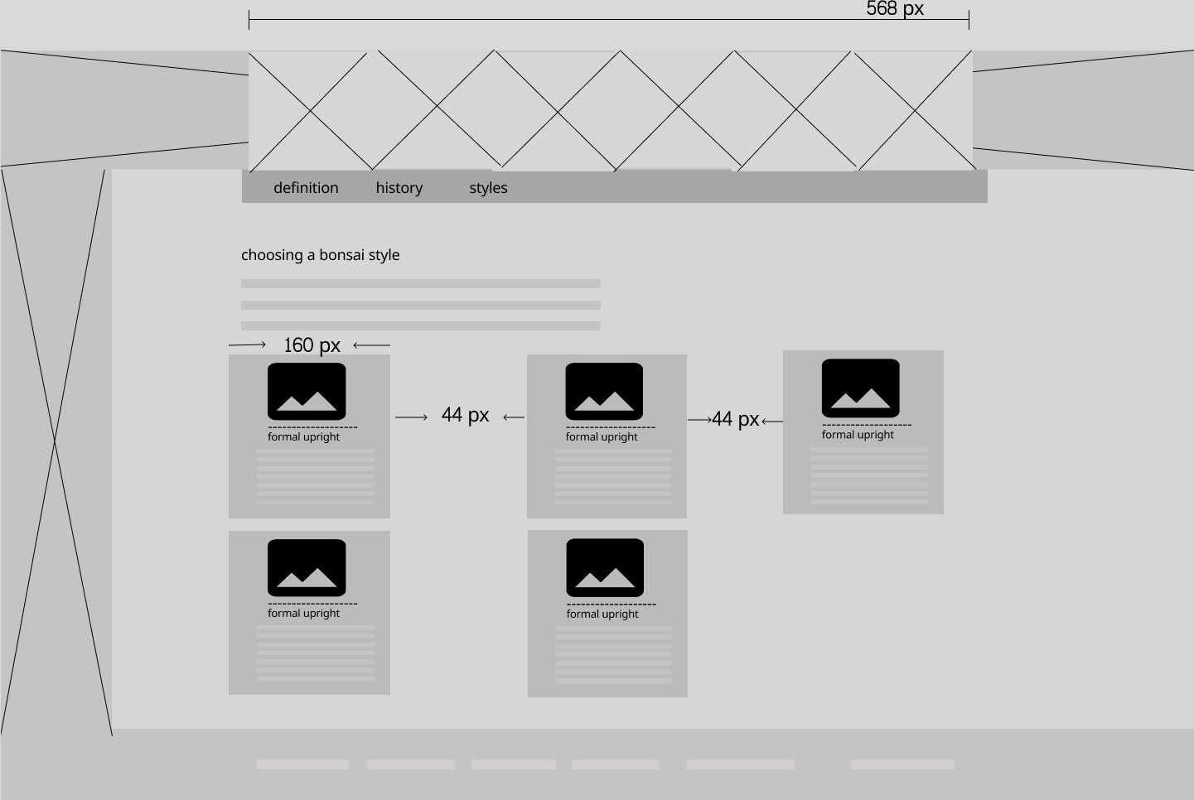

## Howindex.html

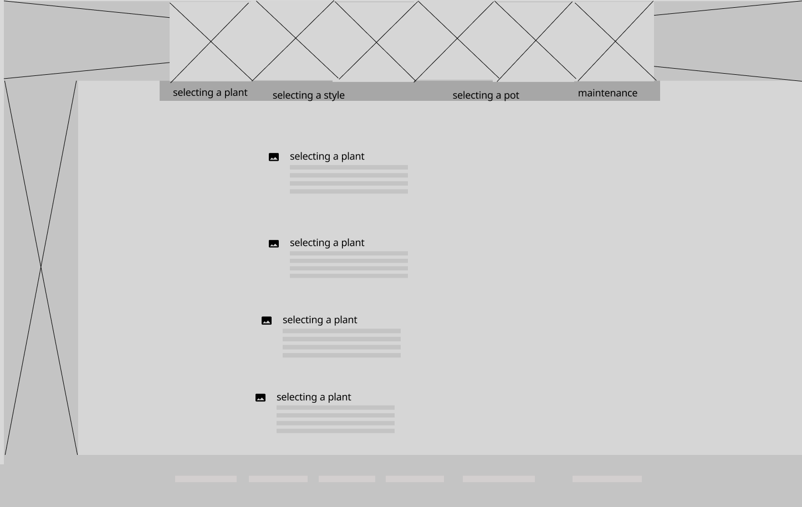

## Selplant.html

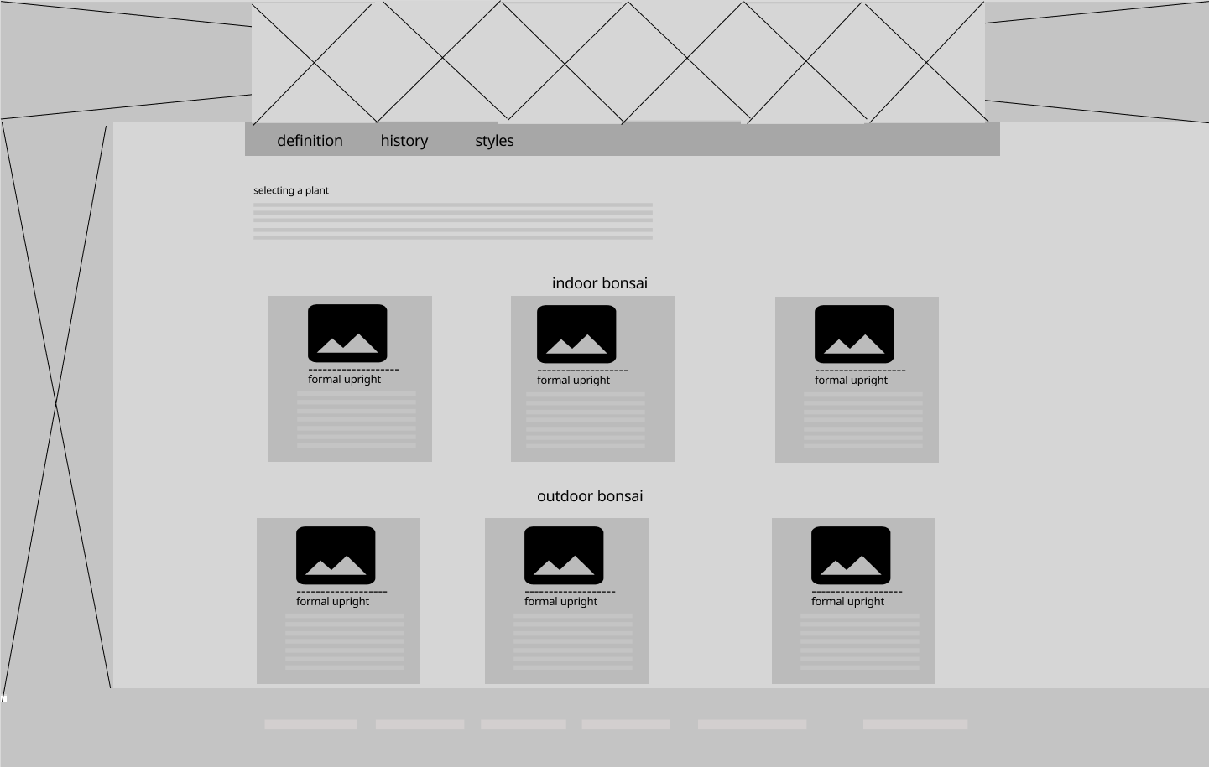

## Selstyle.html

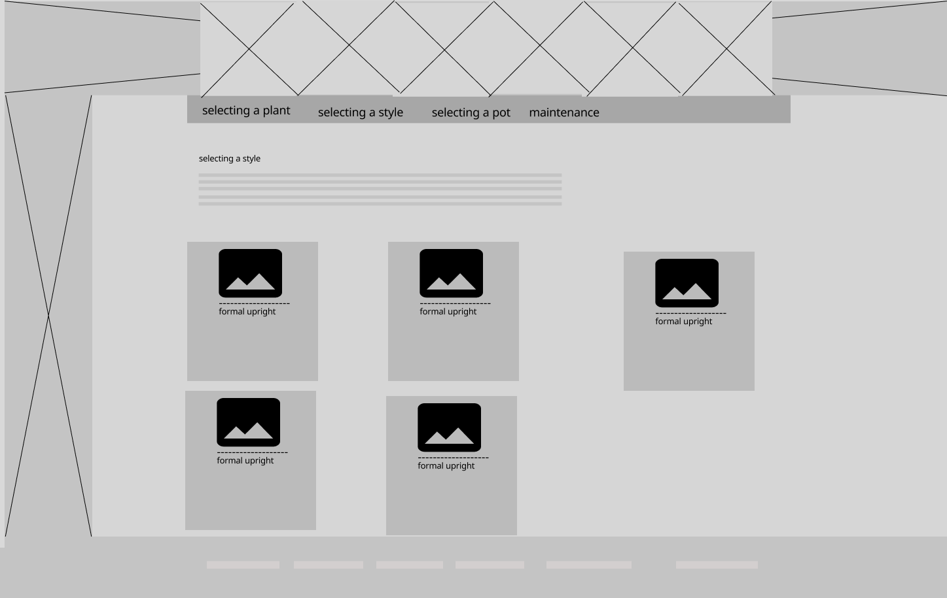

## Selpot.html

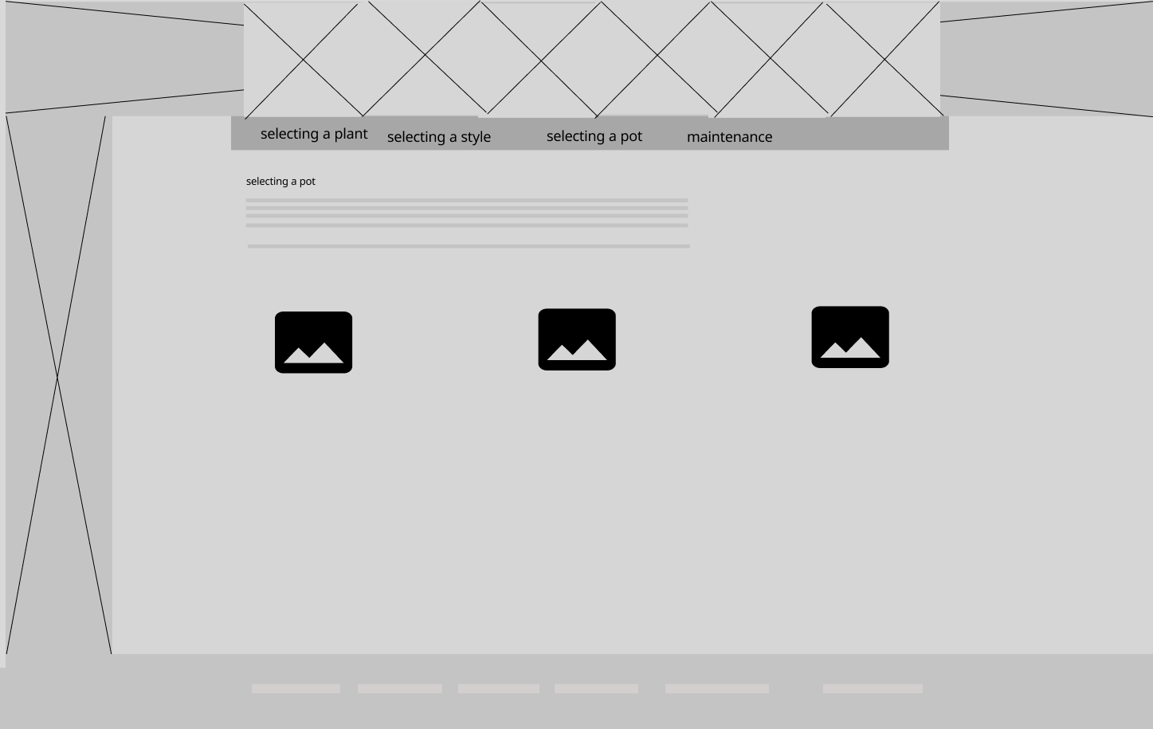

## Maintain.html

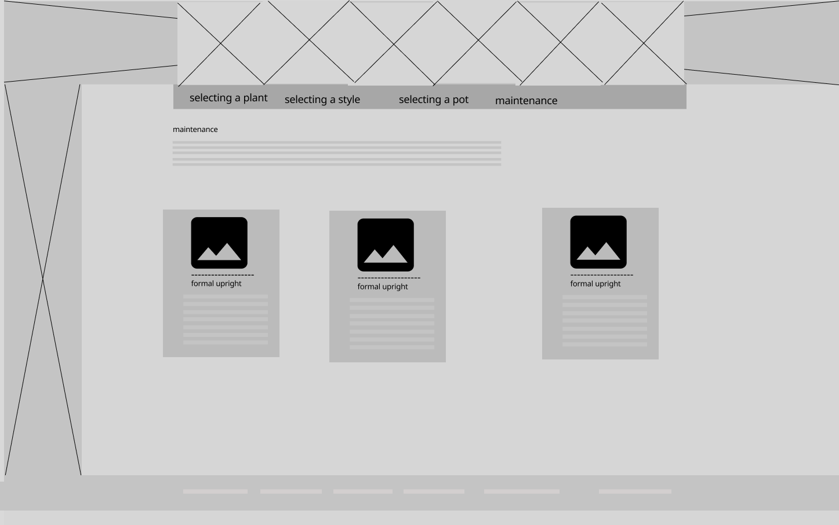

## Tsindex.html

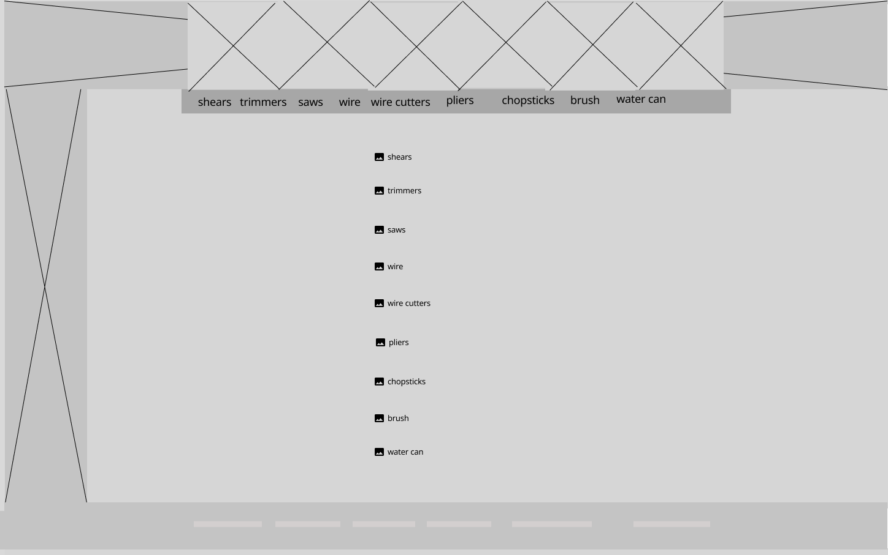

## Shears.html (x9)

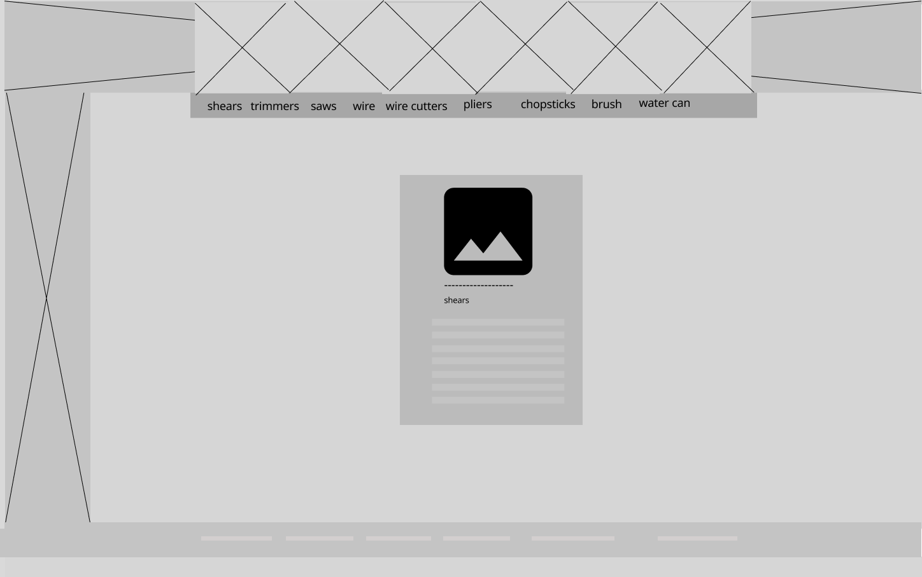

## Resindex.html

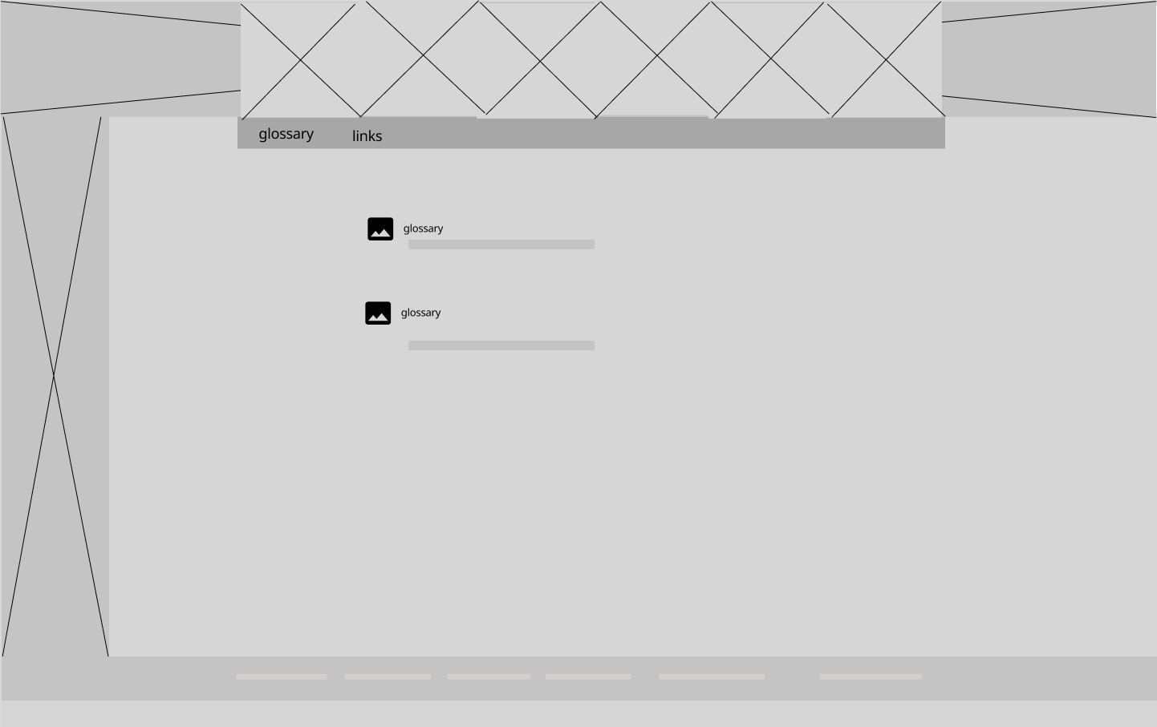

## Glossary.html

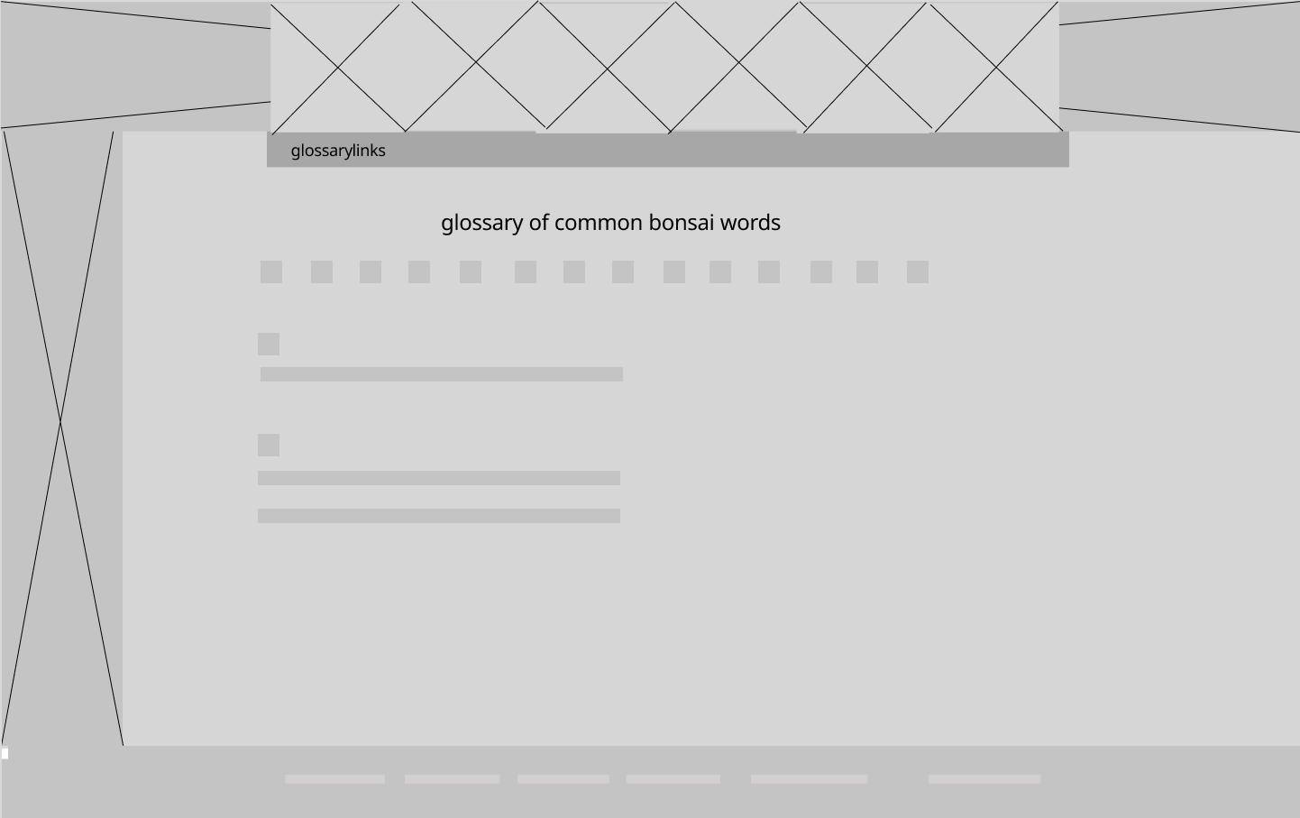

## Links.html

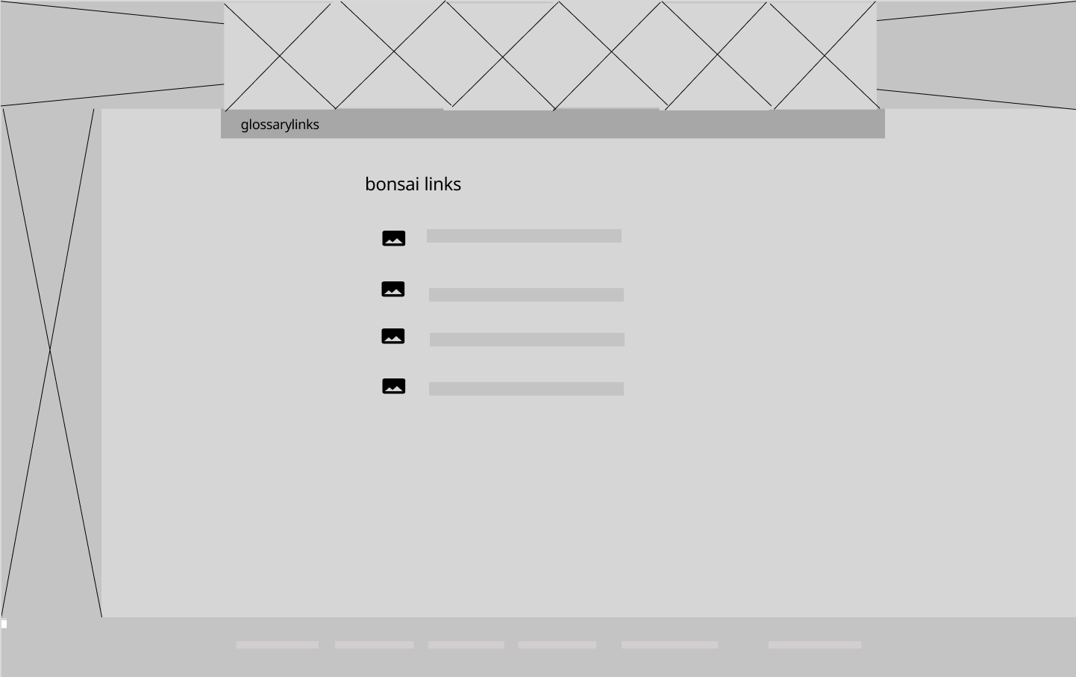

## Galleryindex.html

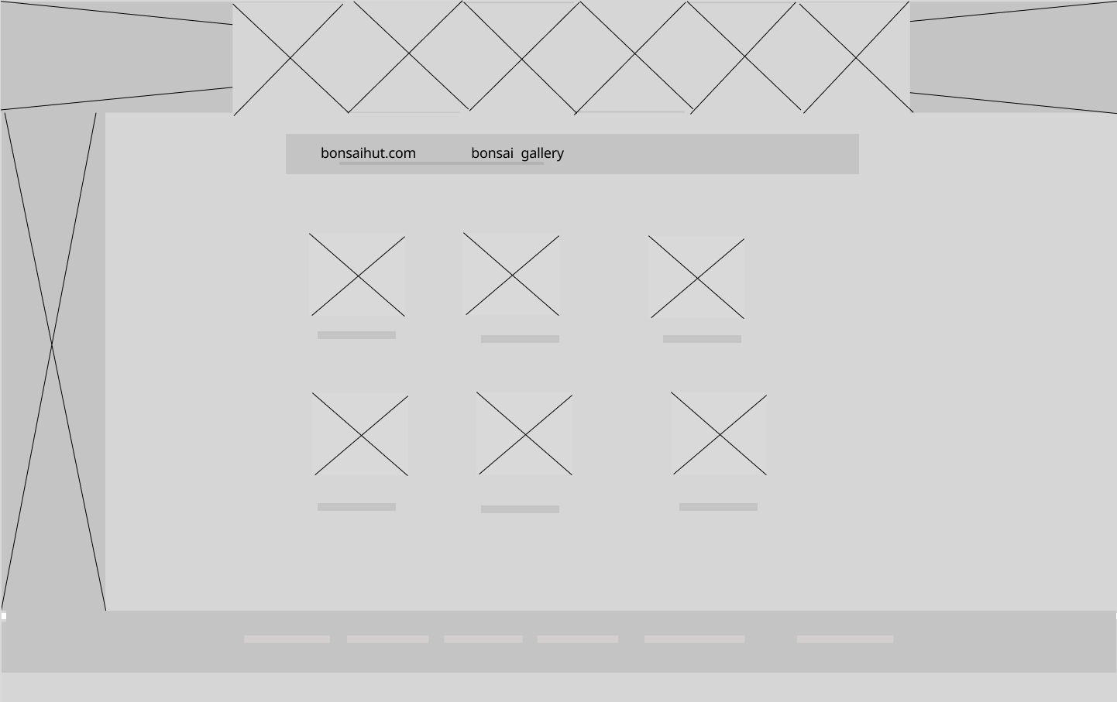

## Elm.html(x6)

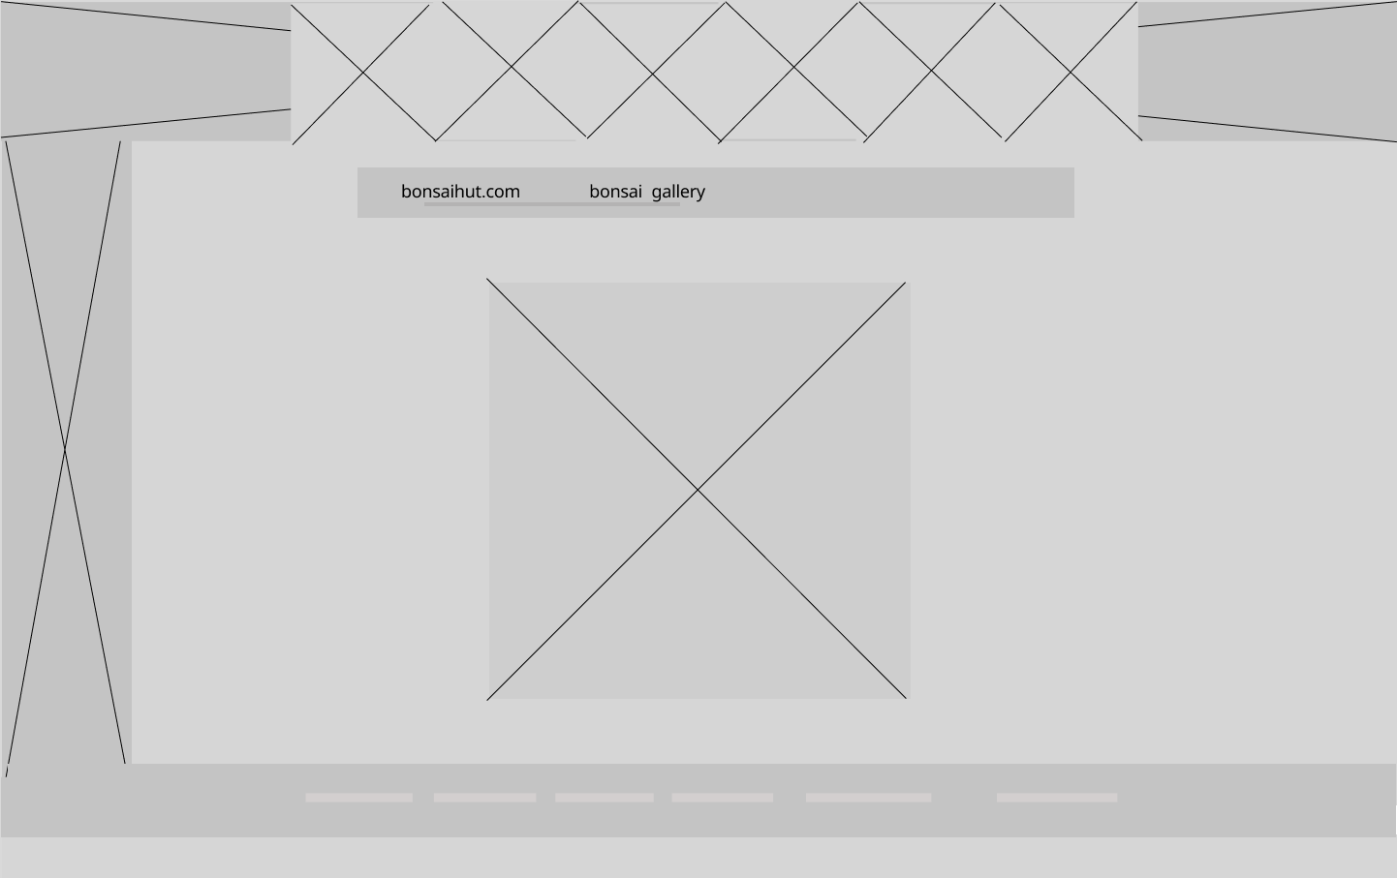

## Contactindex.html

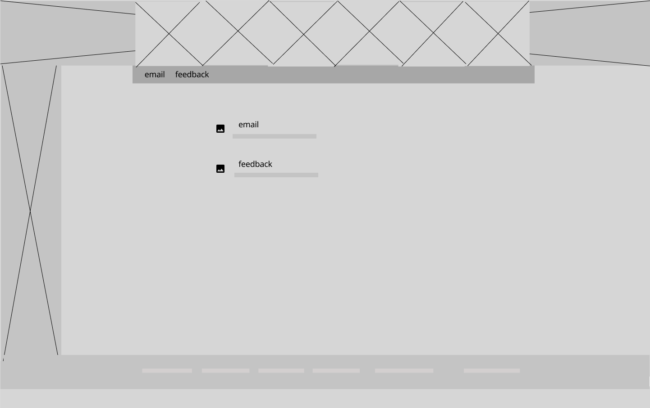

## Email.html

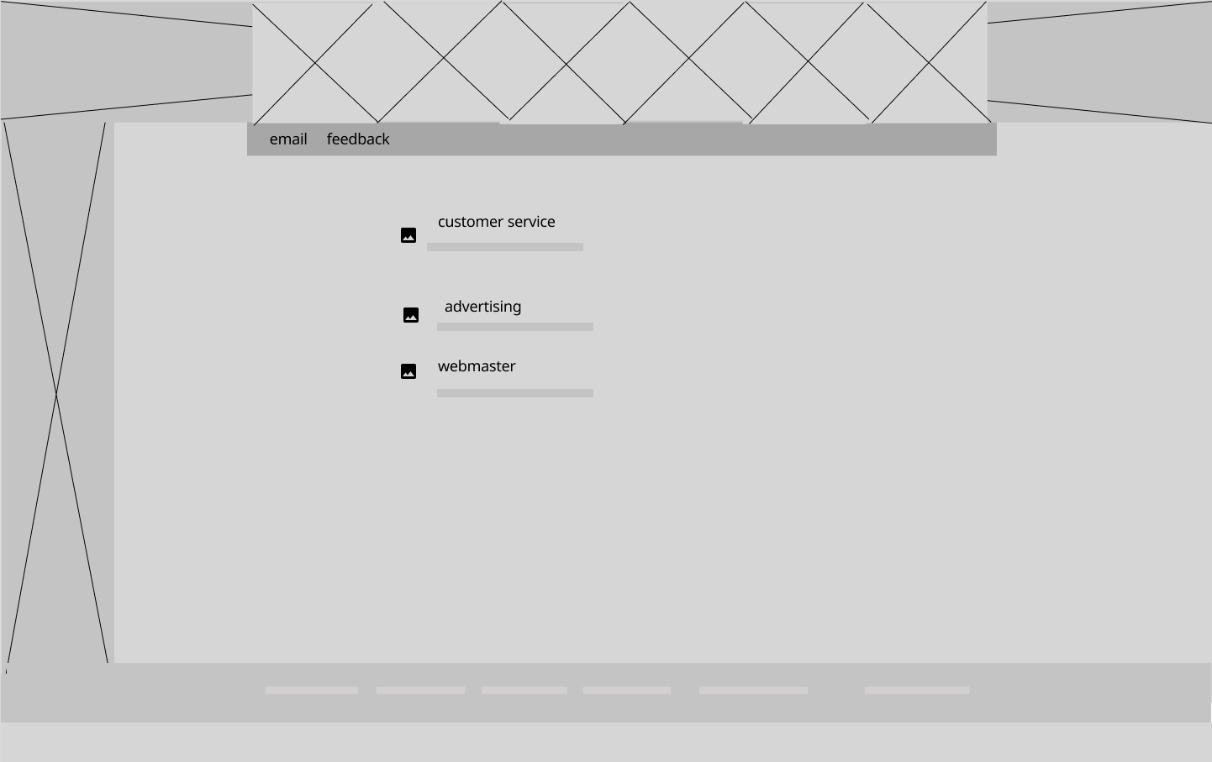

## Feedback.html

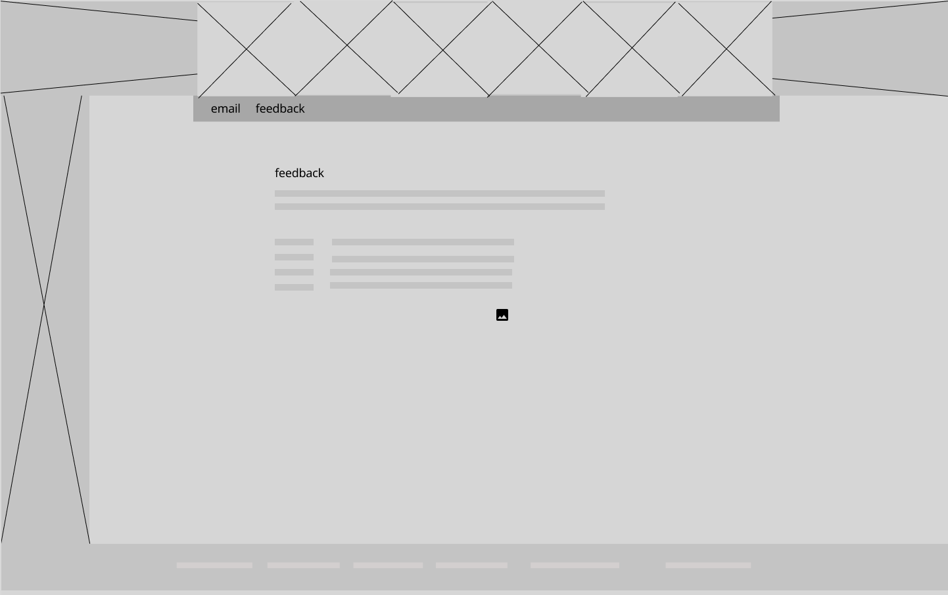

# Colours:

Links, h1 links, h3 #990000

Body background-color, #ffffcf

Text, #000

Footer background-color, h1 #cccc99

Links footer hover, sm-navbar background-color, h1, h2 #999966

# Fonts and Sizes:

## Fonts

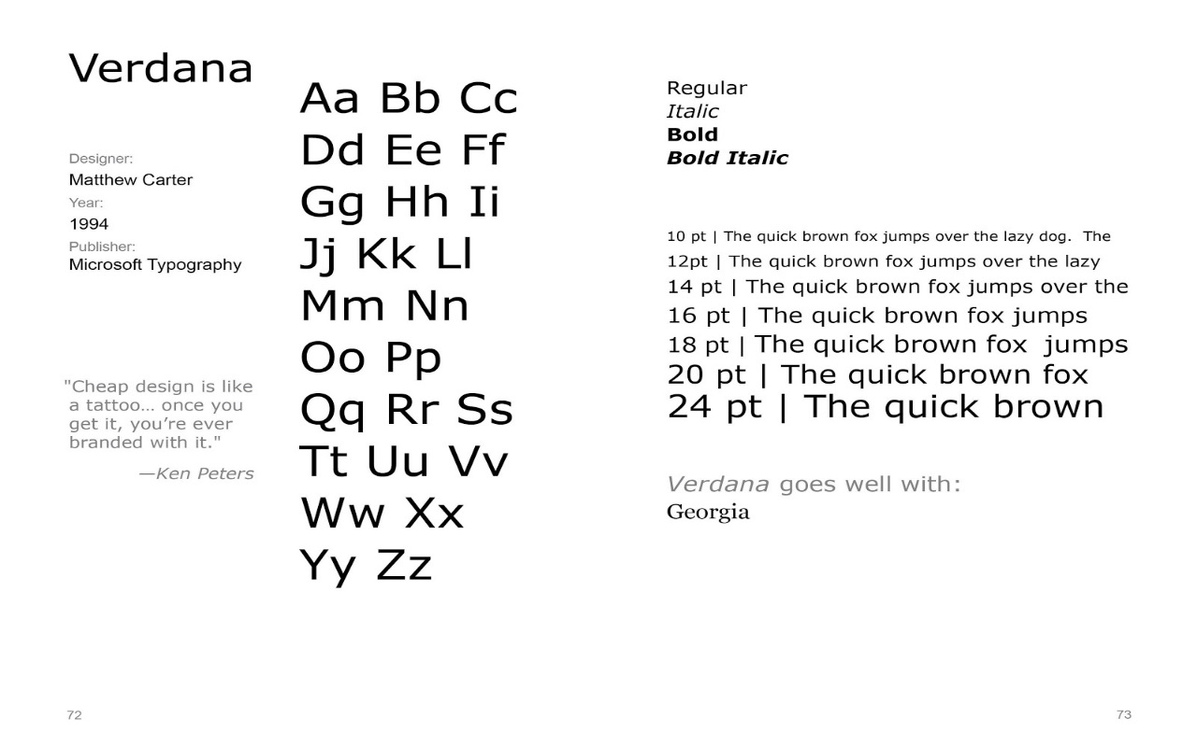

Verdana specimen sheet.

Body text, h3 and nav-links: Verdana font-family.

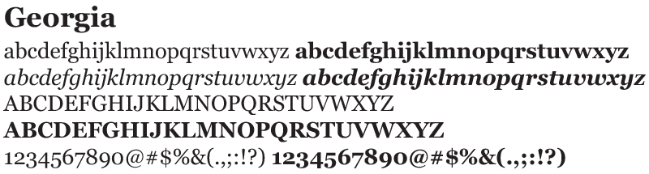

Georgia specimen sheet.

Other links, h1 and h2: Georgia font-family.

## Sizes

Body: 14px

Headings h1: 1.3em

Headings h2: 1em

Headings h3: .9em

Links: .9em

Paragraphs: .8em

# Inventory of Images:

All images provided by client.

## Home-page.html:

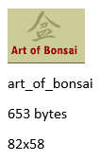 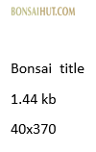 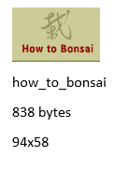 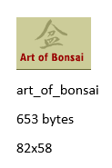 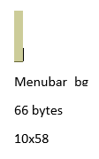

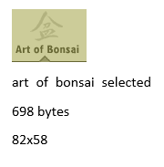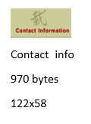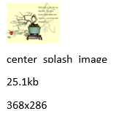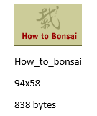

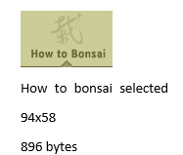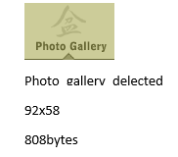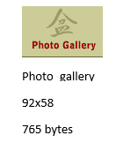

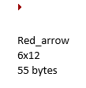  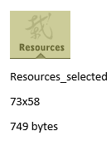

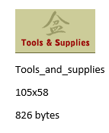 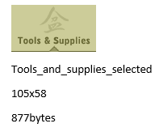

## Gallery.html and Selplant.html

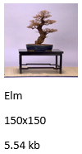 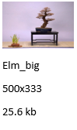 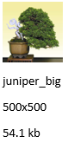 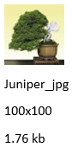

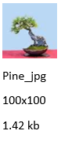 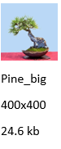 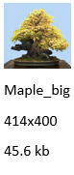 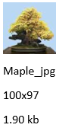

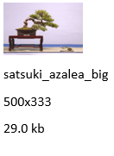 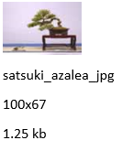 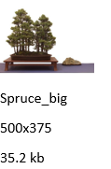

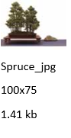

## Styles.html and selstyle.html

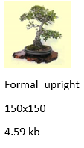 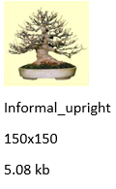 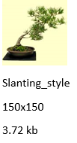 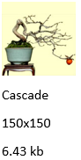 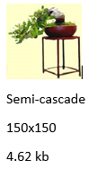

## Selpot.html

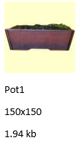 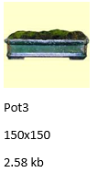 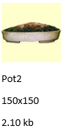

## Maintenance.html

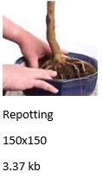 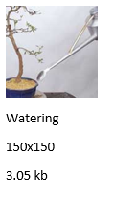 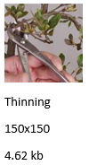

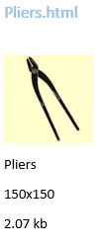 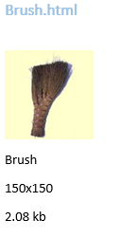 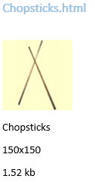

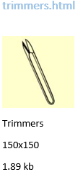 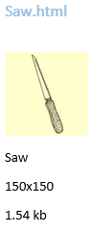 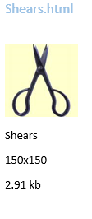

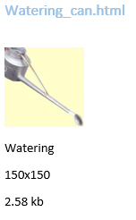 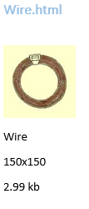 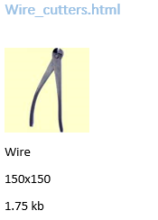

## Feedback.html

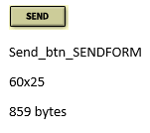

# Inventory of text

## Definition.html

Bonsai Definition:

Bonsai is a Japanese word meaning "potted in a tray." Today, we recognize a bonsai as a potted plant that produces the illusion of a much larger tree found in nature. wn successfully as a bonsai.

## History.html

Bonsai History:

Bonsai is an art form with a rich history. Beginning in China, the cultivation of Bonsai spread to Japan, where it has been refined. Over the past century, interest in this fascinating art form has spread to countries throughout the world where bonsai techniques are applied to native plants.

The creation of a bonsai is an application of techniques under artistic design with the intent to create the illusion of a large tree on a miniature scale. While some plants lend themselves to this practice based on growth habit, leaf size or other features, most any woody plant, tree or shrub can be grown successfully as a bonsai.

## styles.html

Choosing a Bonsai Style:

In choosing a training style appropriate to a particular tree, one must first evaluate the tree's strengths and weaknesses. This will require some study, and if the tree is raw stock, it is best that the tree be removed from the growing container to examine it more carefully.

Formal Upright

Lorem ipsum dolor sit amet, consectetaur adipisicing elit, sed do eiusmod tempor incididunt ut labore et dolore magna aliqua. Ut enim ad minim veniam, quisnostrud exercitation ullamco laboris nisi ut aliquip ex ea commodo consequat. Duis aute irure dolor in reprehenderit in voluptate velit esse cillum dolore eu fugiatnulla pariatur. Excepteur sint occaecat cupidatat non proident, sunt in culpa qui officia deserunt mollit anim id est laborum Et harumd und lookum like Greek tome, dereud facilis est er expedit distinct.

Informal Upright

Lorem ipsum dolor sit amet, consectetaur adipisicing elit, sed do eiusmod tempor incididunt ut labore et dolore magna aliqua. Ut enim ad minim veniam, quisnostrud exercitation ullamco laboris nisi ut aliquip ex ea commodo consequat. Duis aute irure dolor in reprehenderit in voluptate velit esse cillum dolore eu fugiatnulla pariatur. Excepteur sint occaecat cupidatat non proident, sunt in culpa qui officia deserunt mollit anim id est laborum Et harumd und lookum like Greek tome, dereud facilis est er expedit distinct.

Slanting Syle

Lorem ipsum dolor sit amet, consectetaur adipisicing elit, sed do eiusmod tempor incididunt ut labore et dolore magna aliqua. Ut enim ad minim veniam, quisnostrud exercitation ullamco laboris nisi ut aliquip ex ea commodo consequat. Duis aute irure dolor in reprehenderit in voluptate velit esse cillum dolore eu fugiatnulla pariatur. Excepteur sint occaecat cupidatat non proident, sunt in culpa qui officia deserunt mollit anim id est laborum Et harumd und lookum like Greek tome, dereud facilis est er expedit distinct.

Cascade

Lorem ipsum dolor sit amet, consectetaur adipisicing elit, sed do eiusmod tempor incididunt ut labore et dolore magna aliqua. Ut enim ad minim veniam, quisnostrud exercitation ullamco laboris nisi ut aliquip ex ea commodo consequat. Duis aute irure dolor in reprehenderit in voluptate velit esse cillum dolore eu fugiatnulla pariatur. Excepteur sint occaecat cupidatat non proident, sunt in culpa qui officia deserunt mollit anim id est laborum Et harumd und lookum like Greek tome, dereud facilis est er expedit distinct.

Semi Cascade

Lorem ipsum dolor sit amet, consectetaur adipisicing elit, sed do eiusmod tempor incididunt ut labore et dolore magna aliqua. Ut enim ad minim veniam, quisnostrud exercitation ullamco laboris nisi ut aliquip ex ea commodo consequat. Duis aute irure dolor in reprehenderit in voluptate velit esse cillum dolore eu fugiatnulla pariatur. Excepteur sint occaecat cupidatat non proident, sunt in culpa qui officia deserunt mollit anim id est laborum Et harumd und lookum like Greek tome, dereud facilis est er expedit distinct.

## Selplant.html

Selecting a Plant:

Almost any plant can be crafted into a beautiful and balanced bonsai. After all, bonsai simply translated means “plant in pot”; it doesn’t say what kind of plant. The majority of people will recognize the green juniper as the standard bonsai plant. These types of bonsai specimens are often the types seen in movies, television commercials, and in shopping malls. They are also a very sturdy plant, which makes them ideal for beginners to work with as they develop their bonsai skills. While they are used frequently, they certainly are not the only bonsai specimens. Here is a listing of some common indoor and outdoor bonsai specimens:

Indoor Bonsai:

Pine

Lorem ipsum dolor sit amet, consectetaur adipisicing elit, sed do eiusmod tempor incididunt ut labore et dolore magna aliqua. Ut enim ad minim veniam, quisnostrud exercitation ullamco laboris nisi ut aliquip ex ea commodo consequat. Duis aute irure dolor in reprehenderit in voluptate velit esse cillum dolore eu fugiatnulla pariatur. Excepteur sint occaecat cupidatat non proident, sunt in culpa qui officia deserunt mollit anim id est laborum Et harumd und lookum like Greek tome, dereud facilis est er expedit distinct.

satsuki Azalea

Lorem ipsum dolor sit amet, consectetaur adipisicing elit, sed do eiusmod tempor incididunt ut labore et dolore magna aliqua. Ut enim ad minim veniam, quisnostrud exercitation ullamco laboris nisi ut aliquip ex ea commodo consequat. Duis aute irure dolor in reprehenderit in voluptate velit esse cillum dolore eu fugiatnulla pariatur. Excepteur sint occaecat cupidatat non proident, sunt in culpa qui officia deserunt mollit anim id est laborum Et harumd und lookum like Greek tome, dereud facilis est er expedit distinct.

Spruce

Lorem ipsum dolor sit amet, consectetaur adipisicing elit, sed do eiusmod tempor incididunt ut labore et dolore magna aliqua. Ut enim ad minim veniam, quisnostrud exercitation ullamco laboris nisi ut aliquip ex ea commodo consequat. Duis aute irure dolor in reprehenderit in voluptate velit esse cillum dolore eu fugiatnulla pariatur. Excepteur sint occaecat cupidatat non proident, sunt in culpa qui officia deserunt mollit anim id est laborum Et harumd und lookum like Greek tome, dereud facilis est er expedit distinct.

Outdoor Bonsai:

Elm

Lorem ipsum dolor sit amet, consectetaur adipisicing elit, sed do eiusmod tempor incididunt ut labore et dolore magna aliqua. Ut enim ad minim veniam, quisnostrud exercitation ullamco laboris nisi ut aliquip ex ea commodo consequat. Duis aute irure dolor in reprehenderit in voluptate velit esse cillum dolore eu fugiatnulla pariatur. Excepteur sint occaecat cupidatat non proident, sunt in culpa qui officia deserunt mollit anim id est laborum Et harumd und lookum like Greek tome, dereud facilis est er expedit distinct.

Juniper

Lorem ipsum dolor sit amet, consectetaur adipisicing elit, sed do eiusmod tempor incididunt ut labore et dolore magna aliqua. Ut enim ad minim veniam, quisnostrud exercitation ullamco laboris nisi ut aliquip ex ea commodo consequat. Duis aute irure dolor in reprehenderit in voluptate velit esse cillum dolore eu fugiatnulla pariatur. Excepteur sint occaecat cupidatat non proident, sunt in culpa qui officia deserunt mollit anim id est laborum Et harumd und lookum like Greek tome, dereud facilis est er expedit distinct.

Maple

Lorem ipsum dolor sit amet, consectetaur adipisicing elit, sed do eiusmod tempor incididunt ut labore et dolore magna aliqua. Ut enim ad minim veniam, quisnostrud exercitation ullamco laboris nisi ut aliquip ex ea commodo consequat. Duis aute irure dolor in reprehenderit in voluptate velit esse cillum dolore eu fugiatnulla pariatur. Excepteur sint occaecat cupidatat non proident, sunt in culpa qui officia deserunt mollit anim id est laborum Et harumd und lookum like Greek tome, dereud facilis est er expedit distinct.

## Selstyle.html

Selecting a Style:

There are five basic styles of bonsai: formal upright, informal upright, slanting, cascade, and semi-cascade. The style you choose for your tree will depend largely on the natural characteristics of the tree. In the practice of bonsai, it believed that the tree should dictate the style, not the artist. A detailed explanation of each style can be view in the Styles of Bonsai section.

Formal Upright

Informal Upright

Slanting Style

Cascade

Semi Cascade

## Selpot.html

Selecting a Pot:

Selecting the proper pot of your bonsai is as important as selecting the style that brings out the natural beauty of the tree. There are many types of pots, ranging from simple clay to glazed ceramic pots with hand painted detailing. Some pots are designed for indoor use while others are designed for outdoor use.

Here are sample pots used specifically for bonsai:

## Maintain.html

Maintenance:

Creating the bonsai is a first and important part of the bonsai art; caring for your bonsai is a second and no less important part. Indoor plant specimens will require different care than outdoor specimens. With the right care and maintenance, your bonsai will bring you hears of happiness and tranquility. Here are some tips to insure your bonsai has a long and tranquil life:

## Repotting.html

The purpose of repotting is to maintain the vigor of the tree. As soil is watered and roots grow, the soil will become compacted and drainage will be impaired. Also, the root system will continue to grow and expand within the limits of the container. Repotting allows us to trim the roots and encourage the growth of feeder roots, making for a healthier root system and tree. Repotting is considered an activity requiring intermediate skill. It can be learned or self-taught from a book or article, but firsthand experience is hard to beat.

--------------------------------

## Watering.html

Watering is said to be one of the most difficult skills to learn. Most of the problems that beginning bonsai fanciers have can usually be attributed to watering problems.

Considering all of the variables at work, this is not surprising. In addition to the variables of tree species, container size and soil composition, we should consider the timing of watering, the amount of water applied, the frequency of water, and the seasonal variables of temperature, wind and relative humidity.

--------------------------------

## Thinning.html

The general strategy for thinning growth is to reduce each bud to just two leaves. The leaves should be healthy

## Glossary.html

Glossary of common Bonsai words:

A B C D E F G H I J K L M N O P Q R S T U V W X Y Z

A

apex - the tip of a tree or branch

B

bonsai - Japanese term for the the art of cultivating and training a plant to create the illusion of a dwarfed tree.

bonkei - tray plantings containing stones, trees, plants and figurines

branch bender - a clamp or jack used to bend branches or trunk

branch splitter - a cutting tool used to divide branch or trunk to allow it to be bent more easily.

broom style - A training form for bonsai which resembles an inverted broom with a single trunk dividing into many symmetric branchlets which subdivide into twigs and so forth. See Hokidachi

bunjin - Japanese term for an educated person or literati, a tree grown in this style, usually emphasizing a thin trunk, with a lean appearance and container with rough-hewn appearance.

C

callus - The raised roll of tissue that forms as a wound heals and closes

cambium - The layer of tissue between the xylem and phloem, where new wood is formed.

chokkan - Japanese term for the formal upright style

clump style - see Kabaduchi

concave cutters

cutting - a bit of a plant that has been cut and rooted. A means to propagate.

D

deciduous - a plant that sheds its leaves and enters a state of dormancy annually

E

eda - Japanese term for branch

evergreen - a tree that does not shed its leaves in winter

F

fungicide - a chemical used to combat the growth of fungus

G

graft - to join a stem of one plant with another so they grow together. Grafting is used both to propagate plant species and to add foliage where none previously existed on a bonsai.

grafting knife

H

han-kengai - Japanese term for semi-cascade - See also Kengai

hokidachi - Japanese Term for Broom Style

I

ishitsuki - Japanese term for root-over-rock style

J

jin - Pronounced JEEN - Japanese term for snags of deadwood on the ends of branches or trunk.

K

kabaduchi - Japanese term for clump style bonsai

kengai - Japanese term for cascade style. See also han-kengai

L

lava

layering - a method of propagating a tree by ring-girdling the trunk and inducing roots to grow from the wound.

M

miyogi - Japanese term for informal upright style

mycorhizzae

N

neagari - Japanese term for exposed root or octopus style

nebari - Japanese term for the exposed root base of a tree

O

overpotting - planting a bonsai in a container that is larger than necessary to maintain it.

P

pH - measure of soil acidity. pH 7.0 is neutral. lower pH is acid, higher pH is alkaline.

perlite - lightweight, porous, white granules that can hold water and air.

pot - A growing container for bonsai, usually high-fired clay

pumice - A white, hard volcanic product used as an agricultural amendment

R

raffia - A dried shredded reed used to wrap branches and trunk before bending to cushion and reduce the likelihood of splitting.

raft style - a bonsai style in which multiple trunks grow in a line from a connected base.

ramification - the development of a twigging structure by a series of divisions of branches into twigs and twiglets

S

sabamiki -A Japanese term for a tree with a wounded trunk tree that is hollow or split open

saikei - tray plantings containing stones, trees, plants, but in the strict sense, without figurines - See bonkei.

shari - Japanese term for exposed deadwood on a tree

sokan - Japanese term for a twin trunk tree

shakkan - Japanese term for slant style bonsai

sifting

suiban - Japanese term for a shallow tray without drainage holes intended for the display of suiseki

suiseki - Japanese term for viewing stone

T

tachiagari - Japanese term for the lower portion of the trunk

V

variegated - a tree with foliage spotted or striped in two or more colors.

vermiculite - mica that has been expanded with heat into a lightweight granule. Useful in rooting seedlings.

viewing stone - a stone appreciated for its natural characteristics, as a mountain or natural scene, including cliffs, waterfalls or an appearance reminiscent of a figure, animal, implement or structure, or perhaps an entirely abstract shape.

W

whetstone

wire

Y

yamadori - Japanese term for a tree collected from the wild mountain, or a tree with that appearance.

yose-ue - Japanese term for forest or group planting