PRAXIS Project Plan
Self-Improving Knowledge Loop for Claude Code Agents • 9-Day Focused Sprint

Team Members & Leadership Roles
Three Gauntlet AI Fellows collaborating on a production-grade capstone. Each member leads one distinct, high-impact aspect of the project to enable authentic technical interview storytelling.
Matthew Daw | Monica Peters | Dominic Antonelli
ML & Knowledge Pipeline Lead  Ingestion, learning moment detection (ML classifier), LLM distillation, consolidation/dedup/scoring, knowledge graph, provenance.  Interview claim: "I led the ML-powered distillation engine that turns raw JSONL logs into scored, deduplicated, human-approved knowledge with full provenance." | Dashboard & Human Gate Lead  React review dashboard, human approval workflow (proposed→suggested→active), contradiction resolution UI, credibility metrics viz, injection controls.  Interview claim: "I designed and built the human approval dashboard that enforces quality gates and makes knowledge promotion transparent and measurable." | Architecture, Eval & Integration Lead  System design, eval harness (fixed tasks + metrics), GitHub hook/PR automation, Python tooling, deployment, live demo & compounding curve proof.  Interview claim: "I architected the eval harness and integration layer that rigorously proves PRAXIS delivers ≥50% fewer corrections with compounding gains."

Project Overview
PRAXIS transforms Claude Code's raw session logs (JSONL) into a compounding knowledge asset. It automatically detects learning moments, distills them via LLM into structured candidates, consolidates/dedups/scores them, routes contradictions through a human approval gate, and injects only the highest-quality knowledge back into future sessions via generated CLAUDE.md/skills. A rigorous eval harness measures before/after correction rates, proving the agent stops re-learning the same mistakes. The 9-day sprint delivers a production-ready MVP with dashboard, full provenance, and quantified improvement demo.

System Architecture
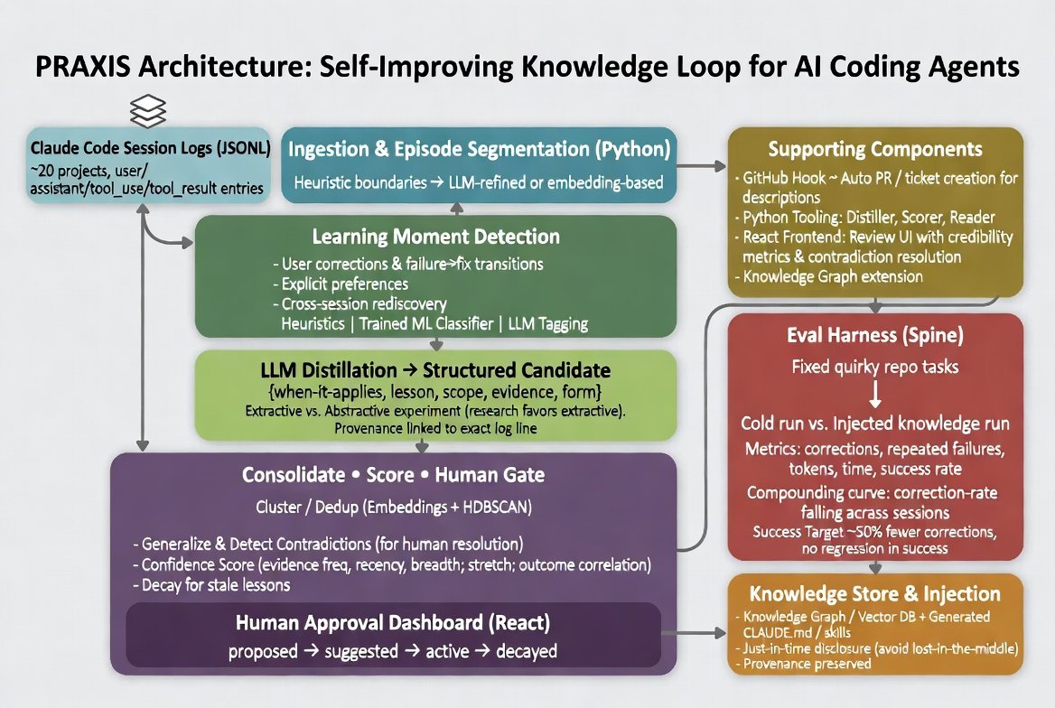
Figure 1: PRAXIS End-to-End Architecture — Raw logs become verified, injectable knowledge with measurable compounding gains.

High-Level 9-Day Timeline
Days 1–2: Project Plan, Foundation & Design | Days 3–5: Parallel Core Build (ML Pipeline + Dashboard + Evals) | Days 6–7: Integration & Human Gate | Day 8: Eval Harness & Measurement | Day 9 - 10: Demo Polish, Documentation & Final Runs

Detailed 9-Day Work Schedule
All three contributors work in parallel streams with daily syncs. Primary ownership ensures clear leadership claims while cross-support builds team cohesion.
Day | Focus & Milestones | Matthew (ML/KG) | Monica (Dashboard) | Dominic (Arch/Eval)
1 | Kickoff, repo setup, log exploration, architecture finalization | Explore sample JSONL logs; define episode segmentation heuristics | Dashboard wireframes & tech stack (React + state mgmt) | Eval harness skeleton + fixed quirky repo tasks; GitHub hook design
2 | Design review, data contracts, first prototypes | Prototype learning moment detector (heuristics + LLM) | Build review dashboard shell + candidate list view | Define eval metrics & cold-run baseline script
3 | Core pipeline build (parallel) | Full distillation pipeline + structured candidate output + provenance | Candidate detail view + confidence score UI components | Python tooling (reader, distiller wrapper) + basic injection
4 | ML & consolidation focus | Embeddings + HDBSCAN dedup/cluster; contradiction detection logic | Human gate workflow UI (proposed → suggested → active) | GitHub PR/ticket automation for promoted knowledge
5 | Scoring, decay, dashboard polish | Confidence scoring (freq/recency/breadth) + decay rules | Contradiction resolution interface + credibility metrics viz | Eval harness expansion: token/time tracking + basic dashboard
6 | Integration sprint | End-to-end pipeline wiring + knowledge graph stub | Dashboard ↔ backend API integration + approval actions | Full eval harness + cold vs injected comparison runner
7 | Human gate + injection complete | Knowledge store (graph + CLAUDE.md generator) + injection logic | Full human approval flow + provenance display in UI | GitHub hook live + PR creation on promotion; demo data prep
8 | Measurement & refinement | Run batch evals; analyze failure modes; tune thresholds | Dashboard polish + edge-case handling in review flow | Full compounding curve measurement; identify demo quirks
9 | Demo, docs, handoff | Final pipeline tuning; knowledge quality report, Practice Presentation | Dashboard demo-ready; user flow video capture | Live demo script + side-by-side before/after; final docs & repo handoff

Target Outcome & Success Metrics
- MVP delivered: Full ingestion → detection → distillation → cluster/dedup/confidence → React review dashboard with human gate → CLAUDE.md/skills injection → eval harness showing quantified improvement.
- Primary success criterion: ≥50% reduction in user corrections on benchmark tasks vs. cold runs, with no regression in task success rate, plus visible compounding curve across sessions.
- Each team member owns one pillar end-to-end and can demonstrate it live in technical interviews.

Work Allocation Notes
Daily 15-min sync at start of each day.

Matthew owns data/ML correctness and knowledge quality.
Monica owns UX clarity and human-gate usability.
Dominic owns measurement credibility and demo readiness.

Cross-pairing on integration days (6-7) ensures seamless handoff.

All code reviewed by at least one other member.

Final demo script co-owned but each presents their pillar.

