INTERVENTION- Naltrexone Implants
Intervention Code- INTERV-2026-03-25-0014
System Category- Mental/Behavioural/Nervous System

- Justification presented by topic nominator
- Issues with Current mental health wellness package
  - Inadequate Reimbursement Rates: The current reimbursement rates are too low and do not cover the cost.
  - High cost of drugs- nearly all psychotropics are imported and are subject to foreign currency fluctuation.

Introduction
Naltrexone
Formulations- Tablet 50 mg (oral), 380mg (Intramuscular injection), 765mg (Implant)
Indications-
- Adult Treatment against alcoholism oral: 50 mg once daily. may increase to 100 mg once daily after 1 week based on response and tolerability. IM: 380 mg once every 4 weeks.

- to reduce the risk of relapse,
- as support treatment in abstinence and
- to reduce the craving for alcohol,

- Adult Treatment against Opioid use (heroin, morphine, codeine) (mild to moderate), Oral: Initial: 25 mg once daily for 1 to 3 days, if no withdrawal signs occur, administer 50 mg once daily thereafter. Opioid use (mild to moderate), IM: 380 mg once every 4 weeks.
Mode of action- It works by blocking opioid receptors, so that opioids won’t produce a “high” and so that alcohol cravings may reduce.
It binds strongly but does NOT activate these receptors.

Paediatric: Safety and efficacy in medically assisted therapy clinics for paediatrics not established
Contraindication: patients currently dependent on opioids, Hepatic impairment, renal impairment, Pregnancy, Breastfeeding, Hepatic impairment, Renal impairment
Adverse effects: nervousness, anxiety, insomnia, headache, restlessness, abdominal pain, nausea, emesis, rash, asthenia Interaction with other medicines: opiate derivatives, methyldopa
Note:
» Use only for patients who are highly motivated or able to comply with techniques such as observed dosing to enhance adherence.
» Naltrexone implant 765 mg is availed on specialist request only.

Clinical effectiveness, safety and quality of the intervention | A significant number of studies suggests a superiority of naltrexone implants over oral naltrexone in maintaining OD individuals opiate-free, up to 12 months after initiating treatment.  Plasma naltrexone levels were found to be between 1 and 2 ng/mL for a longer time in the naltrexone implant group.  Results showed that more patients receiving oral naltrexone had plasma naltrexone levels below 2 ng/mL in the first 2 months of treatment (P = 0.001 and 0.01, respectively) and a higher proportion of them had resumed heroin use by the end of the study compared with the naltrexone implant group (P = 0.003). Time to relapse was shorter among oral naltrexone patients (115 days vs 158 days)  Patients receiving naltrexone had on average 45 days less heroin use and 60 days less opioid use than controls in the 180-day period  Mannelli et al., 2011  Patients with naltrexone implants were significantly more likely than those with placebo implants to report surgical site-related adverse events (RR 4.68, 95% CI 1.63 to 13.44; three trials; Ι²=0%).  There were no statistically significant adverse events possibly related to treatment when naltrexone implants were compared with placebo implants (one trial) or oral naltrexone  Larney et al., 2014

- Burden of disease, Incidence or occurrence of disease
Current use of drugs and substances among the population aged 15 – 65 years in Kenya
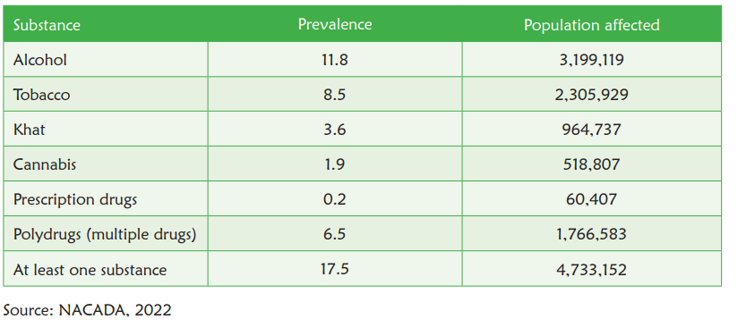
One in every 8 Kenyans aged 15 – 65 years (3,199,119) were currently using alcohol;
One in every 12 Kenyans aged 15 – 65 years (2,305,929) were currently using tobacco;
One in every 28 Kenyans aged 15 – 65 years (964,737) were currently using khat;
One in every 53 Kenyans aged 15 – 65 years (518,807) were currently using cannabis;

Prevalence of severe substance use disorders (addiction) among the population aged 15 – 65 years in Kenya;
• One in every 20 Kenyans aged 15 – 65 years (1,357,040) were addicted to alcohol;
• One in every 30 Kenyans aged 15 – 65 years (887,627) were addicted to tobacco;
• One in every 125 Kenyans aged 15 – 65 years (227,744) were addicted to khat;
• One in every 111 Kenyans aged 15 – 65 years (234,855) were addicted to cannabis;

Results showed that the prevalence of cannabis use almost doubled over the last five years. The growing demand for cannabis especially among the youth could be attributed to the low perception of harm due to myths, misinformation, and misconceptions;

(d) the population; | Drug and substance abuse patients  (specifically alcohol and opioid use)
(e) equity; | Youth vulnerability- Young people are affected by drugs and substance abuse  Alcohol and substance use disorders are often seen as moral failure, not a health condition. They are often criminalized
(f) cost-effectiveness | Cost-effectiveness of extended release naltrexone was as follows:  The 25-week cost per QALY and abstinent-year figures were $162,150 and $46,329, respectively. The 78-week figures were $76 400/QALY and $16 371/abstinent year.
(g) budgetary impact and affordability | Cost per naltrexone implant Kshs 93,420  Approximately 3.1 million population affected  (but not all need naltrexone)
(h) feasibility of implementation of the intervention | Naltrexone implant is present in the Kenya National Medicines Formulary, 2023  Also listed in Kenya Essential Medicines List, 2023  No need for special administration (infrastructure, equipment or HR)
(i) catastrophic health expenditure | Cost per implant 93,420  1 implant every 3 months (on average)
(j) access to healthcare | Its readily available in Kenya, particularly in urban centers.
(k) congruence with existing priorities, policies and guidelines in the health sector. | The National Policy for the Prevention, Management, and Control of Alcohol, Drugs, and Substance Abuse. (NACADA)  Thematic area 2  “Expanded treatment and rehabilitation programs and aftercare services”  Objective: To promote provision of and access to quality and affordable treatment, rehabilitation, and aftercare services for persons with substance use disorders (SUDs):  - Promote and facilitate provision and access to treatment, rehabilitation, reintegration and aftercare services and programs at all levels of health-care services, including distinct services and facilities with targeted focus to persons with disabilities and other vulnerable population groups;  - Promote the adoption and implementation of national standards for treatment, rehabilitation and after-care services of persons with substance use disorders;  Other policies  - Sustainable Development Goals (SDGs): Our policy directly supports SDG Goal 3, Target 3.5, which aims to “strengthen the prevention and treatment of substance abuse, including narcotic drug abuse and harmful use of alcohol, and on ensuring healthy lives and promotion of well-being for all at all ages.” This demonstrates our dedication to achieving broader health and well-being outcomes.  - East African Community (EAC) Regional Policy: This regional framework provides a comprehensive blueprint for prevention, control, management, and rehabilitation strategies related to alcohol and drug use, ensuring a harmonized approach within East Africa.

