Democratic Priority Score
A Data-Driven Composite Index for Campaign Resource Allocation
Swing State Election Analysis: Pennsylvania, Michigan, North Carolina
Antoni Czolgowski | Data Lead
CSCI 5502 Data Mining | Spring 2026 | University of Colorado Boulder

1. Executive Summary
The Democratic Priority Score (DPS) is a composite 0-1 index that ranks 250 counties across three critical swing states -- Pennsylvania, Michigan, and North Carolina -- by their strategic value for Democratic campaign resource allocation. The score integrates six data-driven components derived from Random Forest classification, linear regression, K-Means clustering, and temporal electoral trajectory analysis.
The #1 priority county is Bucks County, PA (DPS = 0.734): 802,000 votes, a margin of just 582 votes (-0.1%), and classified as Highly Volatile. The top 10 includes 5 PA counties (the Philadelphia suburban corridor), 2 MI counties (Kent/Grand Rapids and Oakland/Detroit suburbs), and 3 NC counties (Cabarrus/Charlotte suburbs, New Hanover/Wilmington, and Wilson). The top 10 counties collectively represent 3.45 million votes with an average margin of just 3.6 percentage points.

2. Methodology
The DPS decomposes into six sub-scores, each normalized to [0, 1], combined with data-driven weights:
DPS = 0.20 * Persuadability + 0.20 * Electoral Weight + 0.20 * Competitiveness + 0.20 * Predicted Volatility + 0.10 * Dem. Opportunity + 0.10 * Misfit
Component | Wt | Formula | Source
S1: Persuadability | .20 | 0.6*sigmoid(entropy-0.552) + 0.4*cluster_vol_rate | Diversity threshold (OR=7.15) + K-Means clusters
S2: Electoral Weight | .20 | MinMax(log(1 + votes_2024)) | Academic campaign theory: vote volume
S3: Competitiveness | .20 | exp(-|margin| / 10) | Exponential decay; 10pp margin = 0.37
S4: Predicted Volatility | .20 | RF.predict_proba[:, 1] | Random Forest (AUC=0.828), 28 features
S5: Dem. Opportunity | .10 | MinMax(0.65*d_20_24 + 0.35*d_16_20) | Directional swing; recency-weighted
S6: Misfit | .10 | MinMax(direction_adj_misfit) | Surprise-Dem 1.3x, Surprise-Rep 0.7x
The core four components receive equal weight (0.20), reflecting both academic campaign theory (resource allocation = competitiveness x electoral weight) and our data mining results (persuadability and predicted volatility are the strongest empirical signals). The two supplementary signals receive 0.10 each: directional opportunity is backward-looking (Blue Bounceback is the most common trajectory at 47%), and misfit partially overlaps with predicted volatility.
Key methodological choices: (1) S3 uses exponential decay rather than linear scaling, so a +20pp county scores 14% of a tied county -- reflecting campaign resource reality. (2) S4 integrates all 28 demographic features through a nonlinear Random Forest model, capturing interactions (diversity x density, education x urbanization) invisible to linear formulas. (3) S1 implements the diversity threshold at race_entropy_norm = 0.552 as a soft sigmoid, reflecting the step-function relationship where P(high volatility) jumps from 20% to 80%. (4) S2 uses log-transformed vote counts to prevent mega-counties from dominating while preserving the signal that larger counties deserve more resources.

3. Results

3.1 Top 10 Democratic Priority Counties
# | County | ST | DPS | Pers. | ElWt | Comp. | PVol | DOpp | Misf | Margin | Votes
1 | Bucks | PA | 0.734 | 0.38 | 0.91 | 0.99 | 0.88 | 0.55 | 0.45 | -0.1% | 802,056
2 | Lehigh | PA | 0.702 | 0.73 | 0.80 | 0.76 | 0.85 | 0.52 | 0.21 | +2.7% | 379,620
3 | Northampton | PA | 0.702 | 0.52 | 0.79 | 0.84 | 0.84 | 0.65 | 0.37 | -1.8% | 356,430
4 | Monroe | PA | 0.688 | 0.75 | 0.69 | 0.92 | 0.68 | 0.49 | 0.30 | -0.8% | 171,050
5 | Cabarrus | NC | 0.678 | 0.71 | 0.63 | 0.46 | 0.87 | 0.93 | 0.49 | -7.7% | 120,202
6 | Kent | MI | 0.672 | 0.66 | 0.80 | 0.58 | 0.83 | 0.81 | 0.16 | +5.4% | 371,947
7 | New Hanover | NC | 0.657 | 0.56 | 0.66 | 0.94 | 0.77 | 0.72 | 0.00 | +0.6% | 138,734
8 | Oakland | MI | 0.654 | 0.80 | 0.91 | 0.35 | 0.89 | 0.64 | 0.02 | +10.6% | 772,145
9 | Dauphin | PA | 0.643 | 0.78 | 0.77 | 0.55 | 0.70 | 0.67 | 0.15 | +5.9% | 299,052
10 | Wilson | NC | 0.639 | 0.94 | 0.47 | 0.96 | 0.37 | 0.50 | 0.40 | +0.4% | 40,045

3.2 Top 5 -- Pennsylvania
# | County | ST | DPS | Pers. | ElWt | Comp. | PVol | DOpp | Misf | Margin | Votes
1 | Bucks | PA | 0.734 | 0.38 | 0.91 | 0.99 | 0.88 | 0.55 | 0.45 | -0.1% | 802,056
2 | Lehigh | PA | 0.702 | 0.73 | 0.80 | 0.76 | 0.85 | 0.52 | 0.21 | +2.7% | 379,620
3 | Northampton | PA | 0.702 | 0.52 | 0.79 | 0.84 | 0.84 | 0.65 | 0.37 | -1.8% | 356,430
4 | Monroe | PA | 0.688 | 0.75 | 0.69 | 0.92 | 0.68 | 0.49 | 0.30 | -0.8% | 171,050
5 | Dauphin | PA | 0.643 | 0.78 | 0.77 | 0.55 | 0.70 | 0.67 | 0.15 | +5.9% | 299,052

3.2 Top 5 -- Michigan
# | County | ST | DPS | Pers. | ElWt | Comp. | PVol | DOpp | Misf | Margin | Votes
1 | Kent | MI | 0.672 | 0.66 | 0.80 | 0.58 | 0.83 | 0.81 | 0.16 | +5.4% | 371,947
2 | Oakland | MI | 0.654 | 0.80 | 0.91 | 0.35 | 0.89 | 0.64 | 0.02 | +10.6% | 772,145
3 | Genesee | MI | 0.638 | 0.62 | 0.73 | 0.66 | 0.54 | 0.45 | 0.86 | +4.2% | 223,268
4 | Grand Traverse | MI | 0.581 | 0.19 | 0.54 | 0.84 | 0.73 | 0.90 | 0.32 | -1.7% | 62,772
5 | Macomb | MI | 0.568 | 0.62 | 0.85 | 0.25 | 0.75 | 0.51 | 0.25 | -13.7% | 509,152

3.2 Top 5 -- North Carolina
# | County | ST | DPS | Pers. | ElWt | Comp. | PVol | DOpp | Misf | Margin | Votes
1 | Cabarrus | NC | 0.678 | 0.71 | 0.63 | 0.46 | 0.87 | 0.93 | 0.49 | -7.7% | 120,202
2 | New Hanover | NC | 0.657 | 0.56 | 0.66 | 0.94 | 0.77 | 0.72 | 0.00 | +0.6% | 138,734
3 | Wilson | NC | 0.639 | 0.94 | 0.47 | 0.96 | 0.37 | 0.50 | 0.40 | +0.4% | 40,045
4 | Wake | NC | 0.612 | 0.88 | 0.88 | 0.08 | 0.85 | 0.74 | 0.00 | +25.4% | 653,580
5 | Lenoir | NC | 0.610 | 0.92 | 0.42 | 0.51 | 0.68 | 0.53 | 0.53 | -6.8% | 27,503

4. County-by-County Analysis
Each top-10 county is assessed by its electoral trajectory (2016-2020-2024), demographic profile, cluster archetype, and strategic role.
#1 Bucks County, PA (DPS = 0.734) -- THE bellwether. Trajectory: +0.8% (2016), +4.4% (2020), -0.1% (2024) -- a "Blue Bounceback" that landed on a razor's edge of 582 votes. With 802K total votes, near-perfect competitiveness (0.993), and high predicted volatility (0.878), Bucks is the single most valuable target in the three-state region. Campaign focus: persuasion. Ground game, earned media, and targeted digital advertising in the Bucks County media market should be the #1 budget line item.
#2 Lehigh County, PA (DPS = 0.702) -- Heart of the Lehigh Valley (Allentown, Bethlehem). Trajectory: +4.7%, +7.6%, +2.7% -- a Blue Bounceback with an alarming 5-point 2024 pullback. Racial entropy = 0.699 (well above the 0.552 threshold), driven by Hispanic immigration and NYC commuter spillover. 380K votes. Campaign focus: bilingual outreach and housing affordability messaging targeting the rapidly diversifying population that drives the county's volatility.
#3 Northampton County, PA (DPS = 0.702) -- The classic bellwether. Voted Obama, flipped to Trump in 2016 (-3.8%), flipped back to Biden in 2020 (+0.7%), and returned Republican in 2024 (-1.8%). Has correctly predicted the PA winner in 4 of the last 5 cycles. Paired with Lehigh, it forms a natural media market. Campaign focus: genuine swing voters -- white working-class persuadables in the Easton/Bethlehem area. Distinct from Lehigh's diversity-driven volatility.
#4 Monroe County, PA (DPS = 0.688) -- The Pocono Mountains. Highest racial entropy among PA top 5 (0.730). Trajectory mirrors Bucks: +0.8%, +6.4%, -0.8%. Being transformed by NYC exurban migration along I-80. Highly Volatile classification. Campaign focus: new residents and first-time voters. Monroe is a "future Lehigh Valley" -- investing here builds infrastructure for a county that will only grow more electorally significant.
#5 Cabarrus County, NC (DPS = 0.678) -- Charlotte suburbs. Remarkable trajectory: -19.6% (2016), -9.4% (2020), -7.7% (2024) -- a 12-point Steady Blue Drift over 8 years. Highest S_dem_opportunity (0.932) in the top 10. Entropy = 0.802. Not yet winnable, but the trend is unmistakable. Campaign focus: suburban women, college-educated professionals, and the growing Hispanic community. Every dollar erodes the Republican structural advantage in the Charlotte metro.
#6 Kent County, MI (DPS = 0.672) -- Grand Rapids -- historically the capital of Michigan Republicanism (Gerald Ford's district). Flipped Democratic in 2020 (+6.1%) after -3.1% in 2016, held at +5.4% in 2024. With 372K votes, it is the largest competitive county in MI. Highly Volatile. Campaign focus: THE persuasion county in Michigan. The evangelical GOP base is being offset by the growing urban core and education-driven suburban shift.
#7 New Hanover County, NC (DPS = 0.657) -- Wilmington and the NC coast. Flipped Dem in 2020 (+2.1%), narrowed to +0.6% in 2024 -- a margin of ~830 votes out of 139K cast. S_competitiveness = 0.940, second only to Bucks. Entropy (0.565) sits precisely at the critical diversity threshold. Campaign focus: the "Bucks County of North Carolina" -- a coastal suburban county that swings with the national mood. Razor-thin margin makes resource allocation highly efficient.
#8 Oakland County, MI (DPS = 0.654) -- The most important "protect the gains" county. Once reliably Republican, Oakland flipped decisively: +8.1% (2016), +14.0% (2020), but eroded to +10.6% in 2024 -- a 3.4-point loss in one cycle. With 772K votes (second-largest in the study), this erosion translates to ~26,000 lost votes. If the trend continues, Oakland becomes competitive by 2028 -- and losing Oakland means losing Michigan. Predicted volatility = 0.887, the highest in the top 10. Campaign focus: defensive investment. Not persuasion but turnout infrastructure to arrest erosion. Every 1% turnout increase = ~7,700 votes.
#9 Dauphin County, PA (DPS = 0.643) -- Harrisburg metro, state capital. Trajectory: +2.9%, +8.5%, +5.9% -- the 2024 pullback from Biden's high reveals vulnerability. Racial entropy = 0.775. With 299K votes, it provides a strong voter pool in central PA. Campaign focus: geographic diversification. The only top-10 county outside the eastern corridor. Can anchor a central PA media buy reaching adjacent Cumberland (#20) and Lebanon.
#10 Wilson County, NC (DPS = 0.639) -- The most analytically interesting -- and most debatable -- pick. Only 40K votes, but near-perfect competitiveness (+0.4%) and the highest persuadability in the top 10 (0.940, "Poor & Diverse" cluster). Trajectory: +5.6%, +2.9%, +0.4% -- a Steady Red Drift of 5.2 points over 8 years. If the trend continues, Wilson flips Republican by 2028. Campaign focus: CANARY IN THE COAL MINE. Wilson represents dozens of small, racially diverse, economically struggling Southern counties slipping away from Democrats. The pattern it exemplifies could cost tens of thousands of votes across NC. Strategic value is diagnostic, not volume-based.

5. State-Level Strategic Assessment

Pennsylvania: The Decisive Battleground (19 EV)
PA dominates the national top 10 with 5 counties, reflecting genuine strategic reality: the most electoral votes (19), the strongest regression model (R-squared = 0.674), and an unusual concentration of large, competitive, volatile counties in the eastern suburban corridor. The top 5 PA counties represent 2,007,208 total votes across a 150-mile corridor from Philadelphia (Bucks) through the Lehigh Valley (Lehigh, Northampton) to the Poconos (Monroe) and inland to Harrisburg (Dauphin). This corridor can be served by 3-4 field offices and a single TV media buy.
Near-miss -- Lackawanna (#12): Scranton. 233K votes, +2.8%, Highly Volatile. Its lower diversity (entropy = 0.485, below the 0.552 threshold) reduces its persuadability score, but the decline from +8.4% (2020) to +2.8% (2024) is alarming. A campaign with 6 PA targets should add Lackawanna.
Near-miss -- Erie (#23): The famous bellwether (Obama, Obama, Trump, Biden, Trump). At 275K votes and -1.0%, it seems like it should rank higher, but the RF model assigns only 33% volatility probability -- demographics suggest stable working-class patterns despite historical swings.

Michigan: Volume Targets vs. Bellwethers (15 EV)
MI's top 5 splits into large suburban centers (Kent 372K, Oakland 772K, Macomb 509K) and smaller competitive markets (Genesee 223K, Grand Traverse 63K). Kent (#1 MI) is the premier persuasion target. Oakland (#2) is defensive. Genesee (#3, Flint) shows troubling erosion (+9.5% to +4.2% over 8 years). Grand Traverse (#4, Traverse City) is genuinely competitive at -1.7%. Macomb (#5, -13.7%) is controversial but at 509K votes is too large to ignore.
Not recommended -- Leelanau (now #33): At 17,685 votes, even a 10-point swing yields only ~880 net votes. Interesting as a misfit case study (highest misfit score: 0.956) but not a resource target.

North Carolina: The Most Complex Landscape (16 EV)
NC presents the most challenging targeting decisions. Unlike PA's concentrated corridor and MI's clear suburban targets, NC's priorities are geographically scattered. The state-specific regression model has the weakest performance (R-squared = 0.435) because NC's poverty-driven volatility mechanism is harder to predict.
Strong picks -- Cabarrus (#1) and New Hanover (#2): The two clearest NC targets. Cabarrus shows consistent Democratic momentum (-19.6% to -7.7%). New Hanover is essentially tied at +0.6%. Together: 259K votes in genuinely competitive markets.
Borderline -- Wilson (#3): Small (40K) but near-zero margin (+0.4%) and maximum persuadability (0.940). Value is diagnostic: if a message works in Wilson, it works across similar diverse rural Southern counties.
Caution -- Wake (#4, +25.4%, 654K): NOT a persuasion target. Presence is driven by enormous electoral weight and high persuadability score. In practice, Wake is a TURNOUT target: even 1% improvement = ~6,500 votes. Alternative persuasion picks: Pitt County (87K, +6.0%, ECU university town) or Nash County (52K, -1.8%, essentially tied).
Weakest pick -- Lenoir (#5, -6.8%, 28K, Stable): Most questionable entry in any state's top 5. Classified as Stable, only 28K votes, drifting Republican. High ranking driven entirely by persuadability score (0.918) from demographics that predict volatility which hasn't materialized. Better alternatives: Nash (52K, -1.8%) or Pitt (87K, +6.0%).

6. Visualizations

6.1 Three-State Choropleth: All Counties
Every county shaded by DPS (0 = low priority, darker = higher). Clear geographic clusters: eastern PA, southern MI, and the urban/suburban crescent of NC.
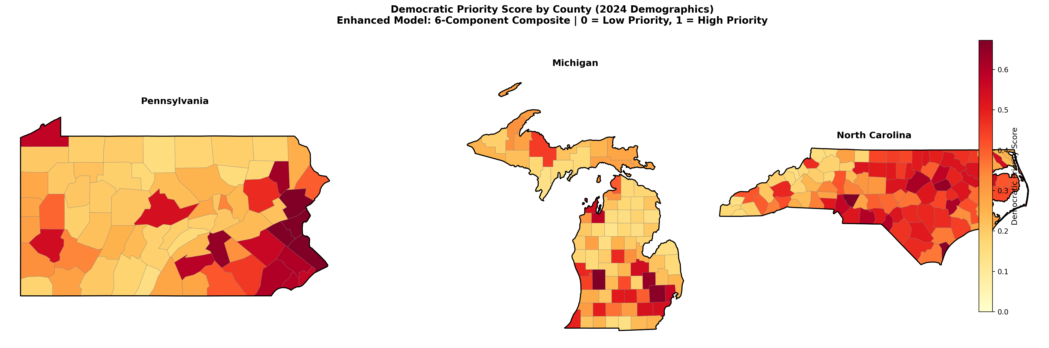

6.2 Top 10 Priority Counties Highlighted
Top 10 counties colored with relative shading; all others in gray. PA dominates with 5 of 10, concentrated in the eastern suburban corridor.
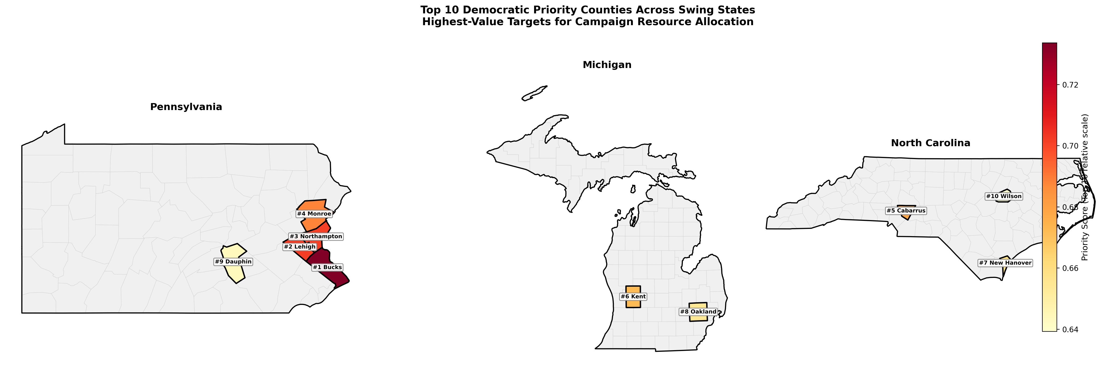

6.3 State Maps: Top 5 Counties
Pennsylvania: Top 5 Priority Counties
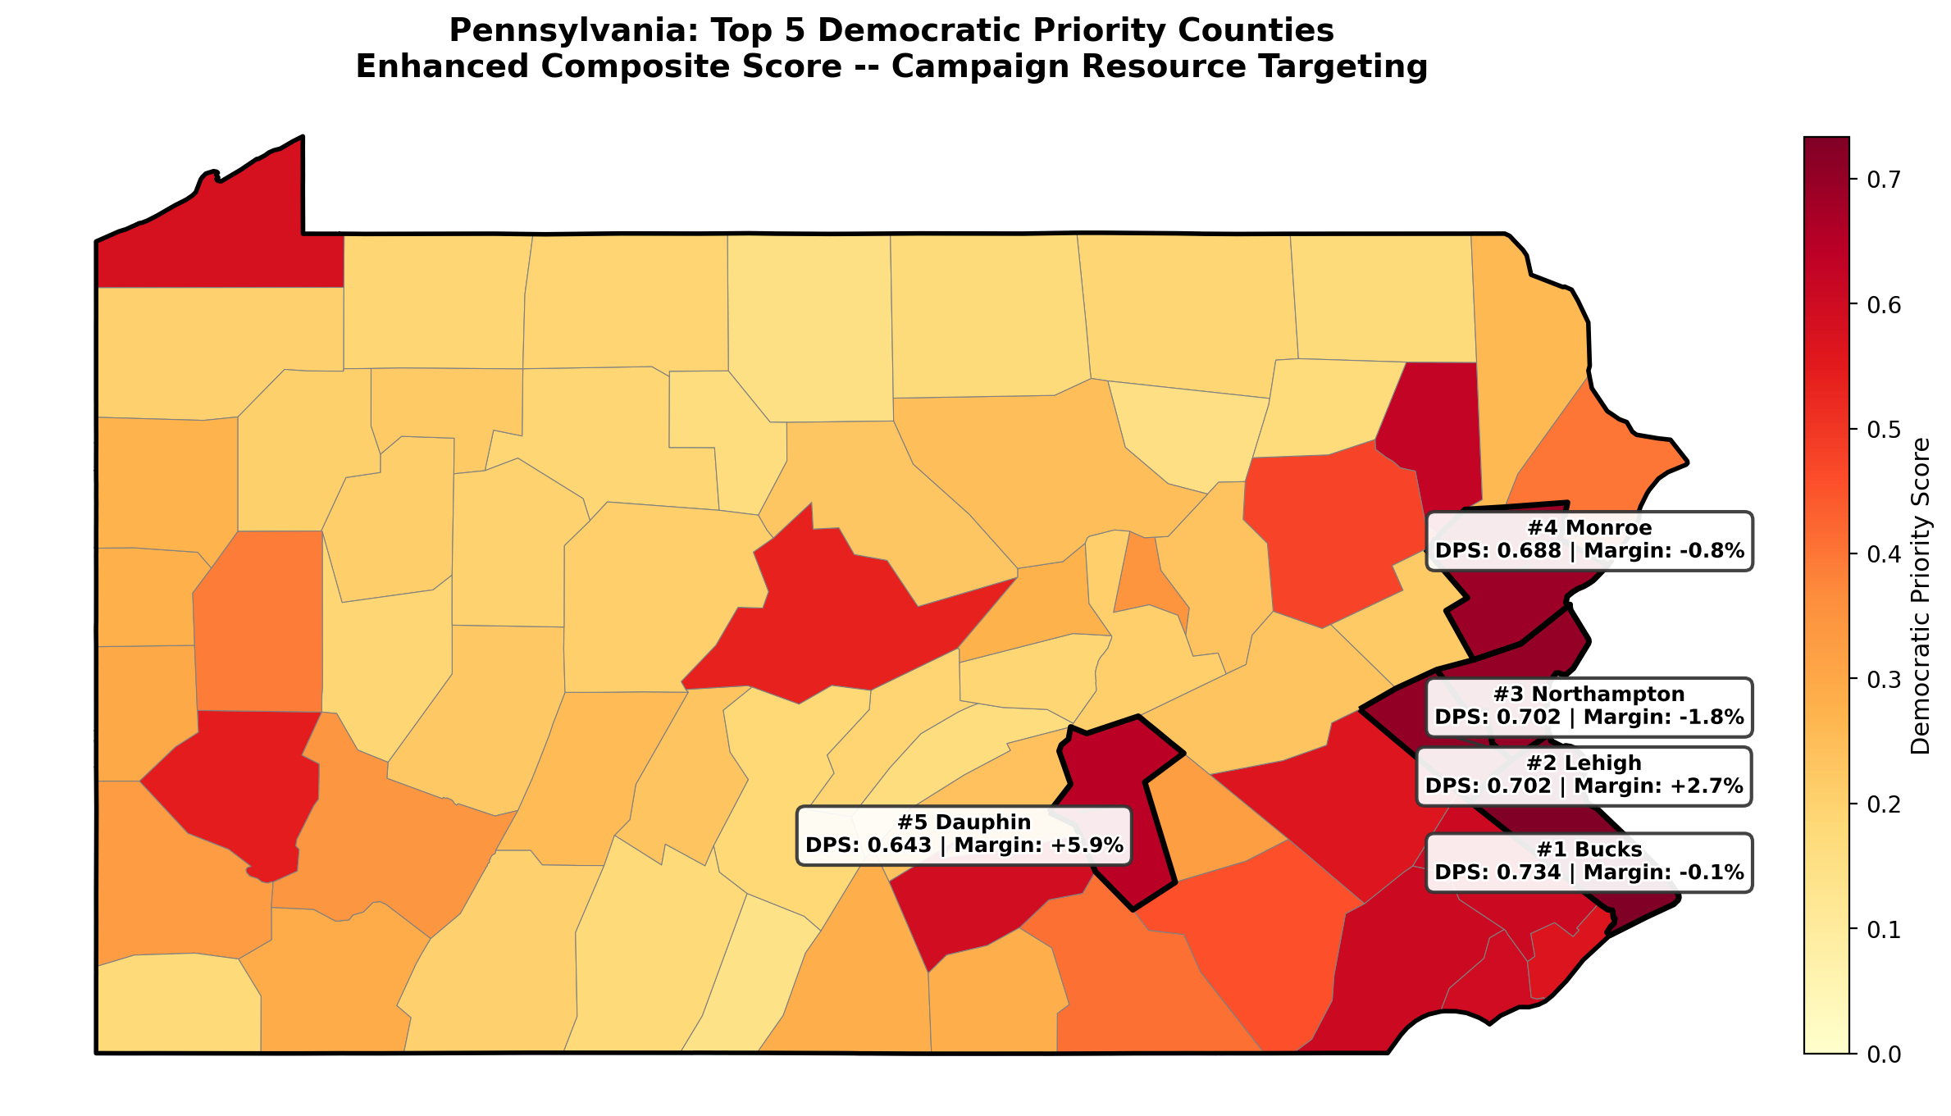
Michigan: Top 5 Priority Counties
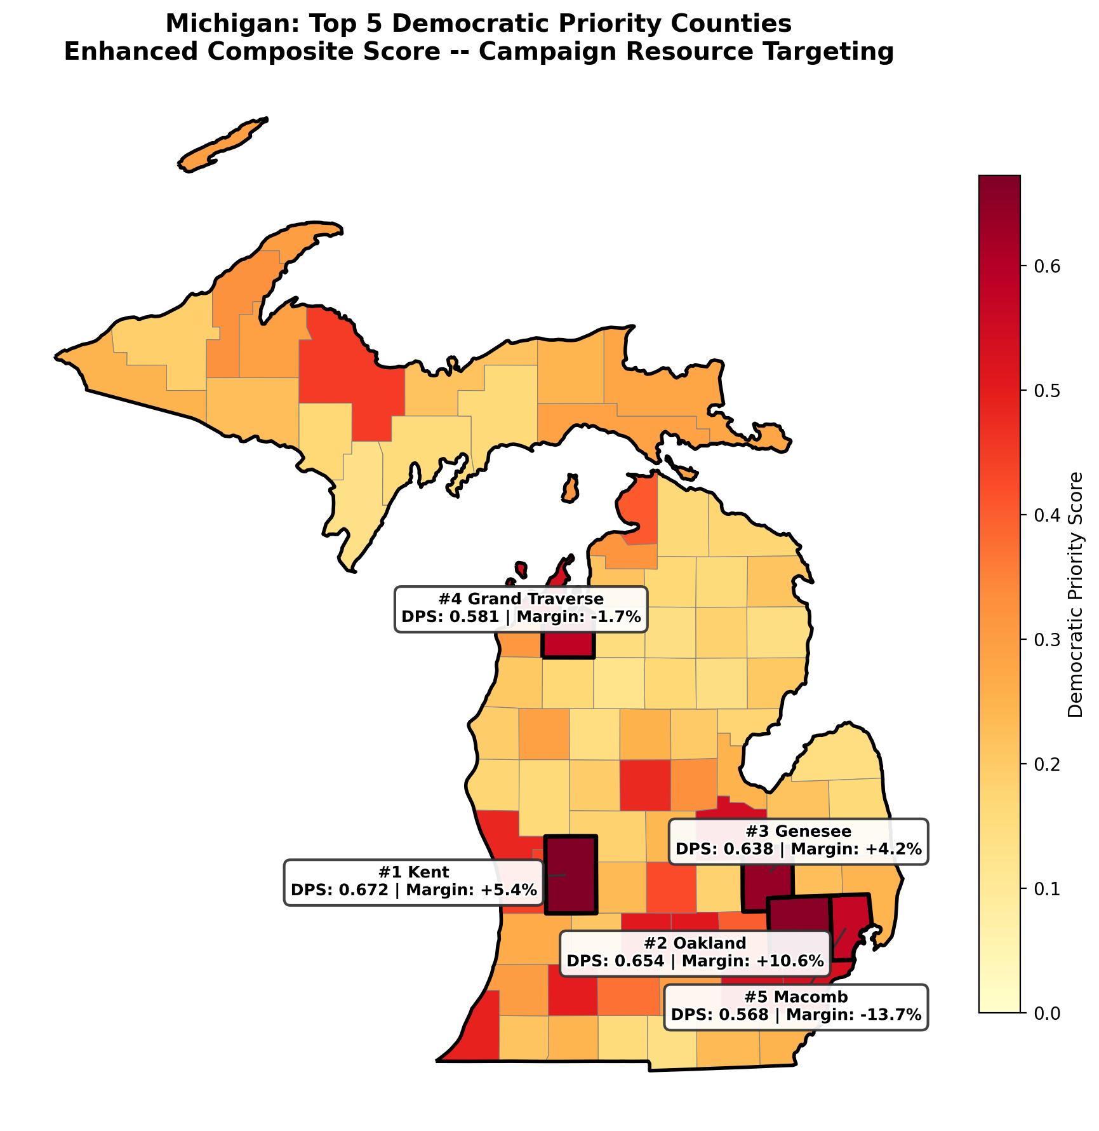

North Carolina: Top 5 Priority Counties
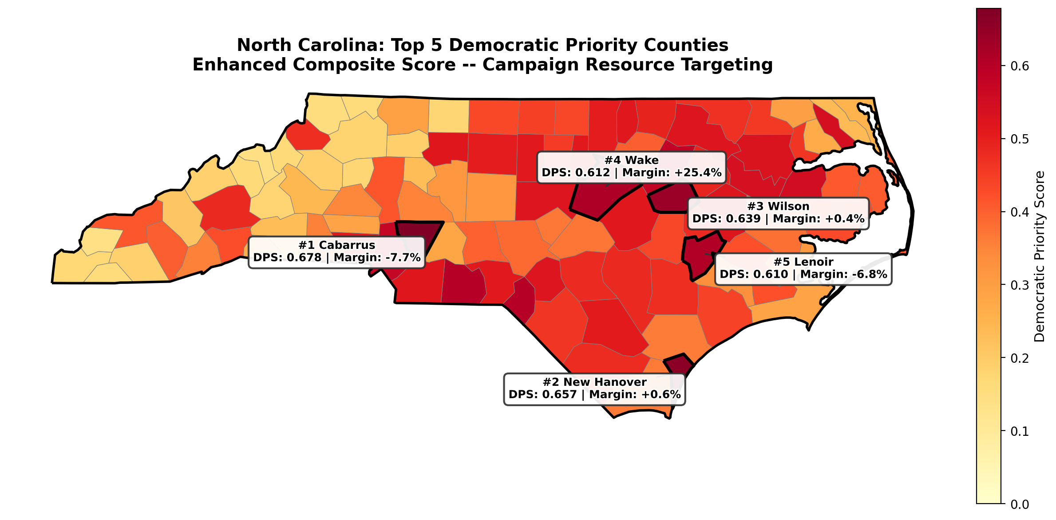

7. Validation & Limitations
Validation checks:
- Top 10 volatility classes: {'Highly Volatile': 5, 'Volatile': 4, 'Moderate': 1}. No Stable or Very Stable county in the top 10.
- Score distribution: mean = 0.341, median = 0.295, skewness = 0.510. Right-skewed as expected: most counties are low-priority with a tail of high-value targets.
- Bucks County PA is #1 -- consistent with conventional campaign wisdom about this critical Philadelphia suburb.
- Top 10 collectively covers 3.45M votes with avg |margin| of 3.6pp -- an efficient allocation of campaign resources to competitive, high-volume counties.
- 9 of 10 top counties have >50K votes. The score correctly prioritizes counties where resource investment can move meaningful vote totals.
Limitations:
- RF model trained on 250 counties (small sample). External validation on other swing states would strengthen confidence.
- ACS demographic data lags real-time population changes by 1-2 years. Fast-growing counties (Cabarrus NC) may have shifted.
- The score does not distinguish between turnout targets (base mobilization) and persuasion targets (swing voters). Voter file-level data would enable this.
- Cross-state models fail (LOSO F1 = 0.195). The DPS handles this through implicit RF encoding rather than explicit state adjustments.
- The score should be recalibrated each election cycle as new data becomes available.

