Classification Analysis — Extra Sections
for Final Report Integration

Sections removed from M3 report for brevity.
Contents: Ensemble Stacking, Practical Playbook, Research Q&A.
Antoni Czolgowski — March 2026

Ensemble Stacking — Can We Do Better by Combining Models?
Ensemble stacking combines multiple models together. "Soft Voting" averages the predictions from RF, XGBoost, and SVM. "Stacking" trains a second-level model (Logistic Regression) to learn the optimal way to combine the first-level predictions.
Model | Accuracy | F1 | AUC | Type
Random Forest | 0.780 | 0.718 | 0.828 | Individual (best)
Soft Voting (RF+XGB+SVM) | 0.768 | 0.691 | 0.826 | Ensemble
XGBoost | 0.748 | 0.667 | 0.803 | Individual
SVM (RBF) | 0.760 | 0.663 | 0.819 | Individual
Stacking (LR meta) | 0.760 | 0.647 | 0.816 | Ensemble
Logistic Regression | 0.680 | 0.604 | 0.745 | Individual

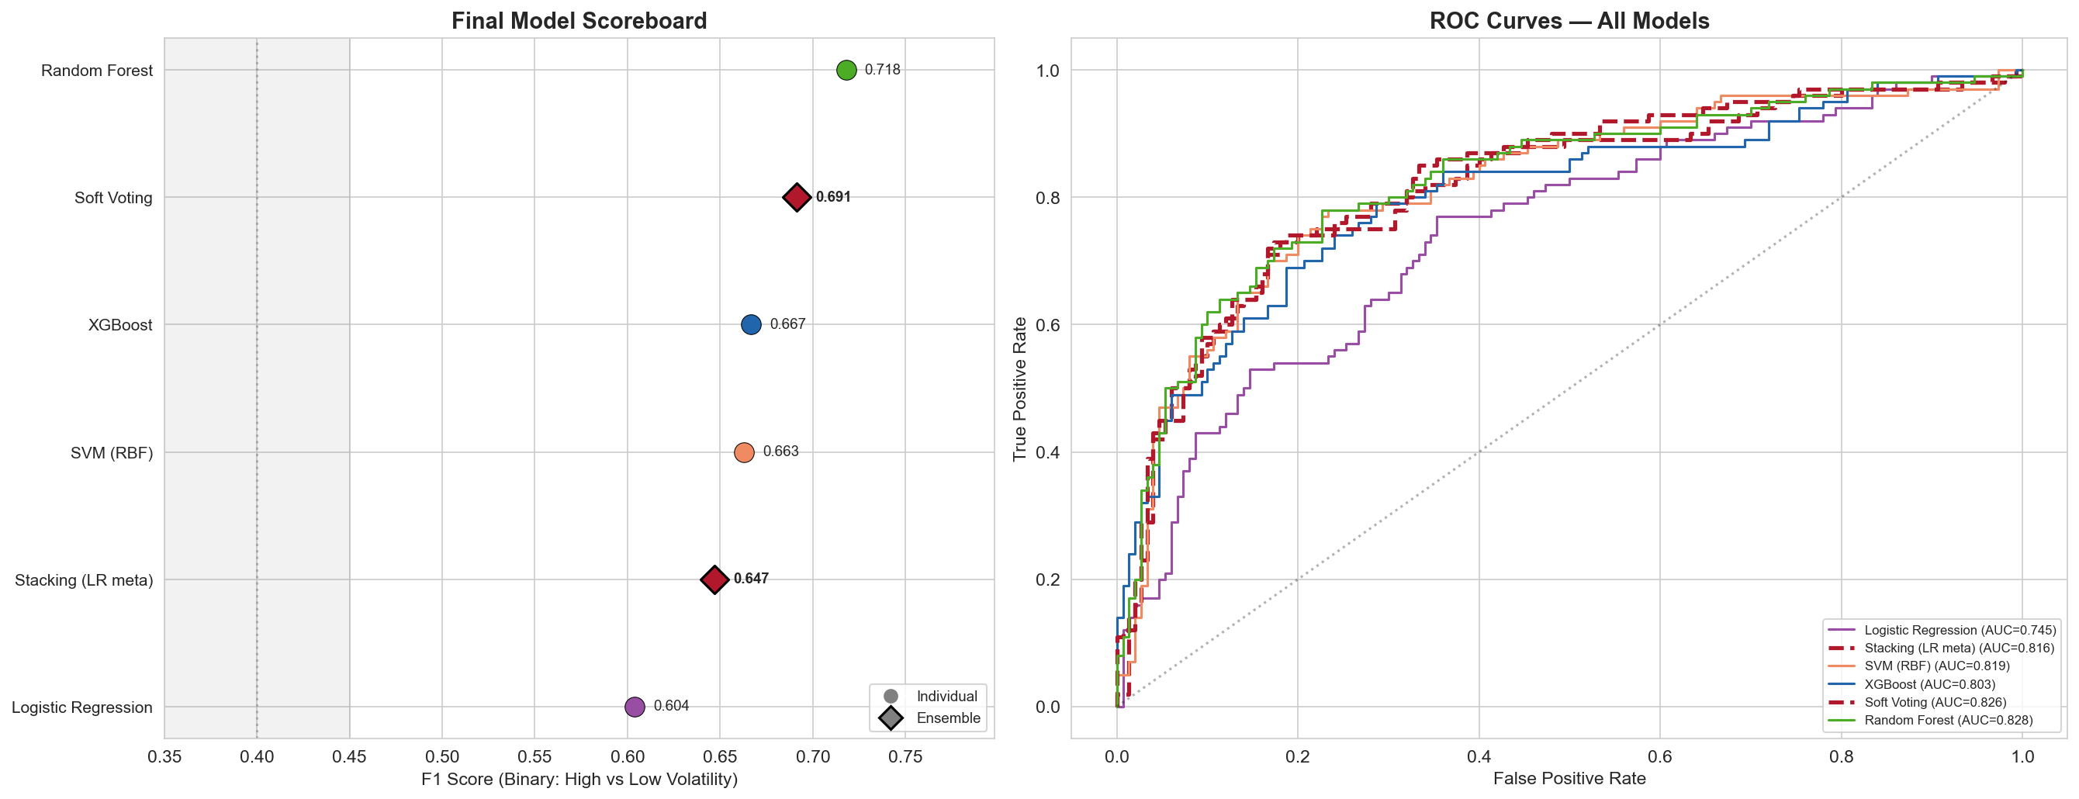
Final scoreboard. Left: F1 scores. Right: ROC curves. Random Forest alone outperforms all ensemble combinations.
Ensembles do NOT improve performance. Stacking actually hurts (F1 drops from 0.718 to 0.647). With only 250 counties, the LR meta-learner oversmooths predictions. The performance bottleneck is dataset size, not algorithm sophistication.

Practical Playbook — Democratic Campaign Strategy
This section translates analytical findings into actionable guidance for Democratic campaign resource allocation in Pennsylvania, Michigan, and North Carolina.

The Core Strategic Insight
Electoral volatility is predictable from demographics. Campaigns don't need to wait for polling data — census data alone can identify high-leverage counties years before an election. Key: look for racially diverse, economically transitioning communities — especially suburbs with rising housing costs.

How to Identify High-Priority Counties
Step 1 — Screen by Diversity: Check if the county's racial composition has no single group above ~60%. Counties above this diversity threshold are 7× more likely to swing.
Step 2 — Check for Economic Transition: Among diverse counties, prioritize those where rents are rising, education levels are shifting, or there is significant immigration.
Step 3 — Weight by Vote Volume and Margin: A volatile county with 800,000 votes and a 0.1% margin (Bucks, PA) is worth more than one with 15,000 votes and a 7% margin (Scotland, NC).
Step 4 — Tailor by State: The same demographics mean different things in different states. Use state-specific models, not national ones.

State-by-State Strategy
PENNSYLVANIA — The Philadelphia Suburban Collar
PA's volatility is driven by racial diversity and housing cost in the suburban belt. The decisive battleground is the Philadelphia collar: Bucks (0.1% margin, 802k votes), Chester, Montgomery, plus the Lehigh Valley (Northampton, Lehigh). Monroe County (171k votes, 0.8% margin) is an emerging target.
- Primary targets: Bucks, Monroe, Northampton, Chester, Lehigh
- Warning: Philadelphia itself is stable despite being diverse — don't conflate suburban and urban dynamics
MICHIGAN — Two-Track Targeting
Track 1: Small "misfit" counties (Leelanau, Marquette, Isabella, Grand Traverse) — university/resort towns that serve as early-warning indicators. Track 2: Large population centers (Macomb, Oakland, Kent, Genesee) deliver actual votes. MI volatility is education-driven, not diversity-driven.
- Primary targets (volume): Macomb, Oakland, Kent, Genesee
- Primary targets (signal): Leelanau, Marquette, Grand Traverse, Isabella
NORTH CAROLINA — The Southern Realignment
NC is undergoing a deeper realignment. 49% of NC counties show Steady Red Drift. Cabarrus County (120k votes, Charlotte suburb) is the standout target. NC volatility is poverty-driven — messaging should address economic conditions.
- Primary targets: Cabarrus (Charlotte suburb), Wake adjacent counties
- Diagnostic: Scotland, Nash, Lenoir (small but indicative)

What NOT to Do
- Don't apply a one-size-fits-all model across states
- Don't target low-diversity counties — they are almost never volatile
- Don't conflate urban and suburban dynamics — cities are stable even when diverse
- Don't assume 2020 surge is permanent — 47% of counties showed Blue Bounceback
- Don't ignore Steady Red Drift counties (50% high vol, ongoing realignment)

The "Money List" — 10 Counties That Could Decide 2028
Rank | County | State | Why It Matters
1 | Bucks | PA | 802k votes, 0.1% margin, diverse suburb — could decide PA
2 | Lackawanna | PA | 233k votes, Scranton area, blue misfit trending volatile
3 | Cabarrus | NC | 120k votes, Charlotte suburb, fast-growing and diversifying
4 | Leelanau | MI | Small but highest misfit score — bellwether for MI trends
5 | Scotland | NC | Highest volatility score, diverse-poor rural archetype
6 | Marquette | MI | University town, votes Dem against all demographics
7 | Genesee | MI | 223k votes (Flint area), working-class transition zone
8 | Monroe | PA | 171k votes, Poconos, NYC migration transforming politics
9 | Isabella | MI | University county (CMU), young and volatile
10 | Grand Traverse | MI | 63k votes, resort/wine country, 1.7% margin

Answering All Research Questions

Results Application Questions
Q: Which counties illustrate a combination of electoral elasticity and impact (vote volume), maximizing the marginal utility of Democratic resource allocation?
Our campaign priority scoring directly answers this. Bucks County, PA is #1: 802,000 votes, 0.1% margin, Highly Volatile. The full top 10 combines volatility, misfit score, vote volume, and margin closeness. Among high-volume counties (>100k votes), Bucks, Lackawanna, Cabarrus, Genesee, and Monroe offer the best return on campaign investment.
Q: Which swing-state counties had the highest electorate volatility between 2016, 2020, and 2024?
The most volatile counties include Scotland (NC), Leelanau (MI), Marquette (MI), Bucks (PA), Cabarrus (NC), and Lackawanna (PA). "Steady Red Drift" counties are the most volatile as a group (50% high volatility). In terms of vote volume, Bucks PA (802k), Genesee MI (223k), and Lackawanna PA (233k) are the highest-volume volatile counties.
Q: What specific demographic and economic features distinguish "High-Volatility" clusters from "Stable" clusters?
High-volatility counties are distinguished by: (1) Higher racial diversity index (odds ratio 7.15× above threshold), (2) Higher housing costs (rent is the only universal predictor), (3) Higher poverty rates (especially NC), (4) Higher education levels (especially MI), (5) Lower homeownership and younger median age. Stable counties are racially homogeneous, moderate housing costs, higher homeownership, older populations. SHAP archetype analysis identifies 5 distinct types with near-perfect separation.

Hypotheses / Predictions
H1: Electoral volatility is inversely correlated with wealth.
CONFIRMED. SHAP analysis: r = −0.602 (p < 0.0001) between income and high-volatility. Poverty rate is top-5 across all models. Nuance: income alone is insufficient (F1 = 0.570); it interacts with diversity — wealthy diverse suburbs are volatile, wealthy homogeneous exurbs are not.
H2: A composite Racial Diversity Index will demonstrate higher feature importance than any single demographic.
CONFIRMED across 6 evidence streams: (1) #1 permutation importance, (2) higher SHAP than pct_black (0.397 vs 0.347), (3) largest PDP range (0.14), (4) race group alone = 86% of baseline, (5) 6/10 top SHAP interactions, (6) threshold odds ratio = 7.15×.
H3: High-volatility counties function as macro-trend amplifiers.
PARTIALLY CONFIRMED. "Blue Bounceback" (47%) amplified both the 2020 blue wave and 2024 correction. "Steady Red Drift" (38%) amplifies the Republican trend. However, cross-state analysis shows mechanisms are state-specific, and misfit counties sometimes swing against expectations. The amplifier hypothesis holds for the majority but is not universal.

Further Contextual Analysis
Q: Do demographic predictors generalize across state lines?
NO. LOSO F1 = 0.195, indistinguishable from random (0.200). PA volatility is diversity-driven, MI education-driven, NC poverty-driven. Only housing cost predicts in all three states. SHAP archetypes confirm: Cluster 0 (NC-only) and Cluster 2 (MI-heavy) represent non-transferable mechanisms.
Q: Does electoral volatility exhibit temporal consistency?
The swing map shifts significantly. 47% showed Blue Bounceback (blue 2020 → red 2024). Only 14% drifted consistently in one direction. Counties with growing Hispanic populations and rising rents are becoming more volatile over time, suggesting the swing map evolves dynamically with demographic change.
Q: Correlation between voter turnout variance and vote share volatility?
Our analysis focused on margin volatility rather than turnout variance. Indirect evidence: log_total_population has moderate importance but works through interactions (PDP is mostly flat). Both large and small counties can be volatile. Direct turnout-variance analysis would require year-over-year turnout data — potential future extension.

