Milestone 3: Classification of Electoral Volatility
Predicting County-Level Electoral Instability
from Demographic Census Data

Antoni Czolgowski
CSCI 5502 Data Mining — Spring 2026
University of Colorado Boulder
March 2026

Table of Contents
1. Research Questions & Motivation
2. Dataset & Feature Engineering
3. Data Formatting for Models
4. Classification Models (Random Forest, XGBoost, SVM)
5. Model D — Demographic Misfit Detector (Logistic Regression)
6. Binary Classification — High vs Low Volatility
7. Model Comparison & Cross-State Generalization
8. Hypothesis Testing
9. Advanced Analysis — Deep-Dives
10. Key Findings & Grand Synthesis
11. Appendix

1. Research Questions & Motivation
Can we predict which U.S. counties will be electorally volatile — likely to swing between parties — using only demographic data, without knowing how they voted in the past?
Electoral volatility determines where campaign resources have the highest return on investment. We study 250 counties across three battleground states — Pennsylvania (67), Michigan (83), and North Carolina (100) — using American Community Survey census data merged with election results from 2016, 2020, and 2024.

Hypotheses
H1 — Wealth-Volatility Inverse: Wealthier counties are more electorally stable. Counties in the bottom income quartile will show higher partisan swing variance than those in the top quartile.
H2 — Diversity Index > Individual Race: A composite racial diversity index (Shannon entropy over 4 racial categories) will outperform any single-race percentage as a volatility predictor. It's racial mixing — not any single group — that predicts instability.

Why Classification?
Campaign strategists need to know: "Will this county swing significantly?" This is a categorization task. We implement classifiers from different families (ensemble trees, gradient boosting, kernel methods, linear models) to compare approaches.

2. Dataset & Feature Engineering

2.1 Source Data
File | Rows | Description
master_dataset.csv | 750 (250×3 years) | 39 demographic + election columns
master_dataset_scaled.csv | 750 | Contains race_entropy_norm (diversity index 0–1)
county_volatility_dimTable.csv | 250 | Volatility target from margin changes

2.2 Target Variable
Our target vol_z_abs_sum measures total swing across two election cycles: the sum of absolute z-scored margin changes from 2016→2020 and 2020→2024. Binned into 5-class quintiles (50 each) and binary: High (Q4+Q5, n=100) vs Low (Q1–Q3, n=150).

2.3 Feature Inventory (28 Demographic Features)
All election variables excluded to prevent leakage. Six thematic groups:
Group | Features | n
Race / Ethnicity | pct_black, pct_asian, pct_two_or_more_races, pct_hispanic,  pct_non_hispanic_white, race_entropy_norm | 6
Urbanization | log_total_population, log_population_density,  pct_drive_alone, pct_carpool, pct_public_transit, pct_work_from_home | 6
Education | pct_hs_or_higher, pct_bachelors_plus | 2
Housing | log_median_gross_rent, log_median_home_value, pct_owner_occupied | 3
Economic | log_median_household_income, pct_below_poverty,  pct_income_under_25k, pct_income_50k_100k, unemployment_rate | 5
Household / Age | median_age, pct_senior_65plus, pct_young_adult_18_24,  pct_foreign_born, pct_family_households, pct_married_couple, pct_living_alone | 7

2.4 The Diversity Index (race_entropy_norm)
Shannon entropy from 4 racial categories. Score 0 = entirely one race; 1 = perfect split across 4 groups; ~0.55 = no group exceeds ~60%. Measures mixing, not the share of any particular group. As we will show, this is the single most important predictor of volatility.

3. Data Formatting for Models

3.1 Log-Transformation
Five heavy-tailed variables received np.log1p() to compress extreme outliers:
Variable | Skewness Before | After
total_population | 5.82 | 0.89
population_density | 4.61 | 0.34
median_household_income | 1.03 | 0.72
median_home_value | 1.67 | 0.81
median_gross_rent | 0.98 | 0.54

3.2 Multicollinearity & Scaling
Dropped pct_income_over_100k (r=0.97 with income). All 28 features standardized to zero mean, unit variance via StandardScaler — required for SVM and Logistic Regression, applied to all models for consistency.

3.3 Before-and-After Snapshots
Stage | total_population | pct_below_poverty
Raw | mean=126,437; range [2,144–1,603,797] | mean=14.8%; range [4.1%–35.2%]
After log | mean=10.8; range [7.7–14.3] | (unchanged)
After scale | mean=0.0; range [−2.6–2.9] | mean=0.0; range [−1.8–3.3]

3.4 Model-Specific Requirements
Model | Needs Numerical? | Needs Scaling? | Our Approach
Random Forest | No | No | Scaling for consistency
XGBoost | No | No | Labels 0-indexed
SVM | Yes | Yes | StandardScaler required
Logistic Regression | Yes | Yes | StandardScaler + balanced weights

▶ Takeaway: Data was log-transformed, de-duplicated, and scaled. Three snapshots (raw → log → scaled) document every transformation step.

4. Classification Models
We implemented three classification models from different algorithmic families. All use nested cross-validation: outer 5-fold for evaluation, inner 3-fold for hyperparameter tuning.

4.1 Random Forest
📖 What is Random Forest? Imagine 300 analysts each seeing a random subset of data and features, each building a decision tree (flowchart of yes/no questions). The final prediction is the majority vote. This "wisdom of crowds" reduces the chance that any single quirk misleads the prediction.
Why chosen: Non-parametric (no distribution assumptions), captures interactions naturally, provides feature importance rankings, robust to noise with small n=250.
Assumptions: Some features carry information about volatility; no linearity assumption.

Hyperparameters
Setting | Search Space | Best | Controls
n_estimators | 100–500 | 300 | Number of trees
max_depth | 5–20, None | 8 | Tree complexity
min_samples_leaf | 3, 5, 10 | 5 | Prevents memorization
max_features | sqrt, log2, 0.3, 0.5 | sqrt | Diversity among trees
class_weight | balanced, subsample, none | balanced | Handles class imbalance

Results (5-Class)
Metric | Value
Accuracy | 0.368
Precision (macro) | 0.369
Recall (macro) | 0.368
F1-macro | 0.362
ROC-AUC | 0.803

Very Stable | Stable | Moderate | Volatile | Highly Volatile
F1=0.46 | F1=0.18 | F1=0.28 | F1=0.30 | F1=0.59

37% accuracy may seem low, but random guessing = 20%. The model excels at extremes (Highly Volatile F1=0.59, Very Stable F1=0.46) — the most actionable classes.
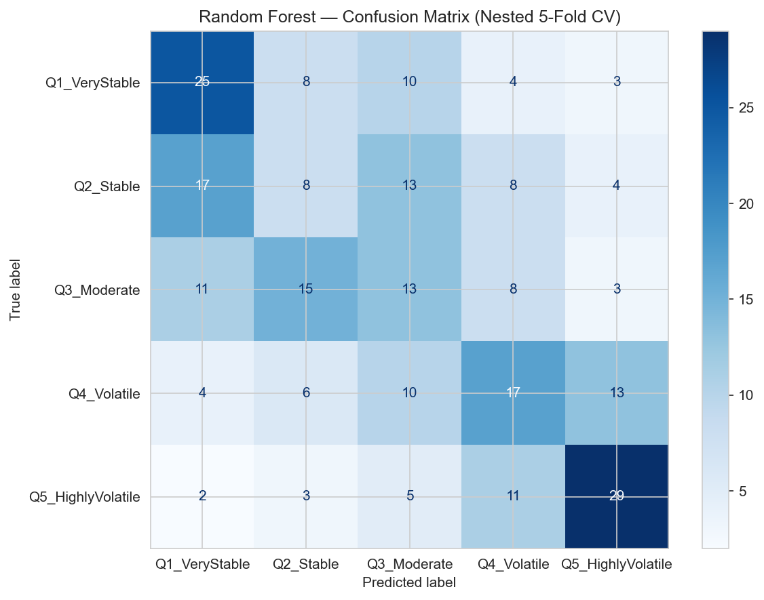
Figure 1: RF confusion matrix. Strong diagonal at Q1 and Q5; middle classes show diffuse misclassification.

Feature Importance
Permutation importance (model-agnostic, 30 repeats) ranks race_entropy_norm as #1. This is the most reliable importance measure — it tests how much accuracy drops when a feature is randomly shuffled.
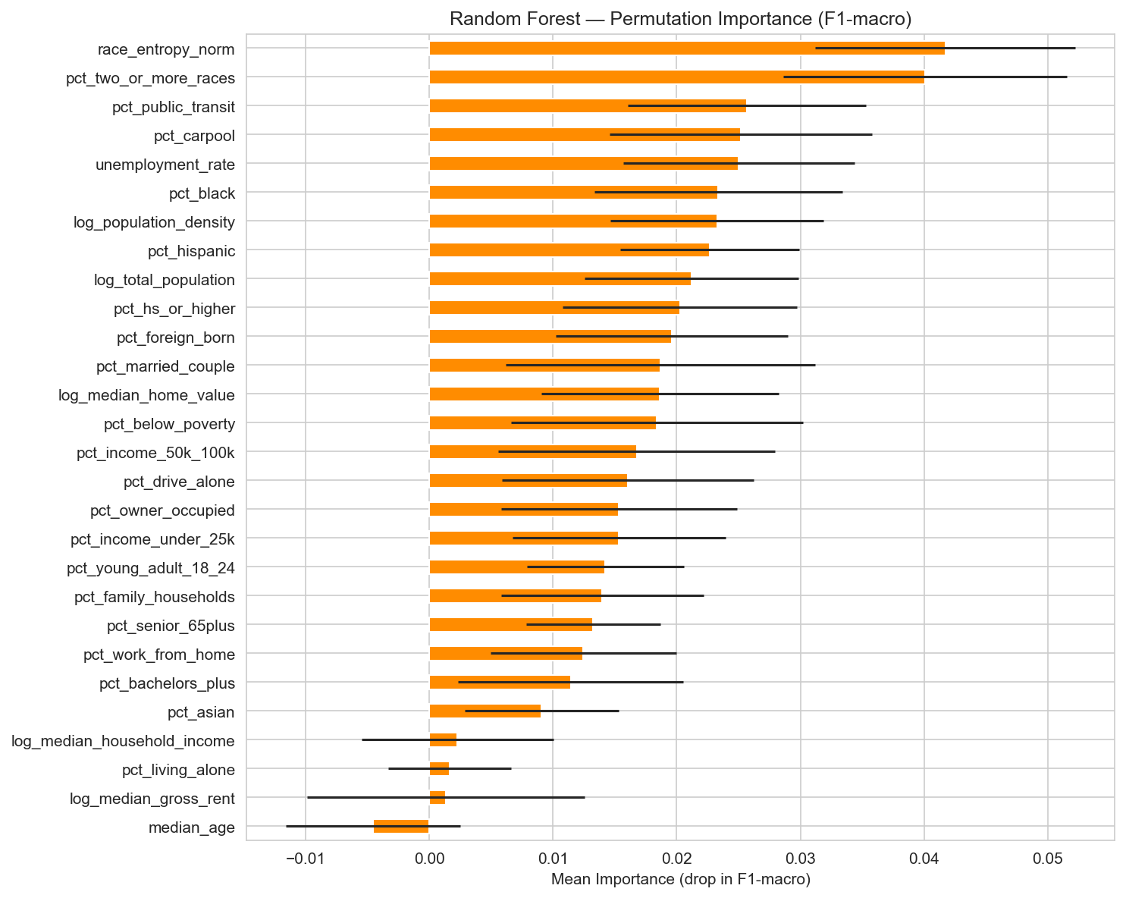
Figure 2: Permutation importance — race_entropy_norm (diversity index) is the single most important feature.
Challenge: Gini importance overweights continuous features. Solution: Used permutation importance as the authoritative ranking.

4.2 XGBoost
📖 What is XGBoost (Gradient Boosting)? Unlike Random Forest which builds trees independently, XGBoost builds them one at a time — each new tree specifically fixes mistakes from the previous ones. Like a student studying specifically the questions they got wrong. Often produces more accurate predictions for hard cases.
Why chosen: Sequential error correction for hard middle classes; built-in regularization; SHAP integration for per-county explanations; state-of-the-art on tabular data.
Assumptions: Additive model (prediction = sum of weak learners); regularization prevents overfitting.

Hyperparameters
Setting | Search Space | Best | Controls
n_estimators | 100–500 | 300 | Total learning capacity
max_depth | 3–8 | 5 | Complexity per tree
learning_rate | 0.01–0.2 | 0.1 | Step size per tree
subsample | 0.6–1.0 | 0.8 | Fraction of data per tree
colsample_bytree | 0.6–1.0 | 0.8 | Fraction of features per tree
reg_alpha (L1) | 0–1 | 0.1 | Feature selection penalty
reg_lambda (L2) | 1–10 | 5 | Prediction smoothing

Results (5-Class)
Metric | Value
Accuracy | 0.388 (best overall)
Precision (macro) | 0.396
Recall (macro) | 0.383
F1-macro | 0.387 (best overall)
ROC-AUC | 0.783

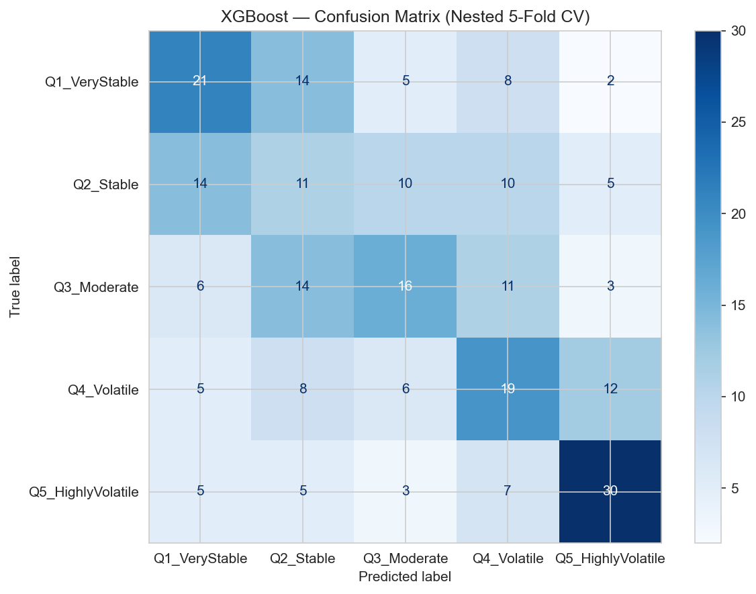
Figure 3: XGBoost confusion matrix. Better middle-class separation, especially Stable (Q2).

SHAP Analysis — Explaining Predictions
📖 What is SHAP? SHAP calculates how much each feature "pushed" each county's prediction toward high or low volatility. Like an itemized receipt: "+0.85 from high rent, +0.40 from high diversity, −0.30 from homeownership." Based on game theory; mathematically rigorous.
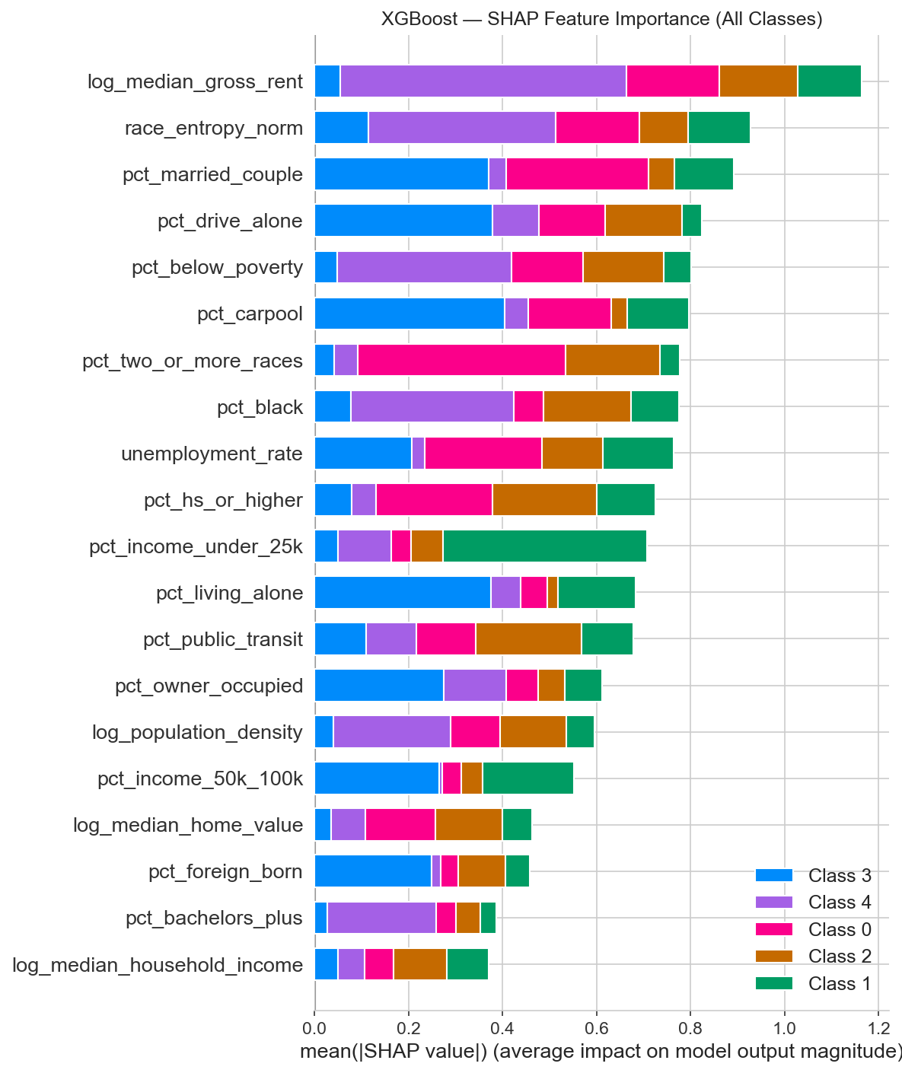
Figure 4: SHAP summary. Each dot = one county. Color = feature value (red=high, blue=low). Housing cost and diversity dominate.
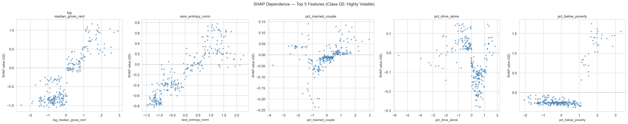
Figure 5: Top 5 SHAP dependence plots. The diversity index shows a clear "step function" — volatility jumps once diversity crosses a threshold.
Challenge: XGBoost requires 0-indexed labels. Solution: y − 1 before fit, +1 after predict.

4.3 SVM (Support Vector Machine)
📖 What is SVM? SVM draws a dividing line between classes and tries to make it as far as possible from the nearest data points on each side. The "kernel trick" allows the boundary to be curved (RBF) rather than straight (Linear). Comparing kernels tells us whether the data boundary is simple or complex.
Why chosen: Margin-based learning; kernel comparison as diagnostic tool; theoretical generalization guarantees.
Assumptions: Linear kernel: boundary is approximately straight. RBF kernel: similar counties behave similarly. Requires scaled features.

Hyperparameters
Kernel | C | Gamma | class_weight | Best C
Linear | 0.01–100 | N/A | balanced | 1
RBF | 0.01–100 | scale, auto, 0.01–1 | balanced | 10

Kernel Comparison
Metric | Linear | RBF
Accuracy | 0.368 | 0.340
F1-macro | 0.364 | 0.347
ROC-AUC | 0.765 | 0.741

Linear > RBF in 5-class: the boundaries between 5 volatility levels are approximately straight. But this reverses in binary (RBF AUC=0.789 > Linear=0.734) — the single High/Low boundary is curved, consistent with the SHAP interaction effects (diversity matters differently by context).
Challenge: No built-in feature importance. Solution: Used RF/XGBoost for rankings; SVM served as a diagnostic benchmark (kernel comparison).
▶ Takeaway: XGBoost is the best 5-class model (F1=0.387); RF has the best ROC-AUC (0.803). The diversity index is the #1 feature across all importance measures. SVM's kernel comparison reveals the volatile/stable boundary is moderately nonlinear. All models excel at extremes (Highly Volatile, Very Stable) and struggle with middle classes.

5. Model D — Demographic Misfit Detector (Logistic Regression)
📖 What is Logistic Regression? One of the simplest classifiers — draws a straight line through data to separate groups and outputs a probability. Here we use it creatively: predict which party a county "should" vote for based on demographics, then analyze the errors.

Two-Stage Approach
- Stage 1: Predict partisan lean from demographics. Accuracy: 89.6%.
- Stage 2: Find "misfits" — counties where the prediction is confidently wrong. If demographics say 96% Republican but it votes Democrat, that's a misfit.
Hypothesis: Misfits are communities in demographic transition, and should therefore be more electorally volatile.

Assumptions
Linear decision boundary between D and R counties; P(Dem) is well-calibrated; prediction errors capture demographic-political misalignment.

Top 5 Misfits
County | State | Model Says | Actually | Misfit | Volatility
Leelanau | MI | 96% Rep | Dem +8% | 0.96 | Highly Volatile
Marquette | MI | 96% Rep | Dem +9% | 0.96 | Highly Volatile
Nash | NC | 95% Dem | Rep −2% | 0.95 | Very Stable
Lenoir | NC | 94% Dem | Rep −7% | 0.94 | Stable
Cabarrus | NC | 87% Dem | Rep −8% | 0.87 | Highly Volatile

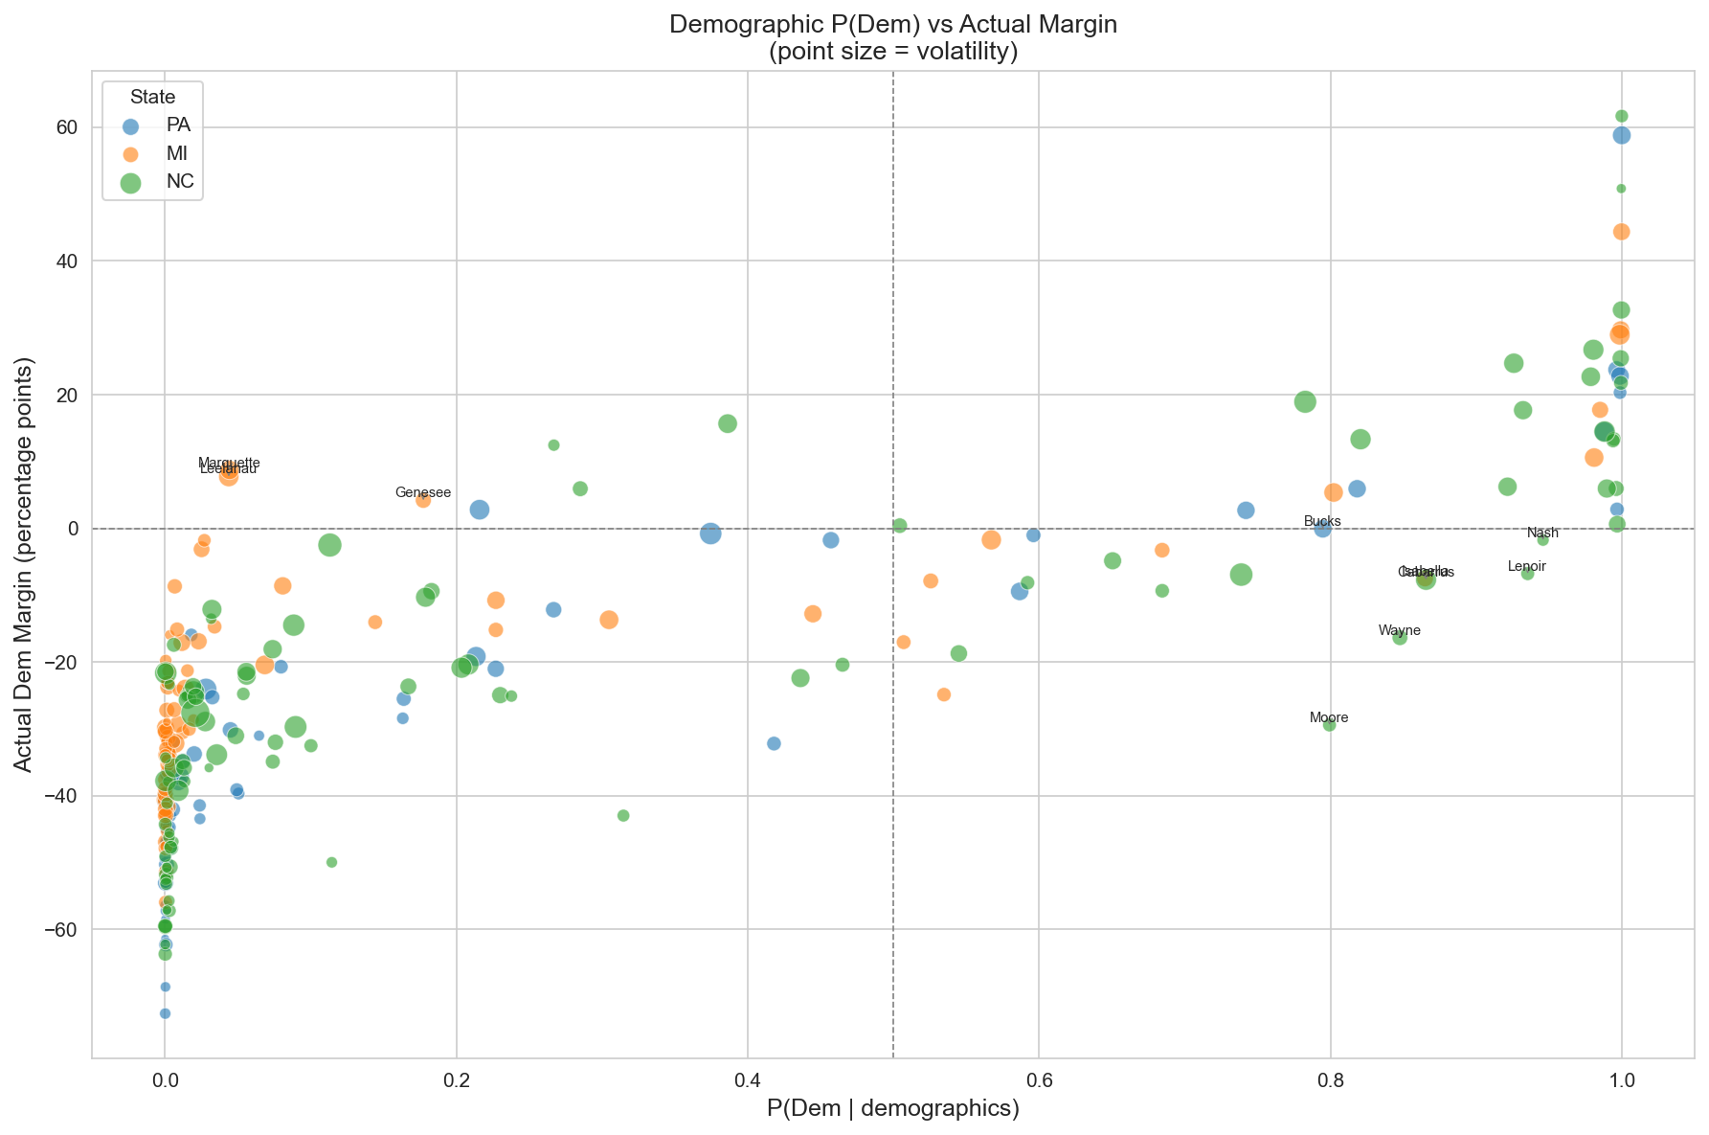
Figure 6: P(Dem) vs actual margin. Dot size = volatility. Counties far from diagonal are misfits.

Misfit-Volatility Link
Finding | Test | Value
Misfits are more volatile | Spearman ρ | 0.408 (p < 0.001)
Misfits don't lean one way | Pearson r | −0.017 (n.s.)

Misfit Profiling
Characteristic | Misfits | Non-Misfits | p-value
Racial diversity | 0.567 | 0.419 | < 0.0001
Bachelor's+ | 30.9% | 24.7% | < 0.0001
Homeownership | 71.1% | 76.3% | < 0.0001
Median rent | $1,056 | $932 | < 0.0001
Median age | 42.5 | 44.5 | 0.003

Misfits are younger, more diverse, more educated, higher-rent, and less rooted — communities "in flux."

Two Types of Misfits
Type | Count | Avg Volatility | Where
"Surprise Dem" | 8/30 | 0.807 (very high) | MI university/resort, PA Scranton
"Surprise Rep" | 22/30 | 0.383 (moderate) | NC rural South

"Surprise Dem" misfits are 2× more volatile — university/resort towns voting against their rural demographics are the most unstable counties.
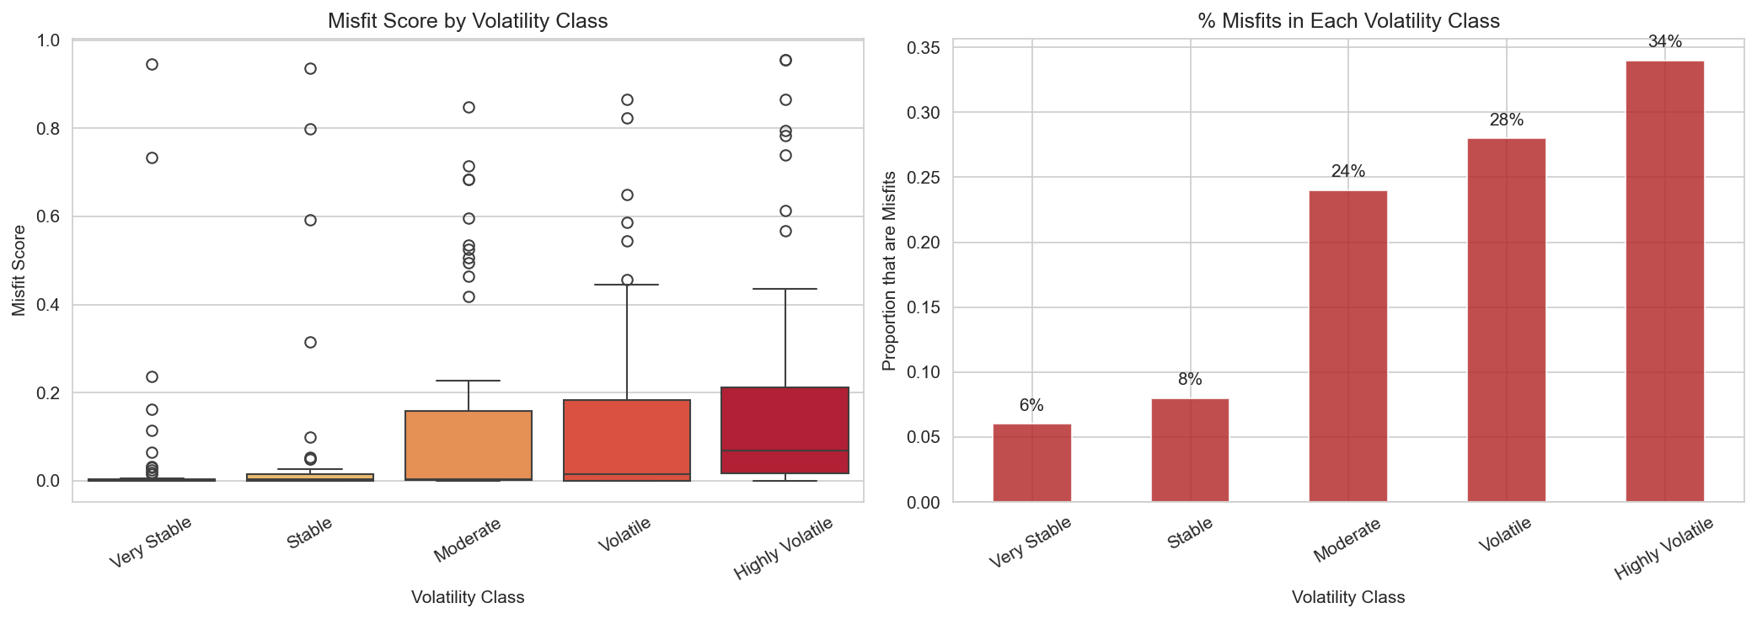
Figure 7: Misfit proportion rises from 6% (Very Stable) to 34% (Highly Volatile). Kruskal-Wallis p < 0.000001.
▶ Takeaway: Counties that defy demographic expectations are significantly more volatile (ρ=0.408). Misfits are younger, diverse, educated, transient — communities in transition. "Surprise Dem" misfits are the most volatile of all.

6. Binary Classification — High vs Low Volatility
The 5-class task (F1~0.39) is limited by middle-class overlap. Collapsing to binary — High (Q4+Q5) vs Low (Q1–Q3) — answers the actionable question: "Will this county swing significantly?"
Model | Accuracy | F1 | Precision | Recall | AUC
Random Forest | 0.780 | 0.718 | 0.726 | 0.690 | 0.828
XGBoost | 0.748 | 0.667 | 0.718 | 0.610 | 0.803
SVM (RBF) | 0.760 | 0.674 | 0.724 | 0.630 | 0.789
Logistic Regression | 0.680 | 0.604 | 0.598 | 0.610 | 0.745
SVM (Linear) | 0.688 | 0.610 | 0.610 | 0.610 | 0.734

5-Class → Binary Improvement
Metric | 5-Class Best | Binary Best | Improvement
F1 | 0.387 (XGBoost) | 0.718 (RF) | +85%
AUC | 0.803 (RF) | 0.828 (RF) | +3%

Simplifying from 5 to 2 classes nearly doubles F1. Problem framing matters more than algorithm choice.
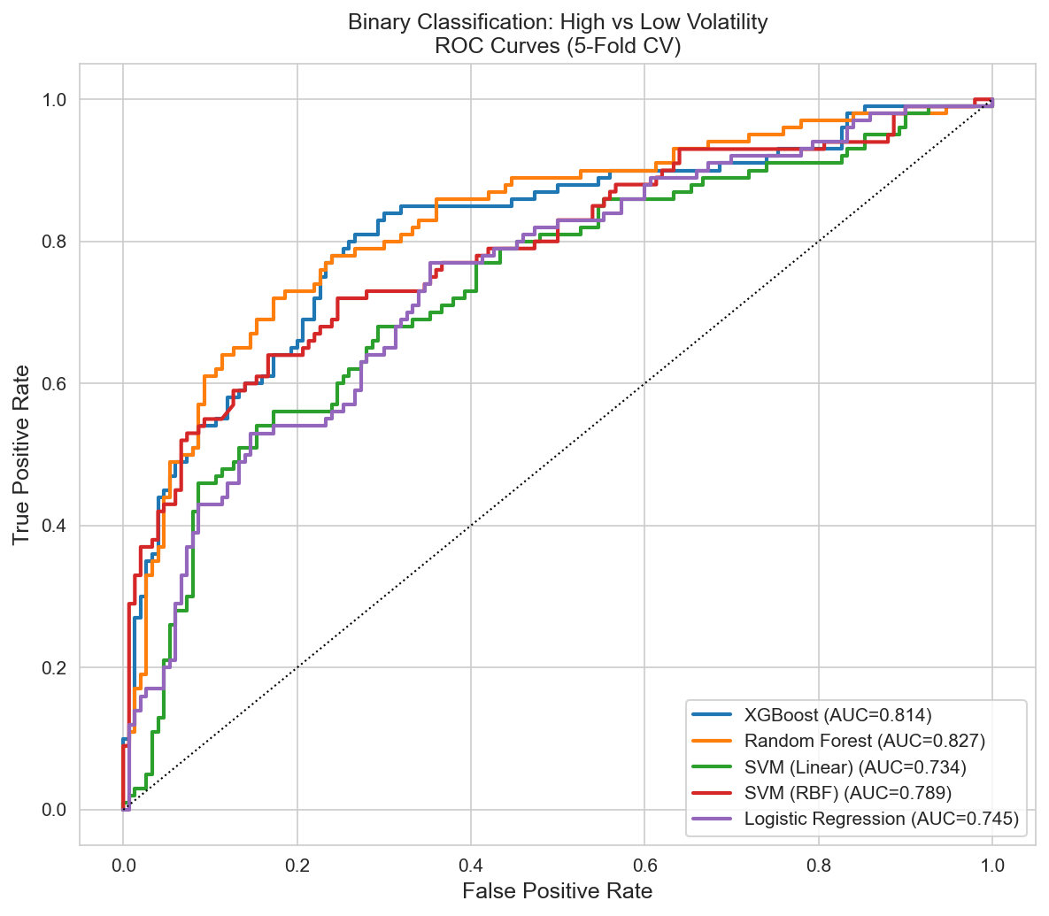
Figure 8: Binary ROC curves. RF (blue) achieves AUC = 0.828.

Bootstrap Confidence Intervals (200 iterations × 5-fold CV)
Model | F1 [95% CI] | AUC [95% CI] | Accuracy [95% CI]
Random Forest | 0.818 [0.764, 0.872] | 0.918 [0.882, 0.946] | 0.856 [0.816, 0.900]
XGBoost | 0.845 [0.789, 0.899] | 0.932 [0.894, 0.966] | 0.880 [0.840, 0.920]

Tight CIs confirm results are robust, not artifacts of a lucky split.

Feature Group Ablation
Group | n | F1 without | F1 drop | F1 alone
Race / Ethnicity | 6 | 0.626 | +0.092 (biggest) | 0.619 (86%)
Urbanization | 6 | 0.684 | +0.034 | 0.583
Education | 2 | 0.708 | +0.010 | 0.583
Housing | 3 | 0.712 | +0.006 | 0.612
Economic | 5 | 0.722 | −0.004 | 0.570
Household / Age | 6 | 0.728 | −0.010 | 0.471

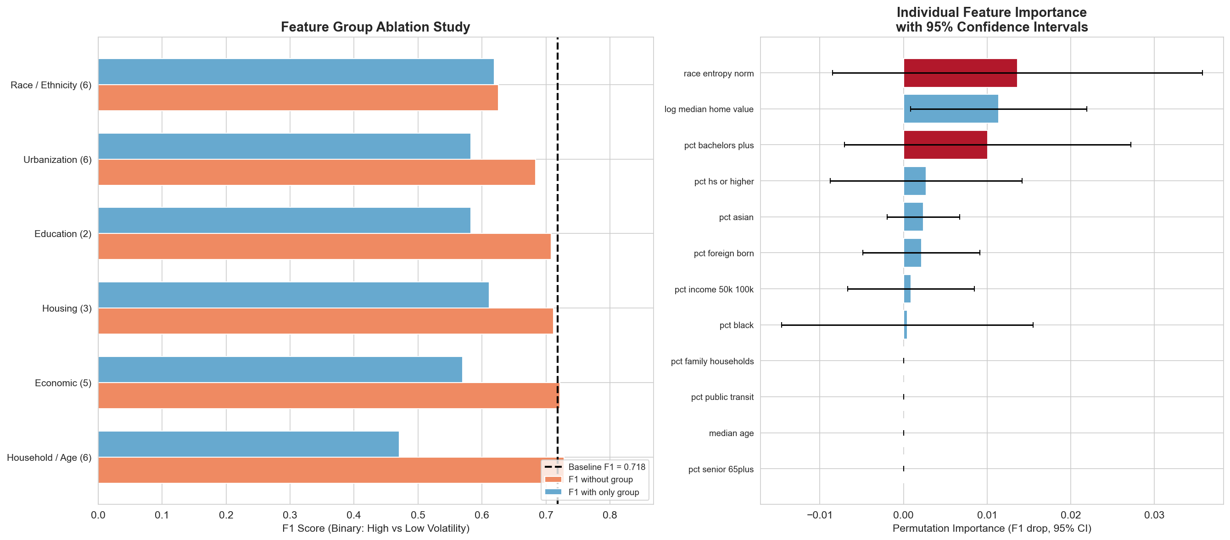
Figure 9: Feature ablation (left) and permutation importance with 95% CIs (right).
▶ Takeaway: Binary RF achieves F1=0.718 (AUC=0.828). Race/Ethnicity is both the most necessary (biggest F1 drop when removed) and most sufficient (86% of full alone) feature group. Economic and age variables are dispensable.

7. Model Comparison & Cross-State Generalization

7.1 Full Model Comparison
5-Class:
Model | Accuracy | F1-macro | ROC-AUC | Best At
XGBoost | 0.388 | 0.387 | 0.783 | Best overall
SVM (Linear) | 0.368 | 0.364 | 0.765 | Middle classes
Random Forest | 0.368 | 0.362 | 0.803 | Best ROC-AUC

Binary (including ensemble attempts):
Model | F1 | AUC | Type
Random Forest | 0.718 | 0.828 | Best overall
Soft Voting | 0.691 | 0.826 | Ensemble (no improvement)
XGBoost | 0.667 | 0.803 | Individual
SVM (RBF) | 0.663 | 0.819 | Individual
Stacking | 0.647 | 0.816 | Ensemble (hurts)
Logistic Regression | 0.604 | 0.745 | Individual

Ensembles do not improve on RF. Stacking hurts (F1: 0.718→0.647) because the meta-learner oversmooths with only n=250. The performance ceiling is dataset size, not algorithm sophistication.
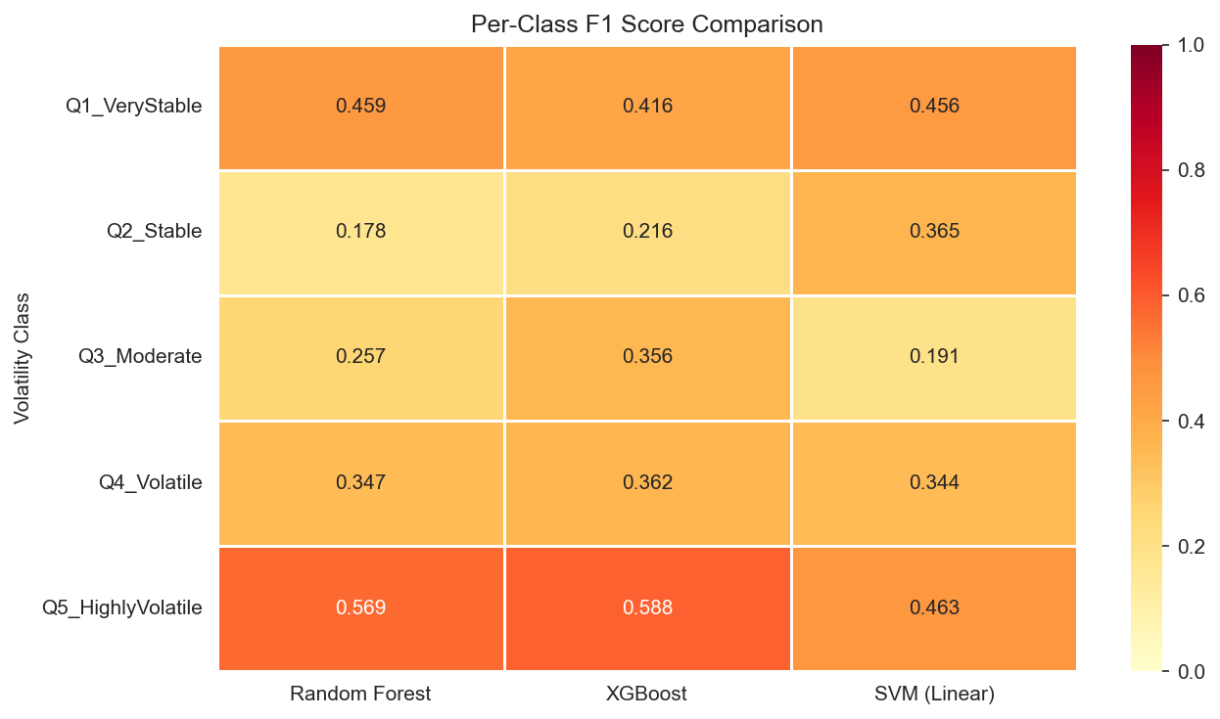
Figure 10: Per-class F1 heatmap. All models excel at extremes, struggle in the middle.

7.2 Cross-State Generalization — Do Demographics Transfer?
LOSO: Train on 2 states, test on the 3rd. Scaler refit on training states only.
Test State | Train States | Accuracy | F1-macro
Michigan | PA + NC | 0.205 | 0.182
North Carolina | PA + MI | 0.210 | 0.213
Pennsylvania | MI + NC | 0.209 | 0.189
 | Random baseline (1/5) | 0.200 | 0.200

Cross-state prediction collapses to random guessing. Each state has a fundamentally different volatility signature:
Rank | PA (Diversity) | MI (Education) | NC (Poverty)
#1 | race_entropy_norm | pct_bachelors_plus | pct_below_poverty
#2 | log_median_gross_rent | log_median_gross_rent | log_median_gross_rent
#3 | pct_foreign_born | pct_work_from_home | log_population_density

Only log_median_gross_rent (housing cost) predicts volatility in all 3 states.
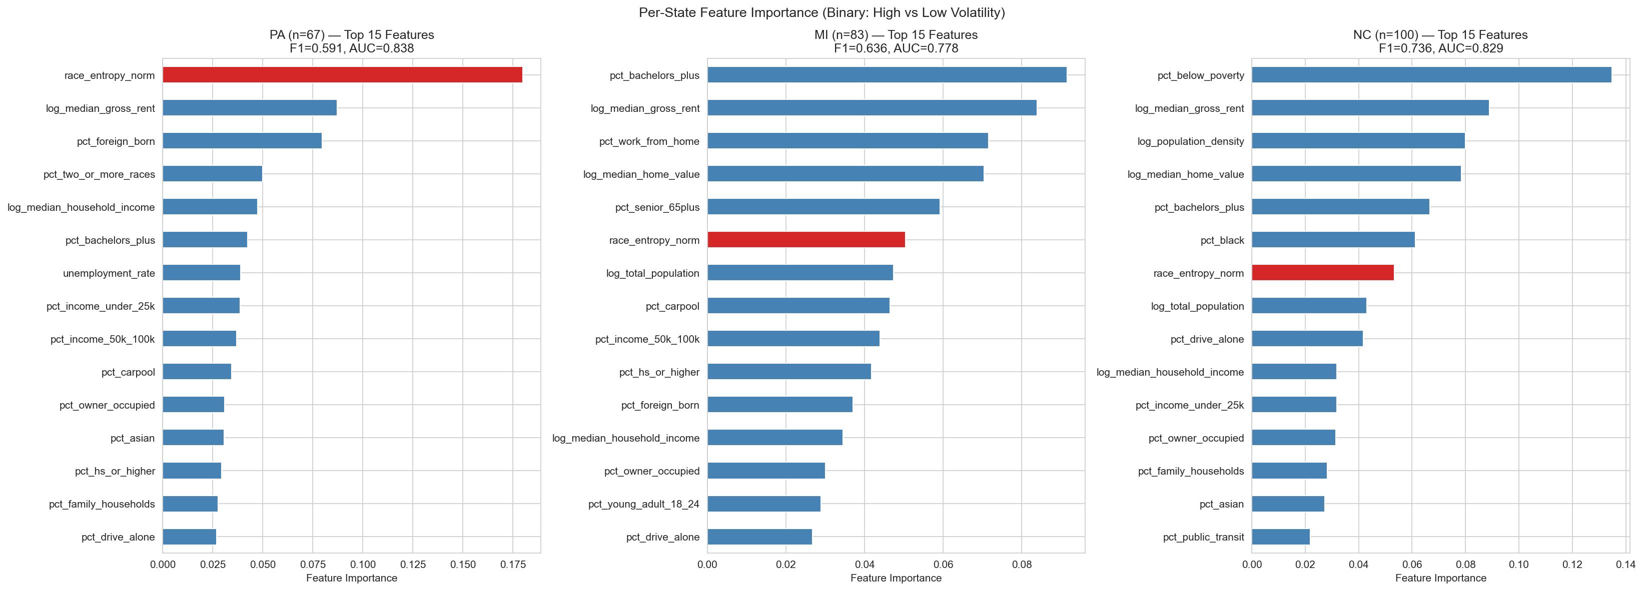
Figure 11: Per-state feature importance. Dramatically different rankings in each state.
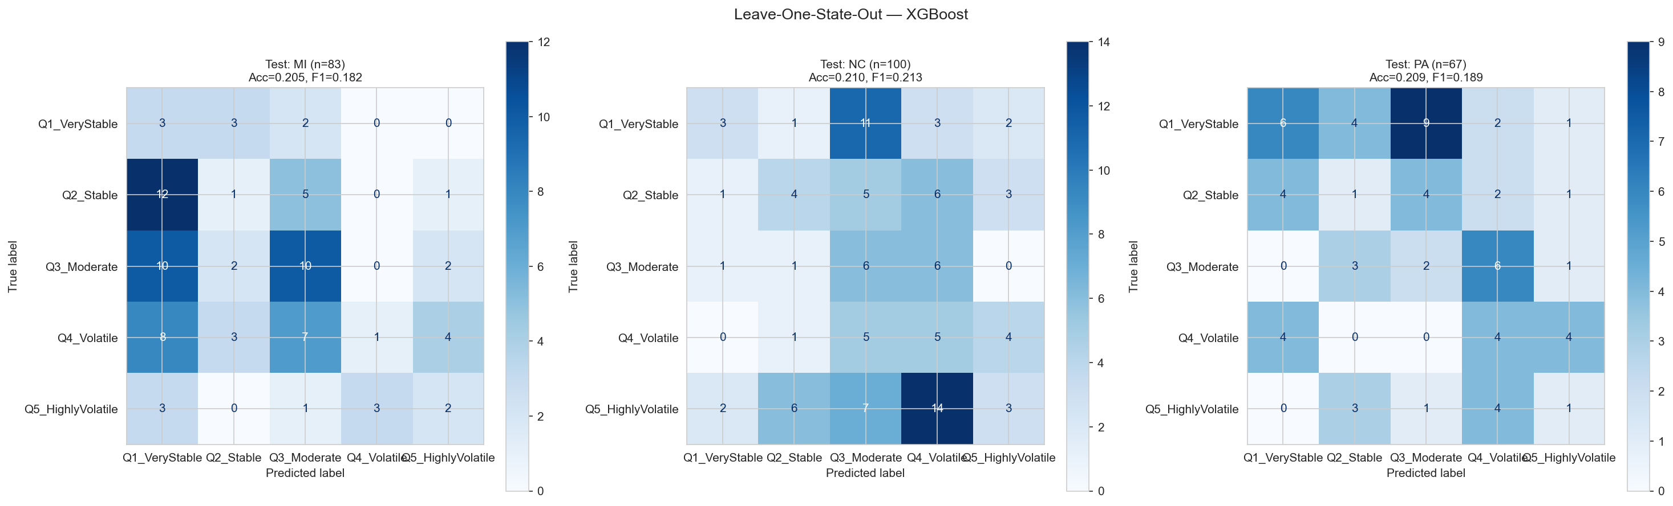
Figure 12: LOSO confusion matrices. All three rotations = near-random.
State | n | Within-State AUC | Within-State F1
PA | 67 | 0.838 | 0.591
MI | 83 | 0.778 | 0.636
NC | 100 | 0.829 | 0.736

▶ Takeaway: Demographics predict volatility well within states (AUC 0.78–0.84) but fail across state lines. National models are fundamentally limited. Housing cost is the only universal predictor. Ensembles don't help at n=250.

8. Hypothesis Testing

H1: Wealth-Volatility Inverse — CONFIRMED
Evidence | Method | Result
SHAP direction | Income SHAP vs Q5 | r = −0.602 (p < 0.0001)
Feature importance | Poverty rank | Top 5 in all models
Partial dependence | Rent effect | Monotonic increase
Ablation | Economic alone | F1 = 0.570 (insufficient alone)

Wealthier counties are more stable. But income alone is insufficient — it interacts with diversity (wealthy diverse suburbs are volatile; wealthy homogeneous exurbs are not).

H2: Diversity Index > Individual Race — CONFIRMED
Evidence | Method | Result
Permutation importance | RF, 30 repeats | race_entropy_norm = #1
SHAP importance | XGBoost | entropy 0.397 > pct_black 0.347
PDP range | Probability swing | entropy = 0.14 (largest)
Ablation | Race group alone | F1 = 0.619 (86% of baseline)
Interactions | SHAP | entropy in 6/10 top interactions
Threshold | Bootstrap | Odds ratio = 7.15×

Confirmed across 6 independent evidence streams. It's racial mixing — not any single group — that predicts volatility.
▶ Takeaway: Both hypotheses confirmed. Wealth → stability (r=−0.602). Diversity index > all individual race vars (7× odds ratio above threshold).

9. Advanced Analysis — Deep-Dives

9.1 Temporal Demographic Shifts (2016 → 2024)
Demographic change over 8 years also predicts volatility:
Change | ρ | p-value | Meaning
Δ pct_hispanic | +0.220 | 0.0005 | Growing Hispanic pop → more volatile
Δ median_gross_rent | +0.209 | 0.0009 | Rising rents → more volatile
Δ pct_two_or_more_races | +0.209 | 0.0009 | Growing multiracial pop → more volatile
Δ pct_black | −0.194 | 0.0020 | Growing single group → less volatile

Diversification predicts volatility; growth of a single group does not.
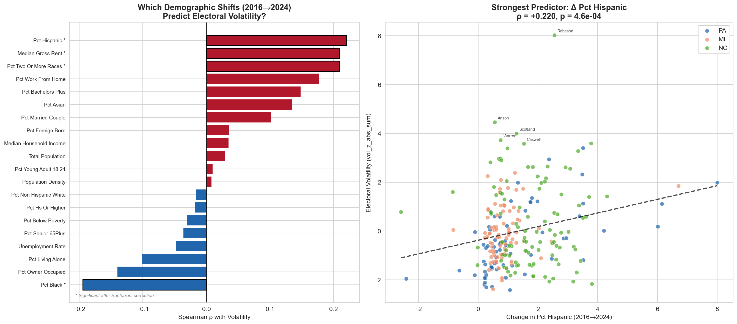
Figure 13: Temporal shifts vs volatility. Correlations (left) and top scatter plots (right).

9.2 Election Margin Trajectories
Trajectory | n | Mean Vol | % High Vol | Pattern
Blue Bounceback | 117 (47%) | −0.17 | 34% | D in 2020, snapped back 2024
Steady Red Drift | 94 (38%) | +0.39 | 50% | R in both — most volatile
Steady Blue Drift | 35 (14%) | −0.28 | 37% | D in both cycles
Red Bounceback | 4 (2%) | −1.82 | 0% | Extremely rare

Blue Bounceback is dominant (47%) — the 2020 Biden surge was temporary. Steady Red Drift is the most volatile (50%). NC is different: 49% Steady Red Drift vs 27–33% in PA/MI.
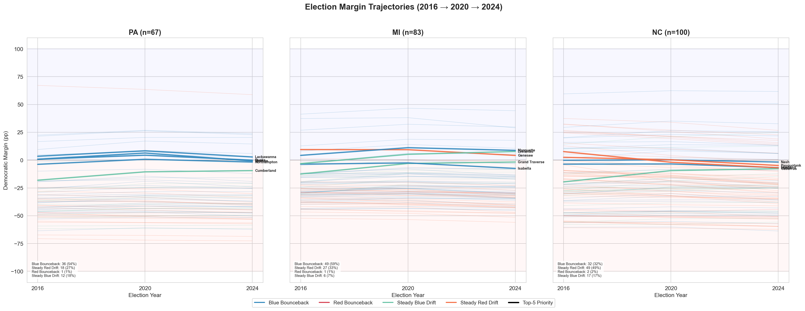
Figure 14: Spaghetti trajectories by state. Each line = one county, colored by trajectory type.

9.3 The Diversity Threshold
Metric | Value
Optimal threshold | race_entropy_norm = 0.552
95% Bootstrap CI | [0.397, 0.642]
Below: % high vol | 24.4%
Above: % high vol | 69.8%
Odds ratio | 7.15×

Counties where no single race exceeds ~60% are 7× more likely to be highly volatile. P(high vol) jumps from ~20% to ~70% across the threshold — a switch, not a dial.
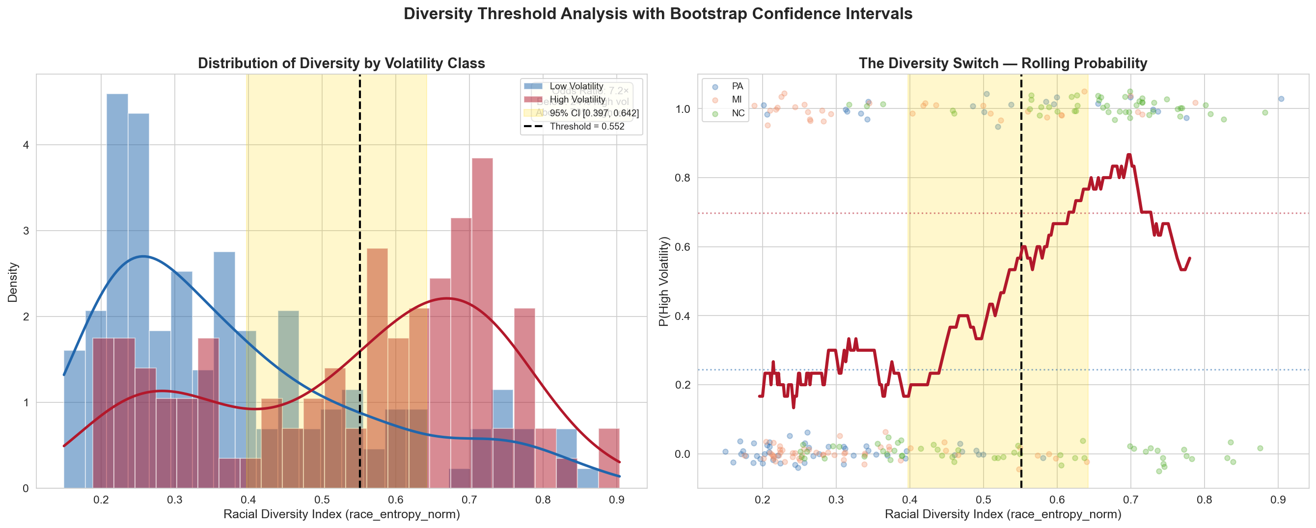
Figure 15: Diversity threshold. KDE distributions (left) and rolling probability curve (right).

9.4 Feature Effects & Interactions
📖 What is Partial Dependence Plots? PDPs show how one feature affects prediction, averaged across all others. "If we changed just this feature while keeping everything else constant, how would the predicted volatility change?"
Feature | Shape | Meaning
Diversity index | Step function | Flat → jumps at threshold → plateaus
Housing cost | Monotonic increase | Higher rent = higher P(volatile)
Poverty rate | Late spike | Flat until extreme poverty, then jumps
Married-couple % | Flat | Works only through interactions
Bachelor's % | Slight upward | Modest effect at high education
Pop. density | Uptick at extremes | Mostly interaction-driven

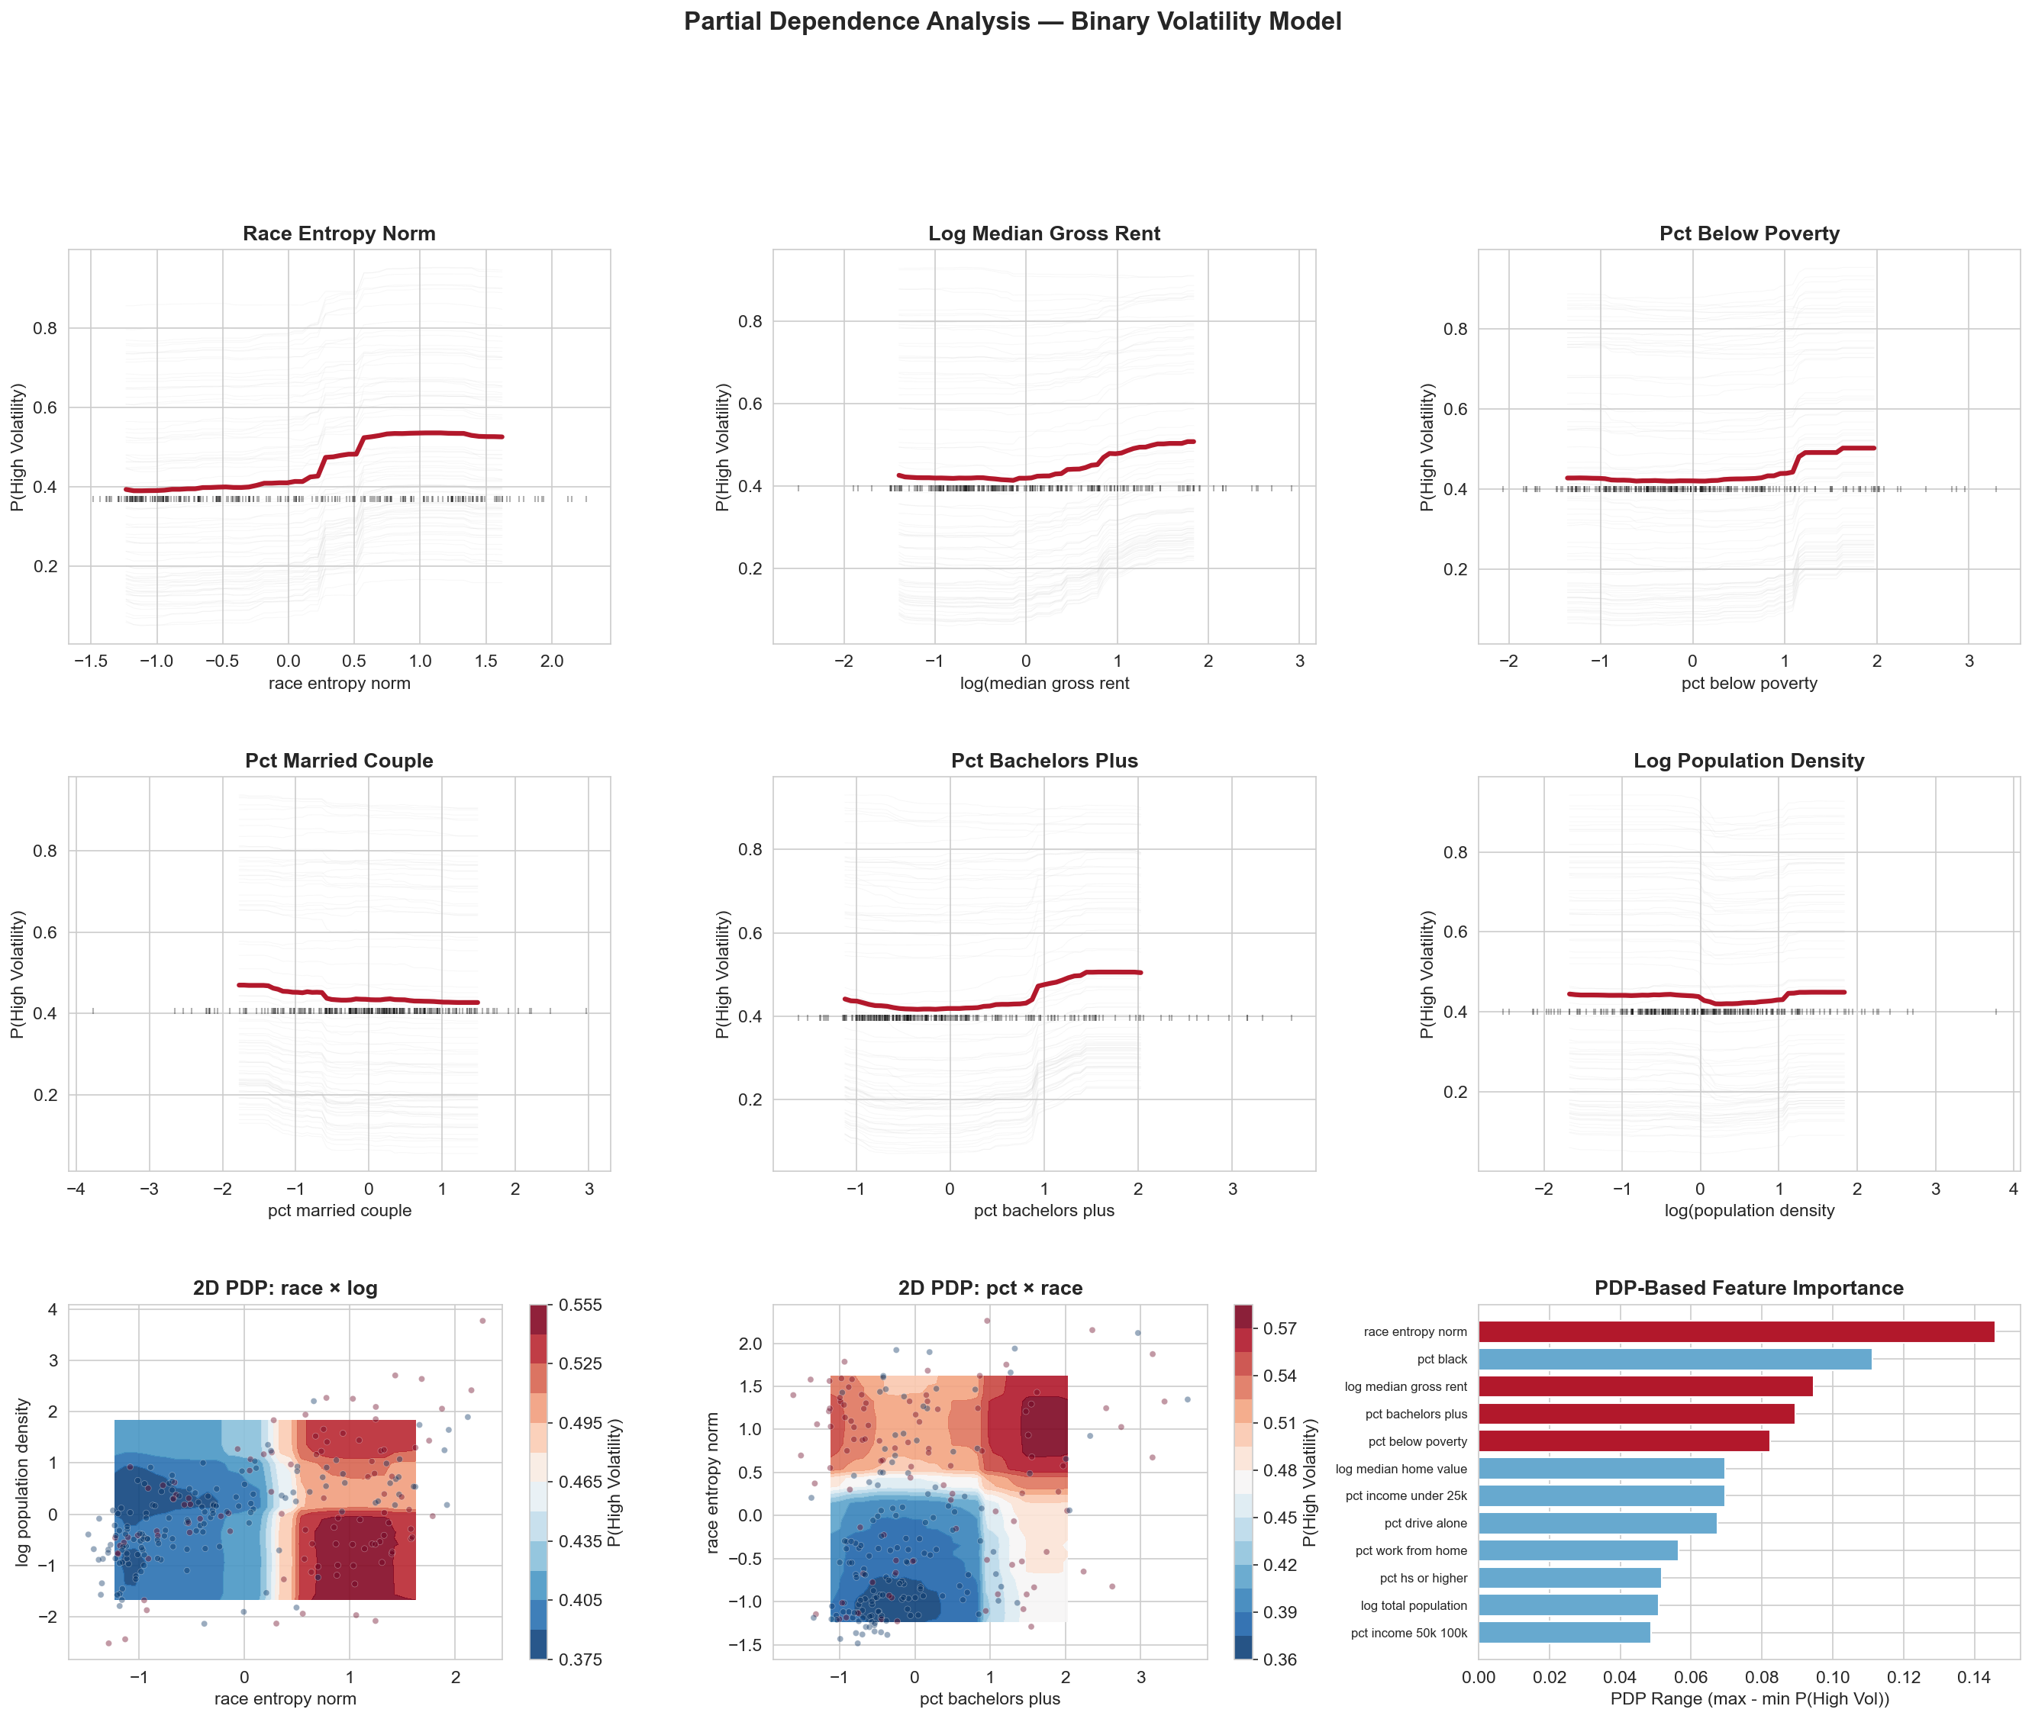
Figure 16: PDPs with ICE lines (top), 2D interaction contours (bottom-left), and PDP-based importance (bottom-right).
Diversity × Poverty — The Clearest Interaction:
Quadrant | n | Mean Vol | % High Vol | % Misfits
Low Div + Low Poverty | 73 | −0.622 | 19% | 11%
Low Div + High Poverty | 52 | −0.669 | 23% | 8%
High Div + Low Poverty | 52 | +0.407 | 60% | 27%
High Div + High Poverty | 73 | +0.808 | 59% | 33%

Diversity is the switch (triples high-vol rate). Poverty adds magnitude but not probability.
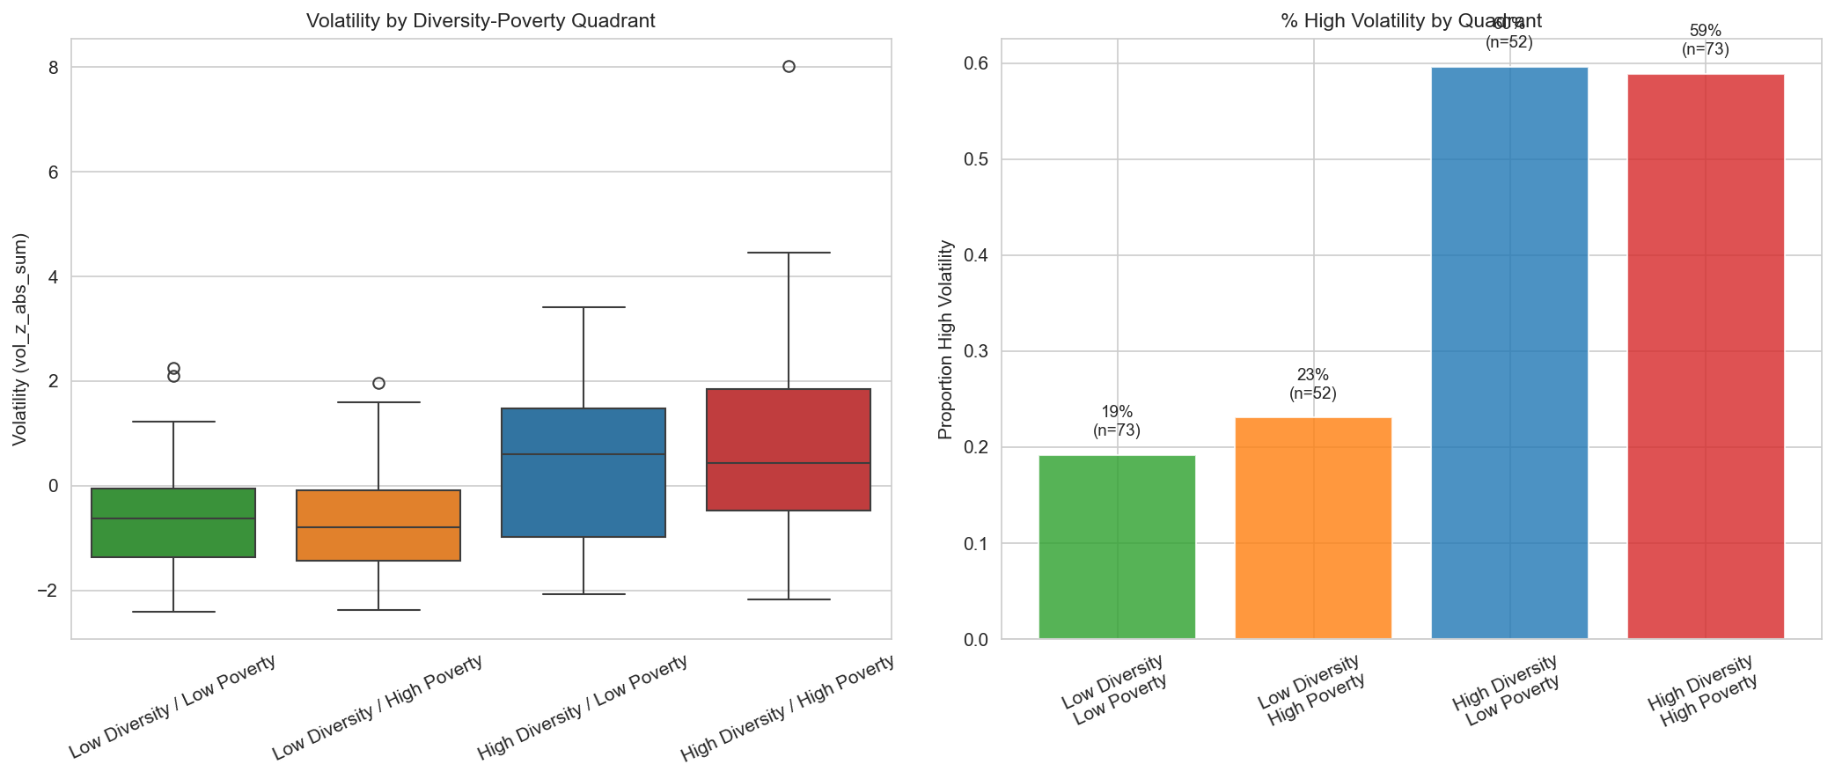
Figure 17: Diversity × Poverty quadrant analysis.
Education × Urbanization:
Quadrant | n | % High Vol
Low Ed + Rural | 89 | 42%
Low Ed + Urban | 36 | 19% (least volatile)
High Ed + Rural | 36 | 33%
High Ed + Urban | 89 | 49% (most volatile)

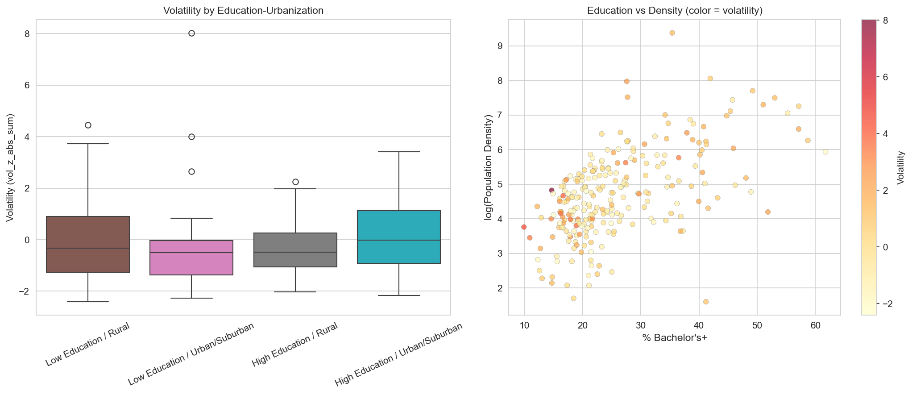
Figure 18: Education × Urbanization. Least volatile = stable working-class cities. Most volatile = educated suburbs.

9.5 SHAP Case Studies
County | Archetype | #1 Driver | Story
Bucks, PA | Suburban swing | Rent (+0.85) | 802k votes, 0.1% margin, bellwether
Leelanau, MI | Misfit | Education (+1.50) | Rural/white but votes Dem
Scotland, NC | Diverse-poor | Diversity (+1.25) | Highest volatility in dataset
Philadelphia | Counter-example | Living alone (−0.80) | Diverse but STABLE —  urban density overrides

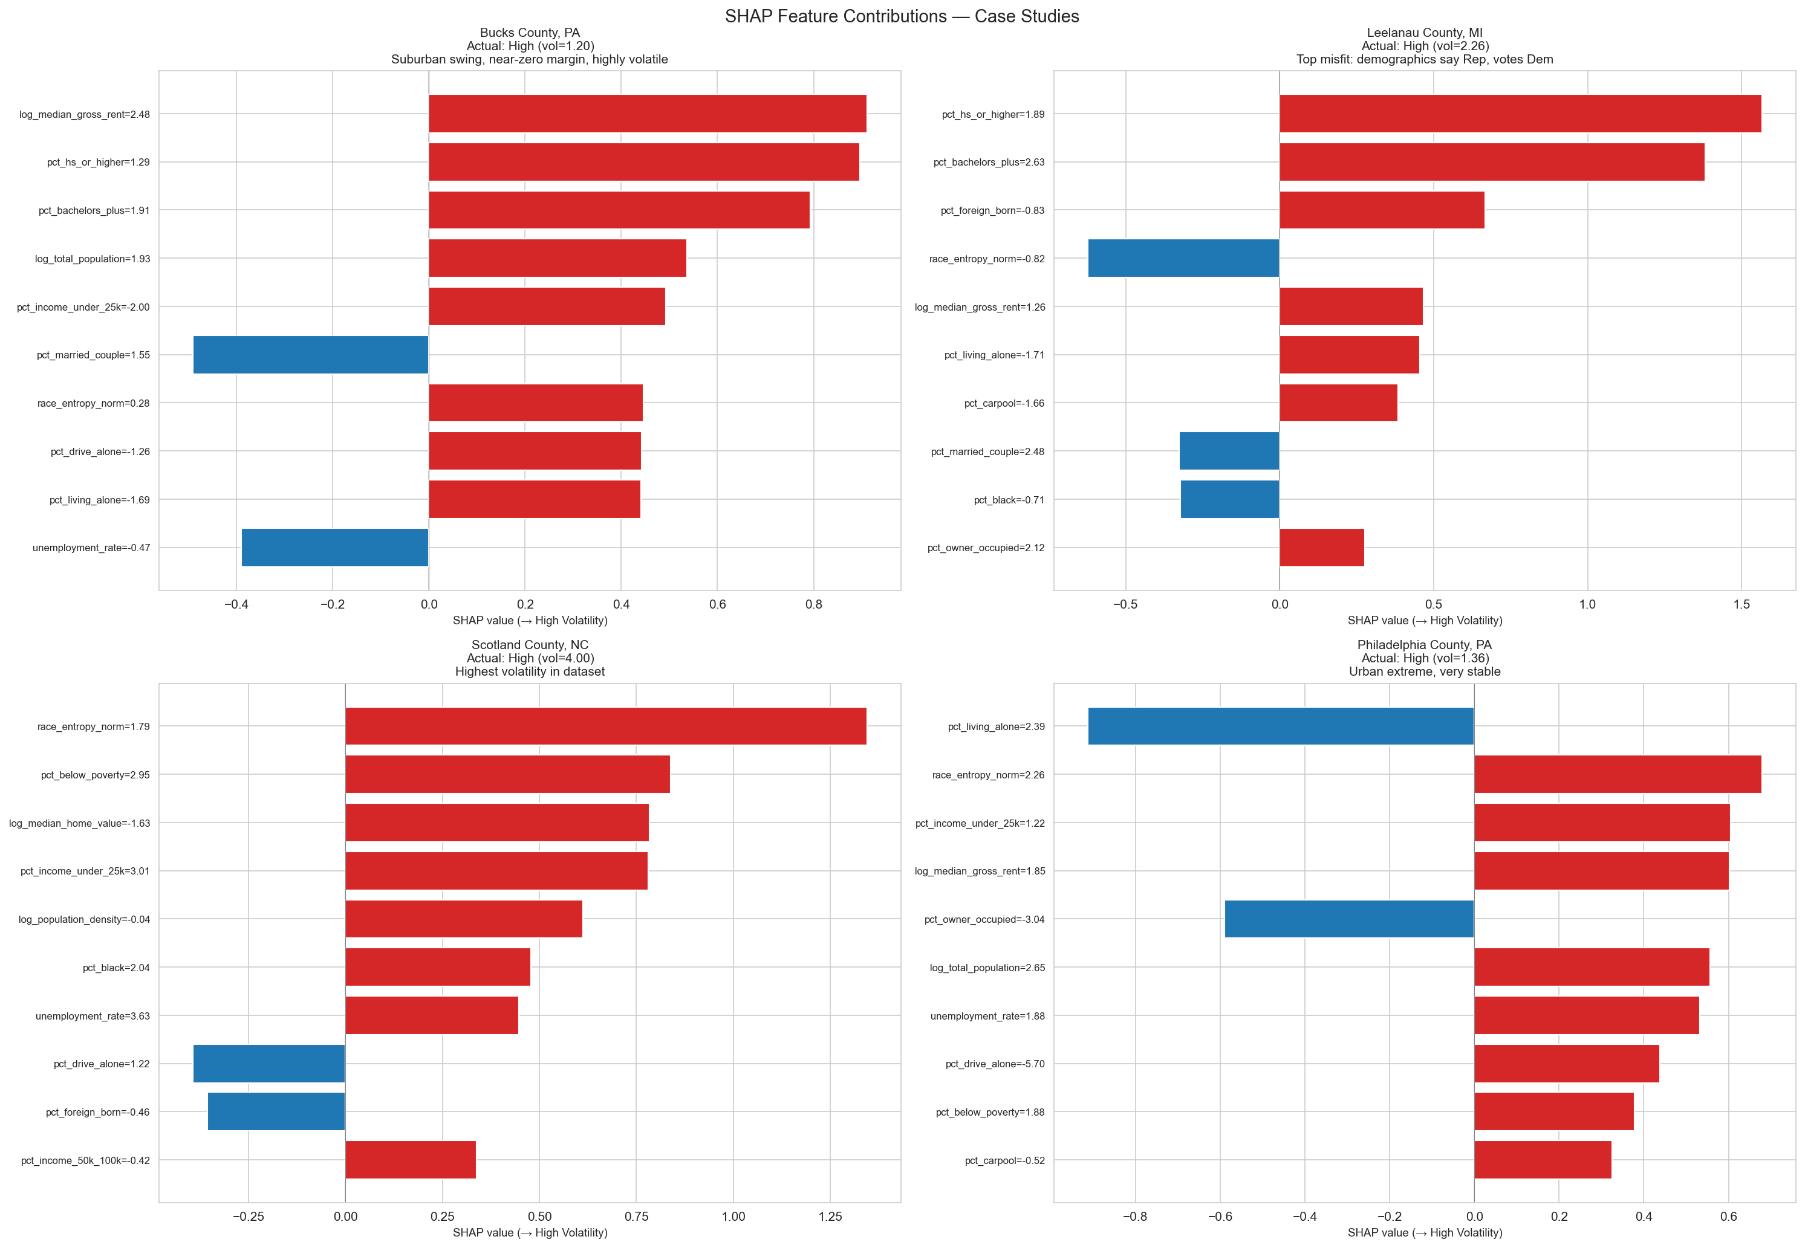
Figure 19: SHAP waterfall plots for 4 county archetypes.

9.6 SHAP-Based County Archetypes
K-Means on SHAP values (not raw features) reveals 5 functionally distinct county types:
Cluster | n | % High Vol | Driver | States | Archetype
0 | 35 | 100% | Diversity (1.54) | NC (33/35) | NC Diverse Rural
1 | 47 | 0% | Small pop (0.82) | NC+MI | Stable Small
2 | 33 | 91% | Immigration (0.66) | MI (21/33) | MI Working-Class
3 | 92 | 0% | Low diversity (1.07) | All | Stable Core
4 | 43 | 81% | Large pop (0.92) | PA+NC+MI | Suburban Battlegrounds

Near-perfect separation: 100%/0%/91%/0%/81%. Cluster 0 is NC-only, Cluster 2 is MI-heavy — explains why LOSO fails.
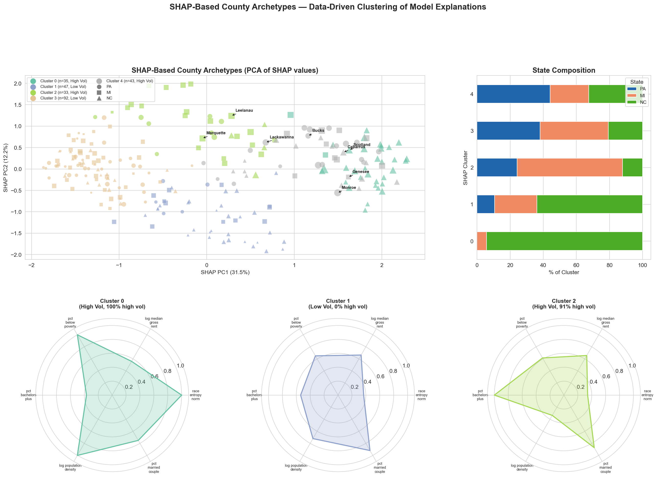
Figure 20: SHAP archetypes. PCA projection (top-left), state composition (top-right), radar charts per cluster (bottom).

9.7 Campaign Priority Scoring
priority = 0.30×volatility + 0.25×misfit + 0.25×vote_volume + 0.20×margin_closeness
# | County | State | Priority | Votes | Margin | Volatility
1 | Bucks | PA | 0.650 | 802,056 | −0.1% | Highly Volatile
2 | Lackawanna | PA | 0.574 | 233,180 | +2.8% | Highly Volatile
3 | Cabarrus | NC | 0.570 | 120,202 | −7.7% | Highly Volatile
4 | Leelanau | MI | 0.566 | 17,685 | +7.8% | Highly Volatile
5 | Scotland | NC | 0.561 | 14,626 | −6.9% | Highly Volatile
6 | Marquette | MI | 0.547 | 39,009 | +8.7% | Highly Volatile
7 | Genesee | MI | 0.514 | 223,268 | +4.2% | Volatile
8 | Monroe | PA | 0.492 | 171,050 | −0.8% | Highly Volatile
9 | Isabella | MI | 0.492 | 30,835 | −7.5% | Volatile
10 | Grand Traverse | MI | 0.484 | 62,772 | −1.7% | Highly Volatile

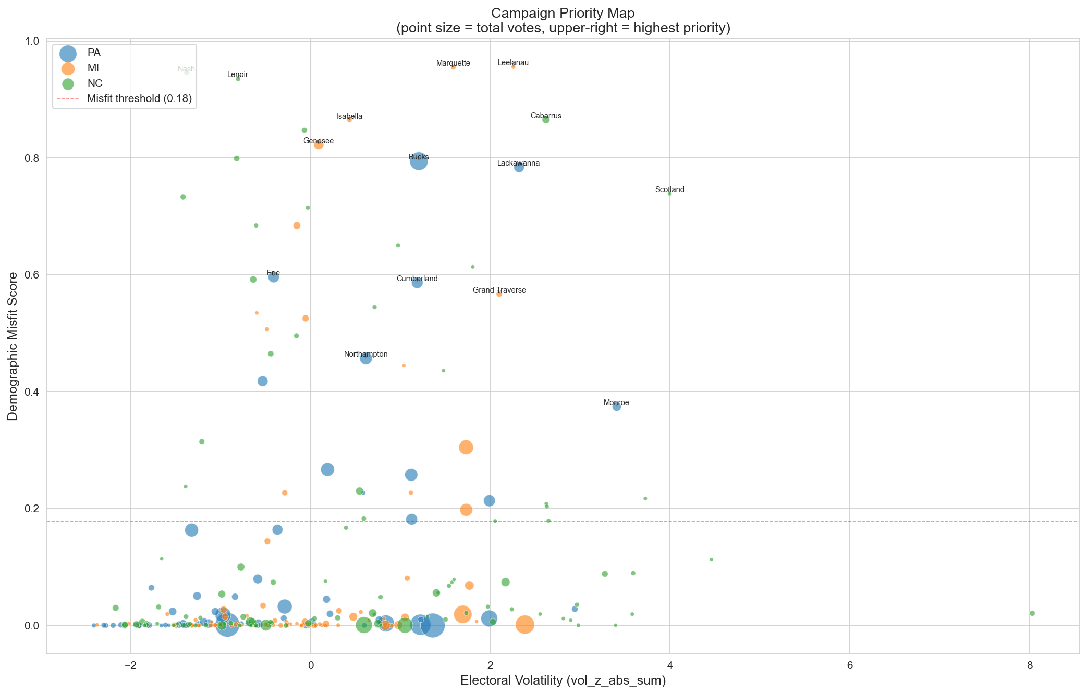
Figure 21: Campaign priority scatter (volatility × misfit, bubble size = votes).
▶ Takeaway: Temporal analysis: diversifying counties are becoming more volatile. Blue Bounceback is the dominant trajectory (47%). The diversity threshold at 0.55 operates as a 7× switch. 5 SHAP archetypes reveal state-specific mechanisms. Bucks County PA is the #1 priority target nationally.

10. Key Findings & Grand Synthesis

The Volatility Formula
1. Racial diversity is the necessary condition. The #1 predictor. Threshold at 0.55 = 7× odds ratio. It's mixing, not any single group.
2. Economic transition is the amplifier. Rising rents, poverty, education shifts amplify volatility in diverse counties.
3. State context is the moderator. PA=diversity, MI=education, NC=poverty. National models fail.

What Does NOT Predict Volatility
- Poverty alone (low-diversity poor counties are stable)
- Education alone (only with urbanization)
- Cross-state demographics (LOSO F1 = 0.195 = random)
- Swing direction (misfit r = −0.017)
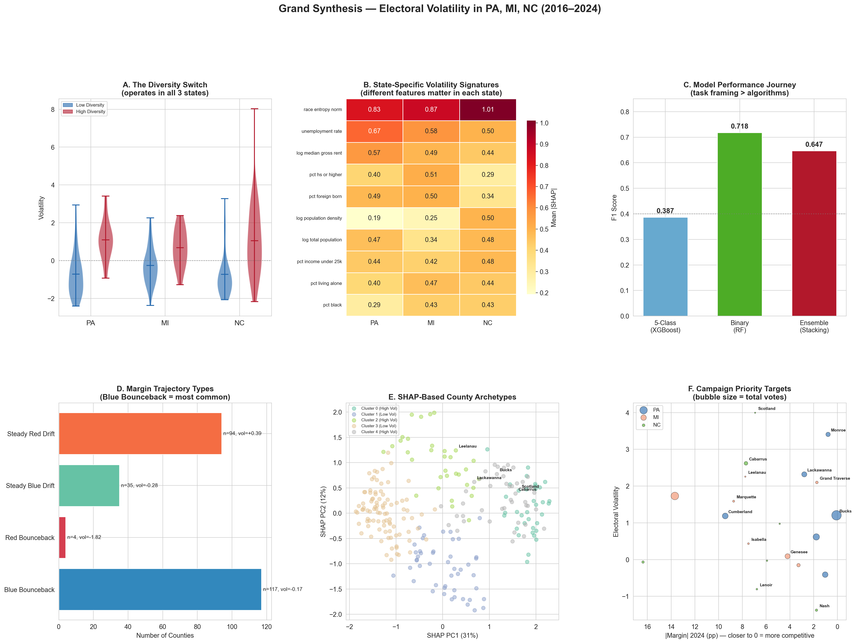
Figure 22: Grand Synthesis — the complete story in 6 panels.
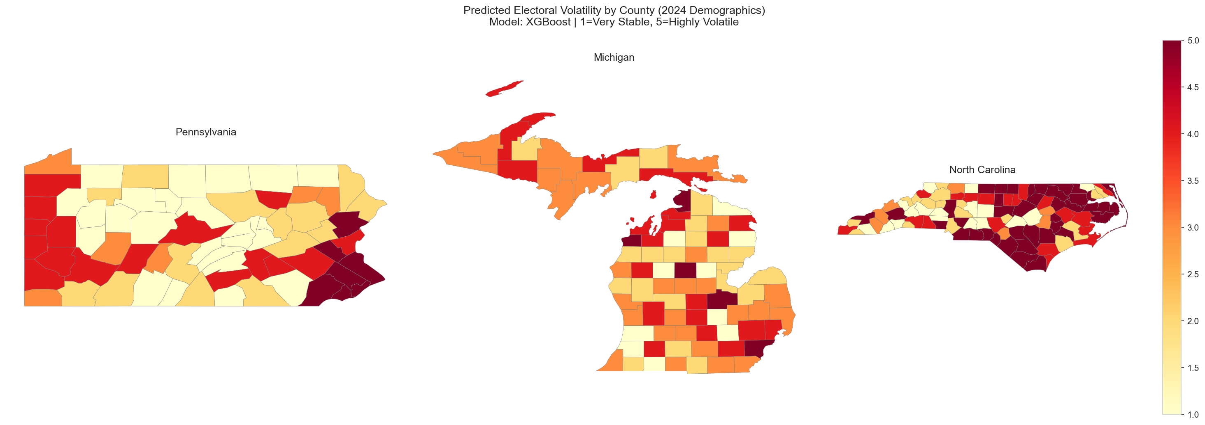
Figure 23: Predicted volatility class by county.
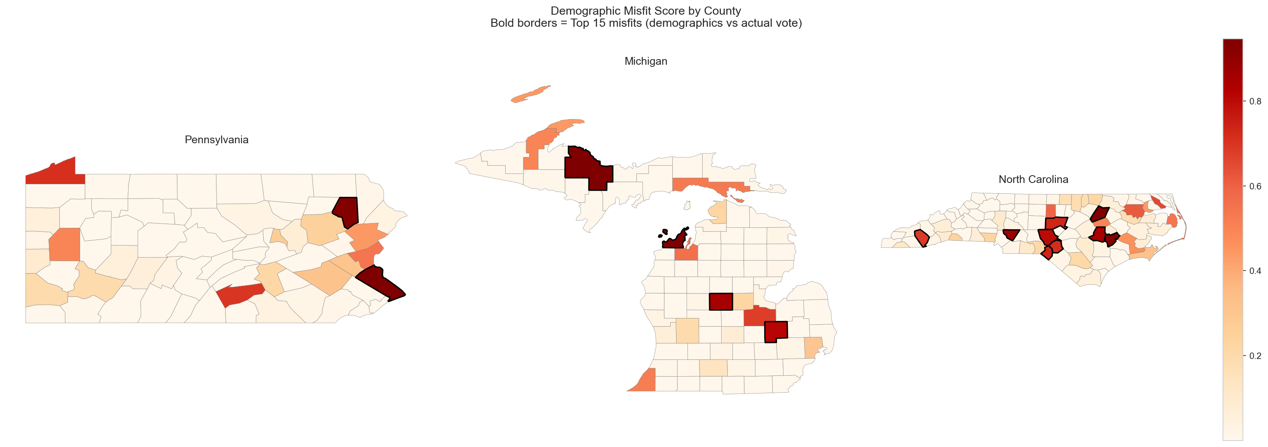
Figure 24: Demographic misfit scores. Top 15 misfits highlighted.

Metrics At-a-Glance
Finding | Value
Best binary F1 | 0.718 (RF)
Best 5-class F1 | 0.387 (XGBoost)
Bootstrap CI (RF) | F1: 0.818 [0.764, 0.872]
Ensemble ceiling | F1 = 0.691 (no gain)
Diversity threshold | 0.552 [0.397, 0.642]
Diversity odds ratio | 7.15×
Most necessary group | Race/Ethnicity (ΔF1 = +0.092)
Top temporal predictor | Δ pct_hispanic (ρ = +0.220)
Most volatile trajectory | Steady Red Drift (50% high vol)
#1 priority county | Bucks PA (802k, 0.1% margin)
SHAP archetypes | 100%/0%/91%/0%/81% high vol
Cross-state transfer | F1 = 0.195 (= random)
H1 (income) | r = −0.602 (confirmed)
H2 (entropy > race) | #1 permutation (confirmed)
Misfit-volatility | ρ = 0.408 (p < 0.001)

11. Appendix

Notebooks
Notebook | Cells | Description
classification_antoni.ipynb | 86 | Core: RF, XGBoost, SVM, Misfit, LOSO, maps
classification_antoni_deepdive.ipynb | 48 | Deep-dive I: misfits, state models, SHAP, binary, campaigns
classification_antoni_deepdive_2.ipynb | 30 | Deep-dive II: temporal, PDPs, bootstrap, archetypes
classification_antoni_deepdive_3.ipynb | 5 | Grand synthesis figure

Data Files
File | Description
classification_dataset_250.csv | 250 counties, 28 scaled features + targets
classification_predictions.csv | All model predictions + misfit scores
rf_predictions.csv | RF predictions for clustering comparison
campaign_priority_rankings.csv | 250 counties with priority scores

Figures (24)
# | Description
1 | RF confusion matrix (5-class)
2 | RF permutation importance
3 | XGBoost confusion matrix
4 | SHAP summary
5 | SHAP dependence (top 5)
6 | Misfit scatter
7 | Misfit by volatility class
8 | Binary ROC curves
9 | Feature ablation + permutation CIs
10 | Per-class F1 heatmap
11 | Per-state feature importance
12 | LOSO confusion matrices
13 | Temporal demographic shifts
14 | Margin trajectories
15 | Diversity threshold
16 | Partial dependence plots
17 | Diversity × Poverty
18 | Education × Urbanization
19 | SHAP case studies
20 | SHAP archetypes
21 | Campaign priority scatter
22 | Grand synthesis (6-panel)
23 | Choropleth: volatility
24 | Choropleth: misfit

