1. How to run it.
2. Open the file “index.html” with chrome.

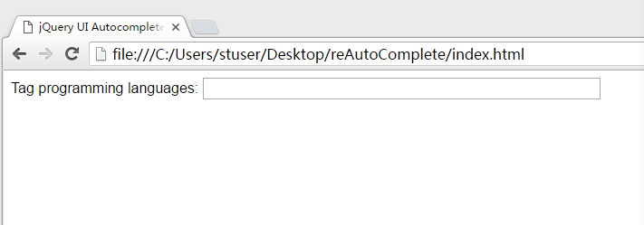

1. Input a letter and select one word which has shown.
2. Press the key “down” and show selectable words.

B.How to add words

Open the the file “content.js”.

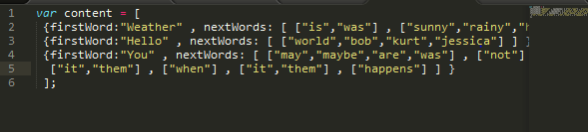

If want to input the words like the words of the excel.

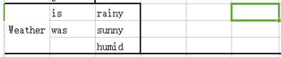

Add data

