1.Put the demo stts into the folder called webapps

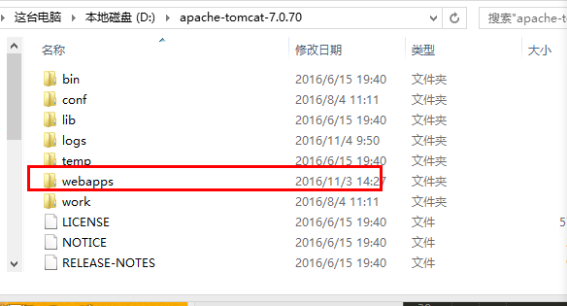

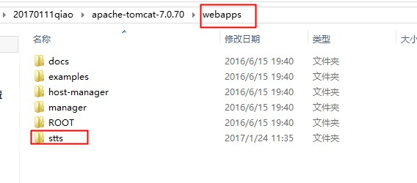

1. Then start tomcat, double click start.bat

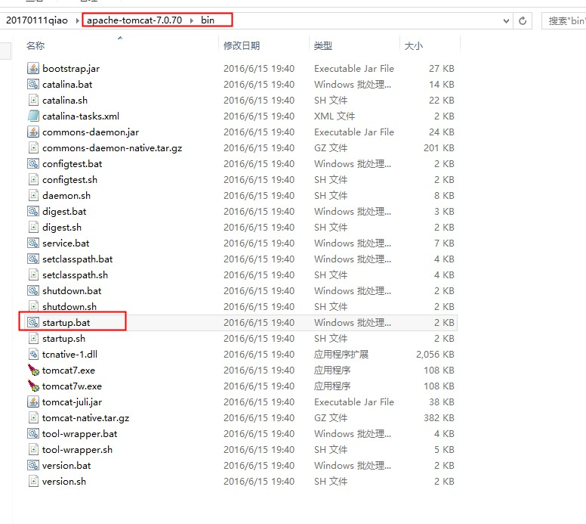

1. Open browser, input localhost:8080/stts/index.html

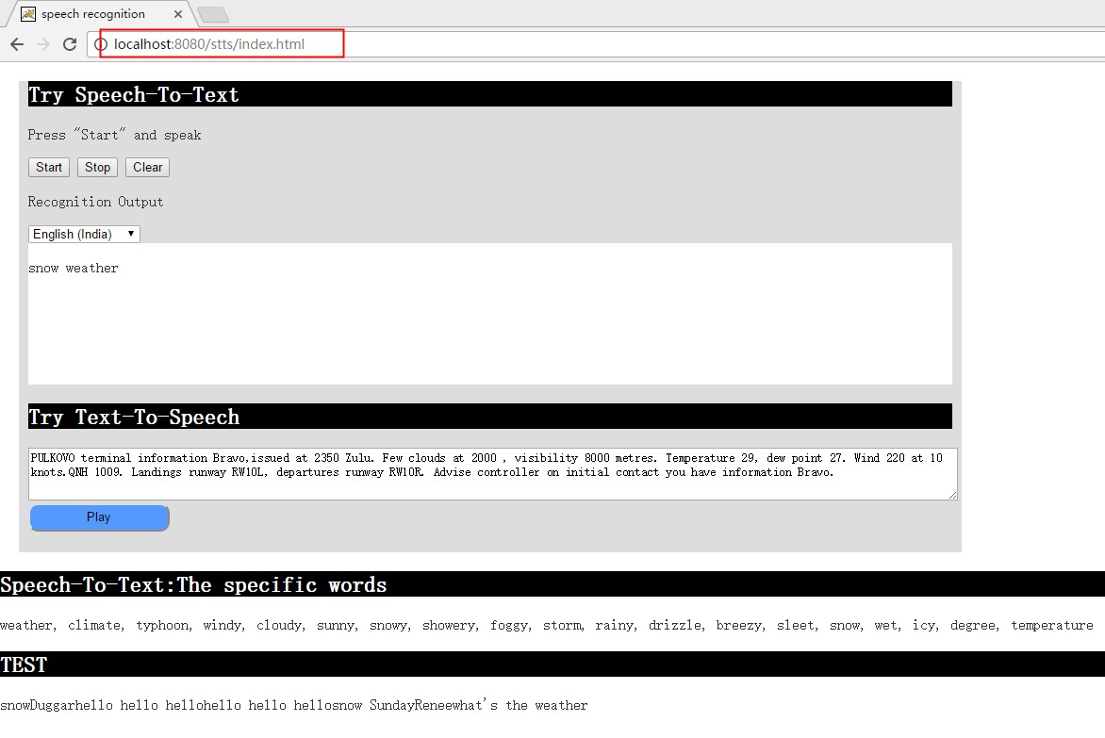

2.open the folder called bin and click double startup.

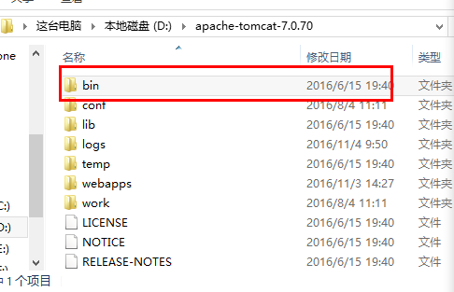

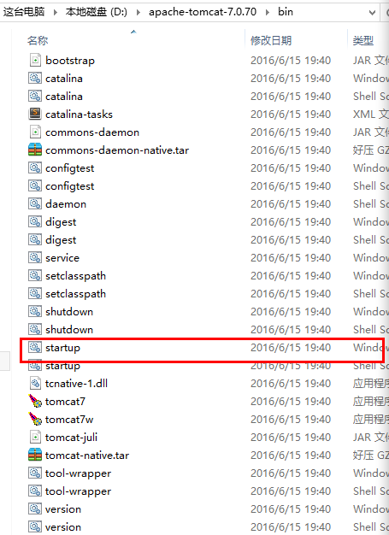

3.Open with ‘ <http://localhost:8080/stts/index.html> ’ in chrome

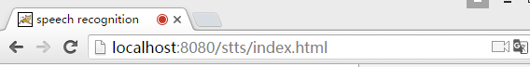

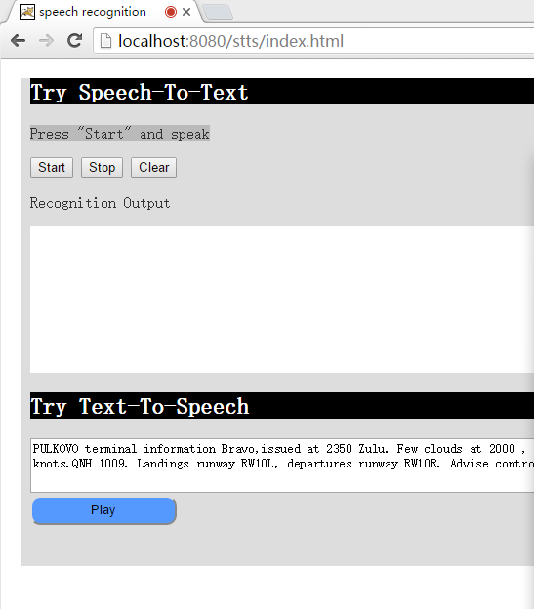

1. Keep the specific words. For example if I say "What’s the weather? The climate is so bad.it’s cloudy”,recognize “weather,climate,cloudy”.

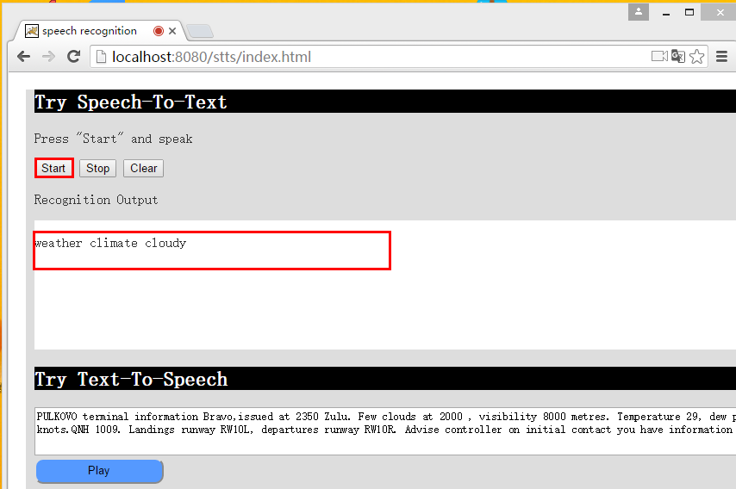

The specific words:

['weather', 'climate', 'typhoon', 'windy', 'cloudy', 'sunny','snowy','showery', 'foggy', 'storm', 'rainy', 'drizzle', 'breezy', 'sleet', 'snow','wet', 'icy', 'degree', 'temperature' , 'go' , 'straight' , 'up' , 'down' , 'one' , 'two' , 'three' , 'four' ]