# Exercises: XML Processing

This document defines the **exercise assignments** for the ["Databases Advanced – EF Core" course @ Software University](https://softuni.bg/trainings/1741/databases-advanced-entity-framework-october-2017).

# Product Shop Database

A products shop holds **users**, **products** and **categories** for the products. Users can **sell** and **buy** products.

* Users have an **id**, **first** **name** (optional) and **last** **name** and **age** (optional).
* Products have an **id**, **nam**, **price**, **buyerId** (optional) and **sellerId** as IDs of users.
* Categories have an **id** and **name**.
* Using Entity Framework Code First create a database following the above description.

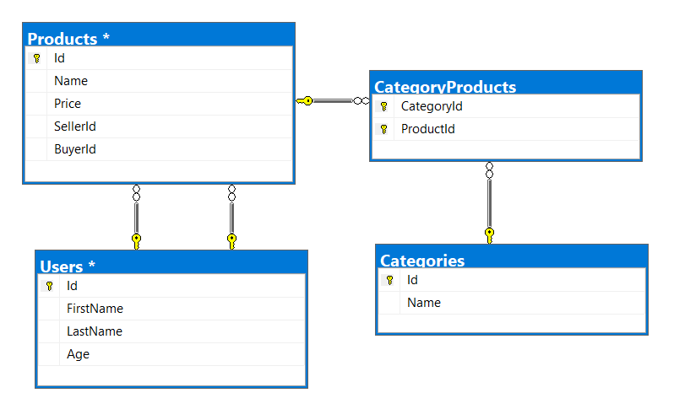

* **Users** should have **many products sold** and **many products bought**.
* **Products** should have **many categories**
* **Categories** should have **many products**
* **CategoryProducts** should **map products** and **categories**

## Import Data

### Import Users

**NOTE**: You will need method public static string ImportUsers(ProductShopContext context, string inputXml) and public StartUp class.

Import the users from the provided file **users.xml**.

Your method should return string with message $"Successfully imported {Users.Count}";

### Import Products

**NOTE**: You will need method public static string ImportProducts(ProductShopContext context, string inputXml) and public StartUp class.

Import the products from the provided file **products.xml**.

Your method should return string with message $"Successfully imported {Products.Count}";

### Import Categories

**NOTE**: You will need method public static string ImportCategories(ProductShopContext context, string inputXml) and public StartUp class.

Import the categories from the provided file **categories.xml**.

Some of the names will be null, so you don’t have to add them in the database. Just skip the record and continue.

Your method should return string with message $"Successfully imported {Categories.Count}";

### Import Categories and Products

**NOTE**: You will need method public static string ImportCategoryProducts(ProductShopContext context, string inputXml) and public StartUp class.

Import the categories and products ids from the provided file **categories-products.xml**. If provided category or product id, doesn’t exists, skip the whole entry!

Your method should return string with message $"Successfully imported {CategoryProducts.Count}";

## Query and Export Data

Write the below described queries and **export** the returned data to the specified **format**. Make sure that Entity Framework generates only a **single query** for each task.

### Products In Range

**NOTE**: You will need method public static string GetProductsInRange(ProductShopContext context) and public StartUp class.

Get all products in a specified **price range** between 500 and 1000 (inclusive). Order them by price (from lowest to highest). Select only the **product name**, **price** and the **full name** **of the buyer**. Take top **10** records.

**Return** the list of suppliers **to XML** in the format provided below.

|  |
| --- |
| **products-in-range.xml** |
| <?xml version="1.0" encoding="utf-16"?>  <Products>  <Product>  <name>TRAMADOL HYDROCHLORIDE</name>  <price>516.48</price>  </Product>  <Product>  <name>Allopurinol</name>  <price>518.5</price>  <buyer>Wallas Duffyn</buyer>  </Product>  <Product>  <name>Parsley</name>  <price>519.06</price>  <buyer>Brendin Predohl</buyer>  </Product>  …  </Products> |

### Sold Products

**NOTE**: You will need method public static string GetSoldProducts(ProductShopContext context) and public StartUp class.

Get all users who have **at least 1 sold item**. Order them by **last name**, then by **first name**. Select the person's **first** and **last name**. For each of the **sold products**, select the product's **name** and **price**. Take top **5** records.

**Return** the list of suppliers **to XML** in the format provided below.

|  |
| --- |
| **users-sold-products.xml** |
| <?xml version="1.0" encoding="utf-16"?>  <Users>  <User>  <firstName>Almire</firstName>  <lastName>Ainslee</lastName>  <soldProducts>  <Product>  <name>olio activ mouthwash</name>  <price>206.06</price>  </Product>  <Product>  <name>Acnezzol Base</name>  <price>710.6</price>  </Product>  <Product>  <name>ENALAPRIL MALEATE</name>  <price>210.42</price>  </Product>  </soldProducts>  </User>...  </Users> |

### Categories By Products Count

**NOTE**: You will need method public static string GetCategoriesByProductsCount(ProductShopContext context) and public StartUp class.

Get **all** **categories**. For each category select its **name**, the **number of products**, the **average price of those products** and the **total revenue** (total price sum) of those products (regardless if they have a buyer or not). Order them by the **number of products** (**descending**) then by total revenue.

**Return** the list of suppliers **to XML** in the format provided below.

|  |
| --- |
| **categories-by-products.xml** |
| <?xml version="1.0" encoding="utf-16"?>  <Categories>  <Category>  <name>Garden</name>  <count>23</count>  <averagePrice>709.94739130434782608695652174</averagePrice>  <totalRevenue>16328.79</totalRevenue>  </Category>  <Category>  <name>Adult</name>  <count>22</count>  <averagePrice>704.41</averagePrice>  <totalRevenue>15497.02</totalRevenue>  </Category>  ...  </Categories> |

### Users and Products

**NOTE**: You will need method public static string GetUsersWithProducts(ProductShopContext context) and public StartUp class.

Select all users who have **at least 1 sold product**. Order them by the **number of sold products** (from highest to lowest). Take first 10 users. Select only their **first** and **last name**, **age, count** of sold products and for each product - **name** and **price** sorted by price (descending).

Follow the format below to better understand how to structure your data.

**Return** the list of suppliers **to XML** in the format provided below.

|  |
| --- |
| **users-and-products.xml** |
| <Users>  <count>54</count>  <users>  <User>  <firstName>Cathee</firstName>  <lastName>Rallings</lastName>  <age>33</age>  <SoldProducts>  <count>9</count>  <products>  <Product>  <name>Fair Foundation SPF 15</name>  <price>1394.24</price>  </Product>  <Product>  <name>IOPE RETIGEN MOISTURE TWIN CAKE NO.21</name>  <price>1257.71</price>  </Product>  <Product>  <name>ESIKA</name>  <price>879.37</price>  </Product>  <Product>  <name>allergy eye</name>  <price>426.91</price>  </Product>  ...  </Users> |

# Car Dealer Database

## Setup Database

A car dealer needs information about cars, their parts, parts suppliers, customers and sales.

* **Cars** have **make, model**, travelled distance in kilometers
* **Parts** have **name**, **price** and **quantity**
* Part **supplier** have **name** and info whether he **uses imported parts**
* **Customer** has **name**, **date of birth** and info whether he **is young driver**
* **Sale** has **car**, **customer** and **discount percentage**

A **price of a car** is formed by **total price of its parts**.

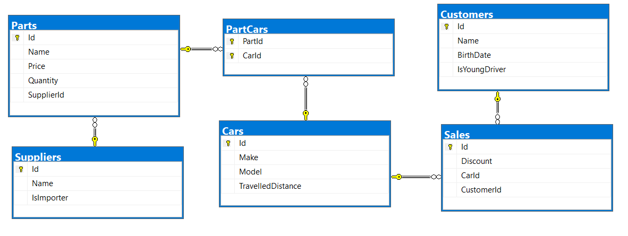

* A **car** has **many parts** and **one part** can be placed **in many cars**
* **One supplier** can supply **many parts** and each **part** can be delivered by **only one supplier**
* In **one sale**, only **one car** can be sold
* **Each sale** has **one customer** and **a customer** can buy **many cars**

## Import Data

Import data from the provided files (**suppliers.xml, parts.xml, cars.xml, customers.xml**).

### Import Suppliers

**NOTE**: You will need method public static string ImportSuppliers(CarDealerContext context, string inputXml) and public StartUp class.

Import the suppliers from the provided file **suppliers.xml**.

Your method should return string with message $"Successfully imported {suppliers.Count}";

### Import Parts

**NOTE**: You will need method public static string ImportParts(CarDealerContext context, string inputXml) and public StartUp class.

Import the parts from the provided file **parts.xml**. If the supplierId doesn’t exists, skip the record.

Your method should return string with message $"Successfully imported {parts.Count}";

### Import Cars

**NOTE**: You will need method public static string ImportCars(CarDealerContext context, string inputXml) and public StartUp class.

Import the cars from the provided file **cars.xml**. Select unique car part ids. If the part id doesn’t exists, skip the part record.

Your method should return string with message $"Successfully imported {cars.Count}";

### Import Customers

**NOTE**: You will need method public static string ImportCustomers(CarDealerContext context, string inputXml) and public StartUp class.

Import the customers from the provided file **customers.xml**.

Your method should return string with message $"Successfully imported {customers.Count}";

### Import Sales

**NOTE**: You will need method public static string ImportSales(CarDealerContext context, string inputXml) and public StartUp class.

Import the sales from the provided file **sales.xml**. If car doesn’t exists, skip whole entity.

Your method should return string with message $"Successfully imported {sales.Count}";

## Query and Export Data

Write the below described queries and **export** the returned data to the specified **format**. Make sure that Entity Framework generates only a **single query** for each task.

### Cars With Distance

**NOTE**: You will need method public static string GetCarsWithDistance(CarDealerContext context) and public StartUp class.

Get all **cars** with distance more than 2,000,000. Order them by make, then by model alphabetically. Take top 10 records.

**Return** the list of suppliers **to XML** in the format provided below.

|  |
| --- |
| **cars.xml** |
| <?xml version="1.0" encoding="utf-8"?>  <cars>  <car>  <make>BMW</make>  <model>1M Coupe</model>  <travelled-distance>39826890</travelled-distance>  </car>  <car>  <make>BMW</make>  <model>E67</model>  <travelled-distance>476830509</travelled-distance>  </car>  <car>  <make>BMW</make>  <model>E88</model>  <travelled-distance>27453411</travelled-distance>  </car>  ...  </cars> |

### Cars from make BMW

**NOTE**: You will need method public static string GetCarsFromMakeBmw(CarDealerContext context) and public StartUp class.

Get all **cars** from make **BMW** and **order them by model alphabetically** and by **travelled distance descending**.

**Return** the list of suppliers **to XML** in the format provided below.

|  |
| --- |
| **ferrari-cars.xml** |
| <cars>  <car id="7" model="1M Coupe" travelled-distance="39826890" />  <car id="16" model="E67" travelled-distance="476830509" />  <car id="5" model="E88" travelled-distance="27453411" />  ...  </cars> |

### Local Suppliers

**NOTE**: You will need method public static string GetLocalSuppliers(CarDealerContext context) and public StartUp class.

Get all **suppliers** that **do not import parts from abroad**. Get their **id**, **name** and **the number of parts they can offer to supply**.

**Return** the list of suppliers **to XML** in the format provided below.

|  |
| --- |
| **local-suppliers.xml** |
| <?xml version="1.0" encoding="utf-8"?>  <suppliers>  <suplier id="2" name="VF Corporation" parts-count="3" />  <suplier id="5" name="Saks Inc" parts-count="2" />  ...  </suppliers> |

### Cars with Their List of Parts

**NOTE**: You will need method public static string GetCarsWithTheirListOfParts(CarDealerContext context) and public StartUp class.

Get all **cars along with their list of parts**. For the **car** get only **make, model** and **travelled distance** and for the **parts** get only **name** and **price** and sort all pars by price (descending). Sort all cars by travelled distance (**descending**) then by model (**ascending**). Select top 5 records.

**Return** the list of suppliers **to XML** in the format provided below.

|  |
| --- |
| **cars-and-parts.xml** |
| <?xml version="1.0" encoding="utf-16"?>  <cars>  <car make="Opel" model="Astra" travelled-distance="516628215">  <parts>  <part name="Master cylinder" price="130.99" />  <part name="Water tank" price="100.99" />  <part name="Front Right Side Inner door handle" price="100.99" />  </parts>  </car>  ...  </cars> |

### Total Sales by Customer

**NOTE**: You will need method public static string GetTotalSalesByCustomer(CarDealerContext context) and public StartUp class.

Get all **customers** that have bought **at least 1 car** and get their **names**, **bought cars** **count** and **total spent money** on cars. **Order** the result list **by total spent money descending**.

**Return** the list of suppliers **to XML** in the format provided below.

|  |
| --- |
| **customers-total-sales.xml** |
| <?xml version="1.0" encoding="utf-16"?>  <customers>  <customer full-name="Taina Achenbach" bought-cars="1" spent-money="5588.17" />  <customer full-name="Johnette Derryberry" bought-cars="1" spent-money="2694.84" />  <customer full-name="Jimmy Grossi" bought-cars="1" spent-money="2366.38" />  ...  </customers> |

### Sales with Applied Discount

**NOTE**: You will need method public static string GetSalesWithAppliedDiscount(CarDealerContext context) and public StartUp class.

Get all **sales** with information about the **car**, **customer** and **price** of the sale **with and without discount**.

**Return** the list of suppliers **to XML** in the format provided below.

|  |
| --- |
| **sales-discounts.xml** |
| <?xml version="1.0" encoding="utf-16"?>  <sales>  <sale>  <car make="BMW" model="M5 F10" travelled-distance="435603343" />  <discount>30.00</discount>  <customer-name>Hipolito Lamoreaux</customer-name>  <price>707.97</price>  <price-with-discount>495.58</price-with-discount>  </ExportSaleDiscount>  ...  </sales> |