Security Protocols
Lab 7: Network Traffic Analysis

  - Author: Antonie Șoga

Write snort rules

Rule 1: Log any ICMP packet
alert icmp any any -> any any (msg:"LAB: ICMP Packet Detected"; sid:1000001; rev:1;)

Rule 2: Log packets with 'malware' keyword (HTTP)
alert tcp any any -> any $HTTP_PORTS (msg:"LAB: Malware keyword detected"; content:"malware", nocase; sid:1000002; rev:1;)

Rule 3: Prevent access to specific website (Target: youtube.com)
reject tcp any any -> any 80 (msg:"LAB: HTTP Block YouTube"; content:"youtube.com", nocase; sid:1000003; rev:1;)

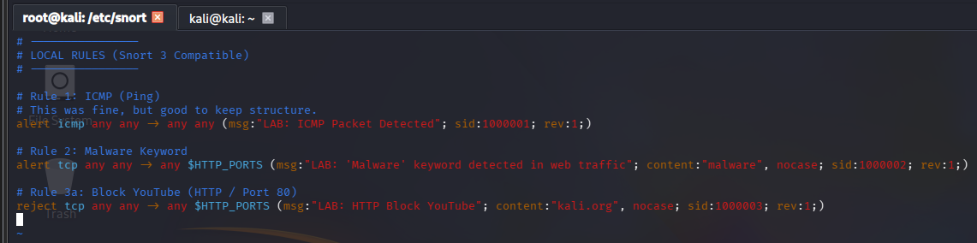

Start Snort
sudo snort -c /etc/snort/snort.lua -R /etc/snort/rules/local.rules -i eth0 -A alert_fast -k none

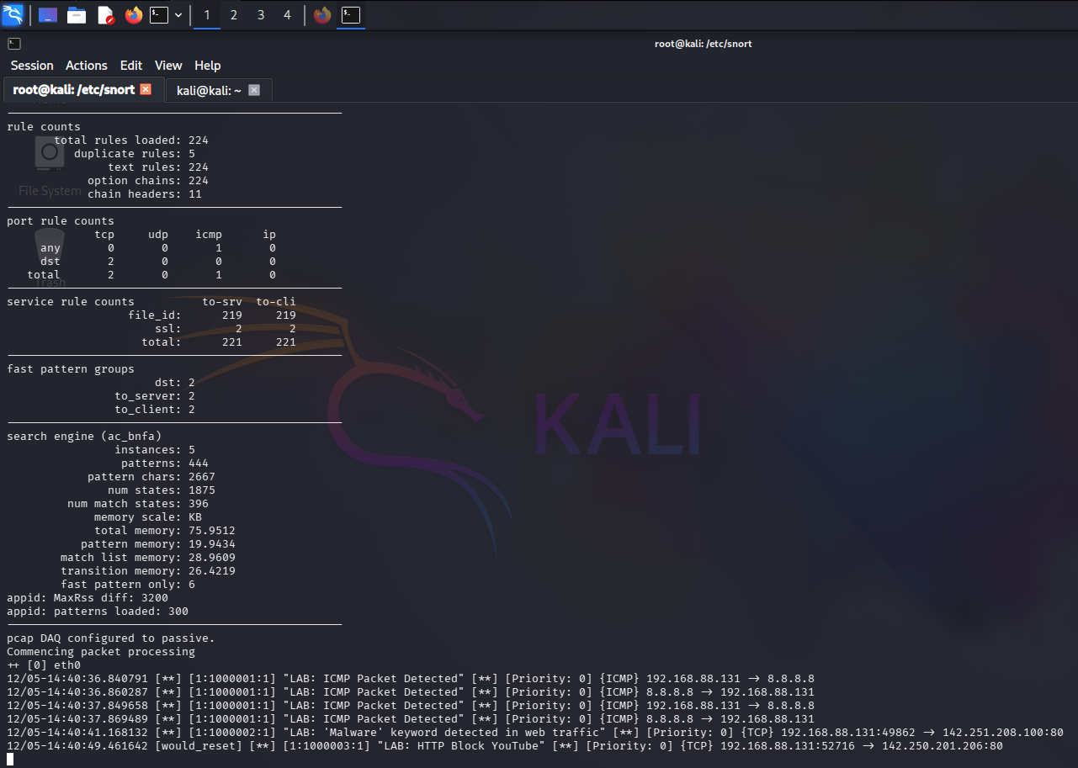

Verify Rules
- Test ICMP:
ping -c 2 8.8.8.8
- Test Malware:
curl "http://www.google.com/search?q=malware" > malware.search
- Test Block:
curl "http://www.youtube.com " > yt.data
