Lab 08: Offline Network Traffic Analysis
  - Author: Antonie Șoga

- [40p] Read the lab text. Install Snort and Wireshark on your physical or virtual machine
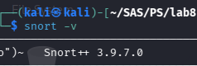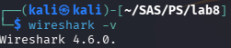

- [30p] Run Wireshark and capture a PCAP file with ICMP traffic. Test the rule you wrote in Lab7 to log this kind of traffic, once you receive an alert for one.
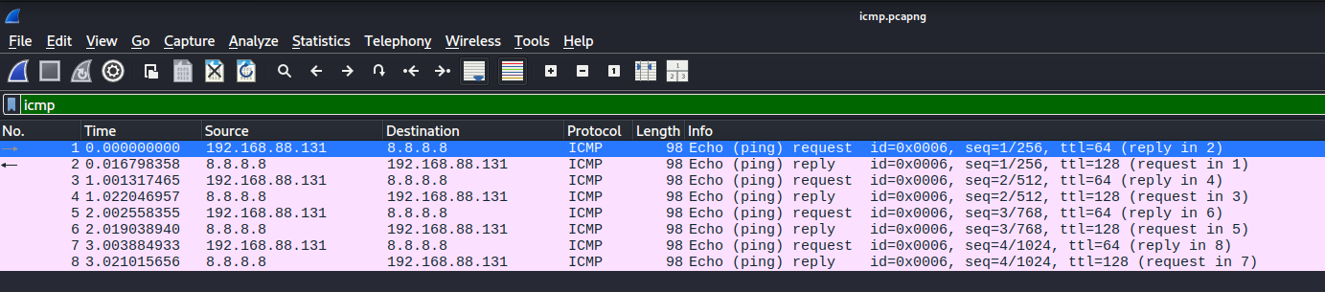
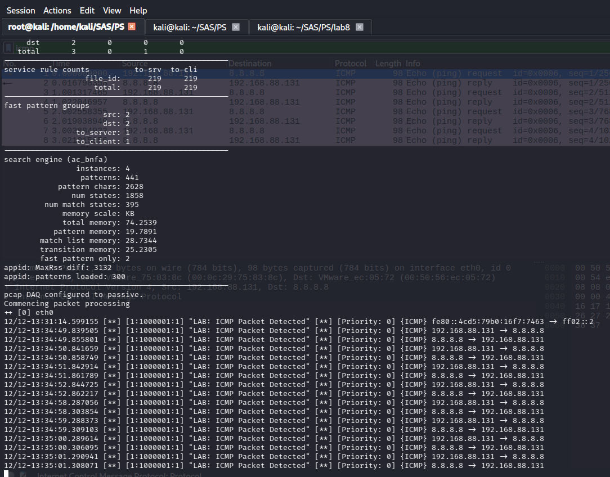
- [30p] Load the Hydra FTP PCAP dump, together with the Snort rules file and run them. What is the output? Include the results in the lab solution and an interpretation of the results.
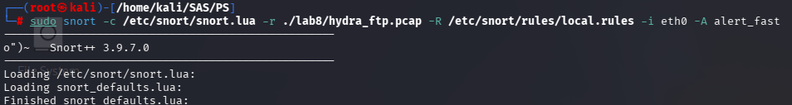
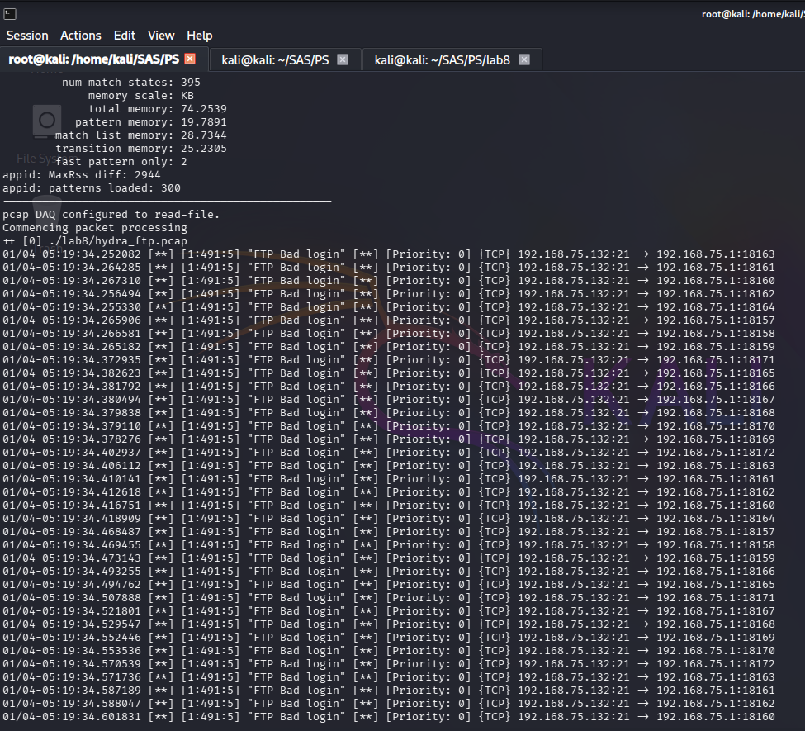
Hydra performs rapid automated login attempts against an FTP server using username/password combinations.
The PCAP shows:
- Many repeated FTP login attempts
- Server returning 530 Login incorrect
- Snort rules detect these failures and classify them as Brute Force Attack
This shows that:
- Snort can detect brute-force attacks offline
- The rules correctly match 530-reply patterns
- Hydra’s attack behavior is easily recognizable in traffic

- [OPTIONAL] Write a rule to detect the Heartbleed attack.
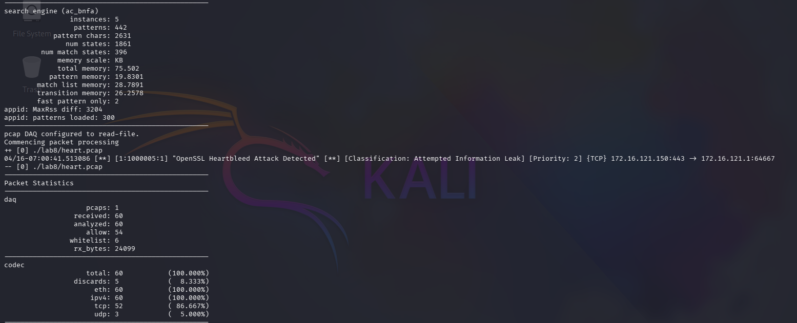

Rules:
