1. Download zip file from . Then unzip it.

*\*\*\* Skip step 2 if python2.7 already installed in your computer. \*\*\**

2. Download and install **Python2.7.14** (For windows / OSX).

Link: <https://www.python.org/downloads/>

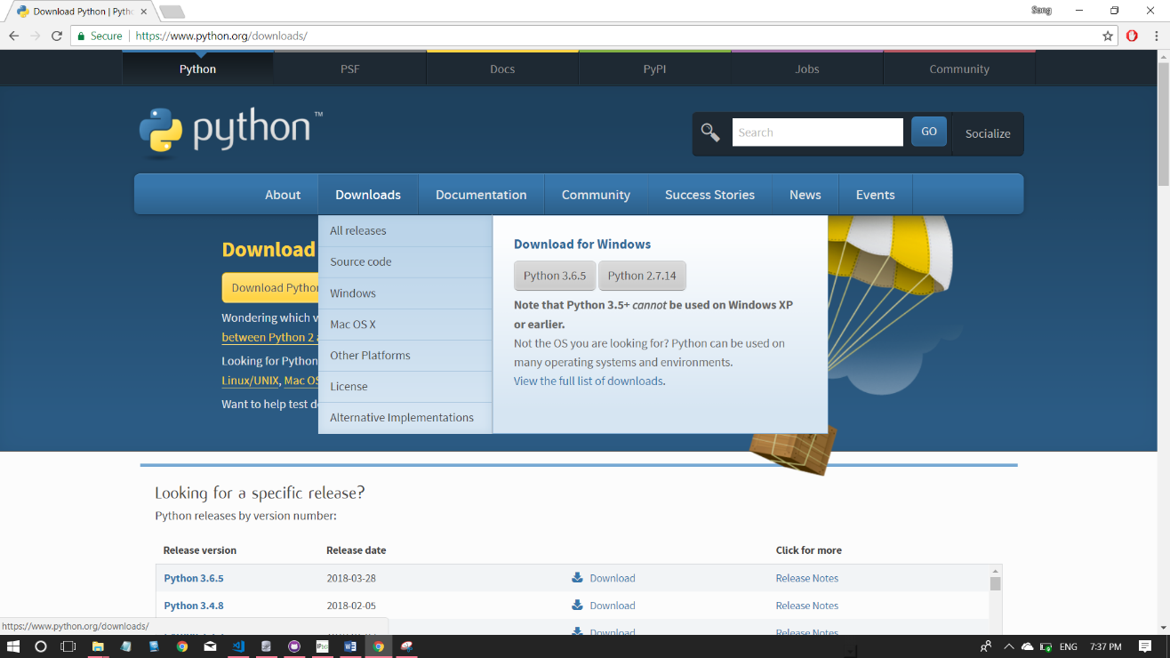

3. Open Image Labelling Software.py. We are done!

4. If you get this error “ImportError: DLL load failed: The specified procedure could not be found.” , can try to run “Pillow-4.0.0.win32-py2.7.exe” in the folder first.