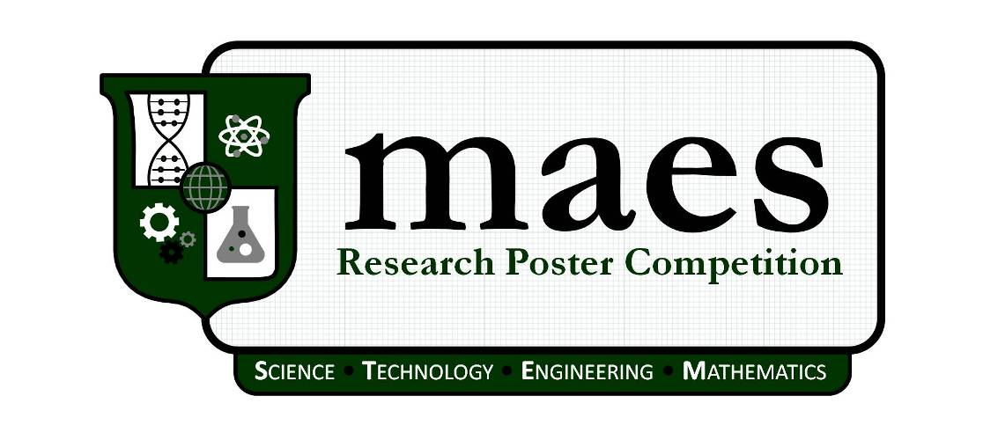
Age  Must be 18 years of age or older by deadline  Enrollment  Must be enrolled as a full time student for the fall semester  - Undergraduate students is twelve (12) credit hours  - Graduate students is nine (9) credit hours  - Students on internship/co-op must show proof of enrollment in the internship/co-op program  - Students at community college must be enrolled in transferable majors to a four-year institution offering a Baccalaureate Degree  GPA  Must have a minimum GPA of 2.0/4.0  Major  Must be pursuing a STEM degree at an accredited U.S. university or community college; medical sciences, nursing, and social sciences are not considered a STEM degree  Membership  Must be a MAES Student Member in good standing and registered in the MAES Membership System  Presence / Attendance  Applicants selected as a finalist must present at the MAES Symposium | 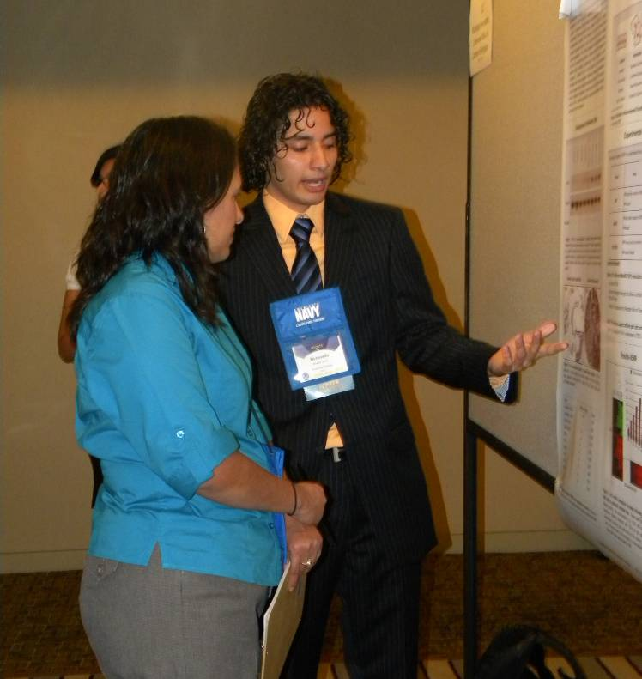
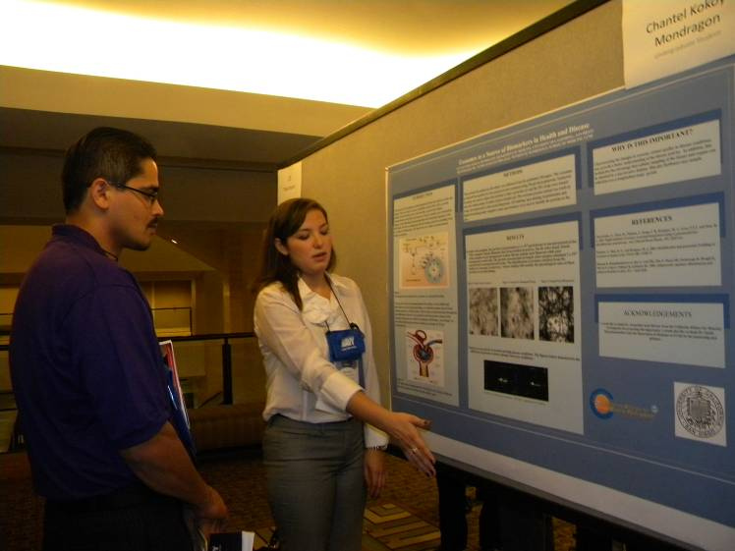 | Electronic Submission Deadline  Extended!  October 2, 2015  posters@mymaes.org

MAES Student Research Poster Competition

Overview
The MAES Research Poster Competition is a forum for students to present cutting-edge research in Science, Technology, Engineering, and Mathematics (STEM). Original works and class projects are encouraged with the abstracts becoming part of the proceedings for the conference. Each poster is judged by a series of technical experts that provide feedback and mentoring to the participants.

How to Submit and Present
- Review guidelines in this package
- Prepare abstract according to guidelines
- Submit completed package by email to posters@mymaes.org by deadline with following components:
  - Application
  - Abstract
  - Résumé
- Presenters should be ready to present at the scheduled time and make travel arrangements accordingly.

Publication Release

By submitting the abstract, the author grants to MAES the rights to publish, reprint, and offer the abstract and poster in whole or in part for reproduction and translation. Posters submitted must be original in content and not identical to prior symposium presentations. MAES may publish presented abstracts from both students and professionals in its official conference proceedings, MAES magazine, and on the MAES website.

It is the author’s responsibility to obtain and transmit to MAES all requisite permissions to release information presented in the abstract and poster.

Abstract Guidelines
Abstract guidelines are contained within this application.

Research Poster Guidelines
Research poster guidelines are as follows:

TITLE | Each presentation should be appropriately titled. The title may span the entire width of the poster presentation.
POSTER PRESENTATION AREA | Presenters should plan on a presentation area of no more than 4' H x 4' W. The posters should be clearly readable from 5 feet away.
HAND-OUT MATERIALS | Presenters may elect to send electronic copies or bring hand-out materials for interested persons viewing their poster.
FORMATTING AND FLOW OF INFORMATION | Presenters should give much thought to the content and arrangement of their posters. The flow of information in the poster layout should be done in a way that easily reveals the process of the task at hand, and salient points are made clearly.  Sections such as Abstract, Introduction, Background, Problem, Hypothesis, Procedure, Results, and Conclusions are suggested. Use pictures that are visually attractive AND add much to the technical content.
ACKNOWLEDGMENTS | Presenters are encouraged to cite the sponsors of their work, such as corporations or government agencies.
REFERENCES | Relevant resources to the work should be recognized.

Section A. Personal Information
1. | Mr. Ms. | Last | Tran |  |  | First | Linh | Middle | To
2. | Address (Number and Street) |  | 209 Alvarado Dr. NE |  |  |  |  | Apt No. | A
 | City | Albuquerque | County |  | Bernalillo | State | NM | Zip Code | 87108
 | Telephone | ( 505 ) 226 - 1286 |  |  | E-mail Address |  | LiTran11794@unm.edu
3. | School Name | University of New Mexico |  |  |  | GPA | 3.86
 | School Type | University/College |  | Community College |  | Classification | Freshman | Sophomore | Junior
 | Major | Computer Science |  |  |  |  | Senior | Master's | Ph.D.
4. | Are you a current MAES Student Member? |  |  |  | Yes No
 | You must be current MAES member in good standing to apply. To become a member you must have a completed profile online at www.mymaes.org and have paid your annual dues.

Section B. Poster Information
1. | Title | The Deterministic Spider: A Benchmark for Evaluating Efficiency of Swarm Search
 | Type |  | Completed Research | Research in Progress
2. | Co-Author |  | G. Matthew Fricke |  | Affiliation | UNM Department of Computer Science
 | Co-Author |  | Joshua P. Hecker |  | Affiliation | UNM Department of Computer Science
 | Co-Author |  | Antonio D. Griego |  | Affiliation | UNM Department of Computer Science
 | Co-Author |  | Melanie E. Moses |  | Affiliation | UNM Department of Computer Science
 | Co-Author |  |  |  | Affiliation
 | Co-Author |  |  |  | Affiliation

Section C. Poster Abstract
Students are required to submit an abstract as part of this application. Abstracts not adhering to the formatting guidelines and/or arrive after the deadline will suffer point reductions in the competition and/or be disqualified. A sample is provided for reference.

Abstracts must adhere to the following formatting requirements:

FORMAT | MS Word 97 or higher  12 pt. Times New Roman.  1 page maximum (including graphics and illustrations).  Single-spaced, single-column.  1-inch margins on all sides
TITLE | 14 pt. Boldface. Centered.
AUTHOR(S) | Include below the title. Centered. Presenter's name listed first in boldface. Use first and middle initials and full last names of each author. Include departmental and/or institutional affiliation with city, state, and zip. If there are multiple departments or institutions, use superscripts to identify author(s) with their respective department and/or institution.
KEYWORDS | List five keywords for abstract indexing.
BODY | Briefly describe the research project objectives, methods, findings, and conclusion. Define all acronyms.
FOOTER | 8 pt. Replicate release clause as shown in sample abstract.

Section D. Submission Requirements and Required Attachments:
The following components must be included in completed application:
APPLICATION: This application with all sections filled out.
ABSTRACT: An abstract for the poster must be attached.
RESUME: A current résumé of the primary author must be attached.
Attachments must be submitted as an electronic file (.doc or .docx or .pdf).
All required documents must be sent via electronic mail to posters@mymaes.org. No materials will be accepted by regular mail. No materials will be accepted if hand delivered. Notification of selection will be sent by October 2, 2015.

Section E. Certification and Disclosure
I affirm that I am a registered and paid MAES Student Member in good standing. I understand that the submission of an abstract constitutes a commitment by the author to present if accepted. I understand that as a submitter I will be the only one presenting. If I am a student, my mentor/advisor cannot present with me during the competition. If I am a college student, I will be/am enrolled full-time (12 hours undergraduate, 9 hours graduate) in an accredited program of study. I understand that under no circumstances will I be able to present my abstract or poster at the MAES Symposium if my abstract is not accepted. I understand that it is my responsibility to contact the MAES to find out the status of my application with regards to my abstract submission. The abstract I have submitted is unclassified and all information submitted is correct to the best of my knowledge. If accepted I promise to present. I also grant MAES full copyright authority to publish my abstract in the conference proceedings and to use my name and publication in any related publications for public relation purposes. All submitted materials become the property of MAES.

I certify that all the information on this form is true, complete, and accurate. I understand that this information may be subject to verification by MAES. I give MAES permission to share contact information for the purpose of recruitment, public relations and possible employment.

Name (Serves as Electronic Signature) |  | Linh Tran |  |  | Date: | 09/ 30 /15

Biochemical Effects of Ultrasound on Mammalian Cells: Improving the Efficacy of Chemotherapeutic Drugs Using Low Frequency Ultrasound

N. L. Balquiedra
Department of Engineering, University of California Santa Barbara, Santa Barbara, CA 93106-5080

Keywords: Ultrasound, Chemotherapy, Cancer, Prostate Cancer, Cancer Treatment

A significant problem in cancer therapy is the compromised quality of life experienced by the patient due to side effects of cancer chemotherapy. An approach toward alleviating this problem is to develop innovative methods of drug targeting and delivery, thus minimizing the toxic effects of the drugs on healthy cells and tissues. One stimulus for drug release that is non-invasive and non-harmful, but that has not been extensively explored, is ultrasound.
Our objective is to see if ultrasound can be used in combination with certain chemotherapeutic drugs to enhance the cyto-toxicity of the drug. It has been shown that, when cells are exposed to ultrasound, survival in heat-shock conditions improves. This suggests that cells can produce heat-shock proteins as a stress response to the ultrasound. Furthermore, this forms the basis of our hypothesis that ultrasound, when applied with heat-shock targeting drugs, could improve the efficacy of the drug.

