Lab Assignment 3: Enhancing HTML Semantics and External Styling
Objective: In this lab, you will improve the structure and styling of an HTML document by replacing non-semantic elements with proper HTML5 semantic tags and moving inline styles to an external CSS file.
Instructions: You are given an HTML file (cha03.html) with some <div> and <span> elements that need to be replaced with semantic HTML5 elements. The expected output of the HTML code is shown in Figure 1.

Tasks to Complete:

1. External Stylesheet:
- Move all inline <style> blocks to a separate CSS file (styles.css).
- Link the styles.css file to your HTML document.

2. Replace Non-Semantic Elements:
- Replace the <div> wrapping the navigation menu with a <nav> element.
- Replace the <div> containing the heading, description, and student image with a <header> or <section>.
- Replace the <div> containing the welcome message with an appropriate semantic element like <article> or <section>.
- Replace the <span> wrapping the copyright notice with a <footer> tag.

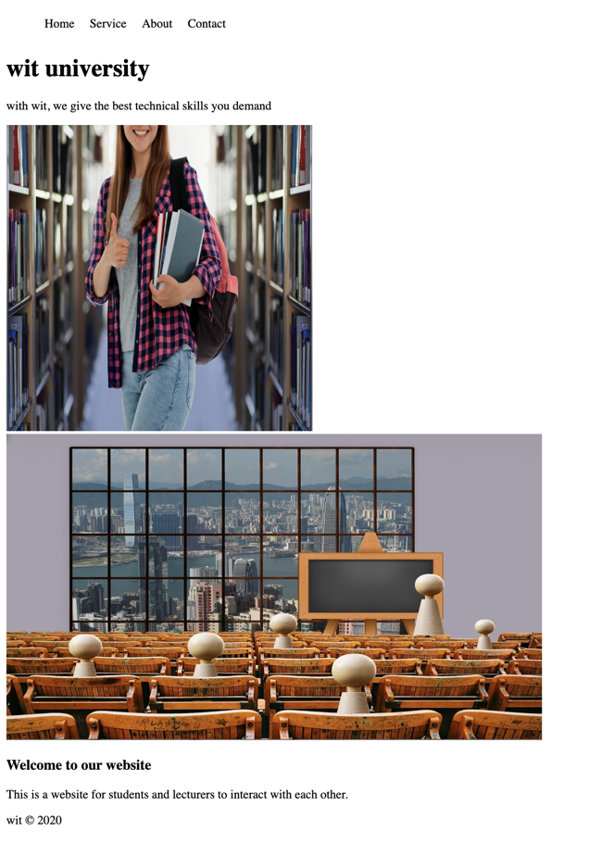
Figure 1: Expected Output

Expected Outcome:
After completing this assignment:
- The HTML structure will use proper semantic tags for better readability and accessibility.
- The CSS styles will be stored in an external file (styles.css).
- The webpage will remain visually identical while following HTML5 best practices.

Assignment: Group Project Showcase

Objective:
Each group will create a Project Showcase Webpage that introduces their team members and presents their project idea using semantic HTML5 elements and CSS styling.

Requirements:
Your webpage must include:
- Navigation Bar (<nav>) - A menu with links to different sections of your webpage.
- Project Overview (<section>) - A detailed explanation of your group's project idea.
- Team Introductions (<article>) - Each team member should have their own <article> with their photo, name, and role.
- Footer (<footer>) - A section containing group details and a copyright notice.
- External CSS File (styles.css) - Styling must be handled separately in an external file.

Bonus Challenge:
- Use CSS Flexbox or Grid for layout styling.
- Add a hover effect to navigation links.
- Ensure the webpage is responsive on different screen sizes.

Submission Guidelines:
📌 Upload your project files to a GitHub repository and share the link.
📌 Alternatively, submit a ZIP file containing your project.
📌 Ensure your code is properly formatted and commented.

Deadline: ()
Good luck, and happy coding! 🚀

