Unity 3D game “Just Dodge”

Team “Nut”

# Introduction

The game “Just Dodge” was developed as a team project for the C# OOP course in Telerik Academy using Game Engine Unity 3D. The following description contains information about the team members, class diagram, brief gameplay details, and the URL of the team repository.

# Team “Nut” members

The team's members have been chosen by the Academy and include the following students (ordered by first name in ascending order):

* Адриан Апостолов ([Adrian.Apostolo](http://telerikacademy.com/Users/Adrian.Apostolov))
* Антонио Филипов ([a.k.filipov](http://telerikacademy.com/Users/a.k.filipov))
* Йордан Гергов ([YordanGergov](http://telerikacademy.com/Users/YordanGergov))
* Марин Маринов ([MarinMarinov](http://telerikacademy.com/Users/MarinMarinov))
* Теодор Ханев ([DareDev1l](http://telerikacademy.com/Users/DareDev1l))

# Class Diagram

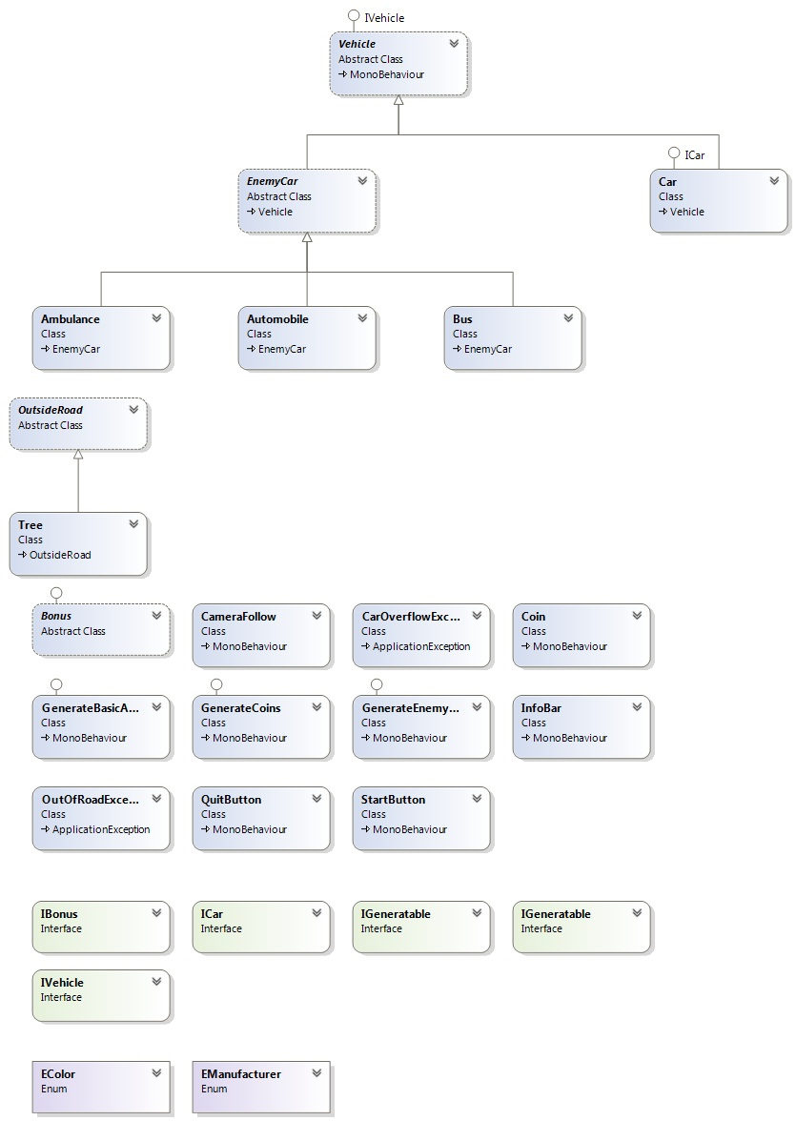

1. Project purpose – The player controls a red car with the directional buttons of the keyboard. Left and right move the car accordingly, the up key accelerates the speed of the car. The player must avoid the enemy cars, generated randomly- automobiles, buses and sometimes even ambulances.

The purpose of the game is to collect coins. The amount collected thus far is displayed in the info bar

But don’t worry, there is a bonus, which will help the player in his objective! It will make him temporally invulnerable.

1. [Git repository](https://github.com/TeamNut-Telerik/JustDodge)