1. Write down the ODE system in symbolic notation for this model.



Figure 1. Wheel brake replacement model

From the figure 1, we can get the following rotational movement equation

$T_{e}-T_{R}=J{\dot{n}}_{s}$ (1)

, where

$T_{e}=C_{E}(φ_{in}-φ_{s})$ (2)

$T_{R}=F_{R}∙d_{R}$ (3)

$F_{s}=\left\{\begin{aligned}Sign\left(n_{s}-dn\right)∙F_{c}+F_{v}∙n_{s} \left|n_{s}\right|≥dn \\ Sign\left(F_{e}\right)∙\min\left(abs\left(F_{e}\right),F_{s}\right) \left|n_{s}\right|<dn\end{aligned}\right.$ (4)

$F_{c}=μ_{b}∙F_{spann}$ (5)

$F_{s}=μ_{s}∙F_{spann}$ (6)

$T_{e}: Torque from spring$

$$T_{s}:Torque from friction$$

$$F_{R}:friction$$

$$F_{c}:coloumb friction$$

$$F_{s}:static friction$$

$$C_{E}:Substitute torsional stiffness$$

$$J:equivalent moment of inertia$$

$$μ_{s}:coefficient of static friction$$

$$μ_{b}:coefficient of sliding friction$$

$$d_{R}:reaming diameter$$

$$F_{spann}:resilience$$

$$φ_{s}:entrance angle$$

$dn:speed range static friction$.

2.

From the equation 1, we can get the following ODE system.

$\left\{\begin{aligned}{\dot{φ}}_{s}=n_{s} \\ {\dot{n}}_{s}=\frac{1}{J}(T_{e}-T_{s})\end{aligned}\right.$ (7)

Let $x_{1}=φ_{s}$ and $x_{2}=n_{s}$.

Then we can get ODE as

$\left\{\begin{aligned}{\dot{x}}_{1}=x_{2} \\ {\dot{x}}_{2}=f(x,t)\end{aligned}\right.$ (8)

, where $x=\left(\begin{matrix}x_{1} \\ x_{2}\end{matrix}\right)$.

From 4th order Runge-Kutta method, we can calculate the states of $φ_{s}$ and $n_{s}$ according to the time as follows.

For n=1 to N

$$K_{1}=hF\left(t,x\right)$$

$$K_{2}=hF\left(t+\frac{h}{2},x+\frac{K_{1}}{2}\right)$$

$$K_{3}=hF(t+\frac{h}{2},x+\frac{K_{2}}{2})$$

$$K_{4}=hF(t+h,x+K_{3})$$

$$y_{n+1}=y_{n}+\frac{1}{6}(K_{1}+{2K}_{2}+{2K}_{3}+K_{4})$$

, where $F\left(t,x\right)=\left\{\begin{aligned}x_{2} \\ f(t,x)\end{aligned}\right.$

1. Answer the following questions:
2. a) What influence do the coefficient of static friction *µ Stick* , the coefficient of sliding friction *µ Slip* and their difference have on the stick-slip effect and thus on brake groaning?

Figure 2,3 and 4 show the solutions with different coefficients of friction.

Figure 2 shows the solution with $μ_{stick}=0.60 and μ_{brief}=0.49$.

And Figure 3 and 4 shows the solutions with $μ_{stick}=0.90 , μ_{brief}=0.49$ and $μ_{stick}=0.60, μ_{brief}=0.19$.

As you can see from the figures, if the difference between coefficient of sliding friction and static friction is increased, the periods of stick-slip effect becomes longer and the step change of disc angle is also increased.

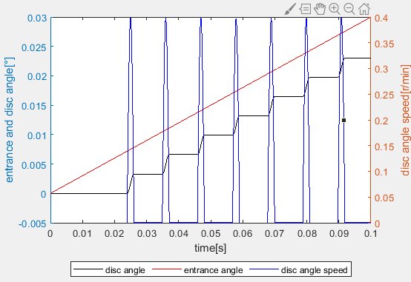

Figure 2. $Solution with μ_{stick}=0.60 and μ_{brief}=0.49$

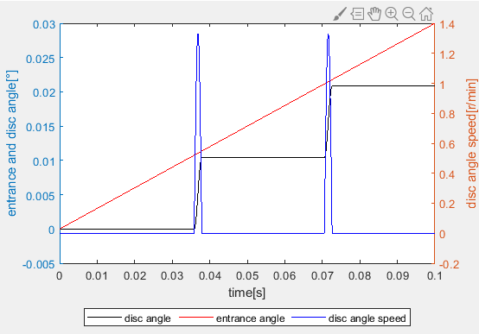

Figure 3. $Solution with μ_{stick}=0.90 and μ_{brief}=0.49$

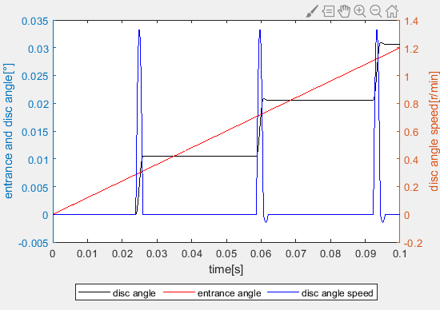

Figure 4. $Solution with μ_{stick}=0.60 and μ_{brief}=0.19$

1. What does the "one-step" procedure mean?

In numerical mathematics, one-step methods are one in addition to multi-step methods large group of calculation methods for solving initial value problems. This Problem in which an ordinary differential equation together with a starting condition is given plays a central role in all natural and engineering sciences Role and always wins, for example in economics and social sciences more important. Initial value problems are used to explain dynamic operations analyze, simulate or predict.

1. For which mathematical problems are the Runge- Kutta methods numerical solution methods?

Runge-kutta methods numerical solution methods are used to solve ODE problems.

Runge-kutta methods can solve both the linear and nonlinear ODE problems and have different orders.

They can also solve simultaneous ODE problems and high-order ODE problems by change them to simultaneous ODE problems.

1. Numerical solution methods such as Euler 's line method or the Runge- Kutta method only provide approximate solutions of differential equations. In which cases are particularly big mistakes made here? What options are there to minimize these errors?

Numerical solution methods provide approximate solutions of differential equations based on derivate.

They can have mistakes in solution especially around the critical point since it can produce numerical errors there.

To solve this problem we should reduce the time step.

However if we reduce the time step then the calculation time will be increased so it is best way to use variable step.

Then we can control the time step to be small around the critical point.

1. Outline (principle representation) one possibility of a mechanical solution for a first-order delay element (PT 1 element) and state its differential equation.