

Assignment 2



A–9–1.

**Consider the transfer function system defined by Equation (9–2), rewritten**

(9-68)

**Derive the following controllable canonical form of the state-space representation for this transfer-function system:**

(9-69)

(9-70)

**Solution.** **Equation (9–68) can be written as**

**which can be modified to**

(9-71)

**Where**

**Let us rewrite this last equation in the following form:**

**From this last equation, the following two equations may be obtained:**

(9-72)

(9-73)

**Now define state variables as follows:**

**(s) = Q(s)**

**X_2(s) =**

**∙**

**∙**

**∙**

**(s) =**

**(s) =**

**Then, clearly,**

**∙**

**∙**

**∙**

**which may be rewritten as**

(9-74)

**Noting that , we can rewrite Equation (9–72) as**

**Or**

(9-75)

**Also, from Equations (9–71) and (9–73), we obtain**

**The inverse Laplace transform of this output equation becomes**

(9-76)

**Combining Equations (9–74) and (9–75) into one vector–matrix differential equation, we obtain Equation (9–69). Equation (9–76) can be rewritten as given by Equation (9–70). Equations (9–69) and (9–70) are said to be in the controllable canonical form. Figure 9–1 shows the block diagram representation of the system defined by Equations (9–69) and (9–70).**

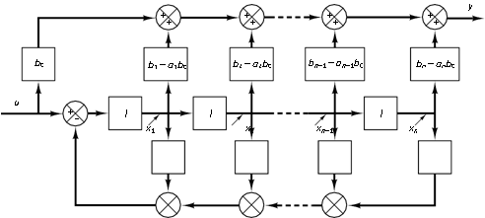

+

+

+

A–9–2.

**Consider the following transfer-function system:**

**Derive the following observable canonical form of the state-space representation for this transfer- function system:**

Solution. **Equation (9–77) can be modified into the following form:**

**By dividing the entire equation by sn and rearranging, we obtain**

**Now define state variables as follows:**

.

.

.

**Then Equation (9–80) can be written as**

**By substituting Equation (9–82) into Equation (9–81) and multiplying both sides of the equations by s, we obtain**

.

.

.

**Taking the inverse Laplace transforms of the preceding n equations and writing them in the reverse order, we get**

.

.

.

**Also, the inverse Laplace transform of Equation (9–82) gives**

**Rewriting the state and output equations in the standard vector-matrix forms gives Equations (9–78) and (9–79). Figure 9–2 shows a block diagram representation of the system defined by Equations (9–78) and (9–79).**

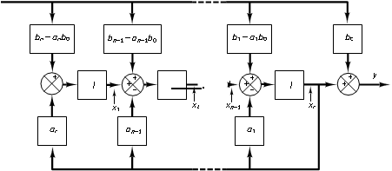

A–9–3.

**Consider the transfer-function system defined by**

**where pi Z pj. Derive the state-space representation of this system in the following diagonal canonical form**:

**Solution.**

**Equation (9–83) may be written as**

**Define the state variables as follows:**

.

.

.

**which may be rewritten as**

.

.

.

**The inverse Laplace transforms of these equations give**

.

.

.

**These n equations make up a state equation.**

**In terms of the state variables X1(s), X2(s), p , Xn(s), Equation (9–86) can be written as**

**The inverse Laplace transform of this last equation is**

**which is the output equation.**

**Equation (9–87) can be put in the vector-matrix equation as given by Equation (9–84). Equation (9–88) can be put in the form of Equation (9–85).**

**Figure 9–3 shows a block diagram representation of the system defined by Equations (9–84) and (9–85).**

**It is noted that if we choose the state variables as**

.

.

.

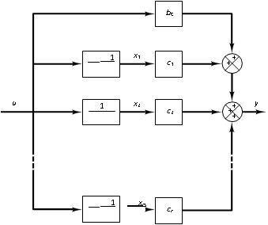

**then we get a slightly different state-space representation. This choice of state variables gives**

**from which we obtain**

.

.

.

**Referring to Equation (9–86), the output equation becomes**

**from which we get**

**Equations (9–89) and (9–90) give the following state-space representation for the system:**

A–9–4.

**Consider the system defined by**

**which may be written as**

**Define**

.

.

.

**Notice that the following relationships exist among X1(s), X2(s), and X3(s):**

**Then, from the preceding definition of the state variables and the preceding relationships, we obtain**

**The inverse Laplace transforms of the preceding n equations give**

.

.

.

**The output equation, Equation (9–92), can be rewritten as**

**The inverse Laplace transform of this output equation is**

**Thus, the state-space representation of the system for the case when the denominator polynomial involves a triple root –p1 can be given as follows:**

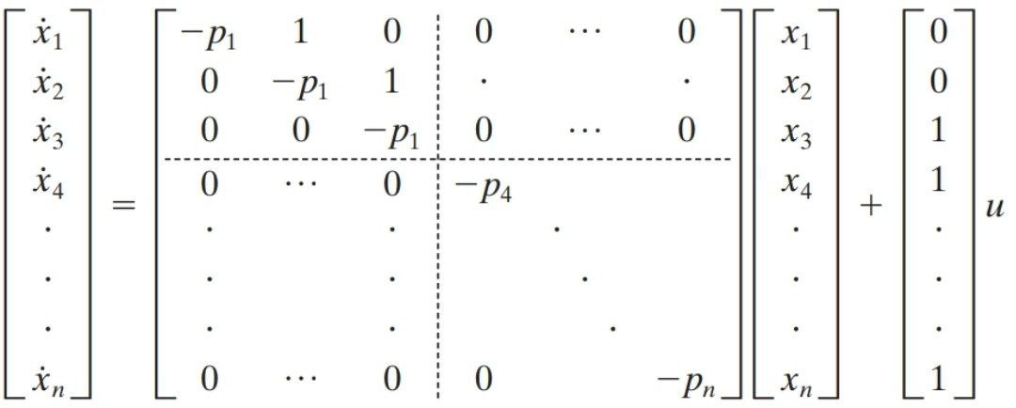

**The state-space representation in the form given by Equations (9–93) and (9–94) is said to be in the Jordan canonical form. Figure 9–4 shows a block diagram representation of the system given by Equations (9–93) and (9–94).**

A–9–5.

**Consider the transfer-function system**

**Obtain a state-space representation of this system with MATLAB.**

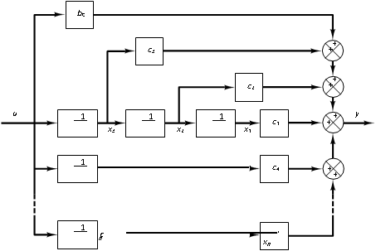

**Solution.**

**MATLAB command**

**[A,B,C,D] = tf2ss(num,den)**

**will produce a state-space representation for the system. See MATLAB Program 9–4.**

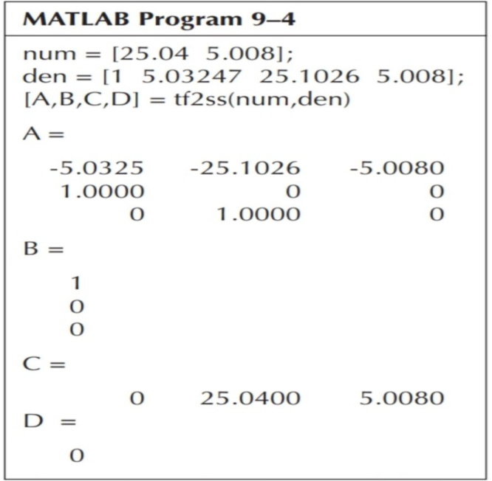

**This is the MATLAB representation of the following state-space equations:**