3.

**(a)** The multiband filter required in the figure is constituted of two parts, ie. Low pass filter and band pass filter.

Low pass filter should have the following properties from the figure.

Ap=1

Fp = 0.2*pi

Fs=0.3*pi

Passband ripple = 0.05

Band pass filter should have the following properties from the figure.

Ap=0.5

Fp1=0.5

Fs1=0.4

Fp2=0.8

Fs2=0.9

Pass band ripple = 0.05

clc; close all; clear;

fp = 0.2; fs = 0.3; Ap = 1; As = -20*log10(0.025);

[N,omegac] = cheb2ord(fp,fs,Ap,As);N, omegac

clc; close all; clear;

fp = 0.2; fs = 0.3; Ap = 1; As = -20*log10(0.025);

[N,omegac] = cheb2ord(fp,fs,Ap,As);N, omegac

N = 5

omegac = 0.3000

[b,a] = cheby2(N,As,omegac);

[sos,G] = tf2sos(b,a);

om = linspace(0,1,501)*pi;

H = freqz(b,a,om);

figure('units','inches','Position',[0,0,6,3]);

Hmag1 = abs(H);

plot(om/pi,Hmag1,'linewidth',1.5); axis([0,1,-40,5]);

xlabel('Normalized Frequency in \pi units'); ylabel('Decibels');

title('Log-Magnitude response');

set(gca,'xtick',[0,0.2,0.3,1],'ytick',[-20,-1,0]);

grid;

set(gca,'xticklabel',{'0','0.2\pi','0.3\pi','\pi'});

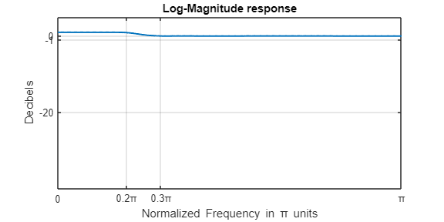

fp = [0.5,0.8]; % Passband edges

fs = [0.4,0.9]; % stopband edges

Ap = -20*log10(0.5); As = -20*log10(0.025); % Attenuations in dB

[N,omegac] = ellipord(fp,fs,Ap,As); % Order of the lowpass elliptic filter

fprintf('Order of the prototype lowpass filter: %g \n',N);

Order of the prototype lowpass filter: 3

[N,omegac] = cheb2ord(fp,fs,Ap,As); % design of bandpass elliptic filter

[b,a] = cheby2(N,As,omegac);

f = linspace(0,1,501); om = f*pi;

H = freqz(b,a,om); % Frequency response

Hmag = abs(H);

plot(f,Hmag,"LineWidth",1); axis([0,1,0,1.1]);

set(gca,'xtick',sort([0,fp,fs,1]),'ytick',(0:0.2:1));

xlabel('Digital frequency \omega/\pi');

ylabel('Magnitude');

title('Magnitude Response: N = 8'); grid;

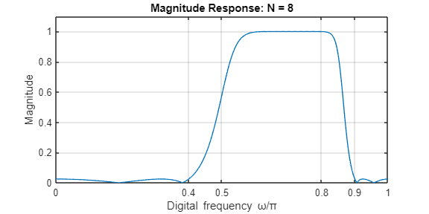

(b)

figure('units', 'inches', 'position', [0,0,8,4]); % Your plot commands here

xlabel('Normalized Digital Frequency in \pi Units');

ylabel( ' Magnitude');

plot(f,Hmag1+Hmag*0.5,"LineWidth",1);

title(' Magnitude Response of a Multiband Filter');

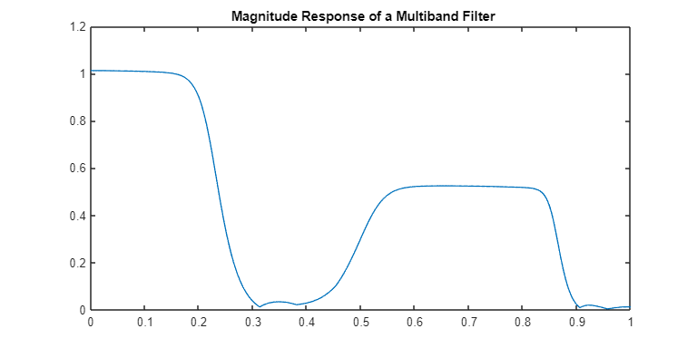

c)

n=5.

For filter, order N is given 5.

d) From the figure, we can see that pass band and stop band specifications are satisfied perfectly.