



False.

For instance, we can think the continuous periodic signal x(t)=sin(2pi\*100\*t).

If we sampled this signal with sampling frequency of 200 $\sqrt{2}$, this signal will not be periodic.

Since we can’t find the non-zero integers m and n, which satisfy m\*100 = n\*200 $\sqrt{2}$.

As we know, we cannot find the integers m and n which satisfy $\frac{m}{n}=\sqrt{2}$ since $\sqrt{2}$ is an irrational number.



True.

For example, $z^{-1}$ is an all pass filter and it is FIR.

As we can see, $z^{-1}$ is a unit delay and is clearly FIR.

It is an all pass filter since it has a pole at the origin and a zero at ∞.

So we can know all pass filter can be FIR.



False. Increasing the window length cannot upgrade the stopband ripples since stop band ripples are related to the type of window function not a length of it.



True. For example, we can think analog IIR filter $\frac{1}{1+\frac{T}{2}s}$ which can be converted to digital IIR filter using bilinear transform as $\frac{1}{1+\frac{T}{2}\frac{2}{T}\frac{z-1}{1+z} }=\frac{1}{2}(1+z^{-1})$ which saves linear phase.



False.

$${y\left(n\right)=\left(-1\right)}^{n}\left(x_{1}\left(n\right)+x_{2}\left(n\right)\right)={\left(-1\right)}^{n}x_{1}\left(n\right)+{\left(-1\right)}^{n}x_{2}\left(n\right)=y_{1}\left(n\right)+y_{2}(n)$$

So we can see that, from the superposition principle, this system is linear system.

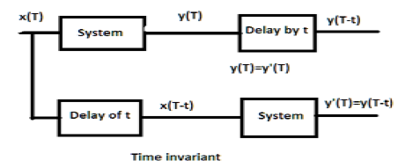

$$y={\left(-1\right)}^{n-k}x(n-k)$$

$$y^{'}={\left(-1\right)}^{n}x(n-k)$$

If k is odd number, $y=-y'$. So this system is not time-invariant.



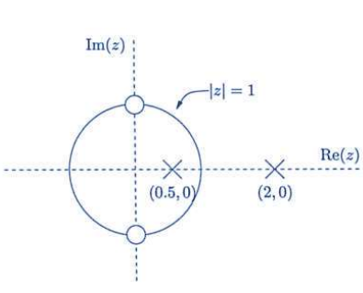

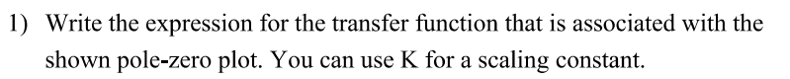



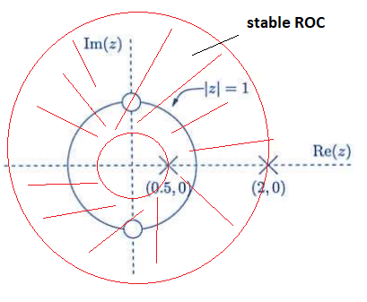

Yes and h(n) would be double sided to be stable.

As we can see from the plot, it has two poles 2, and 0.5.

So there exist 3 ROCs in this system.

First is the inner of the circle with the radius of 0.5 and h(n) is left sided here.

Second is the ring of the between the circles with the radius of 0.5 and 2.

Here, h(n) is double sided.

Third part is the outside of circle with the radius of 2 and h(n) is right sided here.

ROC should include unit circle to be stable. We can see that second part i.e. ring between circles of radius 0.5 and 2 corresponds to a stable system since it has only unit circle.



No. As we can see from 2), roc is the ring and the sequence would be double sided to be stable.

Since stable roc corresponds to the double-sided sequence. However it should be right-sided to be casual. So this system can’t be both stable and casual.

Casual ROC here is the outside of the circle with radius of 2.





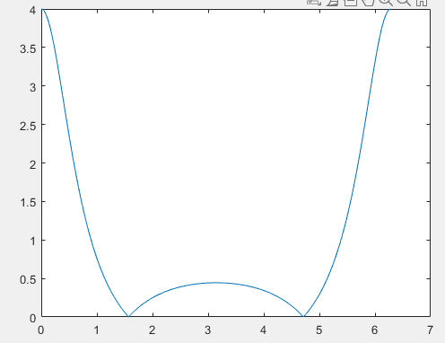



This is a low pass filter. As we can see from the frequency-magnitude response given in 5), given system passes the signals around 0 and 2\*pi. This is a low pass in digital filter.



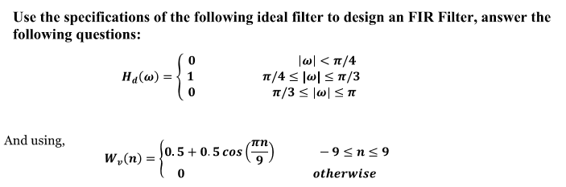



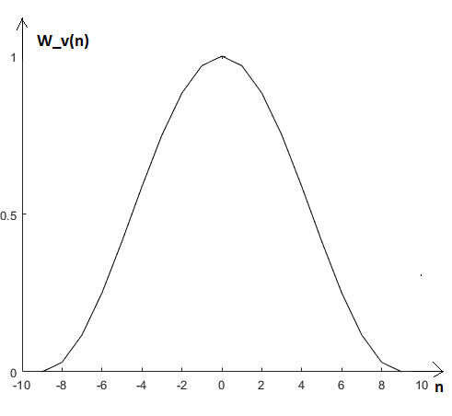

As we can see, $W_{v}(n)$ is the window function to reduce the ripple since of rectangular window.

So we can see that the filter response to the frequency will be similar as the sampling function.

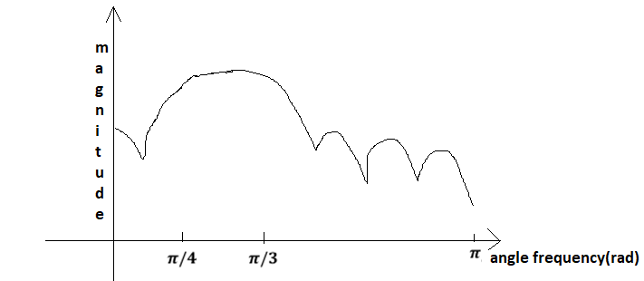

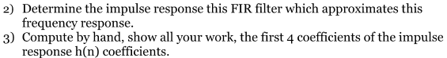



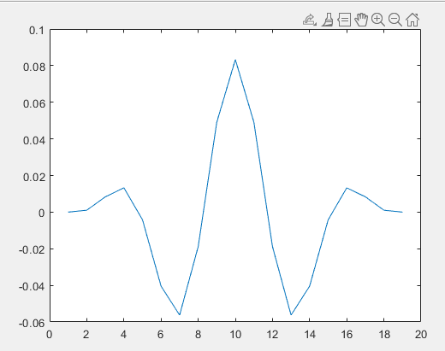

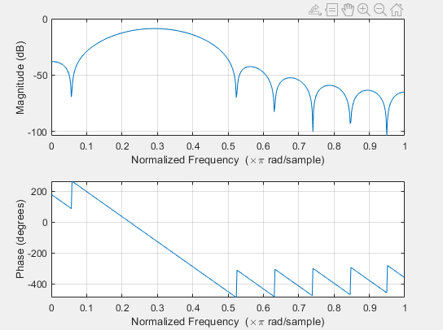



As we can see from the figures in 4), the filter is designed as a band pass filter which has pass band of $(\frac{pi}{4},\frac{pi}{3})$.

We can see that there is no ripple for pass band however transition band is wide and stop band ripple is a bit high.

It is expected that, pass band is a bit wider than we set at first and filter cannot reduce the signal at the frequency around the boundary of pass band.

However stop band attenuation is about 34db, so it has a good performance to reduce the signal for stop band signal.



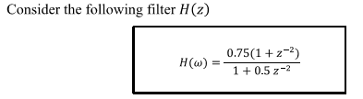





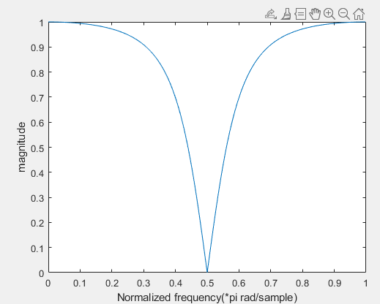

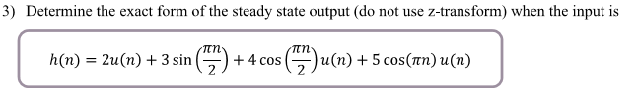

The steady-state output has the same frequency as the input signal. We can calculate the steady state output using frequency response of system.

Phase response to frequency is calculated as following.

$$∠H\left(e^{jω}\right)=\arctan{\frac{sin2ω}{1+cos2ω}}-\arctan\left(\frac{0.5sin2ω}{1+0.5cos2ω}\right)$$

Input $h(n)$ contains 3 frequency elements.

Element $u(n)$ has zero frequency. So we can calculate the steady state response for it as following.



$$y_{1}=u\left(n\right)*H\left(e^{j0}\right)=u\left(n\right)*\frac{0.75\left(1+e^{-2j0}\right)}{1+0.5e^{-2j0}}=u\left(n\right)*(0.75*\frac{1+1}{1+0.5})=u(n)$$

$$y_{2}=\sin\left(\frac{nπ}{2}\right)*H\left(e^{j\frac{π}{2} }\right)=\sin\left(\frac{nπ}{2}\right)*\frac{0.75\left(1+e^{-2j\frac{π}{2}}\right)}{1+0.5e^{-2j\frac{π}{2}}}=\sin\left(\frac{nπ}{2}\right)*0.75*\frac{1-1}{1-0.5}=0$$

$$y_{3}=\cos\left(\frac{nπ}{2}\right)*H\left(e^{j\frac{π}{2} }\right)=0$$

$$y_{4}=\cos\left(πn\right)u\left(n\right)H\left(e^{jπ }\right)=\cos\left(πn\right)u\left(n\right)\frac{0.75\left(1+e^{-2jπ}\right)}{1+0.5e^{-2jπ}}=\cos\left(πn\right)u\left(n\right)(\frac{0.75(1+1)}{1+0.5})=cos⁡(πn)u(n)$$

$$y=2y_{1}+3y_{2}+4y_{3}+5y_{4}=2u\left(n\right)+5\cos\left(πn\right)u(n)$$

As we can see from the result in 3), signals which have zero value in magnitude frequency response are removed and other signals are passed.

The output for input signal which has frequency $ω$ is calculated as the product of input signal and frequency response for it.

We can analysis the effect of filter using frequency response.

Especially, magnitude response shows the pass band range and stop band range of filter.

We can see that signals with the frequencies which have small magnitude response will be filtered out and those which have frequencies large magnitude response will be passed in the filter from 3).