Nonlinear system model for this system is given by as follows.





















Matlab code for Environment

function [stateout, meas] = Envrionment(state0, wk, m)

% Initialization

deltat = 0.1;

g=9.836;

persistent state; %variable to save states of environment

if isempty(state)

state = state0; %initialize the state using state0 from input.

end

h_ = 2;

bet_ = 150;

rho0_ = 1.225;

kp_ = 9200;

%

ry = state(2);

vy = state(4);

deltah = state(5);

deltabet = state(6);

deltarho = state(7);

deltakp = state(8);

%

h=h_+deltah;

bet=bet_+deltabet;

rho0=rho0_+deltarho;

kp=kp_+deltakp;

%

alpha = rho0*exp(-ry/kp)*vy*vy/(2*m*bet);

% calculate the state transverse matrix. This is calculated using equation above and also used in EKF.

phi = [1 0 deltat 0 0 0 0 0; 0 1 0 deltat 0 0 0 0; 0 0 1 0 0 0 0 0; 0 -alpha*deltat/kp 0 1+rho0*exp(-ry/kp)*vy/(m*bet)*deltat 0 -alpha/bet*deltat alpha/rho0*deltat ry*alpha*deltat/(kp*kp);

0 0 0 0 1 0 0 0; 0 0 0 0 0 1 0 0; 0 0 0 0 0 0 1 0; 0 0 0 0 0 0 0 1];

u = [0; -g*deltat*deltat/2; 0; -g*deltat*(1+rho0*exp(-ry/kp)*vy/(2*m*bet)); 0; 0; 0; 0];

%update state and mix with process noise wk which is given by input.You can set the covariance for process noise in the Simulink.

state = phi*state + u + wk;

% Measurement matrix to be used to output measurements.

H = [1 0 0 0 0 0 0 0; 0 1 0 0 0 0 0 0];

b = [0; -h];

%calculate the measurements.

y = H*state + b;

meas = y;

%output the updated state

stateout = state;

**Matlab code for EKF**

function [residual,xhatPreOut, xhatOut] = EXTKALMAN(meas)

persistent P;

persistent xhat

if isempty(P)

xhat = [0; 1000; 0; 0; 0; 0; 0; 0];

P = zeros(8);

P(2)=10;

P(4)=1;

end

g=9.836;

delta_t=0.5;

m = 1;

h_ = 2;

bet_ = 150;

rho0_ = 1.225;

kp_ = 9200;

%get the states of last step to calculate the state transverse matrix.

ry = xhat(2);

vy = xhat(4);

deltah = xhat(5);

deltabet = xhat(6);

deltarho = xhat(7);

deltakp = xhat(8);

%

h=h_+deltah;

bet=bet_+deltabet;

rho0=rho0_+deltarho;

kp=kp_+deltakp;

%

alpha = rho0*exp(-ry/kp)*vy*vy/(2*m*bet);

%

% 1. Compute Phi, Q, and R

% calculate phi from the equation above. It is same used in environment.

Phi = [1 0 delta_t 0 0 0 0 0; 0 1 0 delta_t 0 0 0 0; 0 0 1 0 0 0 0 0; 0 -alpha*delta_t/kp 0 1+rho0*exp(-ry/kp)*vy/(m*bet)*delta_t 0 -alpha/bet*delta_t alpha/rho0*delta_t ry*alpha*delta_t/(kp*kp);

0 0 0 0 1 0 0 0; 0 0 0 0 0 1 0 0; 0 0 0 0 0 0 1 0; 0 0 0 0 0 0 0 1];

Q = diag([0 10 0 1 0 0 0 0 ]);

R = diag([1 4]);

% 2. Propagate the covariance matrix:



P = Phi*P*Phi' + Q;

% 3. Propagate the track estimate::

u = [0; -g*delta_t*delta_t/2; 0; -g*delta_t*(1+rho0*exp(-ry/kp)*vy/(2*m*bet)); 0; 0; 0; 0];

xhat = Phi*xhat+u;

%output the prio estimates.

xhatPreOut = xhat;

% 4 a). Compute observation estimates:

H = [1 0 0 0 0 0 0 0; 0 1 0 0 0 0 0 0];

b = [0; -h];



yhat = H*xhat + b;

% 4 c). Compute residual (Estimation Error)



residual = meas - yhat;

% 5. Compute Kalman Gain:



W = P*H'*inv(H*P*H'+ R);

%

% % 6. Update post estimates



xhat = xhat + W*residual;

%

% % 7. Update Covariance Matrix



P = (eye(8)-W*H)*P*(eye(8)-W*H)' + W*R*W';

%output the post estimates.

xhatOut = xhat;

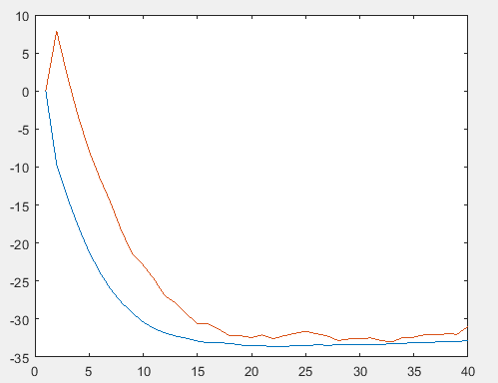

Fig1. ± standard deviation for $v_{y}$

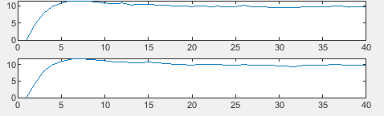

Fig2.covariance for post and prio estimates for $v_{y}$

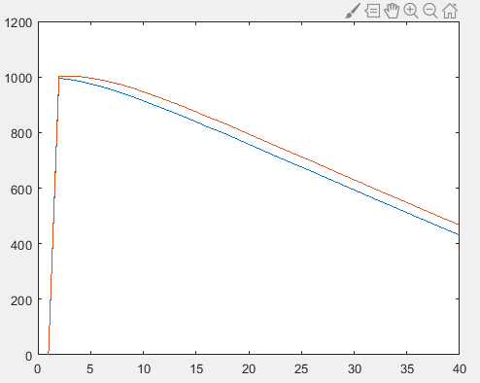

Fig3 ± standard deviation for $r_{y}$

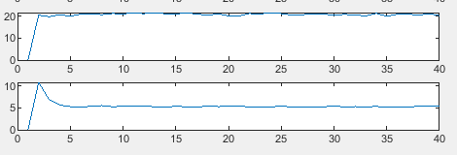

Fig4.covariance for post and prio estimates for $r_{y}$