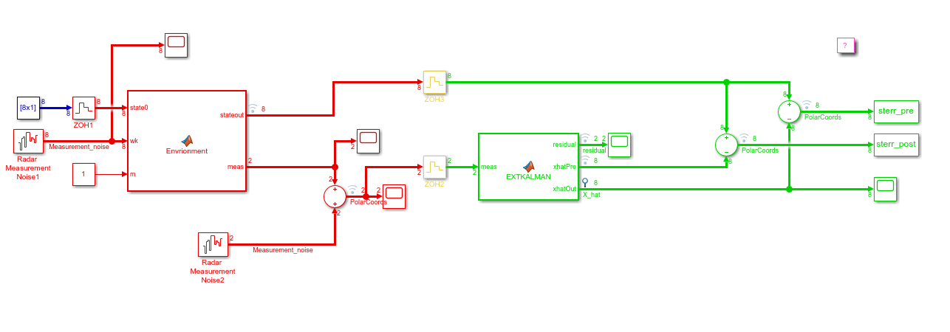

Figure 1.Simulink for ekf

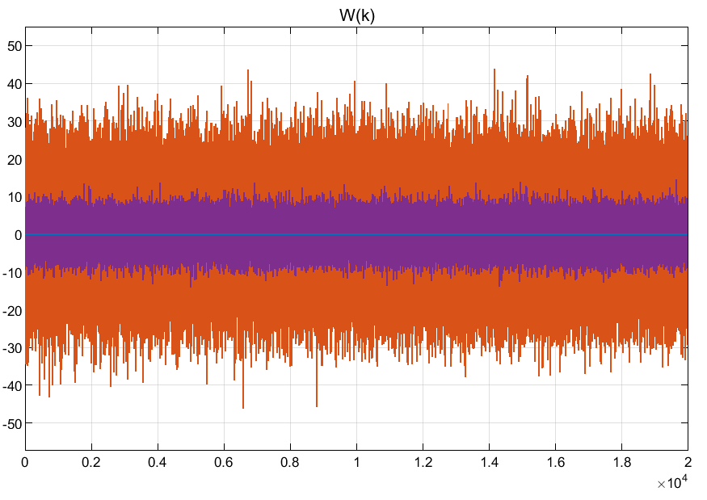

Fig 2.Process noise

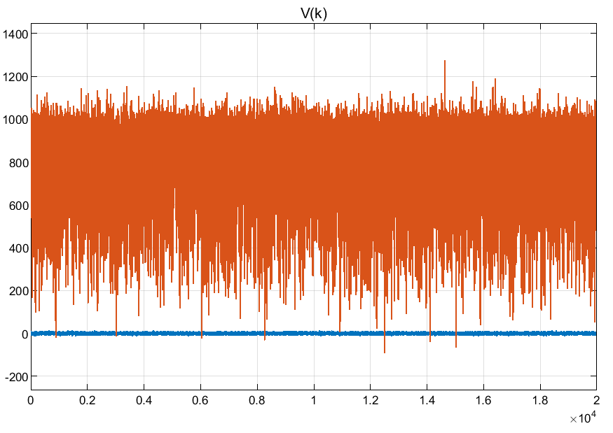

Fig3. Measurement noise

%initialize params

simlen = 40; %simulation length

stderr_pre = zeros(8,simlen,1000); %state errors for pre state estimations

stderr_post = zeros(8,simlen,1000); %state errors for post state estimations

std_pre = zeros(8,simlen); %standard deviation for state errors for pre state estimations

std_post = zeros(8,simlen); %standard deviation for state errors for post state estimations

mean_pre = zeros(8,simlen); %mean for state errors for pre state estimations

mean_post = zeros(8,simlen); %mean for state errors for post state estimations

for i=1:8

for j=2:simlen

for k =1:1000

stderr_pre(i,j,k)=sterr_pre(j+simlen*(k-1),i); %get stderr_pre from simulation result.

stderr_post(i,j,k)=sterr_post(j+simlen*(k-1),i); %get stderr_post from simulation result.

end

std_pre(i,j)=std(stderr_pre(i,j,:)); %get std for pre

std_post(i,j)=std(stderr_post(i,j,:)); %get std for post

mean_pre(i,j)=mean(stderr_pre(i,j,:)); %get mean for pre

mean_post(i,j)=mean(stderr_post(i,j,:)); %get mean for post

end

end

%figures for standard deviation and mean values at each time step for pre and post state estimations.

for i=1:8

figure(i);

subplot(4,1,1);

plot(mean_pre(i,:));

subplot(4,1,2);

plot(mean_post(i,:));

subplot(4,1,3);

plot(std_pre(i,:));

subplot(4,1,4);

plot(std_post(i,:));

end

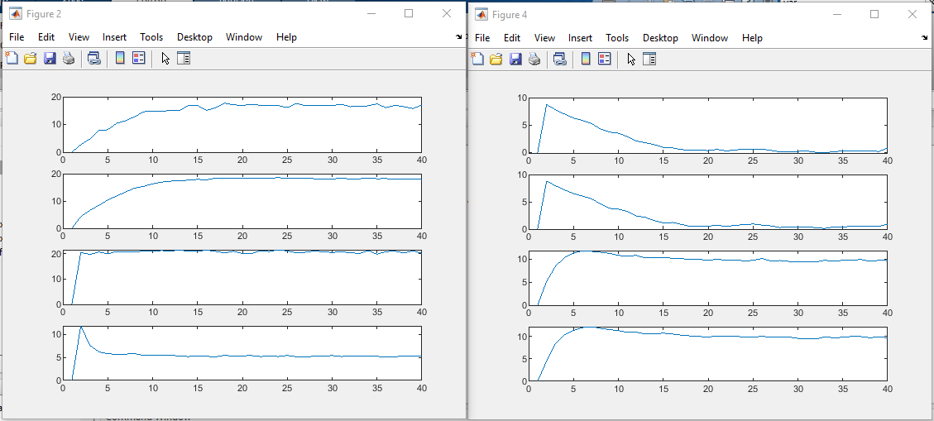

Fig 4. Mean and standard deviation for pre and post estimations.

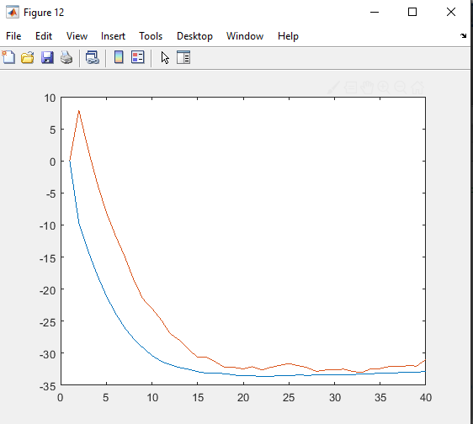

Figure 5.co-plot for standard deviation of vy

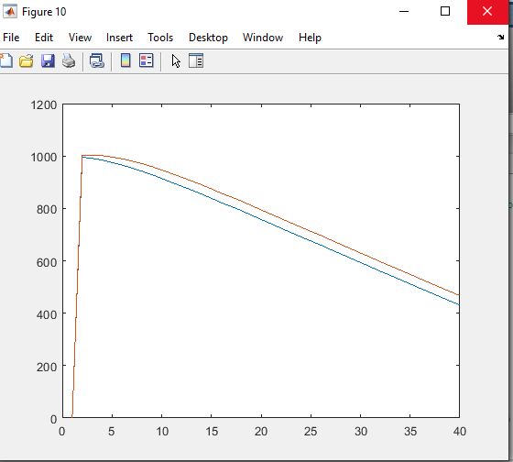

Figure 6.co-plot for standard deviation of ry