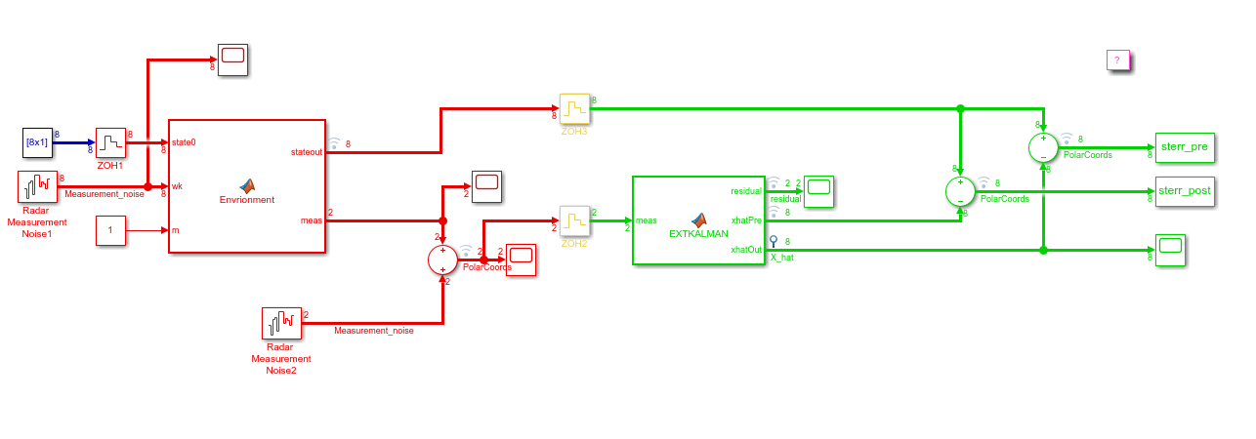

Figure 1.Simulink for ekf

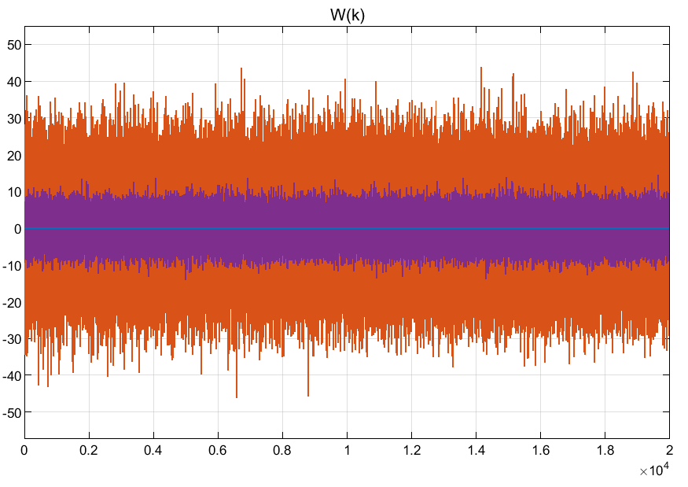

Fig 2.Process noise

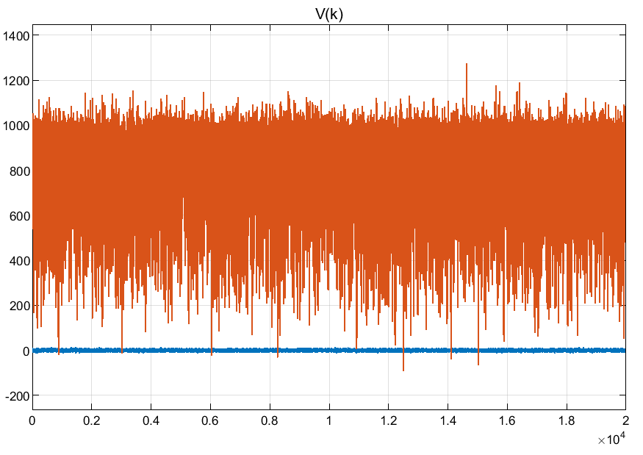

Fig3. Measurement noise

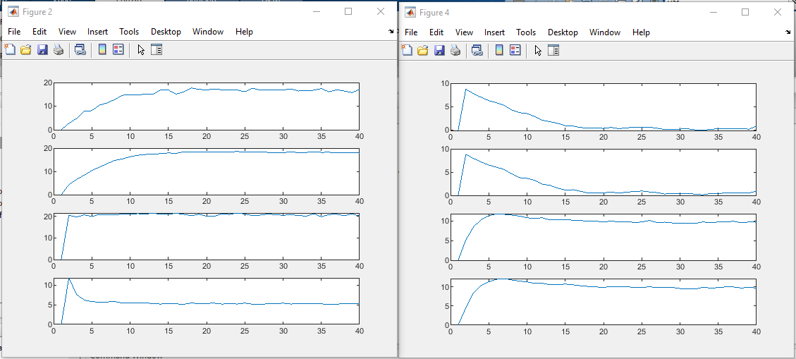

Fig 4. Mean and standard deviation for pre and post estimations.

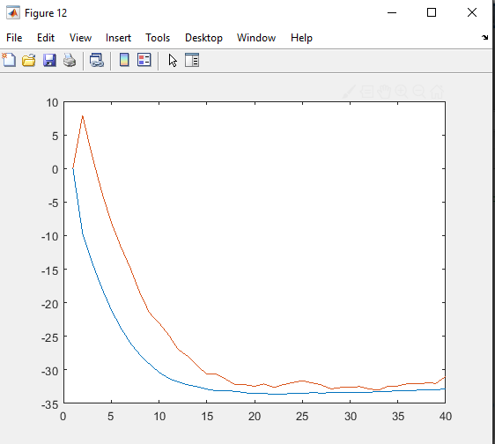

Figure 5.co-plot for standard deviation of vy

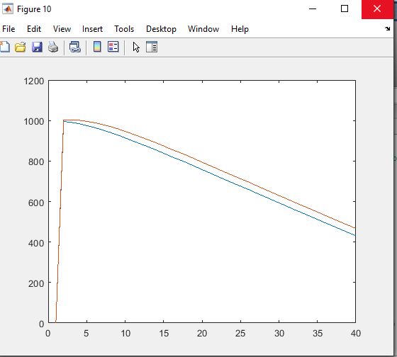

Figure 6.co-plot for standard deviation of ry