2.

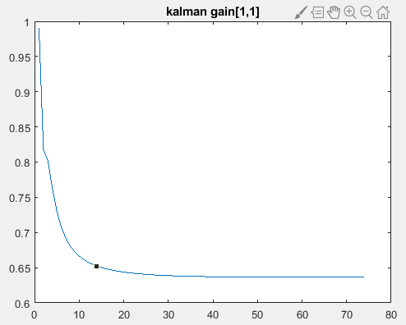

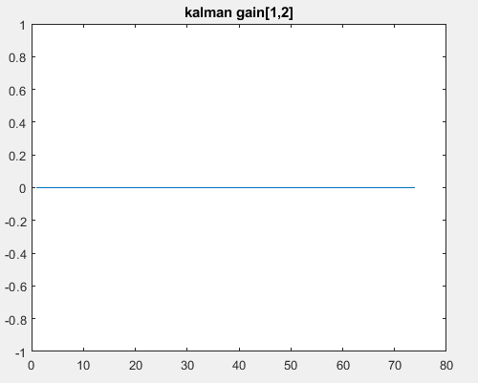

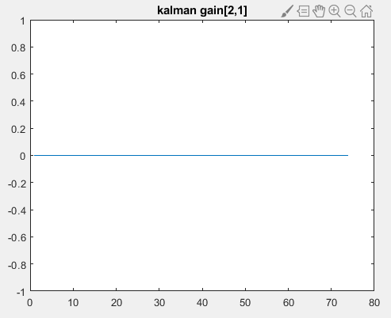

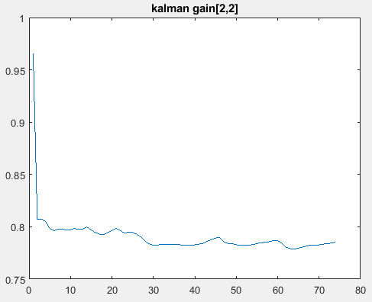

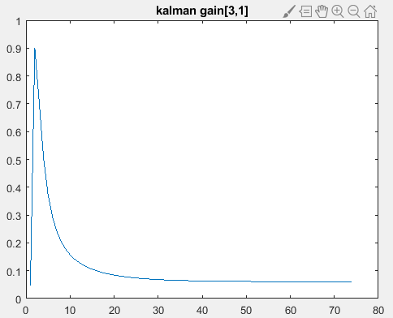

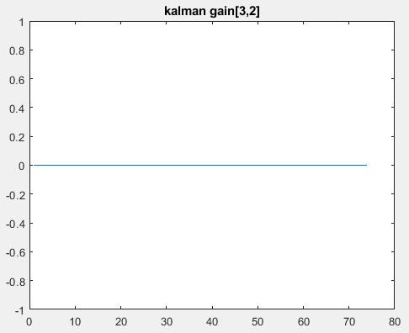

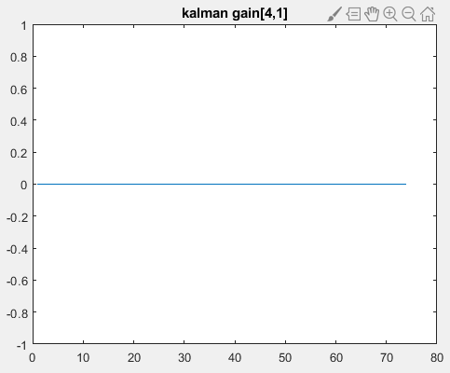

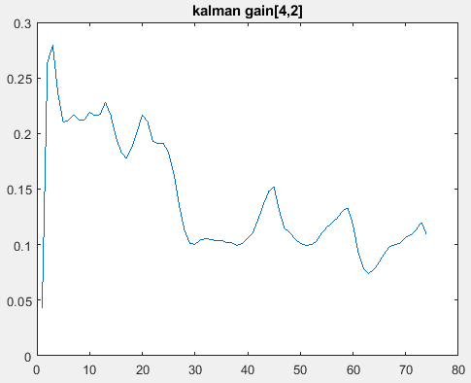

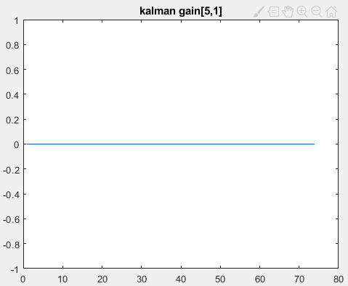

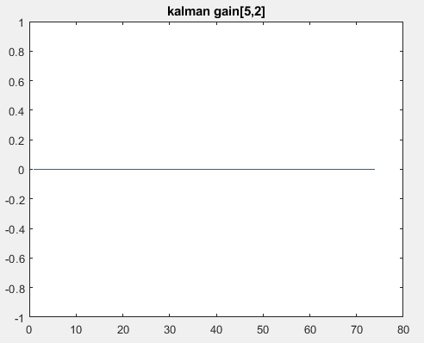

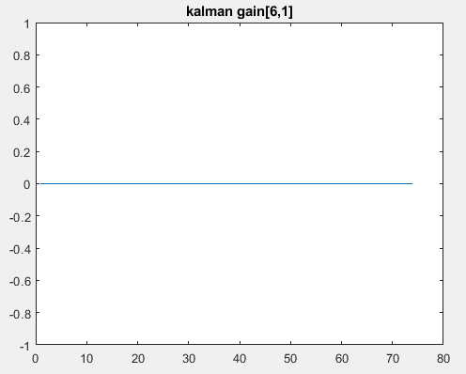

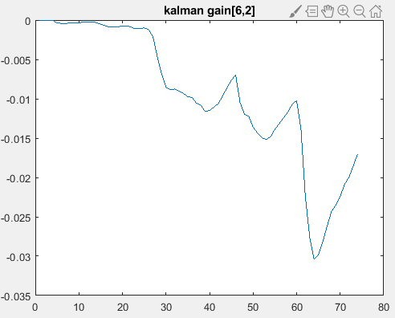

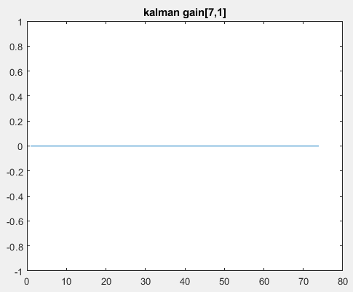

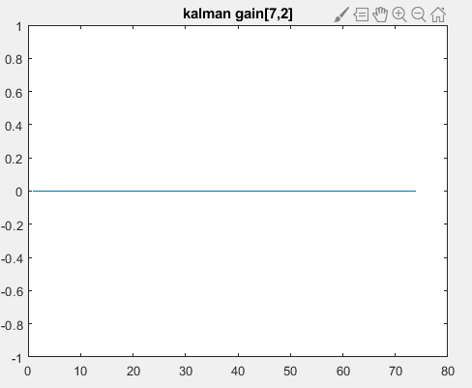

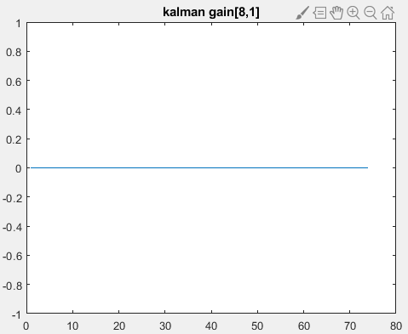

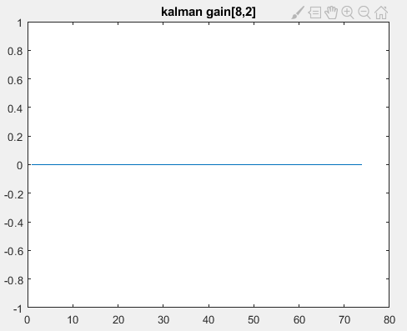

3.

|  |  |  |
| --- | --- | --- |
|  | Group | Name |
| Initial Covariance | 1 | Uncertainty for $Position$ |
| 2 | Uncertainty for *Velocity* |
| 3 | Uncertainty for coefficients of aero drag magnitude |
| Process Noise | 4 | Position process noise |
| 5 | Velocity process noise |
| 6 | Coefficients process noise |
| Measurement Noise | 7 | Velocity measure noise |

4.

|  |  |  |  |  |  |  |  |  |
| --- | --- | --- | --- | --- | --- | --- | --- | --- |
| Error Group | Position | | Velocity | | Drag Coefficients | | | |
| $$r_{x}$$ | $$r_{y}$$ | $$v_{x}$$ | $$v_{y}$$ | $$Δh$$ | $$Δβ$$ | $$Δρ_{0}$$ | $$Δk_{p}$$ |
| 1 | 9.04 | 20.94 | 7.85 | 13.4 | 0 | 0 | 0 | 0 |
| 2 | 10.24 | 20.16 | 9.85 | 11.5 | 0 | 0 | 0 | 0 |
| 3 | 10.24 | 20.7 | 9.85 | 12.2 | 0.1 | 7.35 | 0.1 | 7.35 |
| 4 | 11.8 | 21.8 | 11.2 | 12.65 | 0.1 | 7.5 | 0 | 0 |
| 5 | 31.9 | 12.32 | 20.25 | 23.09 | 0.1 | 7.5 | 0 | 0 |
| 6 | 3.36 | 25.7 | 7.24 | 12.99 | 20.4 | 53.85 | 0 | 0 |
| 7 | 5.61 | 12.4 | 10.6 | 15.33 | 0.1 | 13.21 | 0 | 0 |

5.

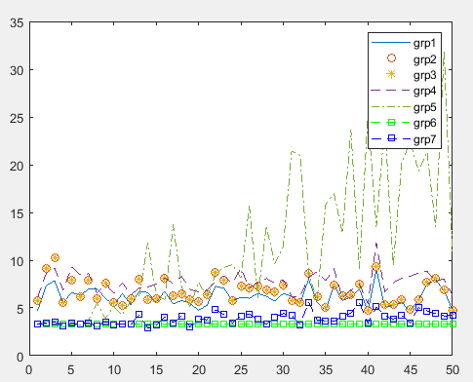

Fig1.Error Sensitivity for $r_{x}$

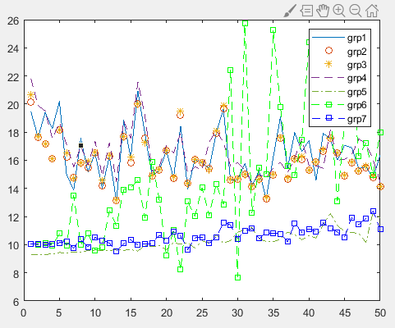

Fig2. Error Sensitivity for $r_{y}$

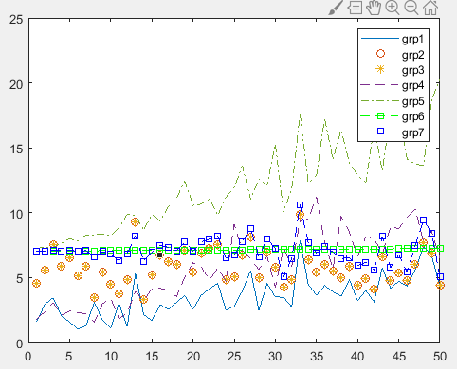

Fig3. Error Sensitivity for $v_{x}$

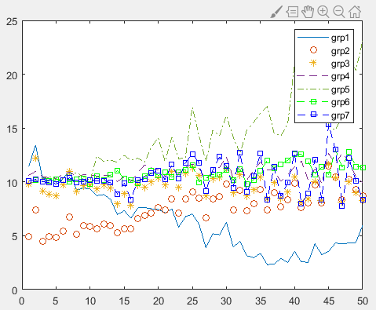

Fig4. Error Sensitivity for $v_{y}$

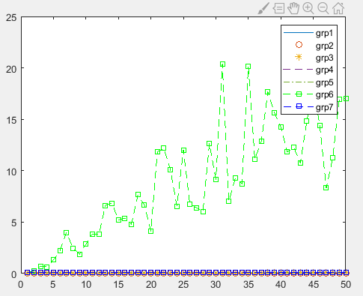

Fig5. Error Sensitivity for $Δh$

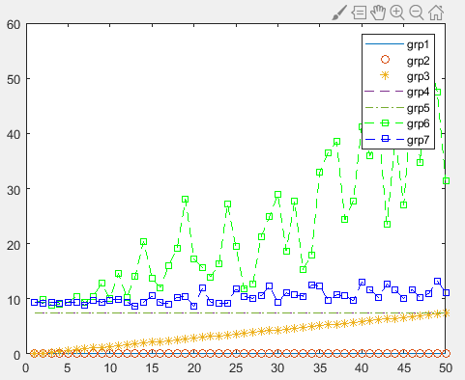

Fig6. Error Sensitivity for $Δβ$

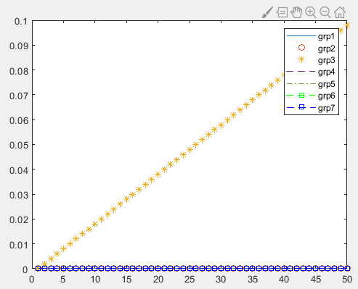

Fig7. Error Sensitivity for $Δρ_{0}$

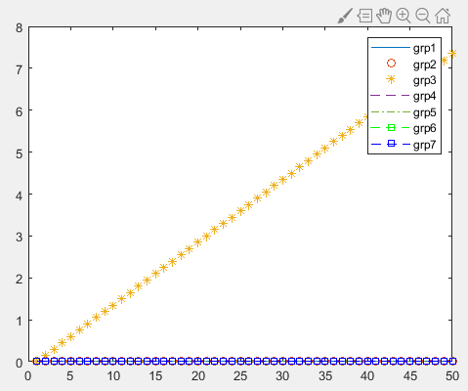

Fig8. Error Sensitivity for $Δk_{p}$