1. Sufficient order case: Set N=50
2. Run the NLMS algorithm for different values of 𝜇 and observe their impact on the convergence properties and (excess) mean squared error.

We have tested the NLMS algorithm with different values of stepsize 𝜇 in the range of (0,2*maxstepsize) which masstepsize means the maximum stepsize value getting by maxstep function of matlab.

As you can see in the first cast mu=0.08, the emse is bigger than other cases and it’s because the convergence rate is not fast than other case.

In the first case, you can see the result is converged slowly and at the first the result of NLMS doesn’t fit the desired values.

As you can see from the results the convergence rate becomes faster according to the mu whereas the emse becomes smaller.

In the last cases when mu=2.16,3.14 NLMS is not converged to the desired value.

It means that NLMS becomes unstable when the mu exceeds the restricted value.

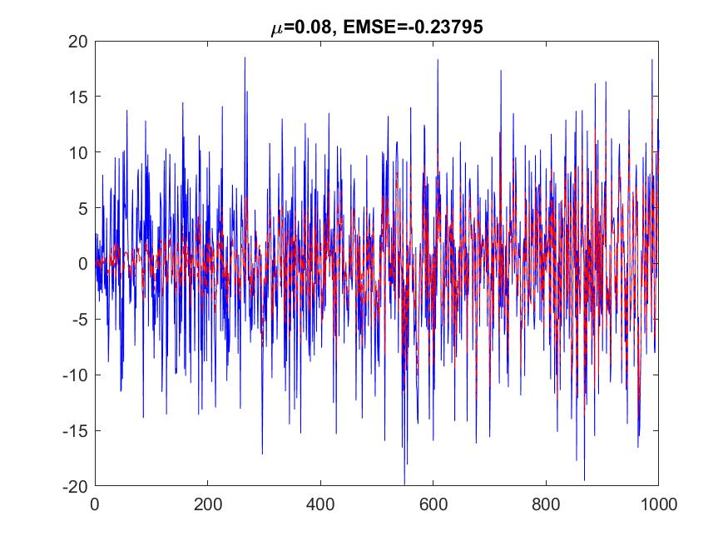

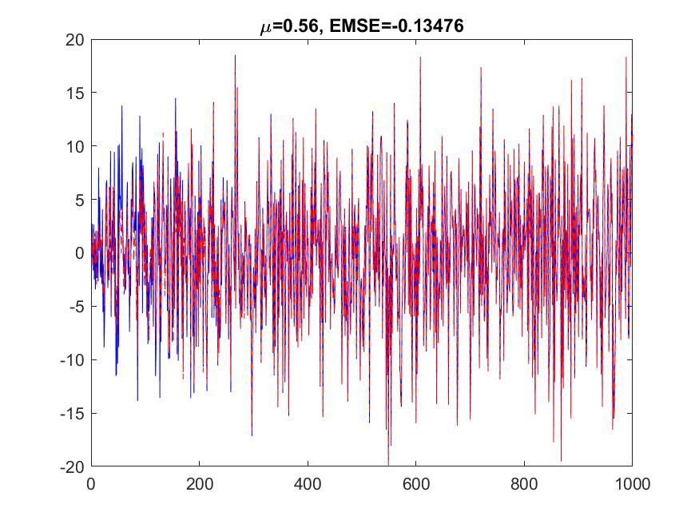

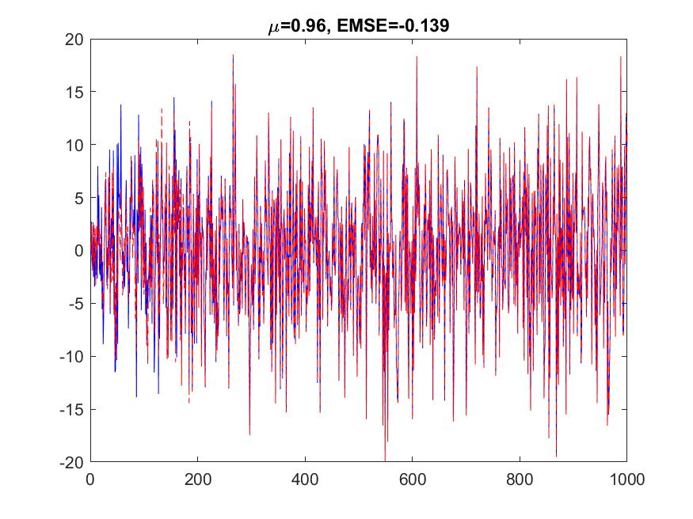

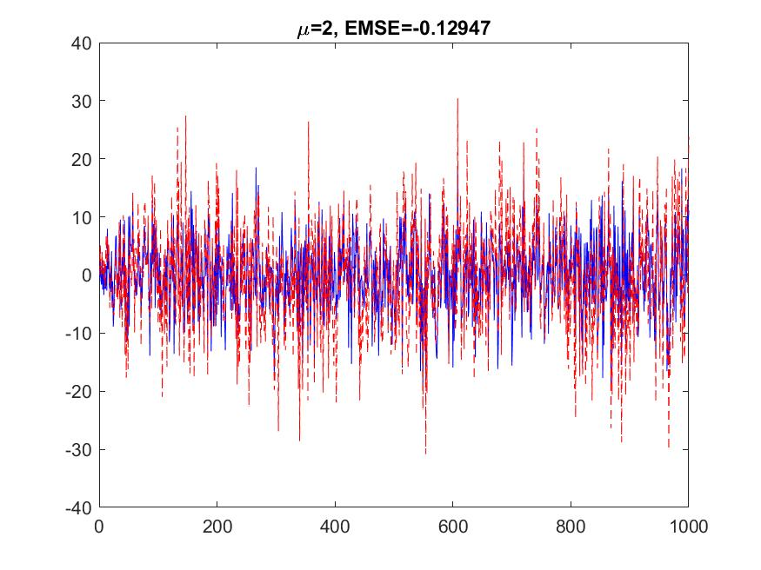

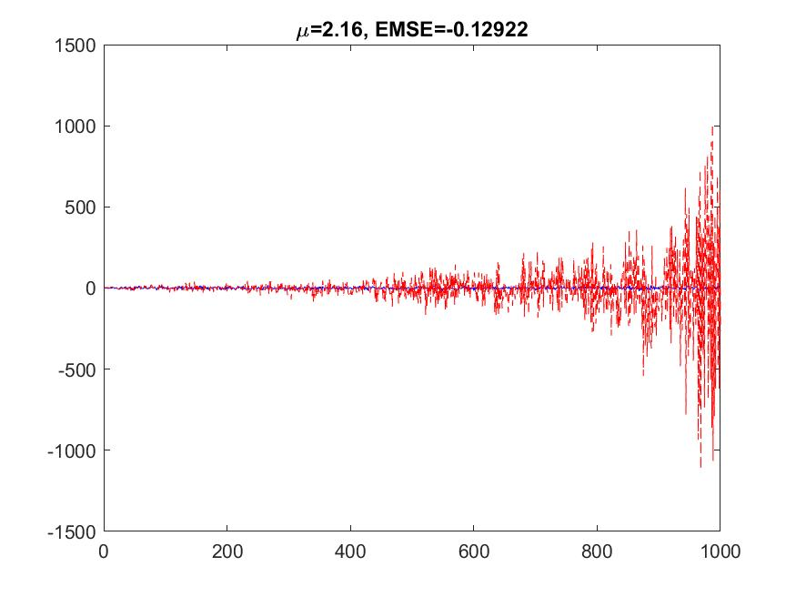

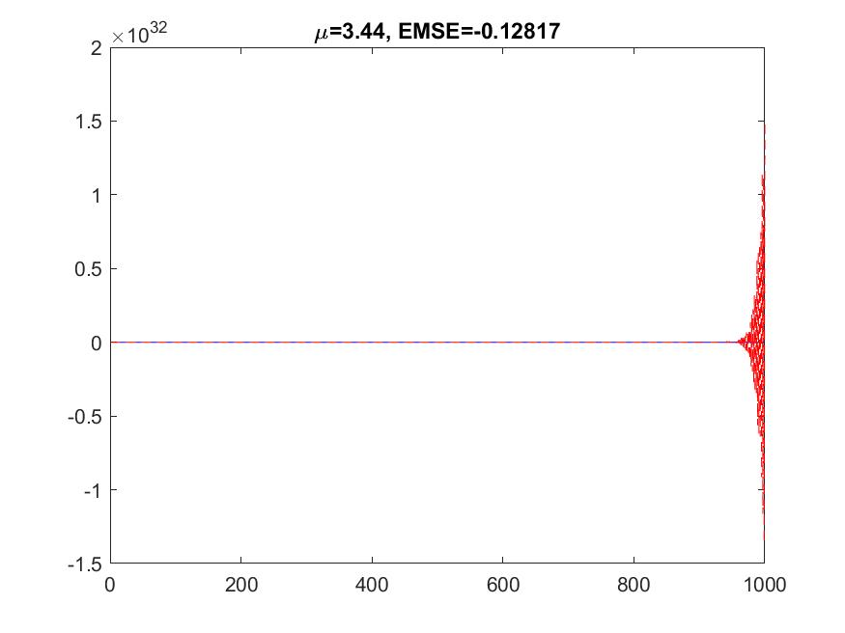

So from the result of test, we can get the conclusion that when the stepsize is increased, the convergence speed becomes faster whereas the stability becomes decreases and

if the stepsize value exceeds the certain value, it causes large variations from the convergence values .

1. Run the NLMS algorithm for 4 independent realizations of the input sequence u.

Plot , for all 4 realizations.

I have run the NLMS function four times for different inputs and filters and the same stepsize. The results are as follows.

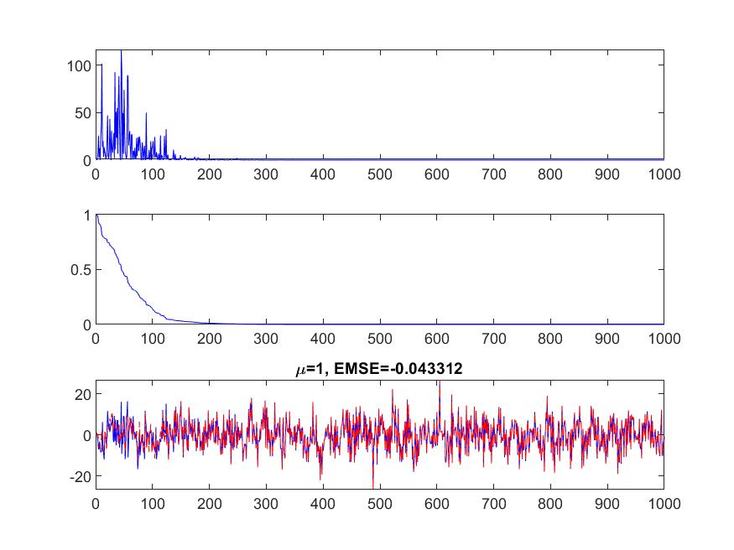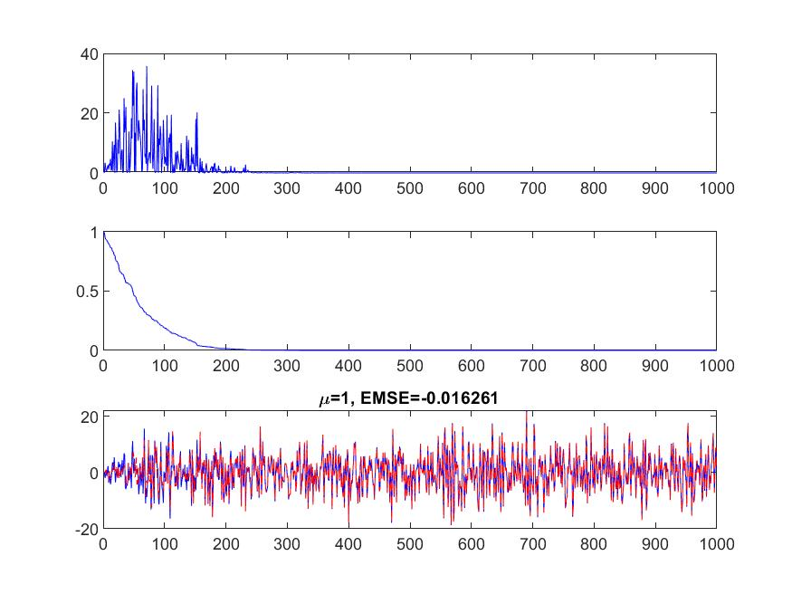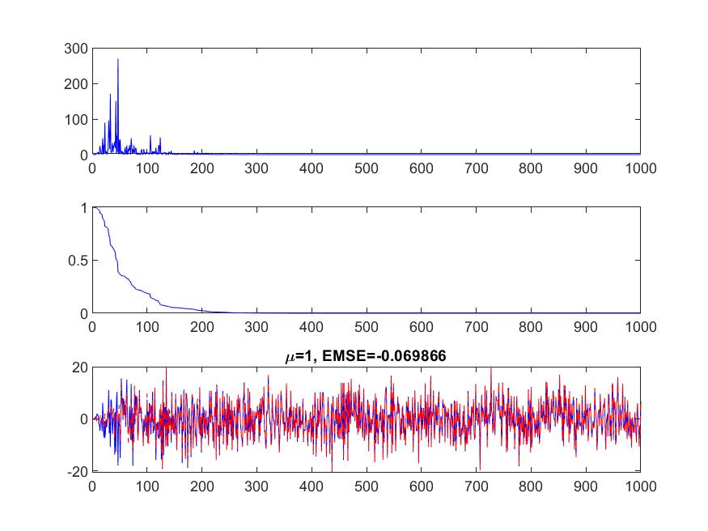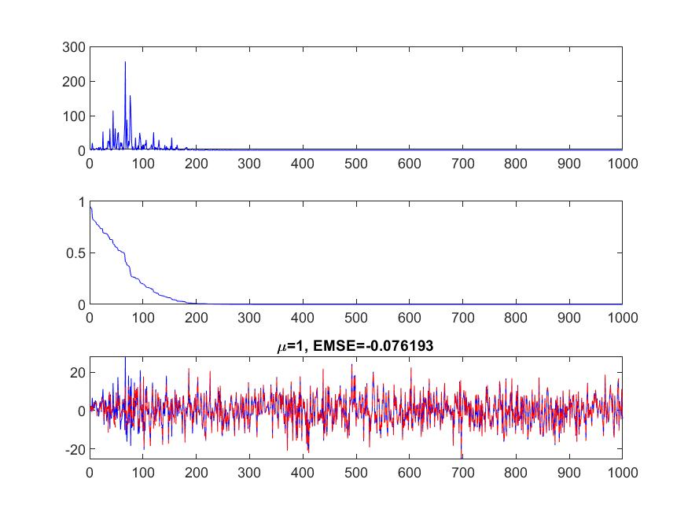

The results are saved in Q1c.

Every folder in Q1c contains the results with the same step size.

I select the step size 1 and as you can see from the results, for all cases NLMS is converged well to the desired values.

You can also see that the mean squared errors ,coefficient errors and emse values varies.

In the second case emse is smallest but the squared errors at the first are large.

In the third and fourth cases, emse values are large than other cases, but the mean squared errors at the first are small.

So from the result we can see that emse values of NLMS become large when the mean squared errors at the first are small.

As you can see in the results, for all cases, NLMS with the same step size has similar convergence properties and step size is important parameter to conclude the convergence property of NLMS.

1. Run the NLMS algorithm for 40 independent realizations of the input sequence u using the same value of 𝜇.

From the results of b) we can see that NLMS with the same step size has nearly same convergence properties and thus we can say that the convergence of NLMS concerns on step size.

So average squared error and average coefficients error vector norm corresponds to an approximate ensemble average.

We run the NLMS algorithm for 40 independent realizations of the input sequence u using the same value of 𝜇 and the results are saved in Q1c.

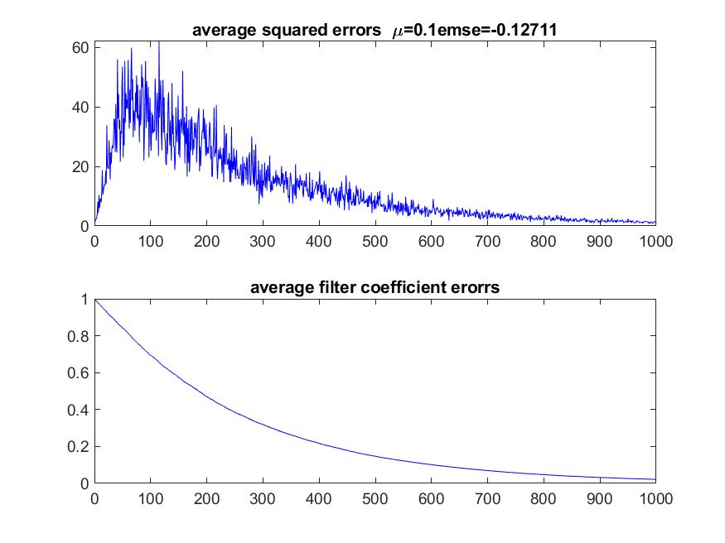

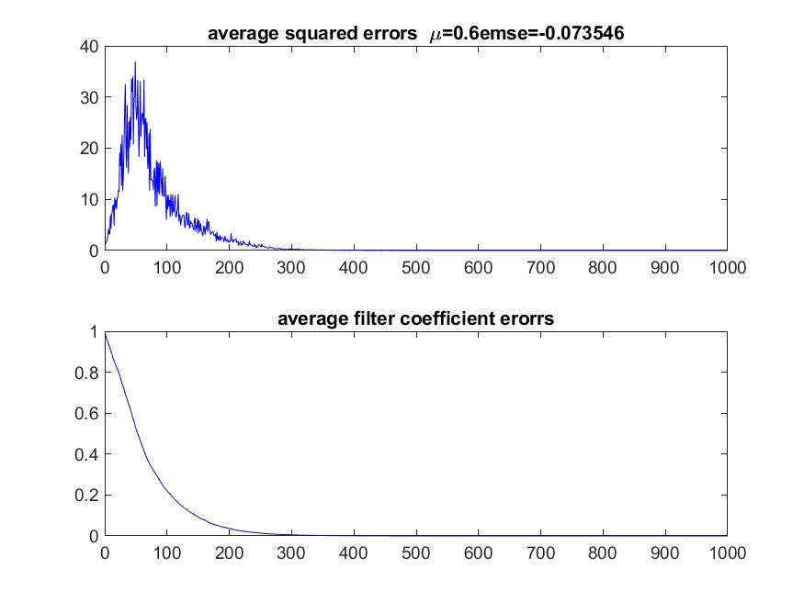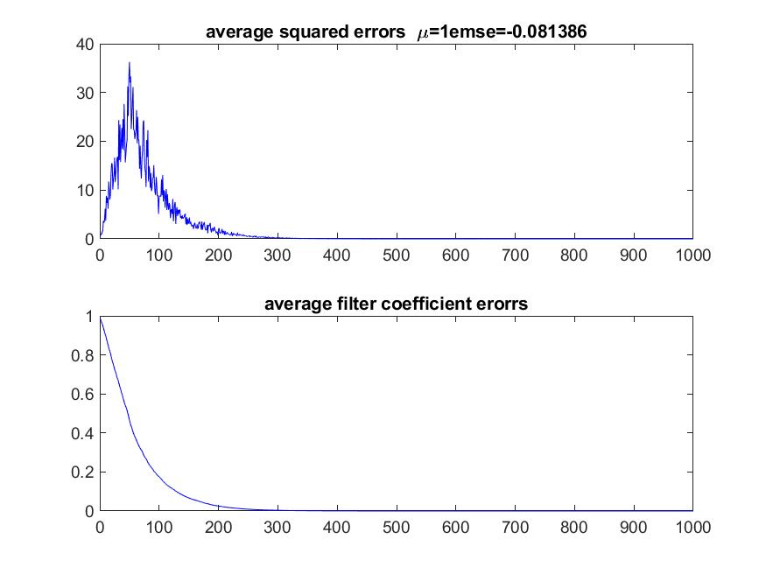 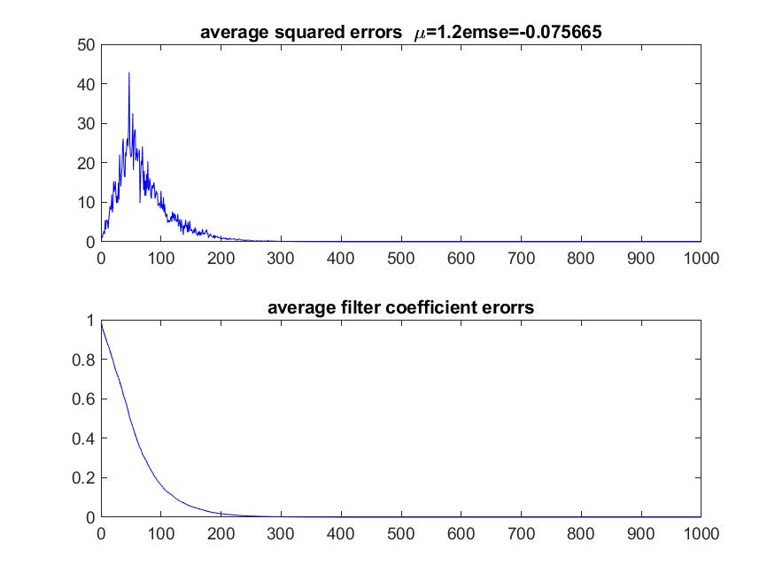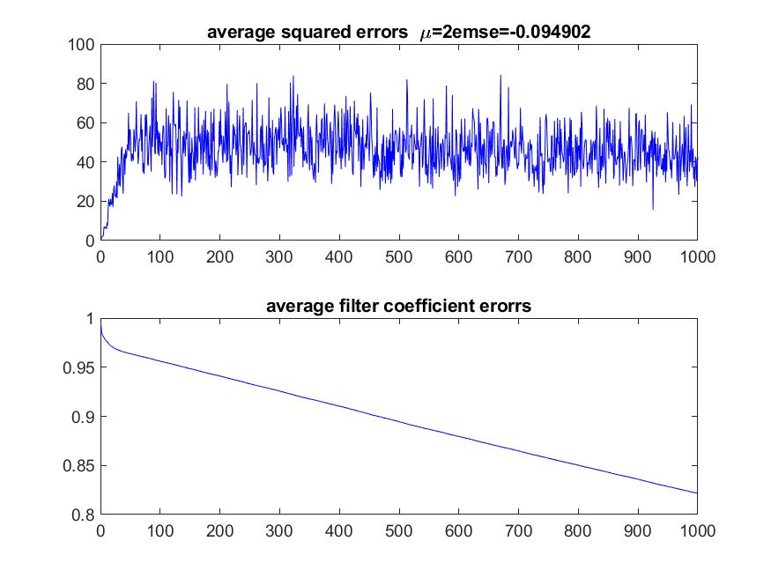

When step size increases, the average squared error also increases and the average filter coefficients error vector norm decreases at first.

But when the step size is around the 1, the properties varies from the start.

When the step size is bigger than 1, the average coefficient errors increase and the average squared errors also increased when the step size is bigger than 1.2.

It is most suitable to select the parameter that makes NLMS to get the correct coefficient values and the convergence time is small.

The correctness of coefficients depends on the coefficient errors and the convergence time depends on the mean squared error.

I select the step size 1 from the filter coefficient errors and the mean squared errors.

It’s because the filter coefficient errors are smallest when the step size is 1 and the average squared error is also small.

As you can see from the figures above, the filter coefficient errors are small in the case of mu=0.6 and 1.

You can also see that the squared error is big in the case of when mu=0.6.

I think that 1 is most suitable value.

From the results, we can see that NLMS is converged when the step size is not bigger than 2.

So we can see that the maximum step of NLMS is 2.

1. Sufficient order case : N>50

We have testes NLMS with the filter length N =60 ,70, 80,90.

The results are in Q2/result(1), Q2/result(2), Q2/result(3) and Q2/result(4).

In every folder, there are 40 results of average squared errors and average filter coefficients error of NLMS for different 30 step sizes.

From the results, we can see that the convergence properties are similar when N=50;

When the step size is bigger than 2, NLMS becomes unstable.

So we can see that maximum step size of NLMS is 2 and it is independent to the length of filter.

The average filter coefficients and emse for the longer N is bigger than the cases for shorter N.

In the following we show the two cases of filter lengths are 60 and 70.

You can see that in the second case the average filter coefficients becomes zero slowly than in the first case when mu=0.6 and 1.2.

You can also see that the emse is small in the second case than the first case.

And in the case of average squared errors, the performance is similar for both cases.

Thus we can see that the convergence performance of NLMS decreases when N becomes longer when N>50.

So you can see that it is best that select the filter length nearly to the desired filter and selecting too large length is not good for the performance and results the long time to converge.

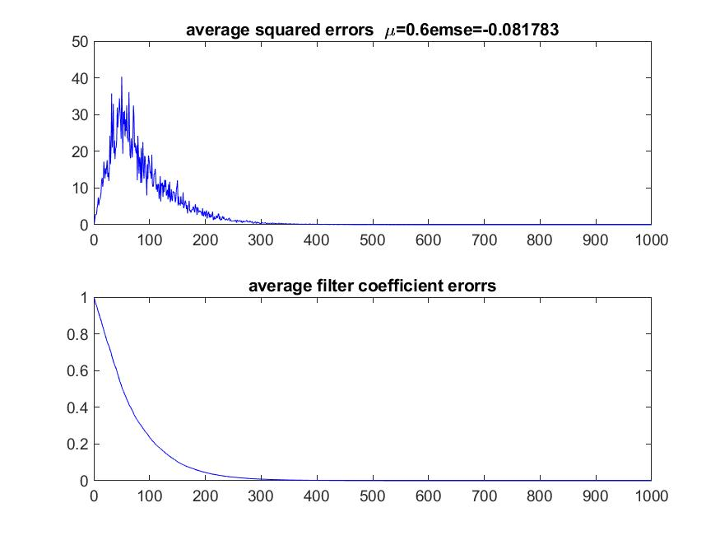

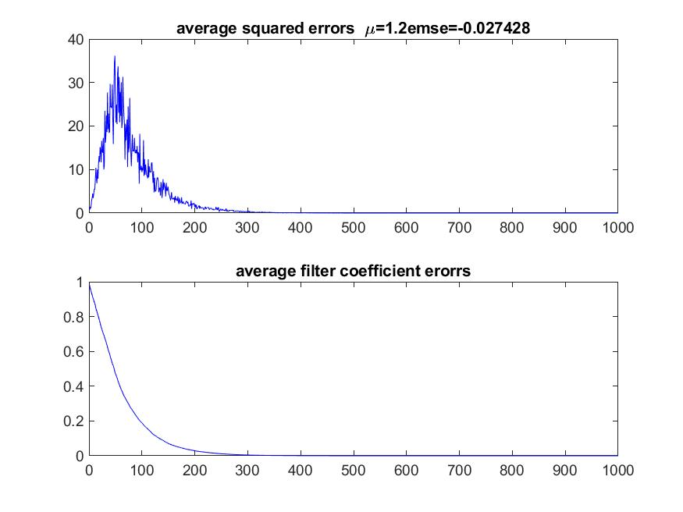

. 

Avg_squared_err and avg_coff_err When N=60

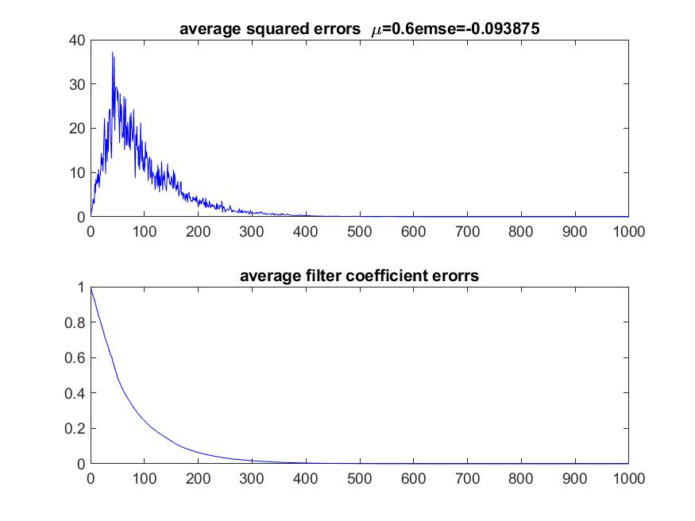

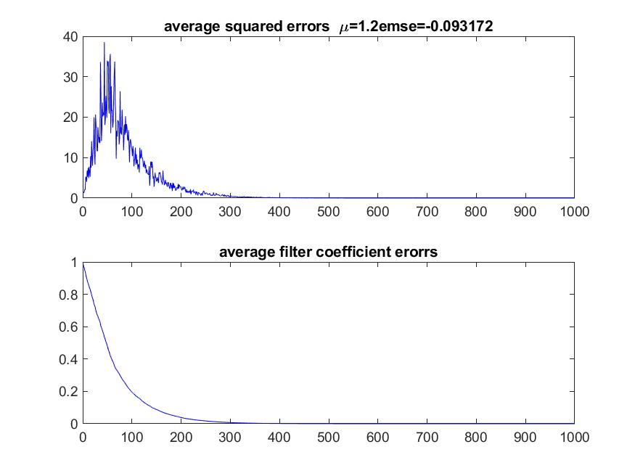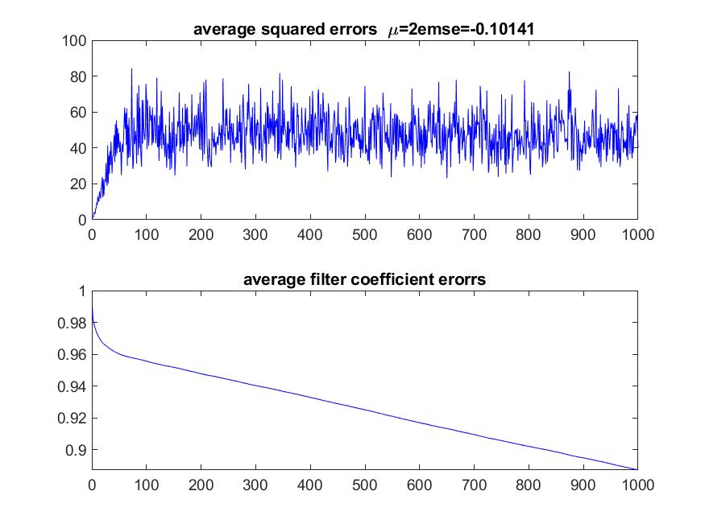

Avg_squared_err and avg_coff_err When N=70

1. Insufficient order case : N<50
2. Run the NLMS algorithm for different values of N using a fixed value for 𝜇.

We select the step size 0.6 which is good value when sufficient case N=50.

We run the NLMS algorithm for N=45,40,35,30,20,20.

For every N, NLMS algorithm is ran 40 times to get the average values.

As you can see in the results, the average filter coefficient errors and squared errors could not be converged to zero and it is because the number of filter coefficients is not sufficient.

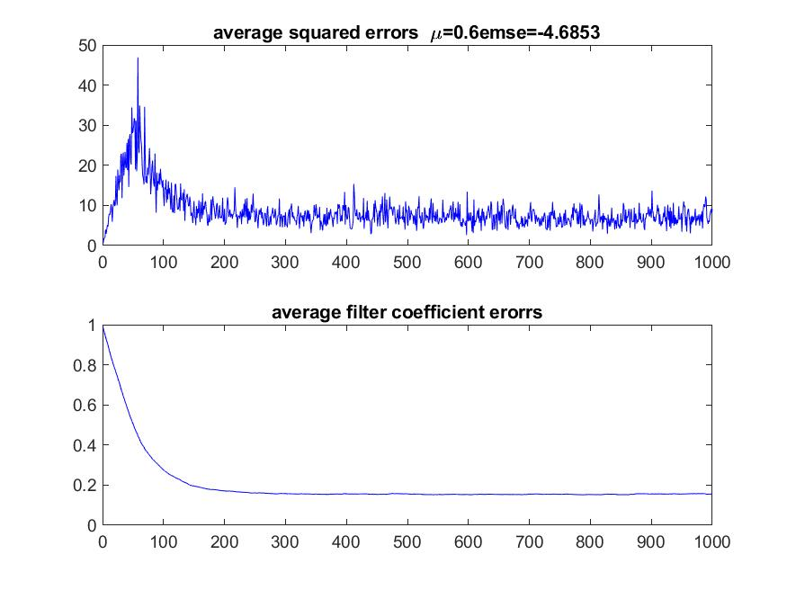

When N=45.

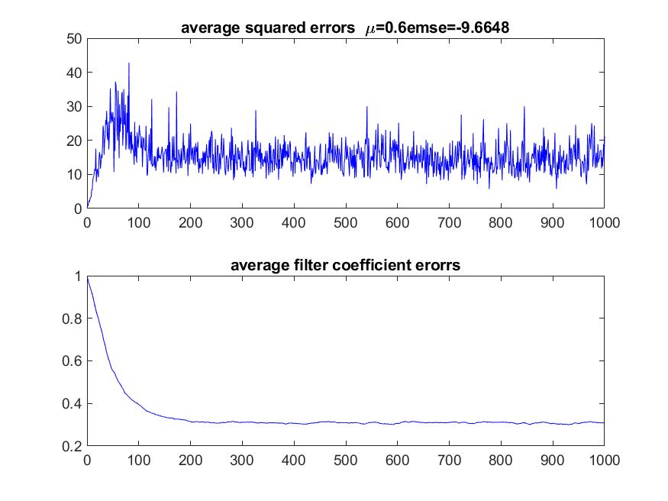

When N=40.

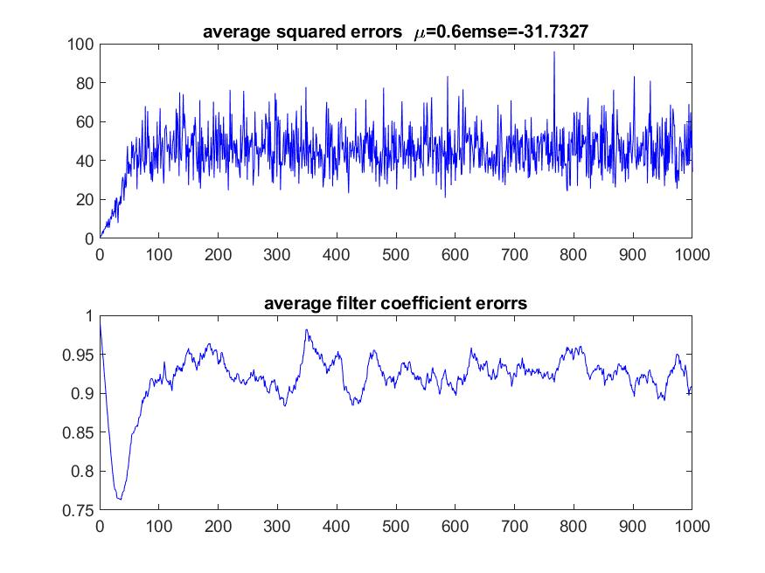

When N=25.

You can also see that the average filter coefficient errors and squared errors in the normal state becomes large when the filter length becomes smaller.

When the length of NLMS is 25,as you can see, NLMS is not converged when the step size is 0.6 and it means that the convergence property of NLMS also depends on the length of filters.

As you can see from the results, NLMS becomes unstable when N<50 .

N becomes shorter, NLMS becomes more unstable.

So it would be good to select the filter length of NLMS equal to the length of original filter.

But in reality it is difficult to find the correct length of original filter.

So you must run tests to get it.

If you get the insufficient values for the step size is around 1, you can think it’s because the length of filters is insufficient and should increase it.

But you must remind that if the length of the filter is too large, it would results the bad performance.

But in the case of large filter length, the convergence is satisfied and the time to only converge becomes long. So in usual case it would be good to select the filter length to large value fully.

1. Run the NLMS for different step size and same N.

I select the N=35.

Step size changed from 0.1 to 3 and for every step size, I ran the NLMS function 40 times to get the averaged values.

The results are in Q3B.

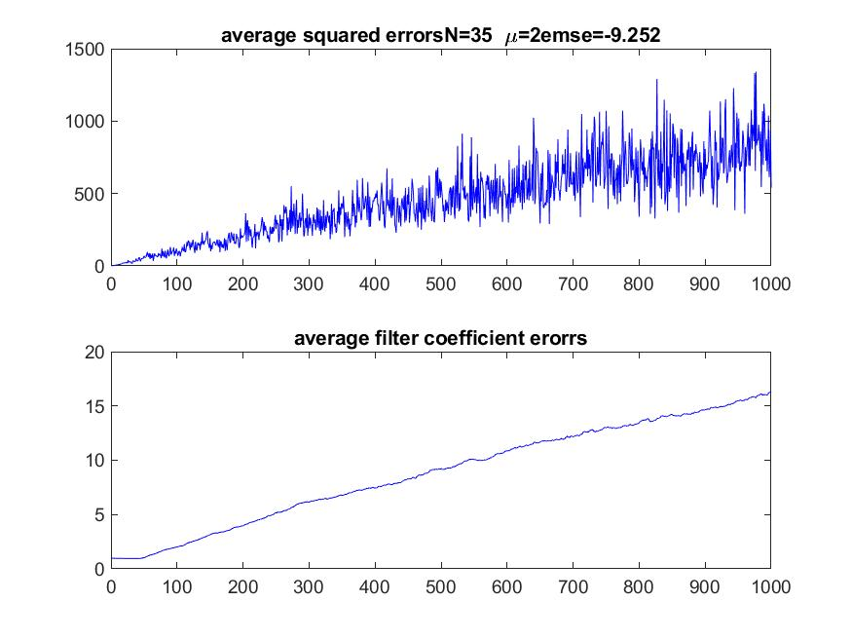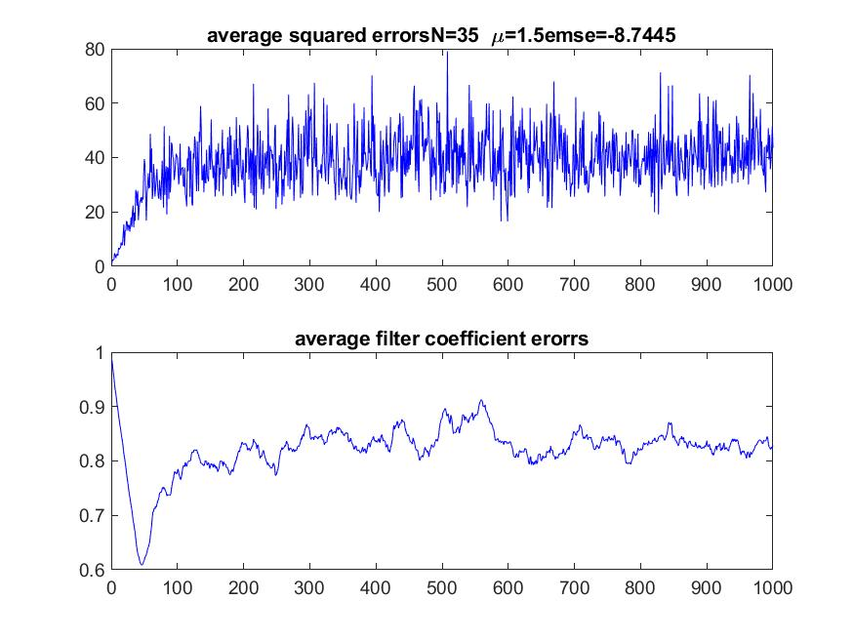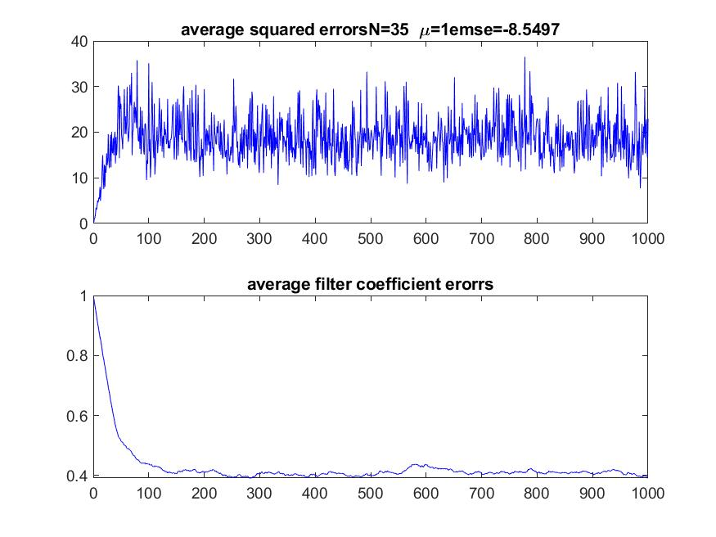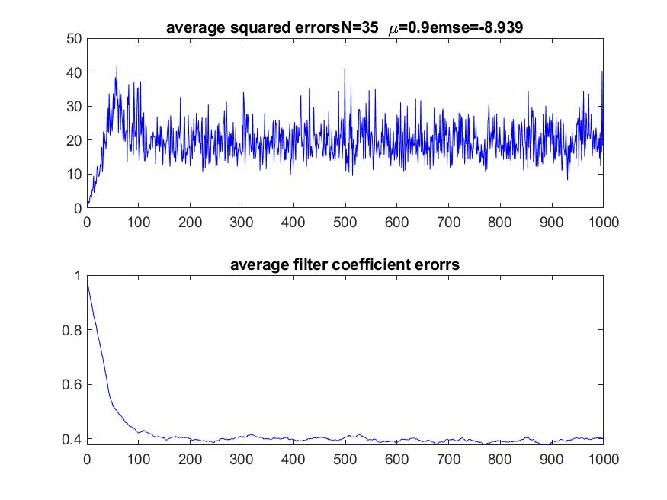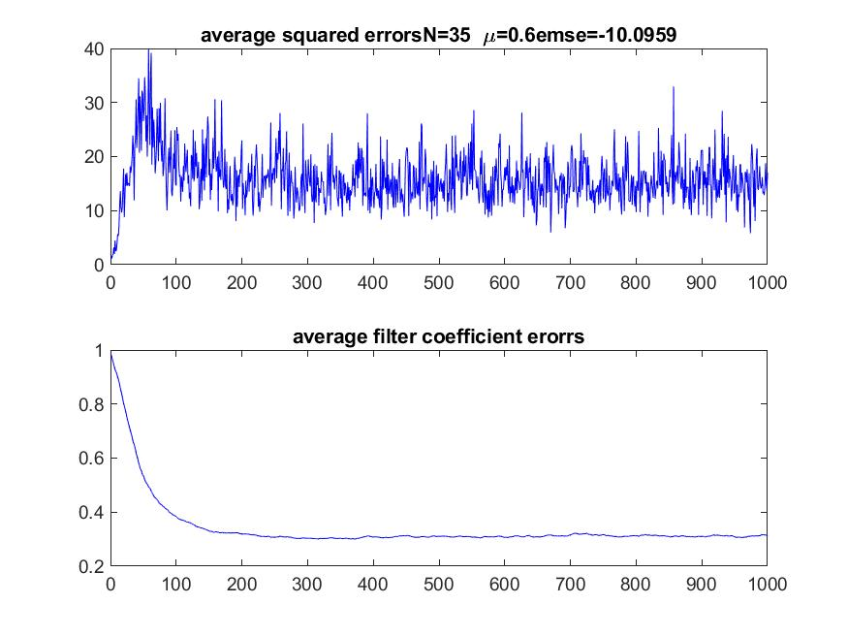

The convergence properties changes similarly with the sufficient case according to step size.

The convergence property is best when step size=0.9,1;

These results are similar in sufficient cases.

When the step size increases, NLMS algorithm becomes unstable.

In the sufficient case, NLMS algorithm is stable when step size is not larger than 2.

However in the insufficient case, NLMS algorithm becomes unstable when step size is not large r than 2 .

As you can see in the results, average filter coefficient errors converged not to zero but to certain value.

And the normal average filter coefficient errors become large when the step size becomes large.

And the step size that makes the NLMS unstable becomes smaller when the step size becomes smaller.

1. Use the audio signal (Ronald.wav) which was provided to you as input signal u.

Set N=50. Use different choices of step size. How long does it take for the filter coefficients to converge? Compare to the white noise case and comment on reasons for observed differences.

I use the ‘ronald.wav’ file.

It has mono channel and 16 bit data format.

Its sampling speed is 8kHz.

The results are in Q4a.

It takes about 500ms for the filter coefficients to converge when step size is 1.

When the step size is 2, it takes 200ms for the coefficients to converge.

You can see that it is slower than white noise case.

It’s because when the noise case is used, the output signal contains only certain range of frequencies and it is simple than other signals.

But audio file contains various frequencies and thus the learning time becomes longer.

