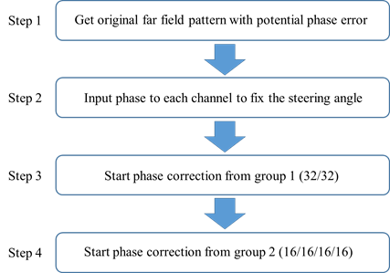

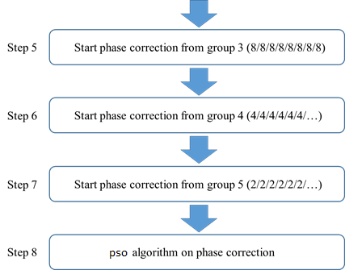

Step 1: For each antenna in the ideal case, a phase of 0 $π$ to 2 $π$ is randomly assigned to simulate an optical phased array with potential phase errors.

Step 2: We will first steer the far field beam to the required angle, and then start the correction step. From Eqs. (3.24) and (3.25), the value of item $ξ$ is changed to perform the beam steering. For the uniform optical phased array, by steering the far field beam angle from a small angle to a large angle, this item will also increase in arithmetic sequence. By finding the appropriate value of $ξ$, we can fix the far field beam at the designated angle and then start the phase correction.

Step 3: The 64 antennas are divided into two groups of 32 antennas. Firstly, we fix the phase of one group, then adjust the phase on the other group. The phase is adjusted until a relatively large PSLL of the far field pattern is obtained. Then, we fix the phase of this group and adjust the phase to the other group to find a relatively large PSLL again. During the optimization process, the phase compensation is the same to all antennas in one group.

Step 4: We keep the compensation phase of each antenna in the previous step, and divided each group into two subgroups. Therefore, each subgroup has 16 antennas. We start the phase correction from the center subgroups as shown in Figure 4-10. After obtaining the relatively large PSLL, the phase is fixed for this subgroup. Repeat the same steps to perform phase compensation for the other three subgroups until a relatively large PSLL in the far-field pattern is obtained.

|  |
| --- |
| Figure 4-10: Step of phase correction |

Step 5 ~ Step 7: Repeat the method of the third and fourth steps by dividing the antenna array into more subgroups. More accurate correction is expected when this procedure proceeds further. With this method, the calculation time and steps required for phase correction are much less than that of optimizing the phase of all antenna at one time.

Step 8: After the above steps, we can obtain an optimized far-field pattern by applying the PSO algorithm for further phase correction.

Imagine that there are 8 antennas and it is separated into two groups.

Firstly we select the first group.

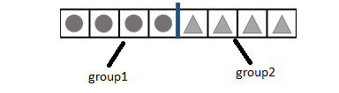

Numpergroup = 4,

Imagine that we select groupnum as 1,

We set Minpsll as inf.

Then we set dphi = (0 0 0 0 0 0 0 0) at first

And we iterate the  from 0 to 2*pi with step of 0.001.

Then dphi will be iterated as (0.001,0.001,0.001,0.001,0,0,0,0), (0.002,0.002,0.002,0.002,0,0,0,0), (0.003,0.003,0.003,0.003,0,0,0,0),…, (6.283,6.283,6.283,6.283,0,0,0,0).

We calculate the psll for each dphi, and if the psll value is smaller than minpsll, we update the minpsll and also best_dphi as

minpsll =psll;

best_dphi = dphi;

for instance, if dphi = (0.003,0.003,0.003,0.003,0,0,0,0), psll is -6.2 and minpsll is -5.6,

minpsll will be updated as -6.2

and best_dphi as (0.003,0.003,0.003,0.003,0,0,0,0).

For this way, after dphi iterated from 0 to 2*pi, best_dphi has the best compensated angles for the first subgroup.

We can imagine the psll has minimum value when the dphi is (0.023,0.023,0.023,0.023,0,0,0,0).

Then the best_dphi would be set as (0.023,0.023,0.023,0.023,0,0,0,0) after all iteration.

Then we update the d_phi as d_phi+best_dphi.

So d_phi will be set as (0.023,0.023,0.023,0.023,0,0,0,0).

Then we can enter the next iteration.

We select the groupnum as 2.

So we set dphi = (0 0 0 0 0 0 0 0) at first and we iterate the  from 0 to 2*pi with step of 0.001.

Imagine that when  is 0.04, the psll is -6.3.

Since psll is smaller than minpsll, best_dphi and minpsll should be updated.

Minpsll is updated as -6.3 and best_dphi is updated as (0.023,0.023,0.023,0.023,0.04,0.04,0.04,0.04).

Then what is preb_dphi?

It is (0.023,0.023,0.023,0.023,0,0,0,0).

So we iterate the angles as preb_dphi+dphi

Then it will be iterated as (0.023,0.023,0.023,0.023,0.001,0.001,0.001,0.001),

(0.023,0.023,0.023,0.023,0.002,0.002,0.002,0.002),…, (0.023,0.023,0.023,0.023,6.283, 6.283, 6.283, 6.283).

And the best_dphi will save the best compensated angles for all groups at this stage.