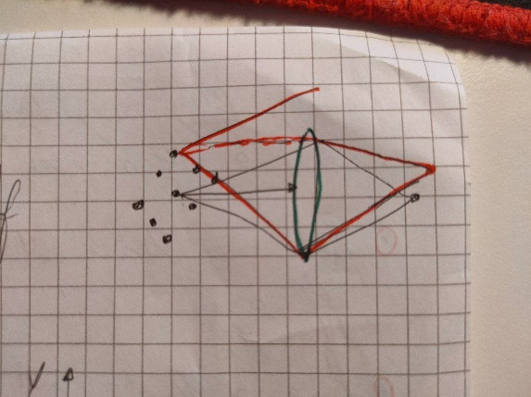Hi, fixes of last task (not included in new task):  
  
- use D=8000m in all LARGE beams simulations (I calculated its good farfield)  
-try to invent a fix to correctly sample small beams (important)   
-in the square the distance between elements HG00 has to be 5 times the beam dimension, so if 1e-2 make it d=5e-2  
  
next tasks  
  
-remember we had 1 HG00 going through 1 lens and showing magnification? Perfect, now I want you to send the 9 apertures (of big beams until you can fix small beams error) and show me that on the back focal distance (so 2f from the start so 1f after the lens, considering the origin at 1f distance from the lens) I see farfield as I saw propagating for LONG distance in the previous 9 apertures example.  
So now we have 9 HG00 in a square and we show farfield propagating for z=8000 meter ok? Now show that putting them in a lens I see the farfield but just on 2f distance because of lens effect.  
  
-as before we did with 2 lenses, then copypaste what above and show that if I put a opposite lens on 3f distance, at 4f distance I see the same as the origin (as we did in the singular HG00 example, do you remember?)  
So I start with 9 squared bigbeams structure, 1f distance propagation, lens, 1f distance propagation, show me farfield, 1f distance propagation, opposite lens, 1f distance, show me it’s the same as beginning  
  
-copypaste all above but now instead of distance f, put f+epsilon (where epsilon is a small number of your choice that simulates error) and show that the realization is not perfect and what errors do we see in this case!   
  
-put 9 squared things again In front of the lens. If the center of the lens is on the z axis , only the center of the squared structure of 9 HG00 is on the axis perfectly, the others are moved, so they are not perfectly aligned with lens . What I want you to show is that , if this is the structure of the 9 HG00 beams:  
  
1 2 3 L  
 E  
4 5 6 N   
 S  
7 8 9  
  
since only 5 is on the axis and perfectly at f distance, if I imagine how only 3 would propagate through the lens, this wouldn’t be centered, see image:

So this applies a tilt to the beam exiting the lens. Show that the central one goes directly forward while the other ones exit a bit tilted, are not centered as number 5 .

Thank you,  
your friend.