**Local shipment/delivery company**

Senior Project

by

**Antonio Al Makdissi,**

**Fawzy Ghazawy**

Submitted to the School of Engineering of the

Lebanese International University

Beirut, Lebanon

in partial fulfillment of the requirements for the degree of

**BACHELOR OF SCIENCE IN COMPUTER ENGINEERING**

**Spring 2022-2023**

**Approved by:**

**Supervisor**  

Dr. Zaher Merhi



**Committee Member**

Dr. TBA



**DEDICATION**

First and foremost, we would like to dedicate this for ourselves, our past selves, to bring to light the progress we have made along the years starting from scratch till what we are today. Though this does not represent our endpoint in life as we are going to strive in order to achieve higher goals via further education and hard work through the many years to come.

John J. Doe

To someone I know and I care for

Jane D. Doe

**ACKNOWLEDGMENT**

We would like to thank our supervisor and the dean and the rest of the people who spared no effort in guiding and instructing us throughout the different steps of the project. And finally the team members who put a lot of work and dedication to help achieve this project.

**ABSTRACT**

The abstract goes here with double space 12pt font. The abstract consists of one paragraph with first line indentation. The page should be numbered. The abstract goes here with double space 12pt font. The abstract consists of one paragraph with first line indentation. The page should be numbered. The abstract goes here with double space 12pt font. The abstract consists of one paragraph with first line indentation. The page should be numbered. The abstract goes here with double space 12pt font. **The abstract consists of one paragraph with first line indentation**. The page should be numbered. The abstract goes here with double space 12pt font. The abstract consists of one paragraph with first line indentation. The page should be numbered.

**TABLE OF CONTENTS**

**ACKNOWLEDGMENT iii**

**ABSTRACT iv**

**TABLE OF CONTENTS v**

**LIST OF FIGURES viii**

**LIST OF TABLES ix**

**LIST OF SYMBOLS x**

**CHAPTER 1 INTRODUCTION 1**

1.1 Background 1

1.2 Problem Statement 1

1.3 General overview of the project 1

1.4 Thesis Outline 1

**CHAPTER 2 Survey of Existing Methods and Similar Systems 2**

2.1 Introduction 2

2.2 Method 1 / System 1 2

2.3 Method 2 / System 2 2

2.4 Method 3 / System 3 2

2.5 Methods/Systems Comparison 2

2.6 Conclusion and Motivation 3

**CHAPTER 3 System Design 5**

3.1 Introduction 5

3.2 Requirements and Specification Analysis 5

3.2.1 Functional Requirements 5

3.2.2 Use Case Diagrams 5

3.3 System Architecture 6

3.4 Class Diagrams 6

3.5 Sequence Diagrams 6

3.6 Activity Diagrams 7

3.7 Entity-Relationship (ER) Diagrams 7

3.8 Non-Technical Aspects 7

3.8.1 Financial Viability 7

3.8.2 Stakeholders 8

3.8.3 Scope 8

3.8.4 Risks 8

3.8.5 Schedule and Milestones 9

3.8.6 Ethical and Social Considerations 9

3.8.7 Environmental and Sustainability Considerations 9

3.8.8 Relevant Standards 10

3.9 Conclusion 10

**CHAPTER 4 Implementation/Simulation and Testing 11**

4.1 Introduction 11

4.2 Implementation Tools 11

4.3 Implementation Summary 11

4.4 Test Cases and Acceptance Criteria 11

4.5 Conclusion 11

**CHAPTER 5 Conclusion and Future Work 12**

5.1 Conclusion 12

5.2 Future Work 12

**APPENDIX A: Implementation Details 13**

**APPENDIX B: USER Manual 14**

**APPENDIX C: deployment and configuration Manual 15**

**REFERENCES 16**

**LIST OF FIGURES**

Figure ‎3-1- System Architecture 6

Figure ‎3-2- Cost Benefit Analysis 8

Figure ‎3-3- Scheduling Tasks and Milestones 9

**LIST OF TABLES**

Table 2-1: Comparison Table Based on Graphical Interfaces 3

Table 2-2: Comparison Table Based on Content and Functionality 3

Table 2-3: Comparison Table Based on Features 3

**LIST OF SYMBOLS**

MUST LISTED IN ASCENDING ALPHABETICAL ORDER. Examples:

Ω: Resistance

μ: Viscosity

A: Ampere

BW: Bandwidth

CD: Compact Disk

COVID: Corona Virus Disease

ISO: International Standardization Organization

LCD: Liquid Crystal Display

LIU: Lebanese International University

WiFi: Wireless Fidelity

# INTRODUCTION

## Background

Our modern world is full of challenges. That’s we, as humans, try our best to invent new technologies in order to make our lives less tedious and easier to go by.

We saw the problems that shipment companies face, such as loss of cargo either through piracy or corruption, absence of trust between customer and company due to lack of communication and data insufficient intel on the companies’ exchanges.

Hence our attempt at developing our app: a cargo/delivery application can address several challenges faced by logistics providers and customers, such as lack of visibility, inefficient processes, limited communication, security concerns, competition, and increasing demand. By providing real-time tracking, automating processes, improving communication and transparency, enhancing security, and offering a competitive advantage, a cargo/delivery application can improve customer satisfaction, reduce costs, optimize operations, and provide valuable data insights.

## Problem Statement

Since its foundation, the logistics and transportation industry encounters various difficulties such as inadequate visibility, ineffective procedures, restricted communication, security threats, intense competition, and growing demand for prompt and dependable shipping services. These challenges can cause delivery delays, higher costs, and lower customer satisfaction, which may have negative effects on the profitability and expansion of logistics providers. To solve these challenges, a cargo/delivery application is necessary to deliver instant tracking, automate processes, enhance communication and transparency, boost security, and provide a competitive edge in the market.

## General overview of the project

The aim of our project is to improve the efficiency, transparency, security, and customer satisfaction of logistics and transportation operations. This can be achieved through real-time tracking, process automation, improved communication, enhanced security measures, and a unique value proposition that sets the application apart from competitors. Additionally, the application should provide valuable data insights on shipment performance and customer behavior, which can be used to make better business decisions…

## Thesis Outline

This section is a prelude of all the remaining chapters in the thesis. Note: before the final report, only the completed chapters (such as survey) are outlined here.

Please respect indentation of each new paragraph.

# Survey of Existing Methods and Similar Systems

## Introduction

This paragraph in meant to introduce the topics to be covered in this chapter.

## Method 1 / System 1

Describe Method 1, System 1 or common features from related work in the literature. Please respect indentation of each new paragraph**. Use a reference to system 1.**

## Method 2 / System 2

Describe Method 2, System 2 or common features from related work in the literature. Please respect indentation of each new paragraph. **Use a reference to system 2.**

## Method 3 / System 3

Describe Method 3, System 3 or common features from related work in the literature. Please respect indentation of each new paragraph. **Use a reference to system 3.**

## Methods/Systems Comparison

This paragraph in meant to highlight the advantages and shortcomings of each of the previously stated methods **with respect to certain criteria**.

**Table 2-1: Comparison Table Based on Graphical Interfaces**

|  |  |  |  |
| --- | --- | --- | --- |
| **Criterion 1** | **System 1** | **System 2** | **System 3** |
| **Graphical Interface** |
| Good user interface |  |  |  |
| Easy and effective navigation |  |  |  |
| Simple and professional Design |  |  |  |
| Responsive |  |  |  |

**Table 2-2: Comparison Table Based on Content and Functionality**

|  |  |  |  |
| --- | --- | --- | --- |
| **Criterion 2** | **System 1** | **System 2** | **System 3** |
| **Content and Functionality** |
| Quality content structure |  |  |  |
| Usability |  |  |  |
| Dynamic content |  |  |  |
| Content management system |  |  |  |

**Table 2-3: Comparison Table Based on Features**

|  |  |  |  |
| --- | --- | --- | --- |
| **Criterion 3** | **System 1** | **System 2** | **System 3** |
| **Features** |
| Security measures |  |  |  |
| Third party integration |  |  |  |
| Accessible content and location |  |  |  |
| Registration form |  |  |  |

## Conclusion and Motivation

This paragraph in meant to draw conclusions about the existing methods and the motivation behind your work. Based on comparison results and the background in chapter 1, what should be the specifications of the newly proposed methodology? What are the problems that remain unsolved by existing methods and what are you planning to do?

# System Design

## Introduction

This paragraph in meant to introduce the topics to be covered in this chapter.

## Requirements and Specification Analysis

This section is meant to explain to the reader use cases for the project, activity diagrams, as well as specification, documentation and requirements of the project. This section can have sub-sections.

### Functional Requirements

Here you have to list the operations and activities that a system must be able to perform.

### Use Case Diagrams

A use case diagram is the primary form of system/software requirements for a new software program. A key concept of use case modeling is that it helps us design a system from the end user's perspective. A use case diagram is usually simple:

* It only summarizes **some of the relationships** between use cases, actors, and systems.
* It does **not show the order** in which steps are performed to achieve the goals of each use case.

Check this tutorial:

<https://www.youtube.com/watch?v=zid-MVo7M-E>

## System Architecture

Define the overall architecture of the system. Layered, Dataflow, Multi-tier, Client-Server, etc. It is worth noting the underlying technologies to be used. Draw a figure that shows the complete system Example of such figures:

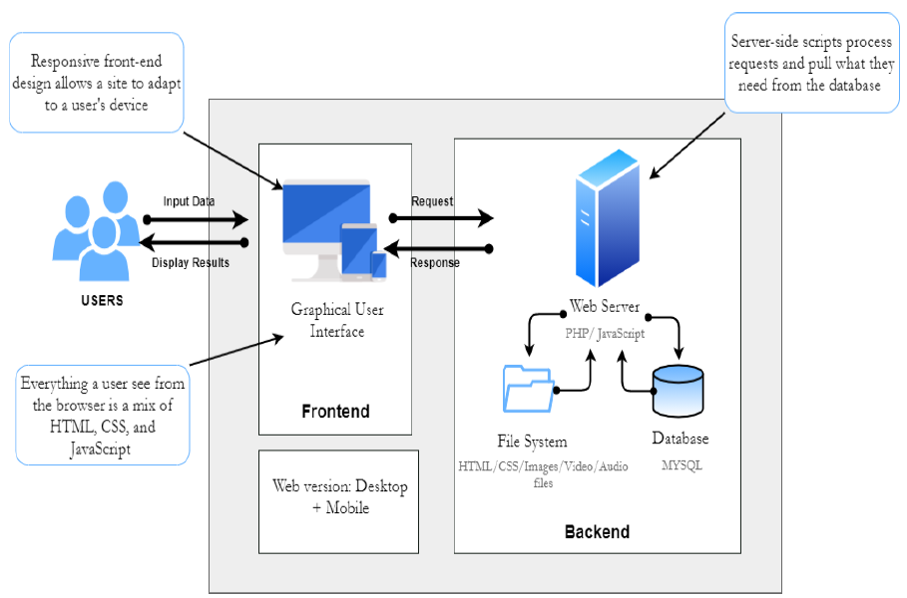

**Figure ‎3-1- System Architecture**

## Class Diagrams

The static design view of the system. It includes all the underlying classes designed and their hierarchy. Check this tutorial: <https://www.youtube.com/watch?v=UI6lqHOVHic>

## Sequence Diagrams

Sequence Diagrams are interaction diagrams that detail how operations are carried out. They capture the interaction between objects in the context of a collaboration. Sequence Diagrams are time focus and they show the order of the interaction visually by using the vertical axis of the diagram to represent time what messages are sent and when.

Check this tutorial: <https://www.youtube.com/watch?v=pCK6prSq8aw>

## Activity Diagrams

Activity Diagrams describe how activities are coordinated to provide a service which can be at different levels of abstraction. Typically, an event needs to be achieved by some operations, particularly where the operation is intended to achieve a number of different things that require coordination, or how the events in a single use case relate to one another, in particular, use cases where activities may overlap and require coordination.

Check this tutorial: <https://www.youtube.com/watch?v=3Hw_VXea73o>

## Entity-Relationship (ER) Diagrams

An entity relationship diagram (ERD) is a graphical representation of entities and their relationships to each other, typically used for modeling the organization of data within databases or information systems. Check these tutorials starting with the first one:

Tutorial 1: <https://www.youtube.com/watch?v=QpdhBUYk7Kk>

Tutorial 2: <https://www.youtube.com/watch?v=-CuY5ADwn24>

## Non-Technical Aspects

### Financial Viability

A cost benefit analysis of the project. Here is an example:

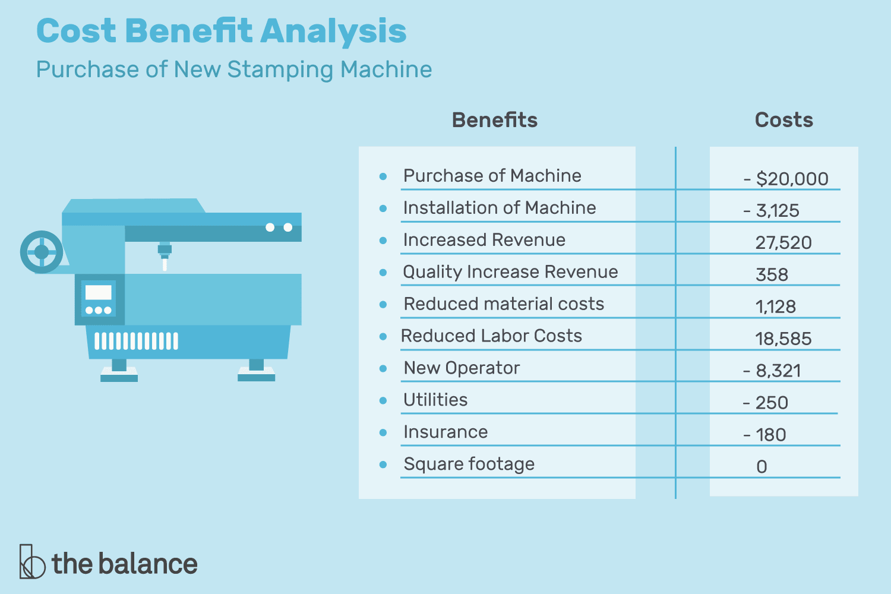

**Figure ‎3-2- Cost Benefit Analysis**

### Stakeholders

Who will benefit? Who may be harmed? Who should have a say in how the project works?

### Scope

Exactly what will be done in the project, sometimes it is helpful to state what will not be done in the project.

### Risks

Things that may stop the project from achieving the goals in the scope.

### Schedule and Milestones

What will be completed and when. Here is an example:

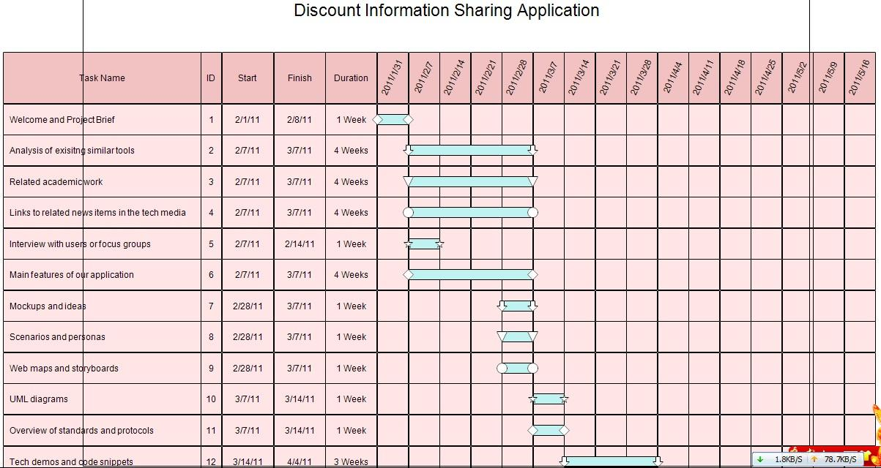

**Figure ‎3-3- Scheduling Tasks and Milestones**

### Ethical and Social Considerations

Are there any ethical issues that should be taken into consideration when completing the design?

### Environmental and Sustainability Considerations

Are there any environmental issues to write about? It is ok to write that this project has no environmental impact.

### Relevant Standards

List the technical (and possibly the non-technical) standards that are relevant to your design. Examples are the WiFi standard (IEEE) and International Standardization Organization (ISO).

## Conclusion

This paragraph in meant to draw conclusions highlighting the main ideas in this chapter.

# Implementation/Simulation and Testing

## Introduction

This paragraph in meant to introduce the topics to be covered in this chapter.

## Implementation Tools

List the tools used for implementing the system. This includes hardware, compilers, IDE, frameworks, CASE tools, etc...

## Implementation Summary

Description of detailed implementation steps. Demonstrate the typical code fragments (details of implementation, e.g. source code listings must be included in an appendix and saved on an accompanying CD/DVD)

## Test Cases and Acceptance Criteria

Describe the test cases used and the acceptance criteria.

## Conclusion

This paragraph in meant to draw conclusions highlighting the main ideas in this chapter.

# Conclusion and Future Work

## Conclusion

Any concluding remarks, lesson learned, etc…

## Future Work

Describe the opportunities for expanding the work done in this thesis.

**APPENDIX A:   
Implementation Details**

Any details not fit in chapter 5: e.g. detailed calculation, complex algorithms, etc…

**APPENDIXB:  
 USER Manual**

Fill in the instruction manual for using the application

**APPENDIXC:   
deployment and configuration Manual**

Outline the deployment and configuration details in addition to any know troubleshooting techniques.

**REFERENCES**

|  |  |
| --- | --- |
| [1] | John Smith and John Doe, "Wireless Sensor Networks," *IEEE Transaction on Mobile Computing ,* vol. 1, no. 2, p. 12, 05 2010. |
| [2] | John Smith et al., How to add IEEE Reference style to Microsoft Word, Beirut, Lebanon: LIU, 2011. |