Form for DKE Student Project Websites

This is the form to be filled for your student project website. To simplify the procedure as much as possible and to make sure that only approved content gets on the website we use this form. Please send the filled form by email to your project supervisor.

* Provide at least one (good quality) image/figure together with this form. Accepted image formats are JPEG, PNG, and GIF. Images should be included in this form (use a lower resolution if needed) so that the editor knows which image is where. Images (provide good quality!) should also be provided as SEPARATE files through a download link. Name images like this: year_name_img_num where name is the last name of (one of) you and num is a number starting from 1. E.g. 2016_Miller_img_1.jpg
* To be uploaded to the website, your report should be provided through a download link. Reports should be provided in the format PDF. Name reports like this: year_name_report where name is the last name of (one of) you. E.g. 2016_Miller_report.pdf
* You can accompany your report with movies. Movies to be uploaded on your website should be provided through a download link. Movies should be provided in the format MPEG4. Name movies like this: year_name_mov_num where name is the last name of (one of) you and num is a number starting from 1. E.g. 2016_Miller_mov_1.mp4
* Your final presentation should be provided through a download link. Presentations should be provided in the format PDF. Name presentations like this: year_name_presentation where name is the last name of (one of) you. E.g. 2016_Miller_ presentation.pdf
* Provide all references in the APA standard. See e.g. <https://scholar.google.com/> for examples. Citations should be done using the author name, year. For instance: [Weiss et al., 2015]

**Type of project (e.g. Bachelor thesis, Master AI thesis, Master OR thesis, Master AI internship project, Master OR internship project, Master AI semester project, Master OR semester project):**

Master DSDM Semester Project

**Year of project:**

2018-2019

**Key words (5 max):**

Machine learning, deep learning, ecg

**Name(s) of student(s) who participated in the project:**

Glazunov M., Jansen J., Lehnen J., Marsella A., Schönwald N., Yeritsyan A.

**Name(s) of supervisor(s):**

Karel J., Bonizzi P.

**Title of the project:**

Detecting sleep apnea from ECG recordings

**Download link for additional content (at least 1 image/figure, report, final presentation, maybe some movies):**

--

**Captions of images/figures. Enter your images (in low resolution if needed) here as well with appropriate captions:**

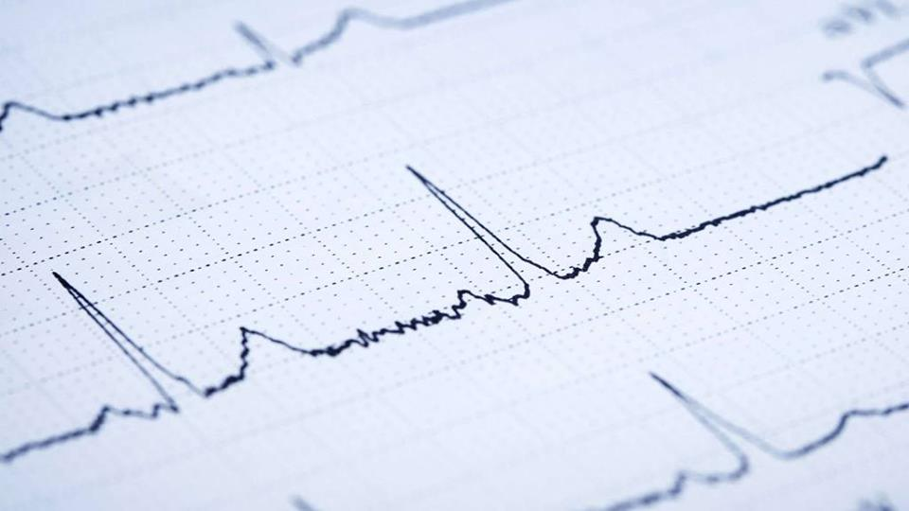

Fig. 1. An example ECG recording

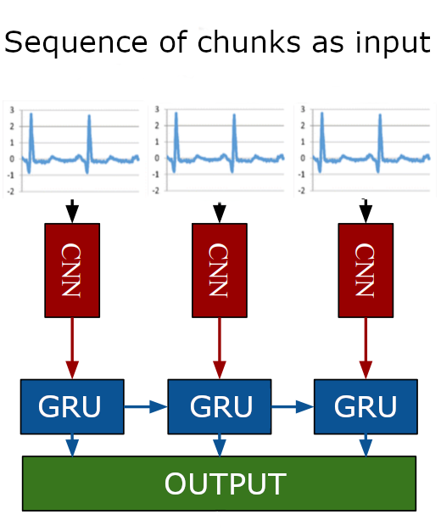

Fig. 2. ECG chunks classification with a Recurrent Convolutional Network

**Problem statement and motivation. Please provide a general description of the problem that you worked on, a short description of why this is relevant, and a few sentences that state precisely what you aimed at:**

Sleep apnea is a common organic sleep disorder; it is estimated to affect about 100 million people world-wide (Franklin et. al, 2015). This disorder creates frequent pauses of breathing during sleep which causes the brain to wake up every time to start breathing again and therefore leads to improper sleep. People suffering from this disease can experience drowsiness during the day or even more serious health risks such as cardiovascular or cerebrovascular diseases, as it is a cause of medical morbidity and mortality.

Currently, diagnosis of sleep apnea requires a long process and several tools. In recent years, researchers have developed techniques to detect OSA using less information, such as from single-lead ECG recordings. From these recordings, often time, time-frequency and frequency features are computed and subsequently used for machine learning algorithms. Examples are Support Vector Machines (SVM) (Khandoker et. al, 2009), Recurrent Neural Networks (RNN) (Cheng et. al, 2017) and Hidden Markov Models and Deep Learning (Li et. al, 2018).

While the accuracy is steadily improving over the years, the techniques proposed are mostly only valid for the sleep apnea case. However, it would be of much more use if it were possible to develop a technique that could be applied to other medical problems that can be detected by changes in the ECG over time e.g ischemia since the current diagnosis is based on a treadmill test which may cause harm to the patient and the test would not be necessary anymore.

We want to compare different representations of the data to find out which are suited better than others for classification and which features are the most important for those. Another aim is to find out if Transfer Learning from a Convolutional Neural Network (CNN) can be used for this task and if furthermore combining CNNs with RNNs can improve the accuracy (see fig. 2).

**Research questions and/or hypothesis: explain the questions/hypothesis that you addressed during your project:**

* Can CNNs classify *one minute* signals to apnea vs non-apnea events?
* Can transfer learning be used based on the CNNs pre-trained on ImageNet (Deng et. al, 2009) instead of training a whole CNN from scratch?
* Can combining CNNs with RNNs improve accuracy taking into account timing?
* What signal representation is better suited for the classification?
  + Signal in time or time-frequency domain?
  + What are the most relevant features for such classification in different representations?

**Major outcomes of your project. Please provide up to seven major outcomes of your project. These should be formulated in a clear but compact way:**

* --

**References: Provide possible references you are using in your text in the APA standard. Use e.g. Google Scholar to obtain references in the correct format:**

Franklin, K. A., &amp; Lindberg, E. (2015). Obstructive sleep apnea is a common disorder in the population—a review on the epidemiology of sleep apnea. Journal of Thoracic Disease, 7(8), 1311-1322

Cheng, M., Sori, W.J., Jiang, F., Khan, A., Liu, S. (2017). Recurrent Neural Network Based Classification of ECG Signal Features for Obstruction of Sleep Apnea Detection. 2017 IEEE International Conference on Computational Science and Engineering (CSE) and IEEE International Conference on Embedded and Ubiquitous Computing (EUC)

Li, K., PanWeifeng, Li, Y., Jiang Q., Liu, G. (2018). A method to detect sleep apnea based on deep neural network and hidden Markov model using single-lead ECG signal. Neurocomputing, 294, 94-101

Khandoker, A.H., Palaniswami, M. (2009). Automated recognition of patients with obstructive sleep apnoea using wavelet-based features of electrocardiogram recordings. Computers in Biology and Medicine, 39(1), 88-96

Deng, J., Dong, W., Socher, R., Li, L.-J., Li, K. & Li, F.-F. (2009). ImageNet: A large-scale hierarchical image database. CVPR, 248-255.

**Any additional information you would like to be mentioned:**

???

**To be filled by supervisors (dear supervisors: delete what you do not want):**

◻ I agree that this project is posted on the DKE student projects webpage. (Feel free to make any modifications to the text/material provided by your students.)

◻ I agree that the final project report is uploaded to the DKE student projects webpage.

◻ I agree that the final presentation is uploaded to the DKE student projects webpage.

◻ I agree that movies provided by the students are uploaded to the DKE Youtube channel and shown on the DKE student projects webpage.