Antonio Monje

CS481

10/6/2017

Assignment 5

This one took me a little longer getting used to binding and using the observable class. But I think I made everything work right using binding. It was difficult to show the refreshing on a screen shot though.

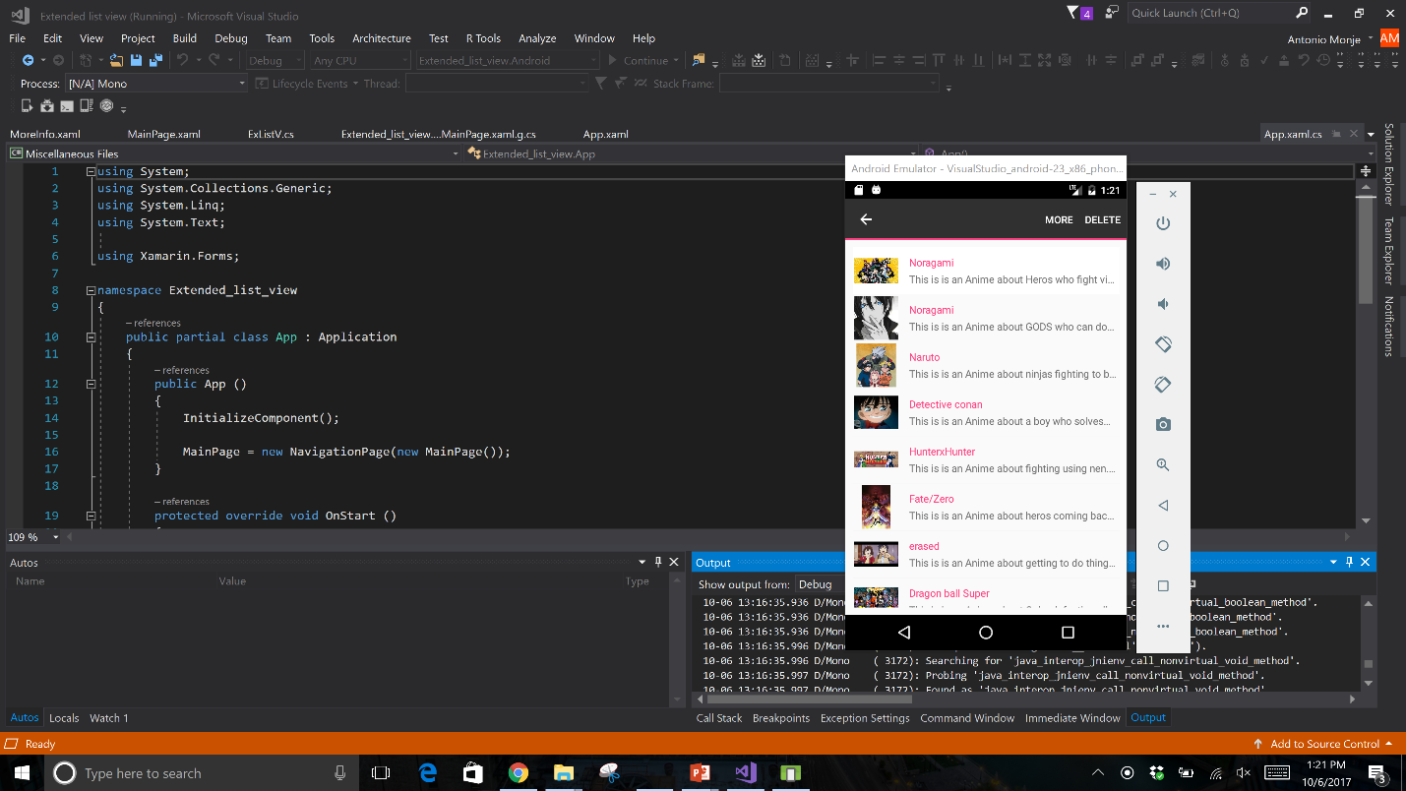List showing the context menu when you hold down

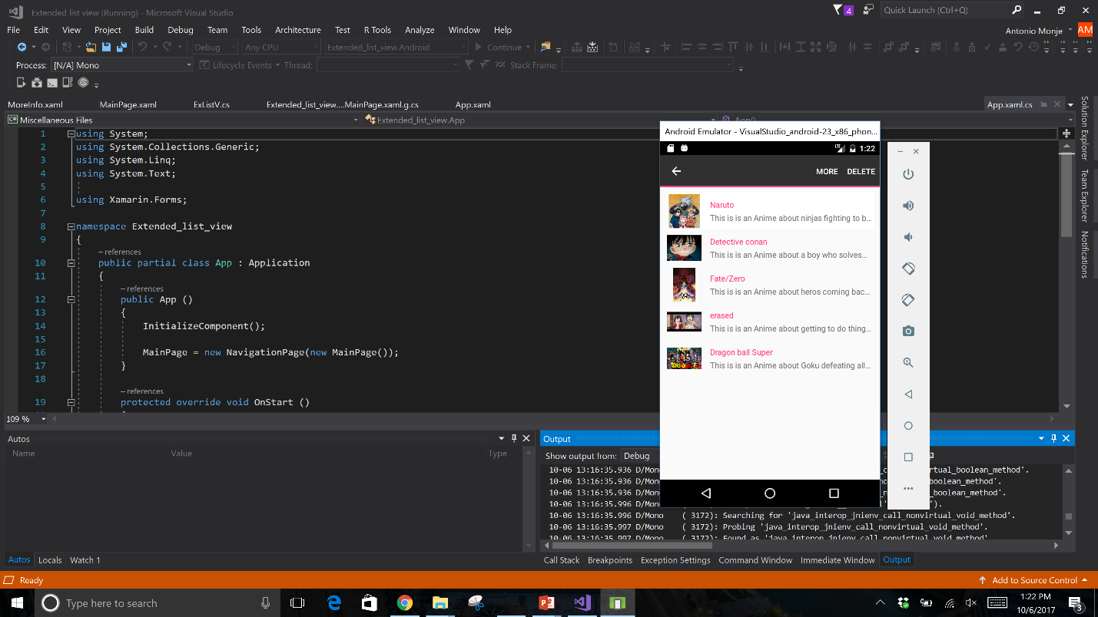3 Deleted items from the list depending on which item I clicked on to delete

Refreshed list after you pull it down

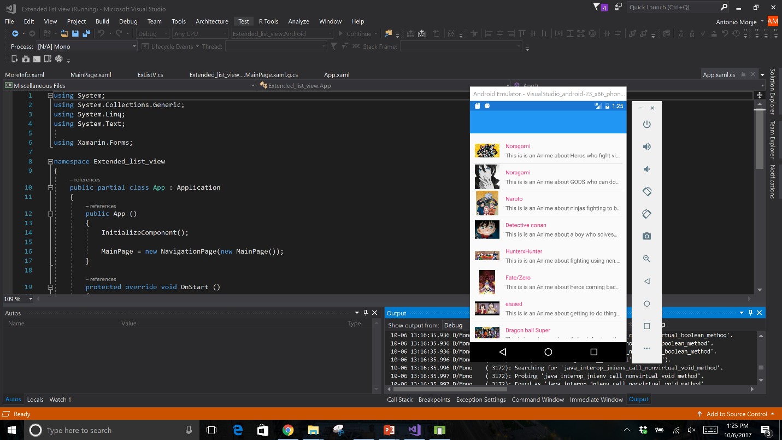

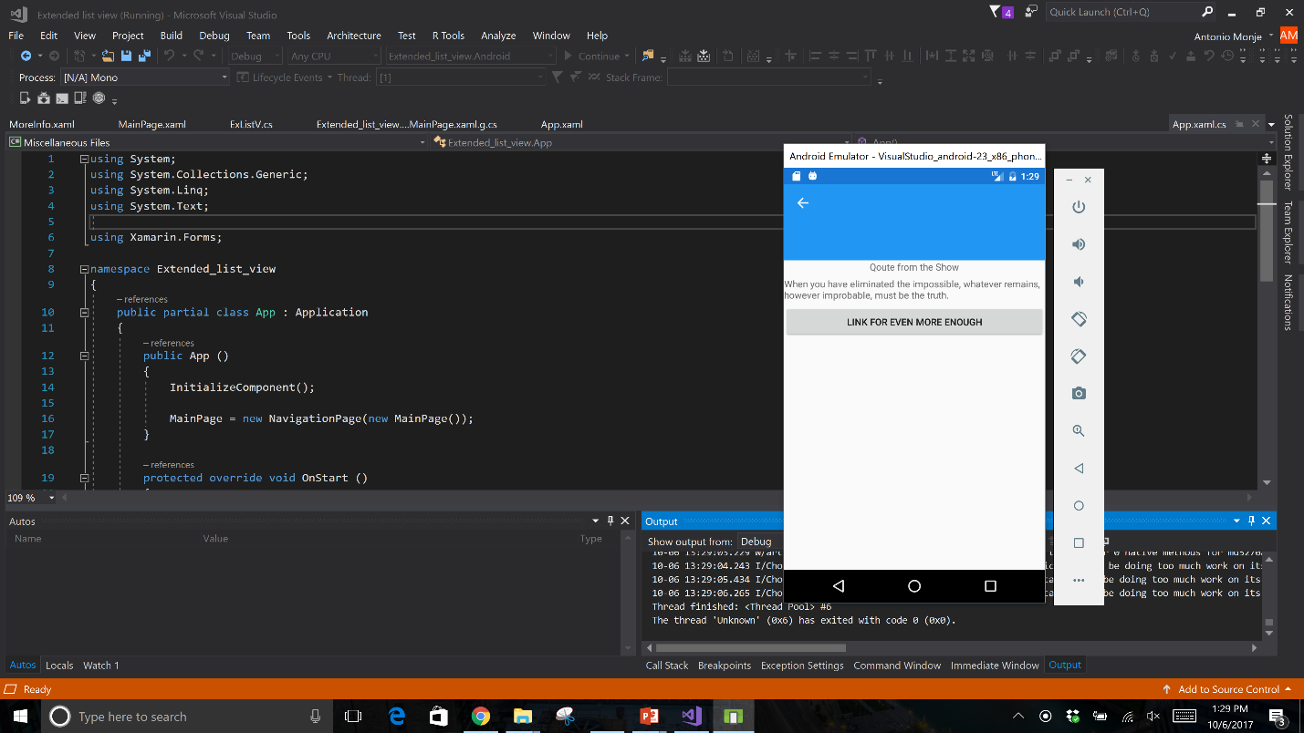More information context menu takes you here depending on which cell you picked it shows that animes quote and a link to a webpage with more information.