Game Boy Camera Technical Information v1.0

by Antonio Niño Díaz (AntonioND)
antonio_nd@outlook.com
03/2015


Antonio Niño Díaz (AntonioND), 2015

This work is licensed under the Creative Commons Attribution 4.0 International License. To view a copy of this license, visit http://creativecommons.org/licenses/by/4.0/.

Introduction
Some years ago (about 2010) I tried to emulate the Game Boy Camera by using its ROM and the sensor datasheet (which is really bad). There was a lot to guess so I couldn't emulate it completely. Since there is no documentation about the Game Boy Camera I decided it was time to document it, but I really couldn't do much without doing tests in the cartridge itself.
This time I've used Arduino to send commands to the cartridge and to read the sensor pins to know how they are translated. This means that I can know how the controller works so I only need to know how the sensor works. I've used the datasheets from sensors M64283FP and M64285FP (the Game Boy Camera has a M64282FP) to understand the things I couldn't before.
I've tried to explain all of the inner workings, enough to interface the cartridge using custom hardware or software and, of course, enough to emulate it correctly!

The Game Boy Camera Cartridge
The Game Boy Camera cartridge contains 4 ICs: the usual ROM and RAM ICs, a big controller IC (like a MBC) and a sensor (M64282FP "retina" chip).
The main board contains all ICs except from the sensor. From GBDev wiki:
Component# | Part#/inscription | Description
U1 | MAC-GBD  Nintendo  9807 SA | I/O, memory control.
U2 | GBD-PCAX-0 F  M538011-E - 08  8145507 | 1MB ROM
U3 | 52CV1000SF85LL  SHARP JAPAN  9805 5 0A | 128KB RAM
The U1 is the only one connected to the GB cartridge pins (besides some of the address pins of the ROM IC). The U2 and U3 (ROM and RAM) are connected to U1. The M64282FP "retina" chip is in a separate PCB, and is connected to the U1.
The M64282FP handles most of the configuration of the capturing process. The U1 transforms the commands from the Game Boy CPU into the correct signals needed for the M64282FP. The detailed timings are described below.
It is a good idea to have the datasheet of the M64282FP, but it is very poorly explained, so this document will try to explain everything about it (except from limits like voltage or signal timings). There are datasheets of similar sensors (M64283FP and M64285FP) that can be very useful to understand some things about the sensor of the GB Camera.

Game Boy Camera MBC
The Game Boy Camera controller works pretty much the same as a MBC3.
0000-3FFF - ROM Bank 00 (Read Only)
First 16 KB of the ROM.
4000-7FFF - ROM Bank 01-3F (Read Only)
This area may contain any ROM bank (0 included). The initial mapped bank is 01.
A000-BFFF - RAM Bank 00-0F (Read/Write)
A000-BFFF - CAM Registers (Read/Write)
Depending on the current RAM Bank Number, this memory space is used to access the cartridge RAM or the CAM registers.
0000-1FFF - RAM Enable (Write Only)
A value of 0Ah will enable writing to RAM, 00h will disable it. Reading from RAM or registers is always enabled. Writing to registers is always enabled. Disabled on reset.
2000-3FFF - ROM Bank Number (Write Only)
Writing a value of 00-3Fh selects the corresponding ROM Bank for area 4000-7FFF.
4000-5FFF - RAM Bank Number/CAM Registers Select (Write Only)
Writing a value in range for 00h-0Fh maps the corresponding external RAM Bank to memory at A000-BFFF. Writing any value with bit 5 set to '1' will select CAM registers. Usually bank 10h is used to select the registers. All registers are mirrored every 80h bytes. RAM bank 0 selected on reset.
IMPORTANT NOTE: Unlike most games, the GB Camera RAM can only be written when PHI pin = '1'. It's an enable signal for the RAM chip. Most cartridge readers and writers can't handle PHI pin so they can't restore a saved backup. It isn't needed to change ROM banks.

Game Boy Camera I/O Registers
The Game Boy Camera I/O registers are mapped to all banks with bit 4 set to '1'. The GB Camera ROM usually changes to bank 16 to use the registers.
There are 3 groups of registers:
- The first group is composed by the trigger register A000. This register starts the capture process and returns the current status (working/capture finished).
- The second group is composed by registers A001-A005, used to configure most parameters of the M64282FP sensor.
- The third group is composed by 48 registers that form a 4×4 matrix. Each element of the matrix is formed by 3 bytes. This matrix is used by the controller for contrast and dithering.
All registers are write-only, except the register A000. The others return 00h when read. The initial values of all registers on reset is 00h.

Register A000
The lower 3 bits of this register can be read and write. The other bits return '0'. Writing any value with bit 0 set to '1' will start the capturing process. Any write with bit 0 set to '0' is ignored.
The value of bits 1 and 2 affects the value written to registers 4, 5 and 6 of the M64282FP, which are used in 1-D filtering mode (effects described in following chapters).
Bit 0 of this register is also used to verify if the capturing process is finished. It returns '1' when the hardware is working and '0' if the capturing process is over.
When the capture process is active all RAM banks will return 00h when read, but the register A000 can still be read to know when the transfer is finished.
The capturing process can be stopped by writing a '0' to bit 0. When a '1' is written again it will continue the previous capture process with the old capture parameters, even if the registers are changed in between.

Register A001
This register is mapped to register 1 of M64282FP. It controls the output gain and the edge operation mode.

Registers A002, A003
This registers are mapped to registers 2 and 3 of M64282FP. They control the exposure time. Register 2 is the MSB, register 3 is the LSB.
u16 exposure_steps = [A003] | ([A002]<<8);

Register A004
This register is mapped to register 7 of M64282FP. It sets the output voltage reference, the edge enhancement ratio and can invert the image.

Register A005
This register is mapped to register 0 of M64282FP. It sets the output reference voltage and enables the zero point calibration.

Registers A006-A035
Those registers form a 4×4 matrix with 3 bytes per element. They handle dithering and contrast, and they are sorted by rows:
 | X
Y | 00 | 10 | 20 | 30
Y | 01 | 11 | 21 | 31
Y | 02 | 12 | 22 | 32
Y | 03 | 13 | 23 | 33

A006 | A007 | A008 | A009 | A00A | A00B | A00C | A00D | A00E | A00F | A010 | A011
D00L | D00M | D00H | D10L | D10M | D10H | D20L | D20M | D20H | D30L | D30M | D30H
A012 | A013 | A014 | A015 | A016 | A017 | A018 | A019 | A01A | A01B | A01C | A01D
D01L | D01M | D01H | D11L | D11M | D11H | D21L | D21M | D21H | D31L | D31M | D31H
A01E | A01F | A020 | A021 | A022 | A023 | A024 | A025 | A026 | A027 | A028 | A029
D02L | D02M | D02H | D12L | D12M | D12H | D22L | D22M | D22H | D32L | D32M | D32H
A02A | A02B | A02C | A02D | A02E | A02F | A030 | A031 | A032 | A033 | A034 | A035
D03L | D03M | D03H | D13L | D13M | D13H | D23L | D23M | D23H | D33L | D33M | D33H
This values are used for the contrast and dithering effects in the following way for each pixel at position (X,Y):
- The sensor outputs an analog value. This value is compared to the corresponding group of 3 values of the matrix probably using 3 DACs and 3 comparators (clock timings doesn't affect the result when converting from analog to digital, most ADCs would be affected).
- This value is compared to the corresponding group of 3 values of the matrix. To know what group of 3 values to use do (X mod 4) and (Y mod 4).
- The controller performs the following operations:
if ( sensor_value < DxyL ) gb_shade = black;
else if ( sensor_value < DxyM ) gb_shade = dark_gray;
else if ( sensor_value < DxyH ) gb_shade = light_gray;
else gb_shade = white;

This means that the minimum value to show a different color than white is 01h. A value of 00h in the 3 values will always show a white screen. A value of FFh in the 3 bytes will always allow some white pixels in a black background.
If two values are the same, the second comparison will be ignored. If the values are reversed (the higher bytes have lower values) that values are ignored. The previous comparisons explain that kind of behaviors.
To disable dithering all groups of 3 values must be the same. Dithering is obtained by doing small variations in the values of each one of the 4×4 groups.
The digital-to-analog conversion is not linear in the sense that a signal of 0V doesn't correspond to a digital value of 00h, it's affine: A value of 00h is around 0.8V and a value of FFh is around 4.1V. Note that the sensor has a 5.0V supply. That means that the value range is approximately 3.3V, but it can't be reached by the sensor output. The sensor can only output from approximately 0.9V to 4.0V (by modifying Vref and other configuration values). The previous limits have been determined by extrapolating, since the values are completely linear (if the offset at 00h is ignored).
According to the sensor datasheet the output voltage range is 2.0V peak to peak. The actual range seems to be up to 3.15V depending on the register configurations. That's the range of values that the controller has to convert into 4 Game Boy gray shades.

Game Boy Camera timings
The capture process is started when the A000 register of the Game Boy Camera cartridge is written any value with bit 0 set to '1'.
The Game Boy Camera cartridge is one of the few cartridges that use the PHI signal (clock from the GB). That signal is a 1MHz clock (1048576 Hz). The M64282FP chip needs a clock input too, which is half the frequency of the PHI pin (0.5 MHz, 524288Hz). The reason for that is that the sensor chip sometimes handles the signals on the rising edge of the clock but other times on the falling edge. NOTE: This means that the GB Camera shouldn't be used in GBC double speed mode!
The time needed to capture and process an image depends on the exposure time and the value of the N bit of the register 1 of the M64282FP chip.
In GAME BOY CYCLES (1MHz):
N_bit = ([A001] & BIT(7)) ? 0 : 512
exposure = ([A002]<<8) | [A003]
CYCLES = 32446 + N_bit + 16 * exposure

Divide that values by 2 to get the sensor clocks.

Capture process timings
The next values are in sensor clocks. Multiply by 2 to get Game Boy cycles.
- Reset pulse.
- Configure sensor registers. (11 x 8 CLKs)
- Wait (1 CLK)
- Start pulse (1 CLK)
- Exposure time (exposure_steps x 8 CLKs)
- Wait (2 CLKs)
- Read start
- Read period (N=1 ? 16128 : 16384 CLKs)
- Read end
- Wait (3 CLKs)
- Reset pulse to stop the sensor

(88 + 1 + 1 + 2 + 16128 + 3 = 16223)

CLKs = 16223 + ( N_bit ? 0 : 256 ) + 8 * exposure

Obviously, that's the previous result divided by 2.
During the read process every pixel is written when it is read from the sensor. If the read process is stopped (by shutting the GB down, for example) the RAM will have the contents of the current picture until the read was stopped, from there it will have the data from the image captured before that one. The sensor transfers 128×128 pixels, but the upper and lower rows are corrupted. The Game Boy Camera controller only uses the medium rows of the sensor image. This means that it ignores the first 8 rows and the last 8 rows.
The clock signal during read period must be the same as the one used during the exposure time. If the clock during the read period is too slow the sensor will continue increasing the charge values of each pixel so the image will appear to be taken with a higher exposure time. The brightness doesn't seem to increase always, there seems to be some kind of limit.

The Game Boy Camera sensor (M64282FP)
The M64282FP does some processing to the captured image. First it performs an edge control, then it does gain control and last it does level control. The resulting analog value is the one that can be read in Vout pin.

The M64282FP registers

Register 1
Values written by Game Boy camera ROM at boot: 00h, 0Ah, 20h, 24h, 28h, E4h, E8h.
When shooting the values change based on how much light there is: 0Ah, E4h, E8h.
Symbol | Bits | Operation
N | 7 | Exclusively set vertical edge enhancement mode.
VH | 5-6 | Select vertical/horizontal edge operation mode.
G | 0-4 | Analog output gain.
The 2 modes used by the Game Boy Camera are 1-D filtering and 2D edge enhancement.
G3 | G2 | G1 | G0 | Gain
0 | 0 | 0 | 0 | 14.0
0 | 0 | 0 | 1 | 15.5
0 | 0 | 1 | 0 | 17.0
0 | 0 | 1 | 1 | 18.5
0 | 1 | 0 | 0 | 20.0
0 | 1 | 0 | 1 | 21.5
0 | 1 | 1 | 0 | 23.0
0 | 1 | 1 | 1 | 24.5
1 | 0 | 0 | 0 | 26.0
1 | 0 | 0 | 1 | 29.0
1 | 0 | 1 | 0 | 32.0
1 | 0 | 1 | 1 | 35.0
1 | 1 | 0 | 0 | 38.0
1 | 1 | 0 | 1 | 41.0
1 | 1 | 1 | 0 | 45.5
1 | 1 | 1 | 1 | 51.5
If G4='1' the total gain is the previous one plus 6dB. The Game Boy Camera uses 00h, 04h, 08h and 0Ah. They are 14.0dB, 20.0dB, 26.0dB and 32dB, which translate to a gain of 5.01, 10.00, 19.95 and 39.81. The Game Boy Camera seems to like to duplicate the gain in each step.

Registers 2 and 3
They contain the exposure time (16 bit unsigned value). According to the M64282FP datasheet each step is 16 µs. In the GB it needs 16 PHI clocks for every step. If N='1' exposure_steps should be greater or equal than 0030h.
u16 exposure_steps = ([Reg2]<<8) | [Reg3]
Step time = 1 / 1048576 Hz * 16 = 0,954 µs * 16 = 15,259 µs

It's a bit less than the 16 µs the datasheet says, but it's close enough. Some example values to get acceptable pictures under various light conditions:
Value | Conditions
0030h | Objects under direct sunlight.
0300h | Objects not under direct sunlight.
0800h | Room during the day with good light.
2C00h | Room at night with light.
5000h | Room at night with no light, only a reading lamp.
F000h | Room at night with only a TV on in the background.
Those values are illustrative, and they are important because the exposure time affects the time that is needed to take a picture.

Registers 4, 5 and 6
They are used by the 1-D processing kernel. They can't be set to any value from the GB Camera cartridge, only to 3 defined sets of values. The value of X must be fixed to 01h according to the datasheet. The values of P and M can't be modified if N='1', they are set to automatic values.
[A000] | [4]=P | [5]=M | [6]=X | Description
1(001) | 00h | 01h | 01h | Negative
3(011) | 01h | 00h | 01h | Positive. This is the value the GB Camera ROM uses.
5(101) | 01h | 02h | 01h | Used for edge detection
7(111) | 01h | 02h | 01h | Used for edge detection

Register 7
At boot is written: 01h – 0Fh, 23h – 27h. At the end of the boot sequence 07h is written and it stays like that forever.
Symbol | Bits | Operation
E | 4-7 | Edge enhancement ratio
I | 3 | Select inverted/non-inverted output
V | 0-2 | Output node bias voltage (Vref)
The final value sets the configuration to: Vref = 3.5V, edge enhancement ratio = 50%, image not inverted.
E2 | E1 | E0 | Edge Enhancement Ratio |  | V2 | V1 | V0 | Vref(V)
0 | 0 | 0 | 50% |  | 0 | 0 | 0 | 0.0
0 | 0 | 1 | 75% |  | 0 | 0 | 1 | 0.5
0 | 1 | 0 | 100% |  | 0 | 1 | 0 | 1.0
0 | 1 | 1 | 125% |  | 0 | 1 | 1 | 1.5
1 | 0 | 0 | 200% |  | 1 | 0 | 0 | 2.0
1 | 0 | 1 | 300% |  | 1 | 0 | 1 | 2.5
1 | 1 | 0 | 400% |  | 1 | 1 | 0 | 3.0
1 | 1 | 1 | 500% |  | 1 | 1 | 1 | 3.5

Register 0
At boot is written: 3Fh, 80h, A0h, B0h, B8h, BCh, BEh, BFh.
At the end of the boot sequence BFh is written and it stays like that forever (calibration for positive signal, +1V output reference voltage).
Symbol | Bits | Operation
Z | 6-7 | Zero point calibration (Set dark level output signal to Vref)
O | 0-5 | Output reference voltage (In both plus and minus direction)
The two calibration modes that are used are '10' (calibration for positive signal) and '00' (disabled). Note: The undefined Z='11' configuration is the same as Z='00'. The unused configuration Z='01' is used for calibration for negative signal.
The reference voltage is adjusted in 32mV steps, with the most significant bit being the sign (O5='1' is positive). The output reference voltage is calculated like this:
int reg_offset = REG[0] & 0x1F;
float offset_step = ( (reg_offset & 0x20) ? 0.032 : -0.032 )
float OFFSET = offset_step * (reg_offset & 0x1F)

M64282FP image processing
The image processing is done in three stages: Edge control, gain control and level control.

Edge control
Note that, before any edge processing, the inverting bit of register 7 is processed. The edge processing type depends on the value of registers N, VH and E. If 1-D filtering is enabled, the registers P, M and X are also used. If N is set to '1' the registers P and M are ignored as they are used by the 3×3 filtering kernel (so changing the value used to trigger the capture doesn't change the resulting image). When using edge extraction modes Z1 should be set to '0'. In any other cases, it should be set to '1'.
N | VH1 | VH0 | E3 | Description | 1-D enabled | 3×3 filtering matrix kernel
0 | 0 | 0 | 0 | Positive image | Yes | Disabled.
0 | 0 | 1 | 0 | Horiz. enhancement | Yes | 0 0 0 | -1 3 -1 | 0 0 0
0 | 0 | 1 | 1 | Horiz. extraction | Yes | 0 0 0 | -1 2 -1 | 0 0 0
1 | 1 | 0 | 0 | Vert. enhancement | No | 0 -1 0 | 0 3 0 | 0 -1 0
1 | 1 | 0 | 1 | Vert. extraction | No | 0 -1 0 | 0 2 0 | 0 -1 0
1 | 1 | 1 | 0 | 2D enhancement | No | 0 -1 0 | -1 5 -1 | 0 -1 0
1 | 1 | 1 | 1 | 2D extraction | No | 0 -1 0 | -1 4 -1 | 0 -1 0
Table 1: Edge processing modes.

Other combinations are undefined and shouldn't be used. The Game Boy Camera ROM doesn't use them, so there are no problems, only 1-D filtering and 2D edge enhancement are used.
- 1-D filtering mode
When using edge extraction, Z1 should be '0'. It uses the P, M and X registers like this:
P, M and X are bitmasks. The bits set to '1' select lines of the image. The lines selected in P register are added, the ones in M register are subtracted. If the 2 bits of the same line are set to '1' the result is the same as if they were '0'. According to the datasheet, the X register must be set to '01h', the Game Boy Camera does it automatically. The three possible configurations depending on the value written to A000 register when triggering the capture are:
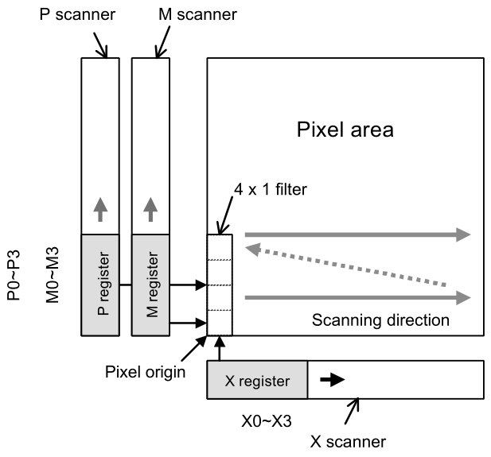Figure 1: 1-D filtering hardware.
[A000] | [4]=P | [5]=M | [6]=X | Description
1(001) | 00h | 01h | 01h | Negative. Figure 3.
3(011) | 01h | 00h | 01h | Positive. Figure 2.
5(101) | 01h | 02h | 01h | Used for edge extraction. Figure 4.
7(111) | 01h | 02h | 01h | Used for edge extraction. Figure 4.
The three following images show how it works:
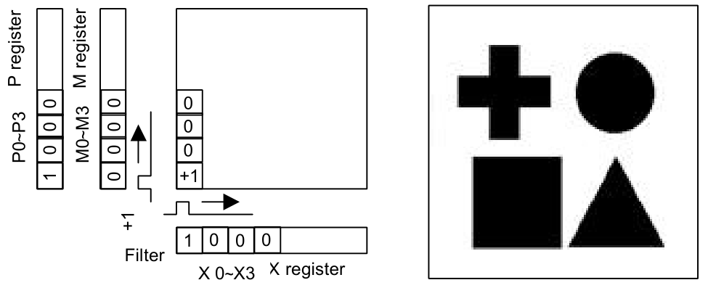Figure 2: Positive image.

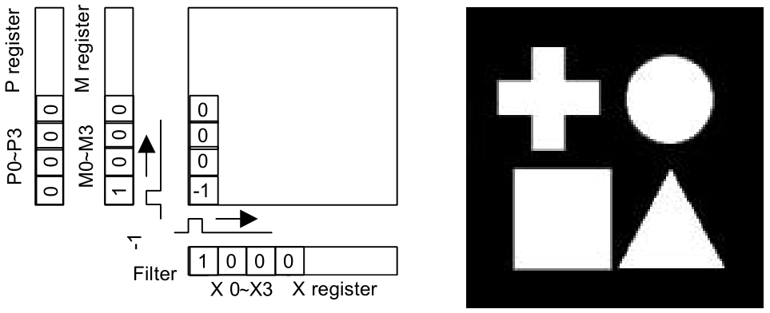Figure 3: Negative image.
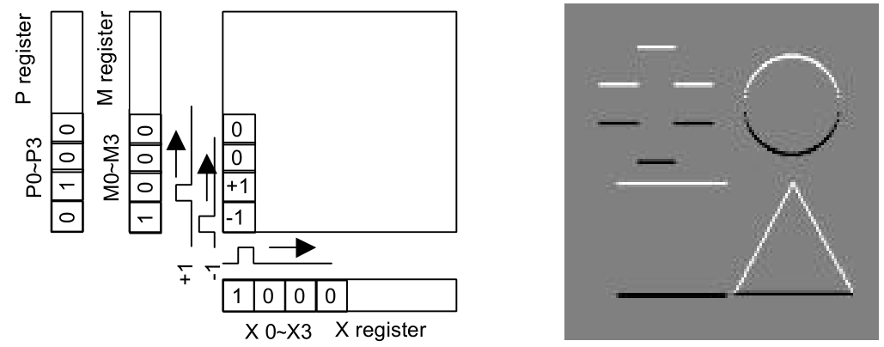Figure 4: Edge extraction.
- 3×3 filtering matrix kernel
This consists on a 3×3 matrix. The configuration values to use each mode and the resulting values used to calculate the final image are specified in Table 1. The following expressions are used to calculate the result (α: edge enhancement ratio):
Edge mode | Operation
Vertical edge extraction | {2P-(MN+MS)} × α
Horizontal edge extraction | {2P-(MW+ME)} × α
2D edge extraction | {4P-(MN+MS+ME+MW)} × α
Vertical edge enhancement | P + {2P-(MN+MS)} × α
Horizontal edge enhancement | P + {2P-(MW+ME)} × α
2D edge enhancement | P + {4P-(MN+MS+ME+MW)} × α

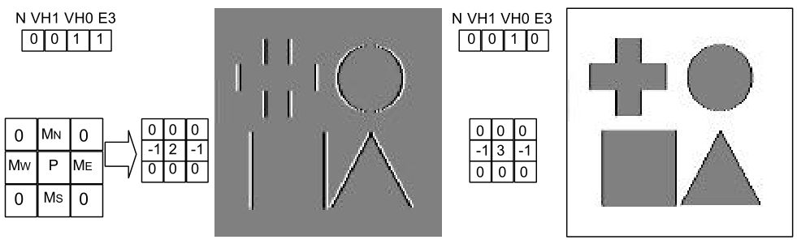Figure 5: Horizontal edge processing modes.
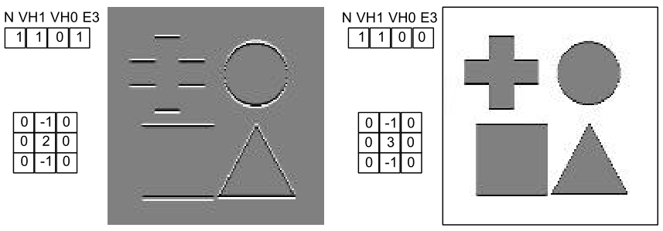Figure 6: Vertical edge processing modes.

Gain control
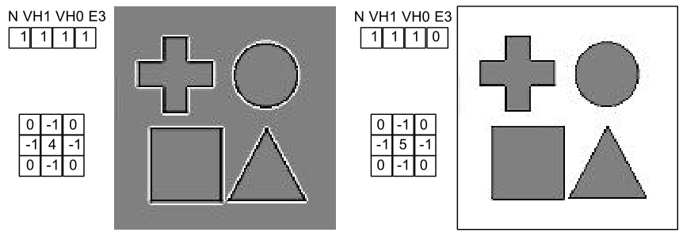Figure 7: 2D edge processing modes.

aaaaaaaaaaaa

Level control
aaaaaaaaaaaaaaaa

Original [0V,5V]
Invert [0V,5V]
1-D filter [0V,5V]
3x3 kernel [0V,5V]

Offset [0V,5V]
Gain -> Origin is 2.5 V [0V,5V]

Vref [0V,5V]

SATURATION [0.9V, 4.0V]
Final output

ZERO OFFSET?

GAMMA? IR?

Registers 6..35h

Max Light Min Light
For example (normal mode, high light): 00112233445566778899AABBCCDDEEFF (input color range 0 - 255)
- Min. contrast (0): 80 8F D0 -> 00000000000000001122222222233333 (output gb palete 0-3)
- Med. contrast (7): 89 92 A2 -> 00000000000000000122333333333333
- Max. contrast (F): 92 92 92 -> 00000000000000000033333333333333
Black White

Normal mode

First 3 values of dithering mode, repeated 48/3 = 16 times

Dithering mode

High light

Reg 6 7 8 9 A B C D E F 10 11 12 13 14 15 16 17 18 19 1A 1B 1C 1D 1E 1F 20 21 22 23 24 25 26 27 28 29 2A 2B 2C 2D 2E 2F 30 31 32 33 34 35
Min contrast
80 8F D0 8B BF E0 82 9B D4 8E CB E4 87 AF DB 83 9F D5 8A BB DF 86 AB D9 81 97 D2 8D C7 E3 80 93 D1 8C C3 E1 89 B7 DD 85 A7 D8 88 B3 DC 84 A3 D6
82 90 C8 8C BA DC 84 9A CD 8F C4 E1 89 AC D5 85 9E CE 8B B6 DA 88 A8 D3 83 97 CB 8E C1 DF 82 93 C9 8D BD DD 8A B3 D8 87 A5 D2 89 AF D7 86 A1 D0
84 90 C0 8D B4 D8 86 99 C6 8F BD DE 8A A8 D0 87 9C C8 8C B1 D6 89 A5 CE 85 96 C4 8E BA DC 84 93 C2 8D B7 DA 8B AE D4 88 A2 CC 8A AB D2 87 9F CA
85 91 B8 8E AE D3 87 98 BE 90 B5 DA 8B A4 CA 88 9A C1 8D AB D1 8A A2 C8 86 95 BC 8F B3 D8 85 93 BA 8E B0 D6 8C A9 CF 89 9F C5 8B A6 CC 88 9D C3
86 91 B1 8E A9 D0 88 97 B8 90 AF D8 8B A1 C6 88 99 BB 8D A7 CD 8A 9F C3 87 95 B6 8F AD D5 86 93 B3 8E AB D3 8C A5 CB 8A 9D C0 8C A3 C8 89 9B BE
87 92 AA 8F A4 CC 89 96 B2 91 A8 D5 8C 9E C1 89 98 B5 8E A2 C9 8B 9C BE 88 95 AF 90 A7 D2 87 93 AC 8F A5 CF 8D A1 C6 8B 9B BB 8D 9F C3 8A 99 B8
88 92 A5 8F A0 C9 89 95 AE 91 A3 D2 8D 9B BD 8A 96 B1 8E 9F C6 8C 9A BA 89 94 AB 90 A2 CF 88 93 A8 90 A1 CC 8E 9D C3 8B 99 B7 8D 9C C0 8B 97 B4
89 92 A2 8F 9E C6 8A 95 AB 91 A1 CF 8D 9A BA 8B 96 AE 8F 9D C3 8C 99 B7 8A 94 A8 90 A0 CC 89 93 A5 90 9F C9 8E 9C C0 8C 98 B4 8E 9B BD 8B 97 B1
8A 92 A1 90 9D BE 8B 94 A8 91 A0 C5 8E 99 B4 8C 95 AA 8F 9C BB 8D 98 B2 8B 93 A5 91 9F C3 8A 92 A3 90 9E C0 8F 9B B9 8D 97 AF 8E 9A B6 8C 96 AD
8B 92 A0 90 9C B6 8C 94 A5 91 9F BC 8E 99 AF 8C 95 A7 8F 9B B4 8E 98 AD 8B 93 A3 91 9E BA 8B 92 A1 90 9D B8 8F 9A B2 8D 97 AB 8E 99 B0 8D 96 A9
8C 92 9E 90 9B AE 8D 94 A2 91 9D B2 8F 98 A9 8D 95 A3 90 9A AD 8E 97 A7 8C 93 A0 91 9C B1 8C 92 9F 90 9B AF 8F 99 AB 8E 96 A6 8F 98 AA 8D 95 A4
8D 92 9C 90 99 A8 8D 93 9F 91 9B AB 8F 97 A4 8E 94 A0 90 98 A7 8F 96 A3 8D 93 9E 91 9A AA 8D 92 9D 91 9A A9 90 98 A6 8E 95 A2 8F 97 A5 8E 95 A1
8E 92 9B 91 98 A2 8E 93 9C 91 9A A4 90 96 A0 8F 94 9D 90 98 A1 8F 95 9F 8E 93 9C 91 99 A3 8E 92 9B 91 99 A3 90 97 A1 8F 95 9E 90 97 A0 8F 94 9E
8F 92 99 91 97 9E 8F 93 9A 91 98 9F 90 95 9C 8F 93 9A 91 96 9D 90 95 9C 8F 92 99 91 98 9F 8F 92 99 91 97 9E 90 96 9D 90 94 9B 90 95 9C 8F 94 9B
90 92 97 91 95 99 90 92 97 91 96 99 91 94 98 90 93 97 91 95 99 90 94 98 90 92 97 91 96 99 90 92 97 91 96 99 91 95 98 90 93 98 91 94 98 90 93 97
92 92 92 92 92 92 92 92 92 92 92 92 92 92 92 92 92 92 92 92 92 92 92 92 92 92 92 92 92 92 92 92 92 92 92 92 92 92 92 92 92 92 92 92 92 92 92 92
Max contrast

Low light

Reg 6 7 8 9 A B C D E F 10 11 12 13 14 15 16 17 18 19 1A 1B 1C 1D 1E 1F 20 21 22 23 24 25 26 27 28 29 2A 2B 2C 2D 2E 2F 30 31 32 33 34 35
Min contrast
80 94 DC 8F CA F6 83 A1 E2 92 D7 FC 8A B8 ED 85 A6 E4 8D C5 F4 88 B3 EB 82 9D E0 91 D3 FA 81 98 DE 90 CE F8 8C C1 F1 87 AF E9 8B BC EF 86 AA E6
82 95 D2 90 C2 F3 85 A0 DA 93 CE FC 8B B3 E8 86 A4 DD 8F BE F0 8A AF E5 84 9C D7 92 CA F9 83 98 D4 91 C6 F6 8D BB EE 89 AB E2 8C B7 EB 87 A8 E0
84 96 CA 91 BD F1 87 9F D3 94 C6 FB 8D B0 E4 88 A3 D7 90 B9 EE 8B AC E1 86 9C D0 93 C3 F8 85 99 CD 92 C0 F5 8F B6 EB 8A A9 DD 8E B3 E7 89 A6 DA
86 96 C4 92 B8 F0 89 9E CF 95 C1 FB 8E AD E1 8A A1 D2 91 B5 EC 8D AA DD 88 9B CB 94 BE F7 87 98 C7 93 BB F3 90 B2 E8 8C A7 DA 8F AF E5 8B A4 D6
88 97 BE 93 B4 EE 8A 9E CA 96 BB FA 8F AA DE 8B A0 CE 92 B1 EA 8E A8 DA 89 9B C6 95 B9 F6 88 99 C2 94 B6 F2 91 AF E6 8D A5 D6 90 AC E2 8C A3 D2
8A 97 B8 93 AF ED 8C 9D C5 96 B5 FA 90 A7 DB 8D 9F C9 92 AD E8 8F A5 D7 8B 9B C0 95 B3 F6 8A 99 BC 94 B1 F1 92 AB E4 8E A3 D2 91 A9 DF 8E A1 CE
8B 98 B2 94 AB E4 8D 9C BE 97 B0 F0 91 A5 D3 8E 9E C2 93 A9 E0 90 A3 CF 8C 9B BA 96 AE EC 8B 99 B6 95 AD E8 93 A8 DB 8F A1 CB 92 A6 D7 8F A0 C6
8C 98 AC 95 A7 DB 8E 9B B7 97 AA E7 92 A2 CB 8F 9D BB 94 A5 D7 91 A0 C7 8D 9A B3 96 A9 E3 8C 99 AF 95 A8 DF 93 A4 D3 90 9F C3 92 A3 CF 8F 9E BF
8D 98 AA 95 A5 D0 8F 9B B3 97 A8 D9 92 A1 C3 8F 9C B6 94 A4 CD 91 9F C0 8E 9A B0 96 A7 D6 8D 99 AD 95 A6 D3 93 A3 C9 91 9E BD 93 A2 C6 90 9D B9
8E 98 A8 95 A4 C6 8F 9B AF 97 A7 CD 93 A0 BC 90 9C B2 94 A3 C3 92 9F B9 8F 9A AD 96 A6 CB 8E 99 AA 96 A5 C8 94 A2 C1 91 9E B7 93 A1 BE 91 9D B4
8F 98 A6 95 A2 BC 90 9A AB 97 A5 C2 93 9F B5 91 9B AD 95 A1 BA 92 9E B3 90 99 A9 96 A4 C0 8F 98 A7 96 A3 BE 94 A0 B8 92 9D B1 94 9F B6 91 9C AF
90 98 A4 96 A1 B4 91 9A A8 97 A3 B8 94 9E AF 92 9B A9 95 A0 B3 93 9D AD 91 99 A6 97 A2 B7 90 98 A5 96 A1 B5 95 9F B1 93 9C AC 94 9E B0 92 9B AA
92 98 A1 96 9E AD 93 99 A4 97 A0 B0 95 9C A9 93 9A A5 96 9E AC 94 9B A8 92 99 A3 97 9F AF 92 98 A2 96 9F AE 95 9D AB 94 9B A7 95 9D AA 93 9A A6
94 98 9D 97 9B A5 94 98 9F 97 9C A7 96 9A A2 95 99 9F 96 9B A4 95 9A A1 94 98 9E 97 9C A6 94 98 9D 97 9C A5 96 9B A3 95 99 A1 96 9A A3 95 99 A0
96 98 99 97 98 9E 96 98 9A 97 98 9F 97 98 9C 96 98 9A 97 98 9D 96 98 9C 96 98 99 97 98 9F 96 98 99 97 98 9E 97 98 9D 96 98 9B 97 98 9C 96 98 9B
98 98 98 98 98 98 98 98 98 98 98 98 98 98 98 98 98 98 98 98 98 98 98 98 98 98 98 98 98 98 98 98 98 98 98 98 98 98 98 98 98 98 98 98 98 98 98 98
Max contrast

