20.

a. Video has been created is labelled as “131_final_project_video_ar.mp4”

b. The purpose of the program is to create an aim trainer for players. Many video games require fast reaction times and precise aiming with the mouse. This is aimed to better the reaction and hitting precision. The video illustrates an example of how players get better by playing over and over to increase reaction times aswell as hits against the circles. The video also shows a easy and hard mode, this helps newer players to a easier experience compared to hard were the circles are a little more random.

c. The algorithm in question is image A. By itself, it asks the player for a response in the difficulty for the game. Players respond with either “Easy” or “Hard.” If any other response is given, it will reset and ask again until a proper response is given.

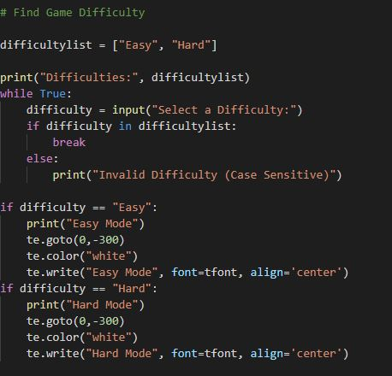**IMAGE A**

But this code relates to the main game itself. Without it, the game wouldn’t work as it wouldn’t know what to do with no difficulty given. In image B, a whole source of code is dedicated to the difficulties chosen. With the difficulties given, we can play the game at 2 different levels.

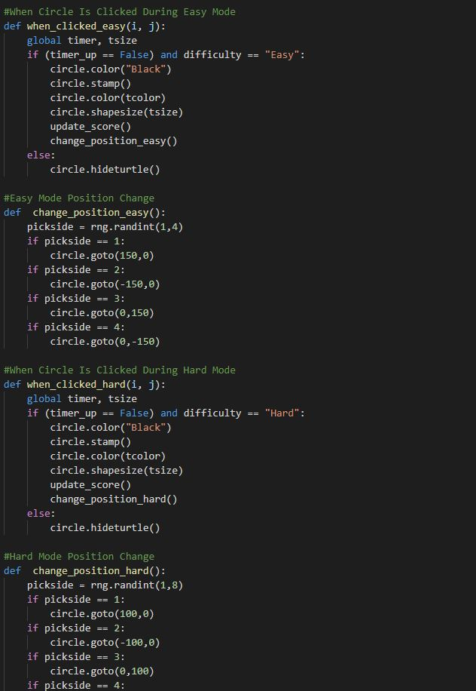**IMAGE B**

Image C shows the difficulty being asked and Image D shows the difficulty allowing the player to play at whatever pace they chose.

**IMAGE C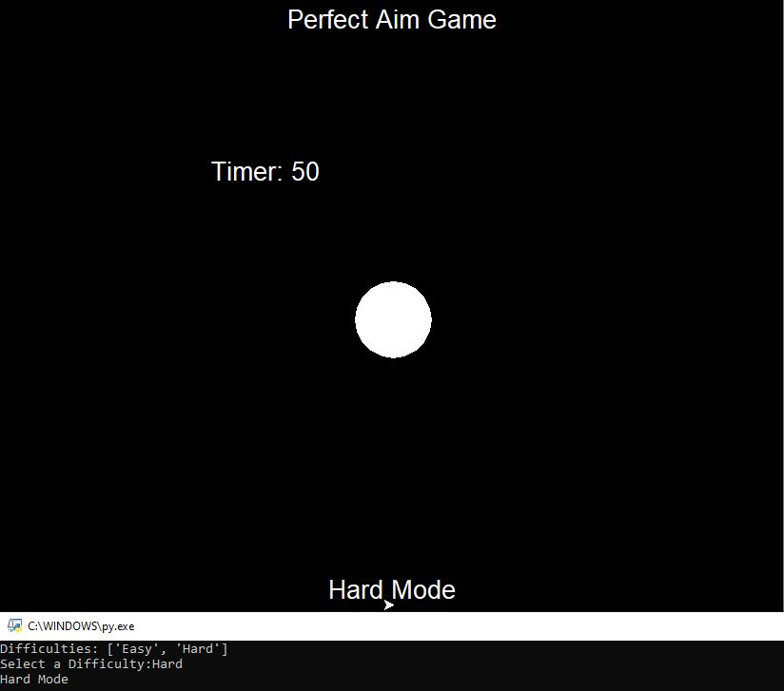 IMAGE D**