TECHNICAL REFERENCE
Job Queue System
A stage-by-stage guide to enqueueing, worker execution, persistence, and frontend completion state
Purpose Explain the current implementation at a surface technical level so a reader can follow one ticket from a stage transition through the worker and back to the UI.
Aycorn codebase
Current implementation reviewed: 26 August 2026

Index
Use this as a quick map of the guide. The page numbers refer to the major section starts.
Section | What it covers | Page
1. System at a glance | The shortest explanation of the queue and its surrounding components. | 3
2. Stage-by-stage flow | How a task transition becomes a durable job and how the worker picks it up. | 4
3. Execution and persistence | How task/persona context reaches the harness and how results become terminal state. | 5
4. Frontend completion | How polling, query invalidation, and the Working badge expose job completion. | 6
5. Failure, recovery, and boundaries | Stale jobs, failure paths, key endpoints, and the meaning of Done. | 7
6. What starts a session? | Current trigger path, shim behavior, and source files to inspect. | 8

Reading rule The queue status describes an agent execution. The ticket stage is separate state. In the current worker, completing an agent job does not automatically move the ticket to a Done stage.

Core terms
Job: the durable queue row in agent_job. Run: the durable output row in agent_run. Worker: the in-process single-goroutine loop in cmd/web. Harness: the execution interface that receives ticket and persona context and returns output.

1. System at a glance
The queue is an in-process background worker backed by SQLite. A task transition into a stage with a bound persona creates an agent_job row. The worker wakes on a timer, claims the oldest pending row, runs the harness once, and records the result. The HTTP API then exposes the job and run rows to the React frontend.
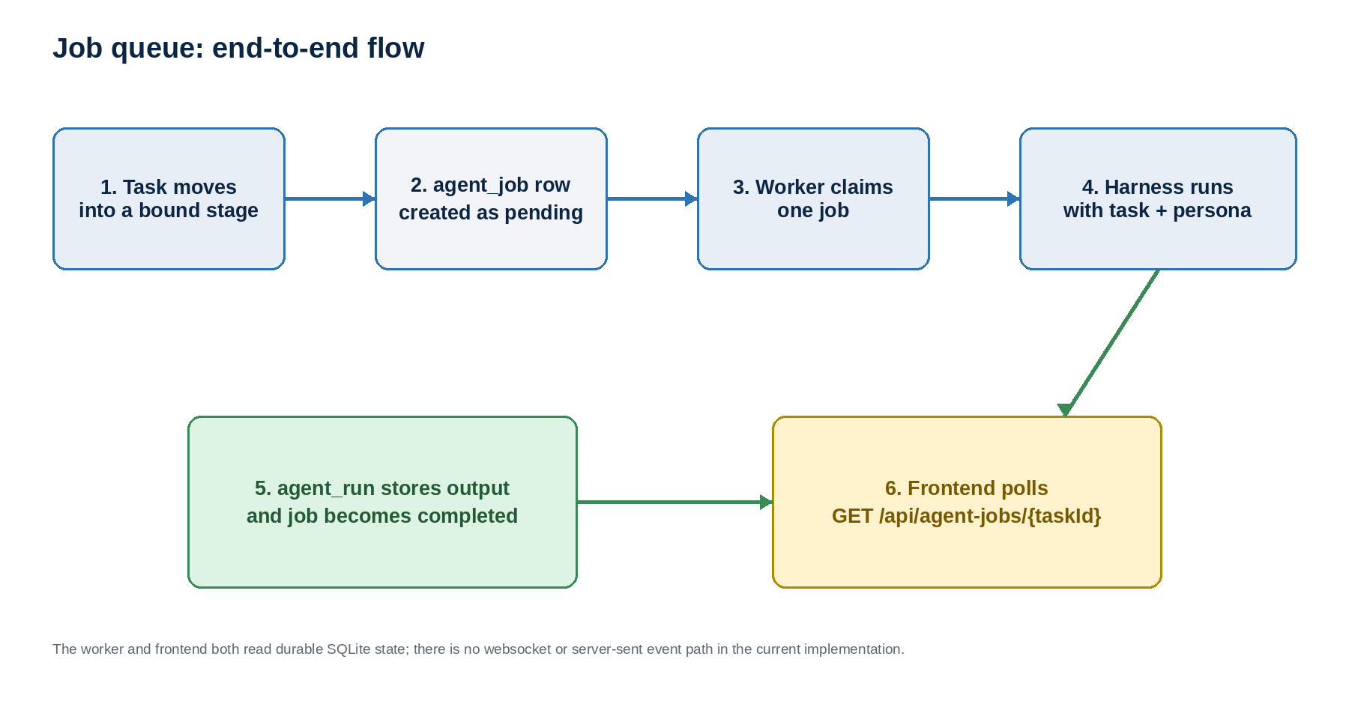
Figure 1. The queue connects task stages, SQLite job state, the worker, the harness, and the frontend.
One-sentence flow Task stage change → pending agent_job → worker claim → running harness → agent_run + completed/failed status → frontend polling.
The backend uses the shared service layer: HTTP handlers and the worker call services, and services call repositories. The frontend does not call the repository or worker directly; it calls GET /api/agent-jobs/{taskId}.

2. Stage-by-stage flow

Stage 1 — A task enters a persona-bound stage
TaskService.TransitionStage compares the task's current stage with the expected fromStage. If the destination stage has a stage_persona binding, the service updates the task and inserts an agent_job in the same SQLite transaction. If there is no binding, the task stage changes without a job.

Stage 2 — The queue records durable work
The new row stores the task ID, persona ID, optional fromStage/toStage values, status=pending, attempts=0, and timestamps. Bulk updates use the same idea through a single transaction and insert jobs for affected tasks in the destination stage.

Stage 3 — The worker picks up one job
cmd/web starts one Worker beside the HTTP server. Its ticker defaults to 10 seconds. On each tick, RunOnce calls ClaimNext, which atomically selects the oldest pending job and changes it to claimed while incrementing attempts. No pending row means the worker simply waits for the next tick.
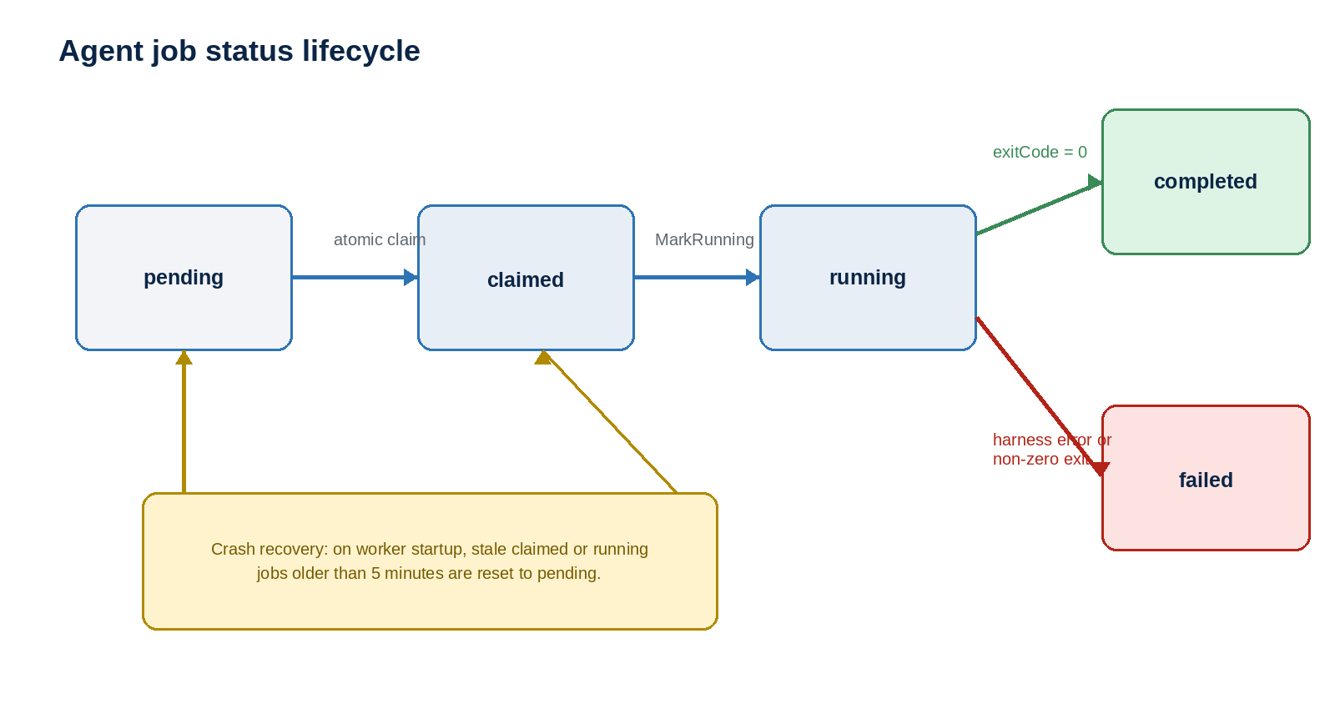
Figure 2. Job state changes and the stale-job recovery path.

3. Execution and persistence

Stage 4 — Claimed becomes running
After claiming, the worker calls MarkRunning. This is a compare-and-set update: it only changes a row that is still claimed, and it stamps startedAt. If the transition cannot be made, the worker attempts to fail the job so it does not remain invisible or stuck.

Stage 5 — The worker loads context
The worker loads the task row and persona row, then builds a harness.RunSpec containing the job ID, task ID, persona ID, task name, the stored Plate JSON body, the persona system prompt, and allowed tools. The current ReadOnlyShim returns deterministic markdown and does not touch the filesystem or spawn a process.

Stage 6 — Result and terminal status are written together
On a successful harness return, AgentJobService.Complete opens a transaction, inserts the output/summary/exitCode/usageJson into agent_run, and updates the job to completed when exitCode is zero or failed when it is non-zero. The update also stamps finishedAt. The transaction commits both writes together, so the frontend sees a consistent result boundary.
Important boundary Agent output is stored in agent_run.output as markdown. It is not written into task.body, which remains the task editor's Plate JSON.
The current worker does not advance the ticket to Review or Done after completion. The task remains in the stage used when the job was enqueued; human stage movement remains the gate described by the architecture notes.

4. How the frontend knows
The frontend learns job state by polling the backend. useAgentJobs(taskId) runs a React Query request to GET /api/agent-jobs/{taskId}. The response contains both jobs and the runs belonging to those jobs, so one request supplies status, timestamps, errors, and output metadata.
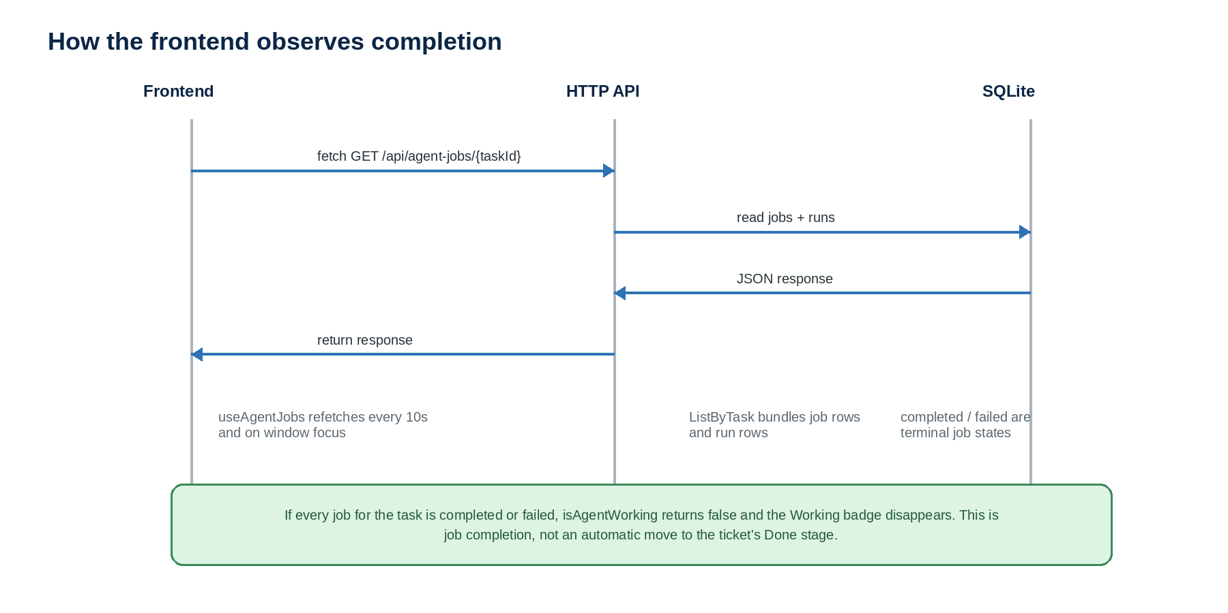
Figure 3. The current completion signal is a polling response, not a push event.

What changes in the UI
The Working badge calls isAgentWorking(data?.jobs). It treats pending, claimed, and running as in-flight. When the response contains only completed or failed jobs, the helper returns false and the badge renders nothing. The badge is used in list, upcoming, and kanban task views.

Refresh behavior
Trigger | Current behavior
Regular refresh | Every 10 seconds while the query is active.
Window focus | Refetches when the browser window becomes active.
Task mutation settled | Invalidates the agent-jobs query for affected task IDs.
Push channel | None in the current code: no websocket or SSE endpoint is used.

Plain-English answer The frontend knows the agent job is done when a fresh API response shows no job in pending, claimed, or running. It does not know that the ticket is in Done unless the task's stage data itself says so.

5. Failure, recovery, and boundaries

Failure paths
A task or persona load error calls Fail and records the error text with failed and finishedAt. A harness error follows the same path. A non-zero harness exit is persisted through Complete as failed, alongside the run data. A completion conflict is also handled defensively with a fallback attempt to fail the job.

Crash recovery
On startup, the worker calls ResetStale with a five-minute timeout. Claimed jobs with an old claimedAt or running jobs with an old startedAt are moved back to pending and their claim/start timestamps are cleared. The next worker tick can claim them again. This is intentionally minimal recovery for the current concurrency-one design.

Key code locations
Area | Current source of truth
Enqueue + stage coupling | server/internal/models/services/taskService.go
Job transitions + result transaction | server/internal/models/services/agentJobService.go and server/internal/models/repos/agentJobRepo.go
Worker loop | server/internal/worker/worker.go
HTTP read API | server/cmd/web/agentJobHandler.go and routes.go
Frontend polling + badge | app/src/features/agentJob/queries/useAgentJobs.ts and agentWorkingBadge.tsx
Database tables | server/internal/migrations/sql/00011_agent_jobs.sql

The meaning of Done
There are two separate completion questions. First: did the agent execution finish? Read agent_job.status and agent_run. Second: is the ticket in a Done-type stage? Read the task's stage/type and its timeCompleted behavior. In this implementation, the first can become true while the second remains false; a human or another explicit stage-transition path must move the ticket.
Bottom line The queue is a durable execution pipeline, not the ticket's workflow engine. It reports work and results; it does not silently decide that a ticket is Done.

6. What exactly starts a session?
Short answer There is no chat command that directly starts the worker. The current system starts an agent execution when a task is moved into a stage that has a persona binding. That move creates a pending job; the already-running worker later picks it up.

The current trigger paths
From the web UI, a stage change is sent to POST /api/task/{taskId}/transition. The HTTP handler calls TaskService.TransitionStage, which checks the expected current stage. If the destination has a stage_persona binding, the task update and the agent_job insert commit together. Bulk stage updates use the same enqueue idea through the bulk task service path.
From an AI chat client, the separate cmd/mcp binary exposes the move_task_stage MCP tool over stdio. A chat model can call that tool, but the tool is only the trigger: it calls the same TaskService.TransitionStage directly. It does not start the worker and it does not itself run the harness.

What the worker does after the trigger
cmd/web starts the worker during server startup by constructing Worker with harness.NewReadOnlyShim() and calling Start with a 10-second interval. The worker goroutine waits on a time.Ticker. On a tick it calls RunOnce, atomically claims the oldest pending job, marks it running, loads task/persona context, and calls Harness.Run(ctx, spec).
In the current implementation, Harness.Run is ReadOnlyShim.Run. It returns canned markdown and usage data. It does not call an LLM, open a conversational chat session, spawn an external process, or make a second MCP call. The word session is therefore an architectural concept for one job execution, not an active chat session in this codebase.
Planned later Documentation/phase-4-coding-harness.md describes a future ClaudeCodeHarness that could invoke claude -p with JSON output. That is a design direction, not the active implementation wired into cmd/web today.

Files to inspect
These are the shortest paths through the implementation. Line numbers are included so you can jump directly to the relevant code; they may move as the code changes.
File and lines | Why it matters
app/src/features/stage/select-task-stage.tsx:54–72 | UI stage picker; builds the updated task and invokes its change callback.
server/cmd/web/routes.go:40 | Registers POST /api/task/{taskId}/transition.
server/cmd/web/taskHandler.go:147–171 | Parses the transition request and calls TaskService.TransitionStage.
server/internal/models/services/taskService.go:21–65 | Updates the task and inserts agent_job when the destination stage has a persona.
server/cmd/mcp/tools.go:243–260 | MCP move_task_stage tool; calls the same transition service directly.
server/cmd/web/main.go:208–217 | Creates the worker with ReadOnlyShim and starts it at 10 seconds.
server/internal/worker/worker.go:48–220 | Ticker lifecycle, claim, running state, context loading, harness call, and completion.
server/internal/harness/harness.go:29–80 | Harness interface plus the active ReadOnlyShim implementation.
app/src/features/agentJob/queries/useAgentJobs.ts:62–74 | Frontend polls GET /api/agent-jobs/{taskId} every 10 seconds.
Documentation/phase-4-coding-harness.md:19–42 | Planned external harness/session design; not active today.

Trace it in one line Stage move → TaskService.TransitionStage → agent_job(pending) → Worker.RunOnce → ReadOnlyShim.Run → agent_run + completed/failed.

