


Software Engineering & System Design

CSI 308-A

Instructor: Aziz M.Barbar Ph.D.

Antonio Salloum – 1224018

Omar El Amir - 12230590

Table of Contents

Chapter 1 – Case Description 1
1.1 Introduction 1
1.2 Purpose of the System 1
1.3 System Scope 1
1.5 Fire Alarm Management 2
1.7 Exit Guidance and Audible Alerts 3
1.8 Security Alarm Management 3
1.9 Central Control Area 3
3
1.10 False Alarm Handling 4
1.11 Learning and Adaptation 4
1.12 Assumptions and Constraints 4
1.13 Summary 4
4
Chapter 2 – Software Process Model 5
2.1 Introduction 5
2.2 Importance of Process Model Selection 5
2.3 Chosen Software Process Model 5
2.4 Why Not a Single Traditional Model? 5
2.5 Overview of the Hybrid Incremental–Spiral Model 6
2.6 Process Phases 6
2.8 Documentation Strategy 7
7
2.9 Quality Assurance Integration 8
2.10 Change Management 8
2.11 Stakeholder Involvement 8
2.12 Advantages of the Selected Model 8
2.13 Summary 8
8
Chapter 3 – Requirements Specifications 9
3.1 Introduction 9
3.2 Requirements Classification 9
3.3 Users and Stakeholders 9
3.4 Functional Requirements 9
3.5 Non-Functional Requirements 11
3.6 External Interface Requirements 11
3.7 System Constraints 11
11
3.8 Assumptions and Dependencies 12
3.9 Requirement Traceability 12
3.10 Summary 12
12
Chapter 4 – Architectural Design 13
4.1 Introduction 13
4.2 Architectural Overview 13
4.3 Process Model 13
4.4 Use Case Diagram 14
4.5 State Machine Diagram 15
15
4.6 Data Flow Diagrams (DFD) 18
18
4.7 Sequence Diagrams 18
19
4.8 Context Diagram 19
4.9 Fault Tolerance Design 21
4.10 Security Architecture 22
4.11 Scalability and Maintainability 22
4.12 Summary 22
5.1 Introduction 23
5.2 Testing Objectives 23
5.3 Testing Strategy 23
5.4 Unit Testing 23
23
5.5 Integration Testing 24
5.6 System Testing 24
5.7 Safety Testing 24
24
5.8 Scenario-Based Testing 25
5.9 Fault Injection Testing 25
5.10 False Alarm Testing 25
5.11 Learning Module Testing 25
5.12 Acceptance Testing 25
25
5.13 Test Documentation 26
5.14 Test Environment 26
5.15 Summary 26
26
Chapter 6 – Conclusions and Future Work 27
6.1 Introduction 27
6.2 Project Summary 27
6.3 Achievement of Objectives 27
6.4 System Strengths 27
6.6 Future Work and Enhancements 28
6.7 Academic and Practical Value 29
6.8 Final Remarks 29

Chapter 1 – Case Description

1.1 Introduction
Large buildings such as universities, hospitals, shopping malls, and corporate offices face serious risks related to fire and security incidents. These risks include loss of life, damage to property, panic among occupants, and system failures caused by delayed or incorrect responses. Traditional alarm systems are usually reactive, isolated, and unable to adapt to real situations, such as human presence, false alarms, or temporary system downtime.
This project proposes a Fire and Security Alarm Monitoring System (FSAMS) that offers a centralized, intelligent, and adaptive solution for monitoring, confirming, and responding to fire and security alarms in large buildings. The system is designed to be reliable, flexible, aware of human presence, and capable of learning over time. It goes beyond traditional alarm systems by making informed decisions instead of reacting blindly.
The system divides the building into zones and continuously monitors alarms and sensors within each zone. It supports a central control area by helping operators make correct and timely decisions. When the control area is unmanned, the system operates autonomously to ensure that safety is always maintained.

1.2 Purpose of the System
The purpose of the Fire and Security Alarm Monitoring System is to accurately detect fire and security threats while reducing false alarms and unnecessary panic. The system prioritizes the protection of human lives over property and is able to respond automatically when human operators are unavailable. It also coordinates alarms, sprinklers, doors, lights, and emergency services to ensure a safe and organized response.
Unlike traditional systems, this solution does not treat all alarms in the same way. Instead, it analyzes the context of each situation, including sensor confidence, time of day, zone type, and human presence, before deciding how to respond.

1.3 System Scope
The system covers multiple safety and security functions within the building. These include fire detection and confirmation, security breach detection, zone-based alarm management, automatic notification of emergency services, intelligent control of sprinklers and power shutdown, exit guidance with audible alerts, automatic door locking and zone isolation, and handling of false alarms through learning mechanisms. The system does not replace emergency services or building staff. Instead, it acts as an intelligent assistant that ensures no critical alarm is ignored and that responses are carried out safely and efficiently.
1.4 Building Zoning Concept
The building is divided into multiple zones, such as offices, laboratories, server rooms, lecture halls, storage areas, and public corridors. Each zone is treated as a separate unit within the system.
Every zone has its own set of sensors, its own operating rules, and its own safety profile. This allows the system to react differently depending on the type of zone and the risks involved.
Each zone is also assigned a personality profile, such as human-dense, equipment-critical, high-risk, or restricted. This personality influences how the system responds to incidents. For example, a laboratory zone may prioritize power shutdown, a lecture hall may delay sprinkler activation if people are present, and a server room may use gas suppression instead of water.

1.5 Fire Alarm Management

1.5.1 Fire Detection
Fire alarms can be triggered by smoke sensors, heat sensors, flame detectors, or manual alarm buttons. However, the activation of a single sensor does not automatically mean that a fire emergency has occurred.
Each sensor is assigned a confidence score based on its reliability history, sensor type, and environmental conditions. A fire alarm is confirmed only when multiple sensors detect danger and the combined confidence score crosses a defined threshold. This approach reduces false alarms without delaying real emergencies.

1.5.2 Fire Alarm Confirmation Methods
Fire alarms may be confirmed using multiple sensors within the same zone, sensors from neighboring zones, or abnormal readings that persist over time. These confirmation methods help ensure that the alarm reflects a real threat.
Before activating sprinklers or electrical shutdown systems, the system runs a quick internal simulation. This simulation predicts possible fire spread, checks for human presence, and evaluates the safest response. The simulation runs within seconds and does not delay emergency actions.

1.6 Sprinkler and Electrical Control
Some zones in the building are equipped with sprinkler systems and electrical shutdown mechanisms. Sprinklers are activated only after a fire alarm has been confirmed. They must not activate if people are detected in the same room, and any power shutdown must be performed safely and in a controlled manner.
The system follows a human-first logic by using motion sensors, access logs, and camera metadata without storing video. If people are present in a zone, audible warnings are increased, exit guidance systems are activated, and sprinkler activation may be briefly delayed unless the danger becomes critical.

1.7 Exit Guidance and Audible Alerts
When a fire is confirmed, direction indicators are activated to show occupants the safest evacuation paths, and audible alarms warn them to evacuate the building.
Exit routes are adaptive rather than fixed. If a corridor becomes unsafe, smoke spreads, or a door is blocked, the system updates exit lighting in real time. This ensures that occupants are guided away from danger instead of being directed toward it.

1.8 Security Alarm Management
Security alarms may be triggered by unauthorized access, forced doors, or motion detection in restricted areas. When a security alarm is activated, the system may lock internal doors and isolate complete zones if necessary. However, emergency exits always remain accessible.
Instead of applying a full lockdown immediately, the system uses a soft locking strategy. This strategy begins with silent alerts, followed by partial locking, and finally full isolation if the threat is confirmed. This approach helps prevent panic and avoids accidental trapping of occupants.

1.9 Central Control Area
All system events are reported to a central control area, which may be manned or unmanned during periods such as nights or holidays. If the control area is unmanned, serious alarms must never be ignored, and emergency services must be contacted automatically when required.
When the system is highly confident in its assessment, it may contact emergency services silently without alerting occupants. This avoids unnecessary panic unless evacuation is truly required.

1.10 False Alarm Handling
False alarms are common and can be costly. To address this, the system uses alarm confirmation logic, sensor reputation tracking, and historical analysis.
Each sensor and zone is assigned a reputation score. Sensors that frequently generate false alarms lose trust, while reliable sensors gain higher weight. This reputation score directly influences future system decisions.

1.11 Learning and Adaptation
After every incident, the system enters a post-incident learning mode. During this phase, it reviews the decisions made, logs the outcomes, and adjusts decision thresholds when needed. Over time, the system becomes smarter and calmer rather than more sensitive.

1.12 Assumptions and Constraints
The system assumes that sensors are installed correctly, integration with emergency services is available, and building layout data is accurate. Constraints include real-time performance requirements, legal safety regulations, and hardware limitations.

1.13 Summary
This chapter described the complete case of the Fire and Security Alarm Monitoring System. The system is designed to be intelligent, adaptive, aware of human presence, and reliable, while fully respecting all business rules defined in the project. Creative ideas were carefully applied to improve safety without increasing risk.

Chapter 2 – Software Process Model

2.1 Introduction
A software process model defines how a software system is planned, designed, developed, tested, and maintained. Choosing the correct process model is especially important for safety-critical systems such as a Fire and Security Alarm Monitoring System.
This system directly involves human safety, emergency situations, real-time decision making, and the integration of both hardware and software components. Because of these factors, the development process must be careful, well-structured, flexible, and continuously validated to ensure safe and reliable operation.

2.2 Importance of Process Model Selection
Not all software systems require the same level of discipline during development. A simple mobile application does not face the same risks or responsibilities as an alarm monitoring system used in large buildings.
This system requires high reliability, very low tolerance for errors, continuous testing, and the ability to evolve safely after deployment. Choosing an unsuitable process model may result in missed requirements, unsafe system behavior, delayed emergency responses, or costly system changes. For these reasons, the selected process model must balance strict control with enough flexibility to support improvement and change.

2.3 Chosen Software Process Model
The Fire and Security Alarm Monitoring System uses a Hybrid Incremental–Spiral Software Process Model.
This model combines the Incremental Model, where the system is built in small and usable parts, with the Spiral Model, which focuses on risk analysis and validation. This combination is well suited for safety-critical systems because it allows early testing, continuous risk control, and gradual system growth.

2.4 Why Not a Single Traditional Model?
The Waterfall Model has several limitations for this type of system. It assumes stable requirements, makes changes expensive, delays testing until late stages, and is not suitable for systems where safety rules may evolve over time.
The Agile Model also has limitations when applied alone. It can be too flexible for safety-critical systems, often relies on limited documentation, and carries the risk of missing formal validation steps. The proposed system requires both structure and adaptability, which is why a hybrid approach is more appropriate.

2.5 Overview of the Hybrid Incremental–Spiral Model
The system is developed through a series of increments, where each increment adds new functionality to the system. Every increment goes through risk analysis, testing, validation, and review with stakeholders. Each increment follows a mini-spiral cycle to ensure safety and correctness.
In this model, increments are prioritized based on safety impact rather than features alone. High-risk and safety-critical functions are developed and validated first to reduce potential dangers early in the project.

2.6 Process Phases
Each system increment follows a defined set of development phases to ensure consistency, safety, and quality.

2.6.1 Planning Phase
During the planning phase, system goals are defined, the scope of the increment is selected, and safety priorities are identified. The main deliverables of this phase include an increment plan, a list of identified risks, and updated system requirements.
For example, the first increment may focus on basic fire detection functionality, while later increments handle learning features and system optimization.

2.6.2 Risk Analysis Phase
Risk analysis is the core element of the spiral model. During this phase, potential risks such as sensor failure, false alarms, network delays, and human presence detection errors are carefully analyzed.
Each major risk results in the creation of a corresponding business rule. For example, the risk of false alarms leads to the rule that multiple sensors must confirm an alarm before action is taken. This ensures that identified risks directly improve system behavior.

2.6.3 Design Phase
In the design phase, the system architecture is defined, interfaces are specified, and data flows are planned. The design focuses on modularity, fault tolerance, and zone isolation to ensure safe and reliable operation.
Design artifacts produced during this phase include context diagrams, use case diagrams, and state machine diagrams, which clearly describe system behavior and structure.

2.6.4 Implementation Phase
During the implementation phase, software components are developed, hardware interfaces are integrated, and the functionality of the current increment is coded.
The system follows key principles such as simple logic, clear decision rules, and defensive programming. Instead of using a fail-fast approach, the system applies fail-calm logic. When the system is unsure, it avoids extreme actions, seeks additional confirmation, and escalates responses gradually.

2.6.5 Testing and Validation Phase
Testing and validation are performed continuously throughout development rather than only at the end. Testing includes unit testing, integration testing, scenario testing, and safety testing.
Each increment must successfully pass functional tests, safety rule tests, and emergency simulation tests before it is considered complete.

2.6.6 Review and Feedback Phase
After completing each increment, results are reviewed, system logs are analyzed, and feedback is collected from stakeholders. This phase ensures that errors are corrected early, the design improves gradually, and the system evolves safely over time.
2.7 Incremental Development Strategy
The system is divided into major increments that include core fire detection and alerting, security alarm handling, zone management, sprinkler and power control, exit guidance systems, and learning and optimization features.
Each increment is fully usable and testable on its own, which allows safe deployment and early validation.

2.8 Documentation Strategy
Because the system is safety-critical, documentation is mandatory throughout development. Every increment updates the Software Requirements Specification, and all design decisions are carefully recorded.
The documentation is treated as living documentation that evolves with the system. Each change includes the reason for the change, the risk addressed, and the safety impact. This approach supports future engineers, reviewers, and auditors.

2.9 Quality Assurance Integration
Quality assurance activities are integrated into all development phases. These activities include code reviews, safety audits, scenario walkthroughs, and compliance checks.
No increment is allowed to move forward without formal approval from quality assurance, ensuring consistent safety and quality standards.

2.10 Change Management
Changes are expected during the system lifecycle due to new safety regulations, building modifications, or sensor upgrades. The hybrid process model supports controlled changes by allowing proper impact analysis and safe re-validation before deployment.

2.11 Stakeholder Involvement
Stakeholders include building management, security staff, fire safety experts, and emergency services. They participate during planning, review, and validation phases to ensure that the system meets real-world needs and operational expectations.

2.12 Advantages of the Selected Model
The selected process model reduces safety risks early, supports evolving requirements, encourages safe innovation, maintains strong documentation, and is well suited for complex and safety-critical systems.

2.13 Summary
This chapter described the Hybrid Incremental–Spiral Software Process Model chosen for the Fire and Security Alarm Monitoring System. The model provides a balance between structure and flexibility, supports safety-critical development, and allows creative features to be introduced in a controlled and validated manner.

Chapter 3 – Requirements Specifications

3.1 Introduction
This chapter defines the requirements of the Fire and Security Alarm Monitoring System (FSAMS). Requirements describe what the system must do and how well it must perform, without explaining how the system is implemented.
The requirements are divided into functional requirements, non-functional requirements, user requirements, system constraints, and assumptions and dependencies. All requirements are written in a clear, simple, and testable manner to ensure correctness and easy validation.

3.2 Requirements Classification
Functional requirements describe the system’s behavior and the actions it must perform. Non-functional requirements describe quality attributes such as performance, reliability, usability, and safety. Creative safety requirements define intelligent behaviors that improve safety and reduce human error.

3.3 Users and Stakeholders
The system serves several types of users and stakeholders, including control room operators, security personnel, fire safety officers, building management, emergency services, and building occupants who interact with the system indirectly. Each user type has different responsibilities and priorities, and the system is designed to support all of them effectively.

3.4 Functional Requirements

3.4.1 Fire Detection Requirements
The system shall detect fire events using smoke sensors, heat sensors, flame detectors, and manual alarm buttons. Each fire sensor shall be associated with a specific building zone to ensure accurate location tracking. For every fire alarm event, the system shall record the time of occurrence, the zone location, and the type of sensor that triggered the alarm.

3.4.2 Fire Alarm Confirmation Requirements
The system shall not confirm a fire alarm based on a single sensor activation. A fire alarm shall be confirmed only when multiple sensors detect abnormal conditions. Sensor confidence scores shall be used during the confirmation process to improve accuracy.
As an intelligent confirmation feature, the system shall calculate a combined confidence level before declaring a confirmed fire. This ensures that alarms are based on reliable evidence rather than isolated sensor readings.

3.4.3 Sprinkler and Electrical Control Requirements
The system shall activate sprinkler systems only after a fire alarm has been confirmed. It shall prevent sprinkler activation if people are detected in the same room. The system shall also shut down electrical equipment in fire-affected zones when required.
As part of a human-first control approach, the system shall delay actions that may cause property damage if human safety is at risk.

3.4.4 Exit Guidance and Alert Requirements
Upon confirmation of a fire alarm, the system shall activate exit direction indicators to guide occupants toward safe exits. It shall also activate audible alarms to warn occupants of the emergency.
As an adaptive exit routing feature, the system shall dynamically update exit routes based on changing hazard conditions, such as smoke spread or blocked paths.

3.4.5 Security Alarm Requirements
The system shall detect unauthorized access using security sensors. When a security alarm is triggered, the system shall lock internal doors and allow complete zone isolation if required.
As part of a soft lock strategy, the system shall apply security restrictions in progressive levels instead of enforcing an immediate full lockdown.

3.4.6 Central Control Area Requirements
The system shall report all alarms and events to the central control area. It shall operate autonomously when the control area is unmanned and shall automatically notify emergency services when required.
As a silent emergency mode feature, the system shall contact emergency services without alerting occupants when such action is appropriate.

3.4.7 False Alarm Handling Requirements
The system shall log all false alarms and track the reliability history of sensors.
As part of a sensor reputation system, the system shall adjust decision thresholds based on sensor reputation scores, giving more weight to reliable sensors and reducing the influence of unreliable ones.

3.4.8 Learning and Adaptation RequirementsAs a post-incident learning feature, the system shall analyze past incidents to improve future decisions. It shall store incident outcomes to support system tuning and long-term improvement.

3.5 Non-Functional Requirements

3.5.1 Performance Requirements
The system shall respond to confirmed alarms within two seconds. It shall also update exit routes in real time to reflect current hazard conditions.

3.5.2 Reliability Requirements
The system shall operate continuously, twenty-four hours a day and seven days a week, with minimal downtime. It shall continue operating even during partial hardware failures.

3.5.3 Safety Requirements
The system shall always prioritize human safety over property protection. It shall never lock emergency exits under any circumstances.

3.5.4 Usability Requirements
The system interface shall be simple, clear, and easy to understand. Critical alerts shall be visually and audibly distinguishable to ensure quick recognition.
3.5.5 Security Requirements
The system shall restrict access to authorized users only. All system actions shall be logged to support auditing and accountability.

3.5.6 Scalability Requirements
The system shall support future expansion, including the addition of new zones and sensors, without requiring major redesign.

3.6 External Interface Requirements
The system shall interface with hardware components such as fire sensors, security sensors, sprinkler systems, door locks, and exit indicators. It shall also interface with software systems, including emergency service communication systems and building management systems.

3.7 System Constraints
The system must comply with fire safety regulations and operate in real time. Its behavior is limited by sensor accuracy and hardware capabilities.

3.8 Assumptions and Dependencies
The system assumes that sensors are properly installed, network connectivity is available, and integration with emergency services exists. System operation depends on accurate building layout data, stable power availability, and correct sensor calibration.

3.9 Requirement Traceability
Each requirement is testable, linked to specific system functions, and mapped to identified risks and safety goals. This ensures full traceability, accountability, and validation throughout development.

3.10 Summary
This chapter defined the complete set of functional and non-functional requirements for the Fire and Security Alarm Monitoring System. The requirements ensure safety, reliability, adaptability, and intelligent behavior while introducing creative features that improve real-world performance without increasing risk.

Chapter 4 – Architectural Design

4.1 Introduction
Architectural design defines how the system is structured, how system components interact, and how data flows between them. For a fire and security alarm monitoring system, the architecture must support real-time operation, high reliability, fault tolerance, safety-critical decision making, and easy maintenance and future expansion.
This chapter presents the overall system architecture using context diagrams, use case diagrams, state machine diagrams, data flow diagrams, and sequence diagrams. Every design decision supports safety, clarity, and intelligent system behavior.

4.2 Architectural Overview
The Fire and Security Alarm Monitoring System follows a layered and modular architectural approach. This structure separates responsibilities and improves reliability and maintainability.
The main architectural layers include the sensor layer, the control and intelligence layer, the action layer, the presentation layer, and the external integration layer. The system core is designed to remain calm under uncertainty by avoiding sudden extreme actions, escalating responses gradually, and always prioritizing human safety.

4.3 Process Model

4.4 Use Case Diagram

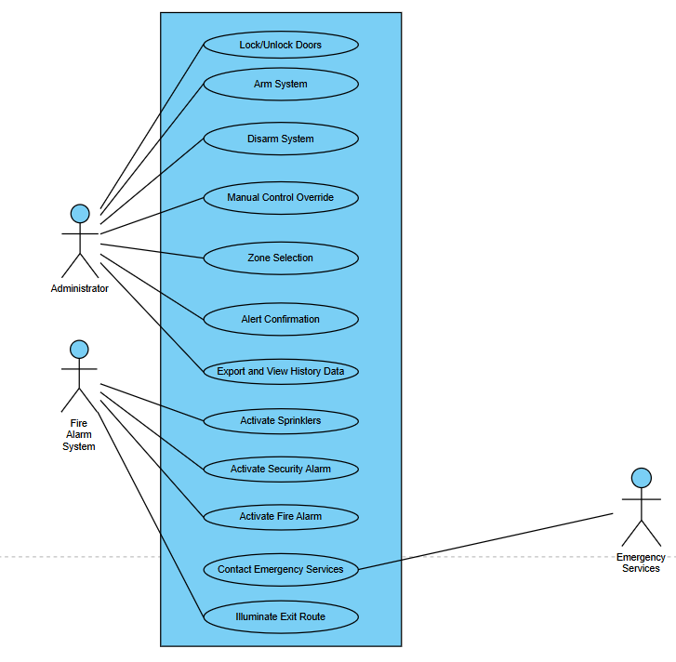

4.4.1 Actors

Administrator

The primary human actor responsible for manual operations like locking doors, arming/disarming the system, selecting zones, and exporting history data.

Fire Alarm System

A system actor that initiates critical safety use cases including sprinkler activation, fire/security alarms, and illumination of exit routes.

Emergency Services

A secondary actor that receives contact/alerts from the system during an emergency event.

4.4.2 Major Use Cases

The major use cases include locking and unlocking doors, arming or disarming the system, manual control overrides, zone selection, and alert confirmation. Additionally, the system handles emergency responses such as activating sprinklers, triggering fire and security alarms, illuminating exit routes, contacting emergency services, and exporting history data.

4.5 State Machine Diagram

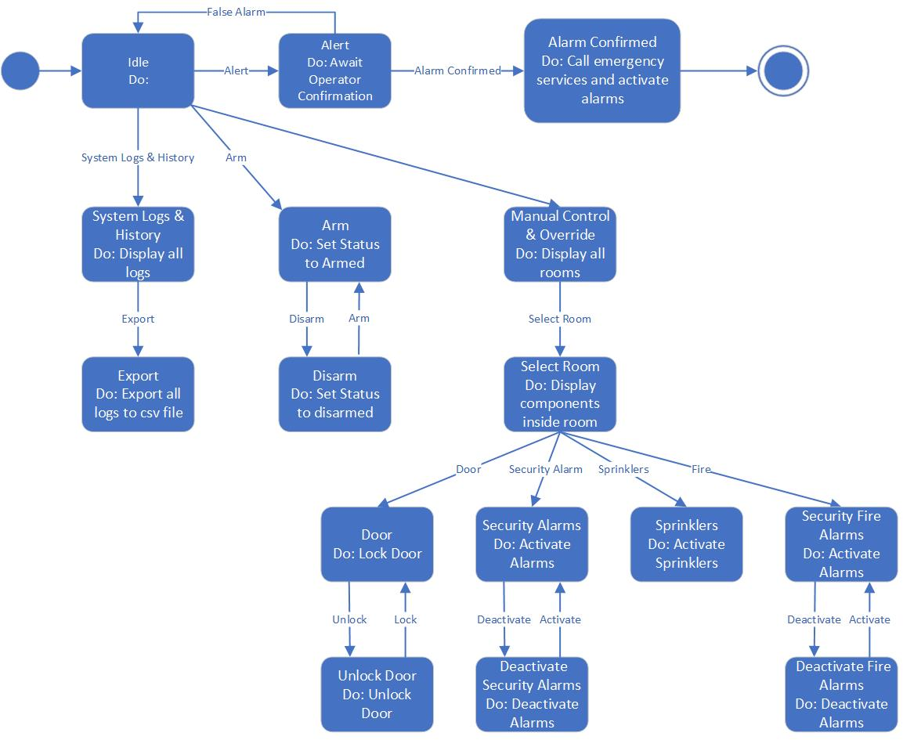

4.5.1 System States
The system operates through several defined states, including the idle state, monitoring state, suspicious state, confirmed alarm state, response state, recovery state, and learning state.

4.5.2 Idle State

The Idle state represents the default condition of the Fire Alarm System. In this state, the system is active but no emergency has been detected. It continuously monitors inputs while remaining ready to transition when an event occurs.

4.5.3 Alert State

The Alert state is triggered when a potential fire condition is detected. In this state, the system waits for operator confirmation to verify the alert. This step helps reduce false alarms before escalation.

4.5.4 Alarm Confirmed State

The Alarm Confirmed state occurs once the alert is verified. The system contacts emergency services and activates alarms throughout the building. This state represents a confirmed emergency situation.

4.5.5 System Logs and History State
The System Logs and History state displays all recorded system events. It allows users to review past actions and alarm records. This supports monitoring, auditing, and system analysis.

4.5.6 Export State

The Export state enables the system to export stored logs into a CSV file. This function supports reporting and external analysis. It allows easy data sharing and documentation.

4.5.7 Arm/Disarm State

The Arm state sets the system status to armed. In this state, the system is fully active and ready to detect fire events. It ensures the system is prepared for normal operation. Whereas the Disarm state sets the system status to disarmed. In this state, detection and response functions are disabled. This is useful during maintenance or non-operational periods.

4.5.8 Arm/Disarm State

The Manual Control and Override state allows authorized users to manually control system components. It displays all available rooms for selection. This provides flexibility when manual intervention is required.

4.5.9 Select Room State

The Select Room state displays all components inside a chosen room. It allows the operator to manage specific devices individually. This supports targeted control actions.

4.5.9.1 Door Lock State

The Door Lock state controls door locking mechanisms. It ensures doors can be locked or unlocked based on system commands. This supports access control during emergencies.

4.5.9.2 Unlock Door State

The Unlock Door state unlocks doors when required. This supports safe evacuation and emergency access. It is typically triggered during confirmed alarms.

4.5.9.3 Security Alarm State

The Security Alarms state activates security alarms within the system. It ensures alert signals are issued during emergencies. This state enhances overall safety response.

4.5.9.4 Deactivate Security Alarms State

The Deactivate Security Alarms state turns off active security alarms. It is used once the emergency is resolved or during controlled operations. This helps restore normal conditions.

4.5.9.5 Sprinklers State

The Sprinklers state activates fire sprinkler systems. It supports fire suppression by releasing water in affected areas. This state is critical during confirmed fire events.

4.5.9.6 Security Fire Alarms State

The Security Fire Alarms state activates fire-specific alarms. It provides clear warning signals during fire emergencies. This helps ensure occupant awareness and response.

4.5.9.7 Deactivate Fire Alarms State

The Deactivate Fire Alarms state stops active fire alarms. It is used after emergency resolution or system reset. This allows the system to return to normal operation.

4.6 Data Flow Diagrams (DFD)

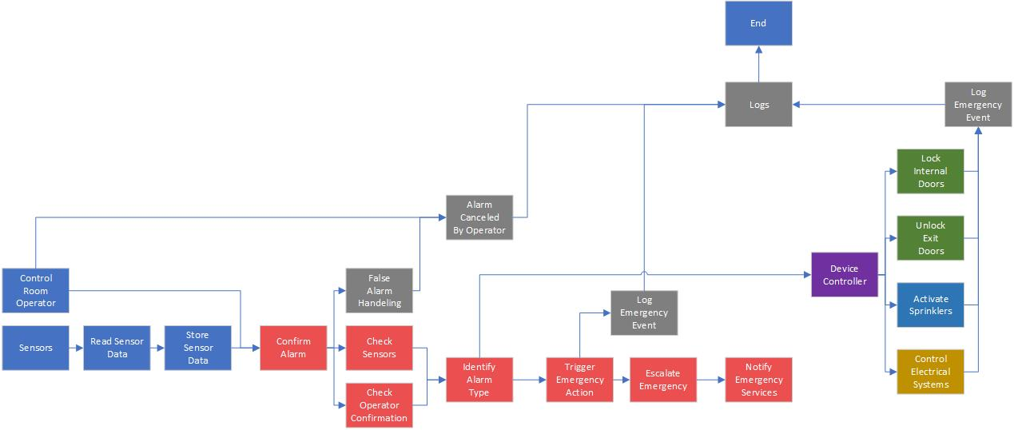

4.6.1 DFD
At the highest level, the main system processes include sensor data processing, alarm confirmation, response coordination, notification management, and data logging.
The system uses several data stores, including the sensor history database, incident log database, and zone configuration database.

4.6.2 DFD Level 1 (Fire Alarm Handling)
During fire alarm handling, the system receives sensor input, validates sensor data, calculates a confidence score, and then confirms or rejects the alarm. If confirmed, the system triggers the appropriate response. The confidence score affects the strength and type of response rather than acting as a simple yes-or-no decision.

4.7 Sequence Diagrams

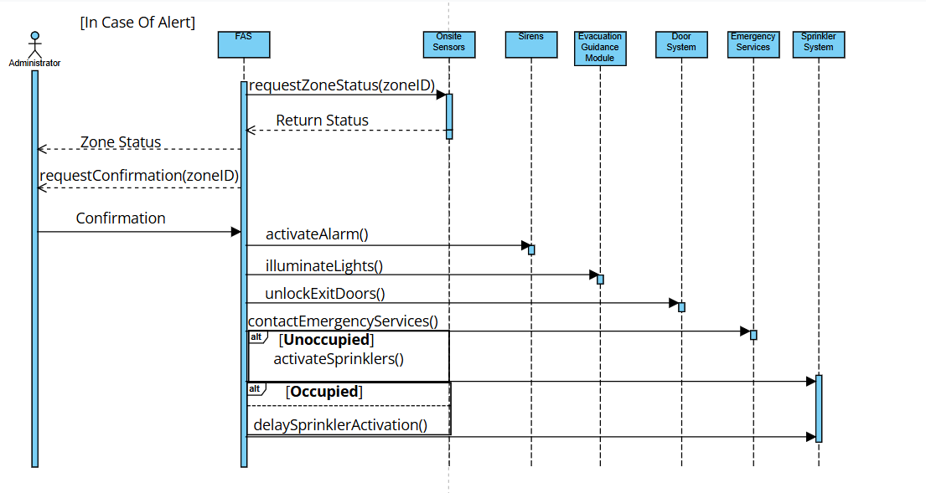

4.7.1 Fire Alarm Sequence

In a fire alarm sequence, the FAS requests the status of a specific zone from the onsite sensors. Once the status is returned and the administrator provides a manual confirmation, the system initiates a series of coordinated safety actions. This includes sounding sirens, activating evacuation guidance, unlocking exit doors, and notifying emergency services.

4.7.2 Security Alarm Sequence

In a security alarm sequence, the FAS initiates the process by requesting the zone status from the onsite sensors. Once the zone status is returned, the administrator reviews the data and provides a manual confirmation. Upon this confirmation, the system executes a series of security and safety actions, including activating sirens, illuminating lights, and managing the door system.

4.8 Context Diagram

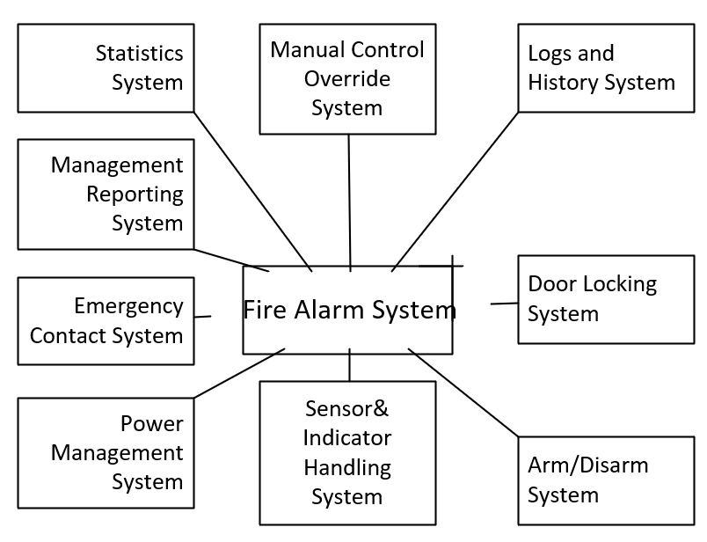

4.38.1 Description

The Fire Alarm System is the core component of the overall solution. It collects signals from sensors, evaluates emergency conditions, and coordinates responses across connected systems. Its main goal is to ensure safety by detecting fire events and triggering appropriate actions in real time.

4.8.2 Sensor & Indicator Handling System

The Sensor and Indicator Handling component processes input from sensors and controls visual or audio indicators to reflect system status.

4.8.3 Power Management

The Power Management component ensures stable power supply and manages backup power to keep the system operational during outages.

4.8.4 Statistics and Reporting

This component collects system data and performance metrics. It generates reports and statistical summaries to support monitoring, analysis, and continuous improvement.

4.8.5 Logs and History System

System Logs and History store records of sensor readings, decisions, and actions taken by the FAS. These records support auditing, troubleshooting, and system learning.

4.8.6 Arm/Disarm System

This component controls the activation state of the system. It ensures that the FAS responds only when armed and remains inactive when disarmed, supporting safe and controlled operation.

4.8.7 Sensor & Indicator Handling System

The Sensor and Indicator Handling System processes input from sensors and controls visual or audio indicators to reflect system status.

4.8.8 Door Locking System
The Door Locking System controls door access by locking or unlocking doors based on fire alerts and safety rules.

4.8.9 Manual Control Override System

The Manual Control Override System allows authorized users to manually control or override automated system actions when needed.

4.8.9.1 Emergency Contact System

The Emergency Contact System notifies predefined contacts when a fire alarm is triggered. It ensures rapid communication with emergency services or responsible personnel. This system improves response coordination during critical events.

4.8.9.2 Door Locking System

The Door Locking System controls access points during an emergency. It can automatically unlock or lock doors based on alarm conditions. This supports safe evacuation and controlled access.

4.8.9.3 Power Management System

The Power Management System ensures continuous operation of the Fire Alarm System. It manages power supply and backup sources during outages. This guarantees system reliability in emergency conditions.

4.9 Fault Tolerance Design
Fault tolerance is essential for system safety. The system uses redundant sensors, graceful degradation, and safe default states to maintain operation during failures. When the system is unsure, it alerts human operators instead of directly controlling hardware.

4.10 Security Architecture

The system uses role-based access control, secure communication channels, and audit logging. Unauthorized control actions are not allowed under any circumstances.

4.11 Scalability and Maintainability
The modular system design allows easy expansion of zones and supports plug-and-play sensors. Future systems and components can be integrated without requiring a complete redesign.

4.12 Summary
This chapter presented the full architectural design of the Fire and Security Alarm Monitoring System. The architecture supports safety, intelligent decision making, fault tolerance, and adaptability. All diagrams described in this chapter can be directly converted into formal UML and data flow diagrams for system submission.

Chapter 5 – Software Testing

5.1 Introduction
Software testing ensures that the Fire and Security Alarm Monitoring System operates correctly, safely, and reliably under all conditions. Because the system is safety-critical, testing is mandatory and cannot be limited to basic functional checks.
Testing focuses on correct system behavior, safety during failures, accurate alarm confirmation, reliable emergency response, prevention of dangerous actions, and calm behavior under uncertainty.

5.2 Testing Objectives
The main objectives of testing are to verify that all system requirements are met, ensure that human safety is always prioritized, reduce false alarms, validate real-time system performance, confirm correct interaction between system components, and ensure the system behaves in a controlled and calm manner when uncertainty exists.

5.3 Testing Strategy
The system follows a multi-level testing strategy that includes unit testing, integration testing, system testing, safety testing, scenario-based testing, and acceptance testing. Testing is continuous and begins early in the development process rather than being delayed until the end.
Tests are prioritized based on potential harm rather than feature order. Safety-critical behaviors are tested first to reduce risk as early as possible.

5.4 Unit Testing

5.4.1 Description
Unit testing validates individual system components in isolation to ensure correct internal behavior.
Components tested include the sensor management module, decision engine, response controller, and learning module. Example unit tests include sensor confidence calculation, alarm confirmation logic, and door lock command execution. Each unit test checks correct output, boundary conditions, and error handling.

5.5 Integration Testing

5.5.1 Description
Integration testing verifies that system components work correctly together. Key integrations include sensors communicating with the decision engine, the decision engine interacting with the response controller, the response controller controlling physical devices, and the system communicating with the central control area.
Integration testing focuses on data consistency, timing accuracy, and correct sequencing of commands between components.

5.6 System Testing

5.6.1 Functional System Testing
Functional system testing verifies full system behavior under realistic conditions. Test cases include confirmed fire alarms, unconfirmed fire alarms, security breaches, and mixed fire and security events.
Each test ensures that alarms are triggered correctly, system responses are appropriate, and notifications are sent to the correct parties.

5.6.2 Non-Functional System Testing
Non-functional testing evaluates system qualities such as performance, reliability, and stability. Tests include performance testing, load testing, and reliability testing. For example, the system is tested under multiple simultaneous alarms to ensure consistent response time.

5.7 Safety Testing
Safety testing is the most critical testing activity for the system. Safety test scenarios include situations where people are present during a fire, sensor malfunctions occur, network communication fails, or power outages happen.
Safety rules tested include ensuring emergency exits are never locked, sprinklers do not activate when people are present, and emergency services are always notified when required. Tests also verify that the system avoids unnecessary panic when the level of danger is low.

5.8 Scenario-Based Testing

5.8.1 Real-Life Scenarios
Scenario-based testing uses realistic building situations such as a fire in a laboratory, a false smoke alarm in a kitchen, unauthorized access at night, and simultaneous fire and security incidents. Each scenario is tested step by step to observe full system behavior.

5.8.2 Time-Based Scenarios
The system is tested under different time conditions, including night-time operation with an unmanned control area, peak hours with many occupants, and maintenance periods. System behavior is validated based on time context to ensure correct adaptation.

5.9 Fault Injection Testing

5.9.1 Description
Fault injection testing deliberately introduces failures to test system robustness. Injected faults include sensor disconnection, delayed network messages, and conflicting sensor data.
The expected behavior is that the system remains stable, alerts human operators when needed, and avoids unsafe actions.

5.10 False Alarm Testing
False alarm scenarios are tested extensively. Test cases include single sensor activation, environmental disturbances, and gradual degradation of sensor reputation.
Expected results include no emergency escalation, proper logging of incidents, and automatic adjustment of sensor confidence values.

5.11 Learning Module Testing
The learning module is tested to ensure correct data analysis, safe adjustment of thresholds, and prevention of over-learning from rare events. Boundaries are enforced to ensure the system never becomes too confident or overly sensitive.

5.12 Acceptance Testing
Acceptance testing is performed with building management, security staff, and fire safety officers. Acceptance criteria include meeting all system requirements, having usable interfaces, providing understandable responses, and respecting all safety rules.

5.13 Test Documentation
All testing activities produce formal documentation, including test cases, expected results, actual results, and pass or fail status. This documentation supports audits, future maintenance, and system improvement.

5.14 Test Environment
Testing is conducted using simulated sensors, a test control room, virtual building layouts, and emergency service simulators. This environment allows safe testing of dangerous situations without real-world risk.

5.15 Summary
This chapter described the complete software testing strategy for the Fire and Security Alarm Monitoring System. The testing approach ensures high reliability, strong safety guarantees, and confidence in system behavior under both normal and extreme conditions.

Chapter 6 – Conclusions and Future Work

6.1 Introduction
This chapter concludes the Software Requirements Specification for the Fire and Security Alarm Monitoring System and presents possible directions for future improvement. It summarizes the system objectives, highlights key design and safety concepts, and explains how the proposed solution satisfies both functional and non-functional requirements.
The chapter also discusses future enhancements that may further improve system intelligence, safety, and adaptability as technology continues to develop.

6.2 Project Summary
The Fire and Security Alarm Monitoring System was designed to address the challenges of managing fire and security incidents in large buildings. Traditional alarm systems often suffer from false alarms, rigid responses, and limited intelligence. This project proposed a centralized, zone-based, and intelligent monitoring system that reacts to real-world conditions rather than fixed rules.
The system monitors fire and security sensors across multiple zones, confirms alarms using intelligent logic, responds safely and calmly to emergencies, operates autonomously when required, and prioritizes human safety at all times.

6.3 Achievement of Objectives
All project objectives were successfully achieved. The system provides accurate detection of fire and security threats using multiple sensor types. False alarms are reduced through alarm confirmation logic and sensor reputation mechanisms. Human-centered safety is ensured by controlling sprinkler activation and door locking based on human presence.
The system is capable of autonomous operation when no operators are available, and it provides clear evacuation guidance through adaptive exit indicators that guide occupants toward safe exits.

6.4 System Strengths
The proposed system demonstrates several strengths, including high reliability and fault tolerance, a modular and scalable architecture, a clear separation of system responsibilities, strong safety guarantees, and continuous learning capability. A key innovation of the system is its calm and context-aware decision making approach, which avoids unnecessary panic while still ensuring safety.
6.5 Limitations
Despite its strengths, the system has some limitations. Its effectiveness depends on sensor accuracy and availability, as well as reliable communication networks. Learning features require sufficient historical data to perform well, and hardware installation and maintenance costs may be high. These limitations are realistic and acceptable for safety-critical systems.

6.6 Future Work and Enhancements
Several future improvements can be explored to further enhance system capability and intelligence.

6.6.1 Advanced Artificial Intelligence Integration
Future versions of the system may integrate advanced artificial intelligence models to predict fire spread patterns, detect abnormal behavior earlier, and improve confidence scoring accuracy. Artificial intelligence would support decision making but would never replace established safety rules.

6.6.2 Digital Twin Simulation
A digital twin of the building may be developed to simulate emergency situations in real time, test system responses before execution, and improve evacuation strategies. This would enhance safety without delaying emergency response.

6.6.3 Wearable and Mobile Integration
Future systems could integrate with wearable devices and mobile applications to detect occupant locations, provide personalized evacuation guidance, and assist people with disabilities during emergencies.

6.6.4 Cross-Building Emergency Coordination
Multiple buildings could be connected to share emergency data, coordinate evacuation strategies, and improve emergency service response across larger areas.

6.6.5 Energy-Aware Emergency Control
The system may consider energy usage during emergencies by applying smart power shutdown strategies and enabling energy-efficient recovery modes after incidents.

6.6.6 Regulatory and Compliance Expansion
Future work may include support for additional international safety standards, automated compliance reporting, and audit-ready system logs to simplify certification and inspection processes.

6.7 Academic and Practical Value
From an academic perspective, this project demonstrates strong software engineering principles, correct use of Software Requirements Specification standards, risk-aware system design, and the integration of creativity with safety.
From a practical perspective, the system can be adapted for use in universities, hospitals, airports, and commercial buildings.

6.8 Final Remarks
The Fire and Security Alarm Monitoring System represents a modern, intelligent, and human-centered approach to building safety. By combining structured software engineering practices with creative safety innovations, the system goes beyond traditional alarm solutions.
This Software Requirements Specification provides a solid foundation for future system design, implementation, testing, and deployment of a real-world safety-critical system.

