HyperCoreg — Automated hyperspectral PRISMA and EnMAP to Sentinel-2 coregistration pipeline
- Aim and scope
HyperCoreg is an automated image co-registration tool designed to geometrically align hyperspectral (HYP) imagery from “PRecursore IperSpettrale della Missione Applicativa” (PRISMA) launched by the Italian Space Agency and “Environmental Mapping and Analysis Program” (EnMAP), launched by the German Space Agency. The pipeline improves the geolocation accuracy of PRISMA/EnMAP Level 2 products by correcting spatial misalignments and ensuring sub-pixel alignment baed on Sentinel-2 Level 2A data.
The Sentinel-2 mission Data Quality Report (June 2025), elaborated by the Optical Mission Performance Cluster of the Copernicus Programme, reports very good geometric performance, supporting the use of Sentinel-2 imagery as a well-suited candidate reference for co-registration. The absolute geolocation accuracy is better than 10 m at 95.5 % confidence for unrefined products and improves to approximately 4 m for refined products [1]. However, this also implies that, despite the near-optimal performance, a residual geolocation error of approximately 4 m remains and should be considered, especially if very high spatial resolution data is combined with co-registered data.
The main motivation of this workflow is to address the well-known and frequently reported geolocation errors present in PRISMA for areas not covered by Ground Control Points (GCPs) and in less extent for EnMAP data. In the case of EnMAP [2], geolocation errors are reported to be on the order of approximately 14.7 to 16.5 m, whereas for PRISMA these errors typically range between 80 and 250 m [3]. The complexity further increases when considering that these co-registration errors are not spatially uniform but vary significantly across different scenes. To perform data integration or fusion with other sources, or any type of multitemporal analysis, high-quality coregistration is essential to ensure the best achievable spatial overlap of different hyperspectral datasets.
The main analytical core of the HyperCoreg pipeline centers on the AROSICS-based [4] geometric co-registration framework, but several key elements work together to optimize this process for hyperspectral data.
- Modules (Pipeline Components)
HyperCoreg consists of modular stages, each handling a series of specific tasks:
  - Data processing module
- PRISMA HDF5 Reader: Extracts hyperspectral cube (VNIR + SWIR), panchromatic band, quality masks, wavelength/FWHM arrays, and geocoding information from *.he5 files.
- EnMAP GeoTIFF Reader: Parses SPECTRAL_IMAGE.tif files with associated XML metadata for wavelength calibration and acquisition parameters.
- Spectral Band Table: A unified data structure (SpectralBandTable class) holds per-band metadata (index, center wavelength, FWHM, name, detector VNIR/SWIR). The table ensures wavelengths are sorted, filters out invalid bands, and can reorder the hyperspectral cube accordingly. This provides a consistent mapping between hyperspectral bands and Sentinel-2 reference bands. It also provides utility methods (e.g. find_closest_band) for spectral matching.

  - Sentinel-2 reference acquisition module
- DSE API Query: Utilizes the Copernicus Data Space Ecosystem (CDSE) OData API to find Sentinel-2 L2A scenes coincident in time and space with the hyperspectral scene. The query is filtered by date window window (± days from the HYP scene considered for coregistration), bounding box overlap (overlap of the S2 tile with the HYP scene), product type, and cloud cover. A valid Copernicus user account (Client ID/Secret) is required; credentials are prompted via a GUI and cached in cdse_credentials.json.
- Scene Ranking and Download: Returned candidates are ranked by spatial overlap and cloudiness. Up to max_s2_candidates (default 3) are processed. The pipeline attempts each candidate: downloading the SAFE archive ZIP (retrying on failure) and extracting the required bands. The greater the number of S-2 candidates considered, the more iterations the code will perform in case the first candidate fails the coregistration accuracy requirements. This is particularly relevant for high cloud cover HYP scenes. If the user expects high cloud cover, it is suggested that a lower number of S-2 is used as input to optimize computational time.
- Multi-Band Stack Creation: The selected Sentinel-2 scene’s 10 m bands (B02, B03, B04, B08, plus optionally SWIR B11, B12 if using 20 m data resampled to 10 m) are read and resampled to a common 10 m grid. The Scene Classification Layer (SCL) is used to mask clouds/shadow pixels. The stack is clipped to the hyperspectral footprint (with a small buffer) to reduce processing load.
  - Coregistration Module
- Global Coregistration (COREG): Performs an initial bulk alignment using AROSICS phase correlation (COREG) on one selected Sentinel-2 band versus an averaged hyperspectral band (binning of adjacent HYP bands to increase the similarity to S-2 matching band). By default, band B08 (NIR) is used, and the hyperspectral band is formed by averaging wavelengths around the selected S2 band. AROSICS is invoked with progressively larger window sizes (256×256 up to 640×640) and maximum shift limits. The user-specified min_accuracy (default 70%) sets the reliability threshold: the algorithm iterates until AROSICS reports success (reliability ≥ threshold) or runs out of configurations. If all S2 candidates fail global coregistration, the pipeline can optionally stop or try a fallback.
- Fallback Local Coregistration (COREG_LOCAL): If global alignment fails or yields inadequate results, HyperCoreg attempts AROSICS’ local registration (COREG_LOCAL) even without a global pre-alignment. This uses smaller 150 m grid tiles to warp the hyperspectral to the reference locally. Success or failure of this step is logged; if successful, it may be taken as a final alignment.
- Local Coregistration (COREG_LOCAL): Once a satisfactory initial alignment from the global coregistration is obtained, HyperCoreg refines it by collecting tie points across multiple bands: for each Sentinel-2 band B02, B03, B04, B08, B11, and B12, it identifies the closest hyperspectral wavelengths (±10 nm) and creates a pseudo-band by averaging those channels. For each band pair, it runs COREG_LOCAL to find local tie points within 256×256 tiles. The resulting tie points (with image/map coordinates and reliability scores) are filtered to remove NaNs and invalid values (e.g. reliability ≤ -9990). This yields a set of tie points per band. This part of the module was inspired in the workflow performed by De Luca et al [3].
- Tie point fusion and filtering: Once a satisfactory initial alignment is obtained, HyperCoreg refines it by collecting tie points across multiple bands: for each Sentinel-2 band B02, B03, B04, B08, B11, and B12, it identifies the closest hyperspectral wavelengths (±10 nm) and creates a pseudo-band by averaging those channels. For each band pair, it runs COREG_LOCAL to find local tie points within 256×256 tiles. The resulting tie points (with image/map coordinates and reliability scores) are filtered to remove NaNs and invalid values (e.g. reliability ≤ -9990).
- Tie point fusion and Filtering: The multi-band tie points are merged and filtered to produce a robust GCP set. This process (implemented in merge_tiepoints_max_reliability) leads to a cleaned list of tie points (XY image, XY map, shifts) and counts at each stage:
  - Outlier Removal: Points flagged as outliers (by AROSICS) are discarded.
  - Reliability Thresholding: Points below a minimum reliability (default 75%) are removed. If too few remain, the threshold is adaptively lowered until enough GCPs exist.
  - Deduplication: If the same map-coordinate point appears in multiple bands, the point with the highest reliability is kept.
  - Residual Trimming: A median-absolute deviation (MAD) filter is applied on point residuals (e.g. Euclidean shifts) to remove extreme mismatches.
  - Geometric Transformation Module
- GCP and Warp: From the filtered tie points, 2nd-order polynomial Ground Control Points (GCPs) are constructed (rasterio GCPs). If at least min_tie_points (default 10) GCPs remain, the pipeline applies a 2nd-order polynomial warp via GDAL (gdalwarp) to resample the hyperspectral cube to the Sentinel-2 grid. An output resolution (typically 30 m for PRISMA) and target CRS (Sentinel-2 UTM) are used. The output is written as a tiled, compressed GeoTIFF.
- Affine Fallback: If the polynomial warp fails or there are insufficient GCPs, the pipeline can fallback to a simple affine warp (linear reproject). This ensures at least a coarse alignment, although with lower accuracy (usually a few pixels). The code logs a warning in this case.
  - Quality assessment module
After transformation, HyperCoreg computes statistics to assess alignment quality, and although the last part of the coregistration process, it is considered the most important to understand if the coregistration really failed or not:
- Tie Point Residuals: It computes the residual shifts (in meters) of the retained tie points. From these, it derives mean, median, RMS, and 90th-percentile residual error.
- Spatial Distribution: It analyzes how tie points are distributed using spatial metrics: the convex hull area vs. bounding box area (hull/bbox ratio), mean nearest-neighbor distance, and a composite spatial spread score (0–100) that rewards well-spread points. If tie points cluster or cover only a small image fraction, warnings are generated.
- Confidence Scoring: A final confidence score (0–100) is computed as a weighted sum: 40% from AROSICS reliability, 20% from tie point count, 25% from residual magnitude, and 15% from spatial coverage. A composite quality tier (HIGH/MEDIUM/LOW/FAIL) is assigned based on checks (e.g. requiring ≥3 of 4 criteria passed). These metrics are reported to the user (console, logs, and output JSON).
  - Output generation module
- The co-registered hyperspectral cube (*_COREG.tif), with embedded spectral metadata.
- Optional ancillary products (pre-coregistered image, PAN coregistered band, quality mask).
- A multi-page report (JSON/Excel) including all metrics, and quicklook JPEGs of the scene with tie points overlay.
- All temporary files (intermediate stacks, tie point tables) are cleaned up unless keep_temp_files is enabled.
Output files and metrics are summarized in tables. For example, tie point metrics include Count, Residual Mean/Median/RMSE/P90 (in meters), Spatial Spread Score (0–100), and Hull/Box Ratio (ideally ~0.4–0.8).
- Workflow
The coregistration workflow consists of the following sequential processing steps:
- Step 1: Input Validation: Detect sensor type (PRISMA/EnMAP), validate file integrity, extract acquisition timestamp and geographic bounds.
- Step 2: Cloud Threshold Check: Evaluate input image cloud coverage against a configurable threshold; skip processing if exceeded.
- Step 3: Sentinel-2 Scene Discovery: Query the CDSE OData API for Sentinel-2 L2A scenes within ±days_window (default 30 days) of the hyperspectral time. Apply filters: maximum cloud cover (max_cloud, default 20%) and minimum spatial overlap (min_overlap, default 0.5, meaning ≥50% overlap). Sort candidates by overlap, then cloud. Select up to max_s2_candidates (default 3) in order.
- Step 4: Reference Stack Preparation: Download top-ranked S2 candidate, resample all bands to 10 m, apply SCL-based cloud masking, clip to hyperspectral footprint with a buffer.
- Step 5: Hyperspectral Cube Preparation: Merge (for PRISMA) or load (EnMAP) the hyperspectral cube into memory. Ensure bands are in ascending wavelength order (using SpectralBandTable sort indices).
  - Estimate a rough affine geotransform from PRISMA corner coordinates if available, to assign an approximate spatial grid.
  - Build a pseudo-reference band by averaging HSI channels near the chosen Sentinel band (default S2 B08 ~842 nm), e.g. ±10 nm. This band will be used for the initial alignment.
- Step 6: Global Coregistration: Run AROSICS’ global-correlation algorithm on the reference band pair (S2 vs HSI). Iterate through window sizes (256→640 pixels) and corresponding max_shift (150–200 m). Capture and log the output for debugging.
  - Check CRG.coreg_info["success"]. If above the min_accuracy threshold, declare success. If not, retry with the next S2 candidate (up to max_s2_candidates).
  - If global COREG fails on all candidates, optionally try a direct AROSICS Local run (COREG_LOCAL) on the entire scene.
- Step 7: Iterative S2 candidate selection: if step 6 fails, an additional candidate will be downloaded and selected for retrying step 6. The amount of times this step is performed relies on “max_s2_candidates” parameter selected by the user. CRITICAL POINT: If global coregistration fails and the maximum S2 candidates are reached, the image won’t be processed. It is important to mention that this iterative process is the most time-consuming part of the pipeline. If the number of maximum candidates are reduced, the computing time may be reduced, especially when many scenes are processed.
- Step 8: Local Coregistration: nce a satisfactory coarse alignment is achieved, perform AROSICS COREG_LOCAL on smaller tiles across multiple spectral bands. For each S2 band (B02, B03, B04, B08, B11, B12) :
  - Identify the closest hyperspectral band
  - Run COREG_LOCAL (tile size 256×256, grid step 150 m) to find tile-based shifts. This yields a “CoRegPoints” table with columns X_IM, Y_IM (HS pixel), X_MAP, Y_MAP (S2 map), shifts (X_SHIFT_M, Y_SHIFT_M), and reliability.
  - Filter each table: drop rows with NaN or infinite coordinates
- Step 9: Tie Point Fusion & Filtering: Consolidate tie points from all bands. First, remove any points marked as outliers. Then, iteratively apply a reliability threshold (MIN_RELIABILITY_THRESHOLD, default 75%); if too many points are removed, the threshold is adaptively lowered (down to a floor) so at least ~10 points remain. Next, deduplicate by (X_MAP, Y_MAP): keep only the copy with highest reliability. Finally, apply a MAD-based residual filter (with residual_mad_factor, default 3.0) to trim outliers. The result is a filtered set of tie points ready for GCP generation.
- Step 10: Polynomial Warp: Use the filtered tie points to form GCPs (row, col ⇔ X,Y) and apply a second-order polynomial warp via GDAL (gdalwarp. If the warp succeeds, save the final coregistered HSI image. If it fails or too few GCPs were available, log a warning and proceed to fallback.
- Affine Fallback (if needed): If the polynomial transform fails (or if the number of GCPs falls below min_tie_points), the pipeline reprojects the original HSI by a simple affine transform (same projection and resolution as S2) without further adjustment. This leads a coregistered product with only geocoding (no local alignment). A warning is issued (“alignment may be degraded”) to indicate the fallback.
- Step 11: Quality Assessment: Compute residuals of the applied transform using the final tie points (post-trimming). Calculate residual mean, median, RMSE, and 90% percentile (in meters). Compute spatial distribution metrics on those tie points (convex hull area, hull/bbox ratio, mean nearest-neighbor distance, and a composite spatial spread score 0–100). Feed these into the confidence algorithm: ensure tie point count ≥ min_tie_points (default 10), residual p90 ≤ residual_threshold (default 25 m), reliability ≥ min_accuracy, and spatial score ≥25. Assign a quality tier (HIGH/MEDIUM/LOW/FAIL) based on passed checks and the confidence score (weighted 40% reliability, 20% tie count, 25% residual, 15% spatial). All metrics and decisions are logged and saved (JSON/Excel).
- Step 12: Output Finalization: Write the final outputs to disk: the coregistered hyperspectral GeoTIFF with updated metadata; optional products (PAN coregistered band, quality mask, pre-coreg TIFF if requested). Generate quicklook JPEGs (RGB composites) with overlays of tie points and reference outline. Save a summary report (JSON/Excel) listing key parameters and quality metrics. If in batch mode, append results to a master Excel file.
- Step 13: Cleanup: Remove temporary files unless keep_temp_files is enabled.
- Input
  - PRISMA input requirements. Product Level: L2D
  - EnMAP input requirements Product Level: L2A
  - Sentinel-2 input requirements
- Product Level: L2A
- Required Bands: B02 (Blue), B03 (Green), B04 (Red), B08 (NIR), B11 (SWIR1), B12 (SWIR2), SCL (Scene Classification)
- Source: Downloaded automatically from Copernicus Data Space Ecosystem (CDSE)
  - Authentication requirements
Access to Sentinel-2 data requires valid CDSE credentials (Client ID and Client Secret). These can be obtained by registering at https://dataspace.copernicus.eu/. Credentials are stored locally in cdse_credentials. json after first use.
- Output
  - Directory structure
[OUTPUT_DIR]/
└── [SENSOR]_[YYMMDD]/
├── 00_inputs/ # Pre-coregistration image (if save_pre enabled)
├── 01_reference/ # Downloaded Sentinel-2 reference stack
├── 02_temp/ # Temporary processing files (for debugging)
├── 03_coreg/ # Primary coregistered outputs
├── 04_reports/ # Processing reports and metrics
└── 05_quicklooks/ # Visual overview products
  - Primary outputs
File | Description | Format
*_COREG.tif | Coregistered hyperspectral cube with all spectral bands | Float32 GeoTIFF, LZW
*_PAN_COREG.tif | Coregistered panchromatic band (PRISMA only, optional) | Float32 GeoTIFF, LZW
*_QM_COREG.tif | Coregistered pixel quality mask (PRISMA only, optional) | Float32 GeoTIFF, LZW
*_COREG.tif.aux.xml | GDAL auxiliary statistics (optional) | XML

  - Secondary outputs
File | Description | Format
*_pre_coreg.tif | Original hyperspectral cube before coregistration (for comparison) | Float32 GeoTIFF, LZW
S2_stack_10m.tif | Sentinel-2 multi-band reference stack (B02, B03, B04, B08, B11, B12, SCL) resampled to 10 m | Int16, GeoTIFF
*_metrics.json | Machine-readable JSON with complete processing metrics and quality assessment | JSON
*_overview.jpg | Annotated RGB composite with scene name, date, CRS, bounds, and optional shapefile overlays | JPEG (150 dpi)
*_tiepoints_global.png | Tie point distribution visualization from global coregistration | PNG
*_tiepoints_local.png | Tie point distribution visualization from local coregistration | PNG

  - Batch processing output
The batch processing delivers an excel where all scenes processed are listed along rows, with a series of columns:
Name | Description
scene_name | Identifier for the hyperspectral scene (e.g. PRISMA_YYYYMMDD). Derived from the input file name or scene metadata, this string uniquely labels the image in the workflow.
*_id
  Sensor‐specific scene ID from metadata (e.g. prisma_id or enmap_id). This is the internal satellite image identifier extracted from the PRISMA/EnMAP product header.
*_date | Acquisition date of the hyperspectral scene
*_cloud_pct
  Fraction of scene covered by clouds (percentage)
*_sea_pct | Fraction of scene covered by water/sea (percentage)
observation_angle | Sensor viewing (off-nadir) angle for the hyperspectral scene. The mean angle between the sensor’s line-of-sight and the nadir direction during acquisition. Reflects how oblique the image was taken.
rel_azimuth_angle
  Relative azimuth angle between sensor and sun directions (degrees). Equal to sun_azimuth – view_azimuth, indicating the orientation of illumination vs. sensor.
sun_azimuth_angle
  Sun azimuth angle at acquisition (degrees). The direction of the sun’s rays when the scene was captured. Part of acquisition geometry (from metadata). See also Sentinel-2 metadata (sunAzimuth)
solar_zenith_angle
  Solar zenith angle (degrees). Angle between the sun direction and the local zenith at acquisition time. Indicates sun elevation.
bbox_top_left_x | Longitude (X) of the upper-left corner of the hyperspectral scene’s bounding box.
bbox_top_left_y | Latitude (Y) of the upper-left corner of the scene bounding box.
bbox_bottom_right_x | Longitude of the lower-right corner of the scene bounding box.
bbox_bottom_right_y
  Latitude of the lower-right corner of the scene bounding box
s2_product_id | ID of the chosen Sentinel-2 reference product.
s2_date | Acquisition date/time of the Sentinel-2 reference product
s2_cloud_cover_pct | Cloud cover percentage of the Sentinel-2 product
tie_points_count | Number of tie points used in coregistration.
accuracy_pct | Coregistration accuracy (percent)
residual_mean_m | Mean residual displacement (meters). After coregistration, this is the average remaining shift of all tie points (mean absolute error).
residual_median_m | Median residual displacement (meters).
residual_rmse_m | RMSE of residuals (meters). Root-mean-square of the tie-point displacements after alignment
residual_p90_m
  90th-percentile residual (meters). 90% of tie-point displacement errors are below this magnitude
status | Processing outcome status. Indicates whether coregistration succeeded, failed, or used a fallback. Possible values are SUCCESS, FAIL, SKIPPED (due to too many clouds in the input), or FALLBACK.
notes | Processing notes or warnings. Any additional information (e.g. errors, skip reasons) is recorded here.

- Quality metrics and validation procedure
  - Tie points statistics
Metric | Description
Tie Point Count | Number of valid tie points after AROSICS filtering
Residual Mean (m) | Average means geometric displacement of tie points
Residual Median (m) | Average median geometric displacement of tie points
Residual RMSE (m) | Root means square error of displacements
Residual 90 % percentile (m) | 90th percentile displacement threshold

  - Spatial distribution metrics
Metric | Description
Spatial spread | 0-100 score indicating how well tie points cover the image extent. Higher values indicate better distribution.
Hull Ratio | Ratio of convex hull area to bounding box area. (0; very clustered points, 100; equally spatially distributed points)
Residual Median (m) | Average median geometric displacement of tie points

From these, HyperCoreg computes a Confidence Score and a Quality Tier: if reliability≥min_accuracy (default 70%) and tie point count≥min_tie_points and p90≤residual_threshold (25 m) and spatial score≥25, the result “passes”. If ≥3 of 4 checks passes (with no critical failure), it is labeled HIGH/Medium/Low quality (based on score); otherwise FAIL.
- Performance considerations
Based on a range of test, a minimum of 16 GB of usable RAM is recommended; therefore, a machine with at least 24 GB is considered optimal for performing the coregistration. This is due to the significant memory load imposed by hyperspectral spaceborne scenes. This was done using diverse diagnostic functions which are already removed. CPUs usage seems to be low, so no minimum requirement can be set.
- Parameter personalization
  - Basic parameters
Parameter | Default | Range | Description
days_window | 30 | 1-365 | Temporal search window for S2 scenes (± days)
min_overlap | 0.5 | 0.1-1.0 | Minimum spatial overlap fraction
max_cloud | 20 | 0-100 | Maximum S2 cloud cover percentage
max_input_cloud_cover | 70 | 0-100 | Skip input images exceeding this threshold
min_accuracy | 70 | 0-100 | Minimum acceptable reliability percentage based on AROSICS global accuracy
max_displacement | 350 | 50-1000 | Maximum allowed shift in meters

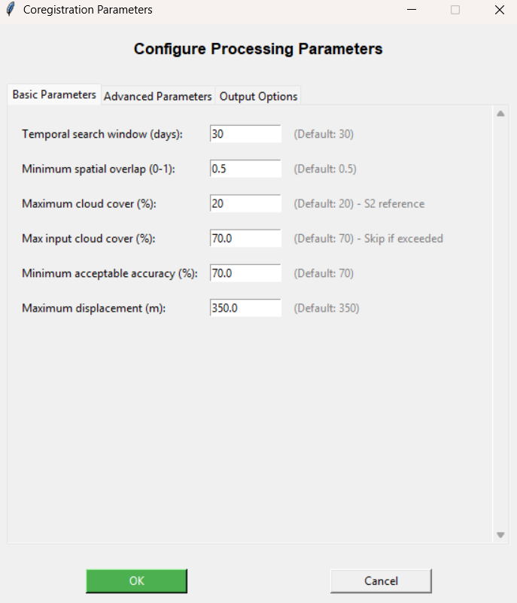

  - Advance parameters
Parameter | Default | Range | Description
residual_threshold | 25 | 10-100 | Maximum residual in meters for acceptance
min_tie_points | 10 | 5-50 | Minimum tie points required for polynomial warp
max_s2_candidates | 3 | 1-10 | Maximum S2 scenes to evaluate per iteration
residual_mad_factor | 3.0 | 1.5-5.0 | MAD multiplier for outlier trimming
s2_ref_band | B08 | B02-B12 | Sentinel-2 band for global coregistration

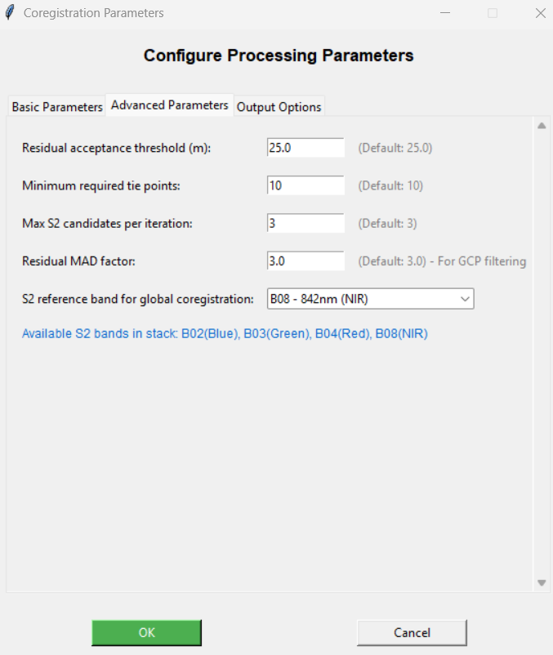
  - Output options
Option | Default | Description
save_pre | False | Save pre-coregistration image for comparison
save_pan | False | Save PRISMA panchromatic band (PRISMA only)
save_quality_mask | False | Save PRISMA quality mask (PRISMA only)
gen_tiepoint_pngs | False | Generate tie point visualization PNGs
gen_aux_xml | False | Generate GDAL auxiliary statistics file
use_inmemory | False | Use in-memory processing (faster, more RAM)
keep_temp_files | False | Preserve temporary files for debugging
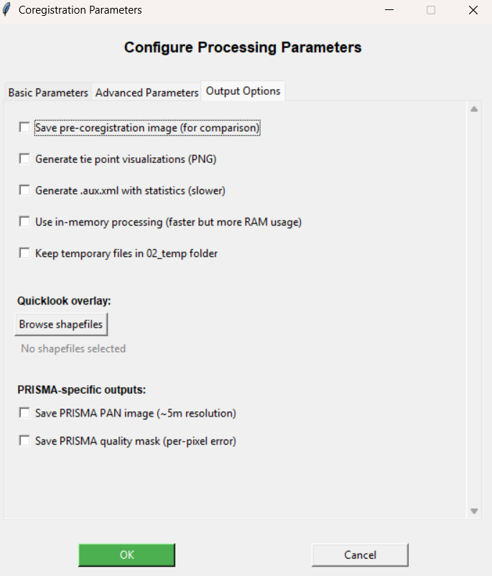
- Future improvements
There is a series of improvements and fixes that can be ranked by priority:
- HIGH PRIORITY
- Modularize the code: Right now, the code is very long, thus difficult to manage for implementing changes and analyse by the end-user if needed. Thus, it would be needed to structure the code into main, ancillary, diagnostic functions. This would be also a priority if the code wants to be published.
- Fix PAN image corregistration: right now, the coregistration of the PAN image is bugged.
- Robust Error Handling: Improve resilience in the presence of download failures, corrupted metadata, or inconsistent dimensions.
- Support for Multitemporal Coregistration: Enable coregistration between two hyperspectral scenes (e.g., PRISMA-to-PRISMA, EnMAP-to-EnMAP)
- MEDIUM PRIORITY
- Include FWHM factor for band correlation between S2 and hyperspectral scenes: this may improve the final accuracy as more correlated bands from HSI, could be selected.
- Test options for a better performance of the code: the use of xarray of rasterio instead of GDAL for some procedures may improve the general performance of the code in terms of speed. Also, the reader procedure may be improved, by reading in smaller chunks, which would reduce the RAM demand.
- LOW PRIORITY
- Cloud masking inclusion for hyperspectral inputs: in this way, any false tie points correlations will be reduced.
- Installation procedure
10. Required packages
Package | Purpose
h5py | HDF5 file reading (PRISMA)
rasterio | GeoTIFF handling
GDAL | Geospatial transformations (gdalwarp)
pyproj | Coordinate reference system handling
shapely | Geometric operations
geoarray | GeoArray data structure
arosics | Automated image coregistration
requests | HTTP client for CDSE API
matplotlib | Quicklook generation
openpyxl | Excel report generation

- References
[1] S2 MSI ESL Team, ‘Data Quality Report – Sentinel-2 L1C MSI, June 2025’, European Space Agency (ESA), Paris, France, Data Quality Report OMPC.CS.DQR.01.05-2025, Jun. 2025. [Online]. Available: https://sentiwiki.copernicus.eu
[2] EnMAP Ground Segment, ‘EnMAP Ground Segment – Mission Quarterly Report #13’, German Aerospace Center (DLR), Germany, Mission Quarterly Report EN-GS-RPT-1113, Dec. 2025. [Online]. Available: https://www.enmap.org
[3] G. D. Luca et al., ‘Improving PRISMA hyperspectral spatial resolution and geolocation by using Sentinel-2: development and test of an operational procedure in urban and rural areas’, ISPRS J. Photogramm. Remote Sens., vol. 215, pp. 112–135, 2024, doi: https://doi.org/10.1016/j.isprsjprs.2024.07.003.
[4] D. Scheffler, A. Hollstein, H. Diedrich, K. Segl, and P. Hostert, ‘AROSICS: An Automated and Robust Open-Source Image Co-Registration Software for Multi-Sensor Satellite Data’, Remote Sens., vol. 9, no. 7, 2017, doi: 10.3390/rs9070676.

