Contents

List of Figures 1

Introduction 1

MAIN 3

HSS 4

HSSController 5

Components 6

Valve 6

Pump 6

Temperature Sensors 6

Hydraulic Mixing Circuit 7

Simulated Input Data 7

Sensor Data: 7

EnvTemperature: 7

OSCAT 7

Interfaces 8

# List of Figures

Figure 1 Heating Supply Circle 2

Figure 2 Libraries 2

Figure 3 Structure of the program 3

Figure 4 UML Class Diagram 3

Figure 5 Modes 5

Figure 6 OSCAT 8

Figure 7 Interfaces 8

# Introduction

This program represents a controlling of a heating supply circle. A small overview can be seen in the diagram below:

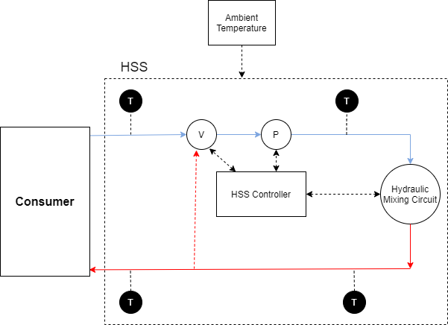

Figure Heating Supply Circle

The Heating Supply System consists of a pump, valve, four temperature sensors, controller and a hydraulic mixing circuit. The Ambient Temperature effects the also the circle as it determines the setting temperature. The Hydraulic mixing circuit uses the controller and the components: valve and pump to mix the cold and hot water. This process results in a desired temperature of the room.

This program is implemented on TwinCAT Beckhoff 3.0 using the following libraries:

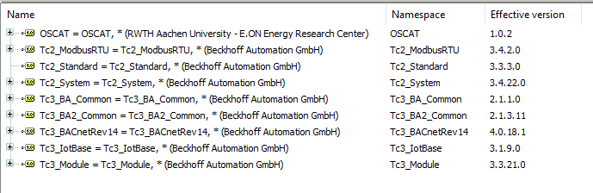

Figure Libraries

The following figure illustrates the structure of the program:

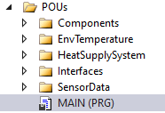

Figure 3 Structure of the program

To understand the relation between the different components in this program, consider the following UML class diagram:

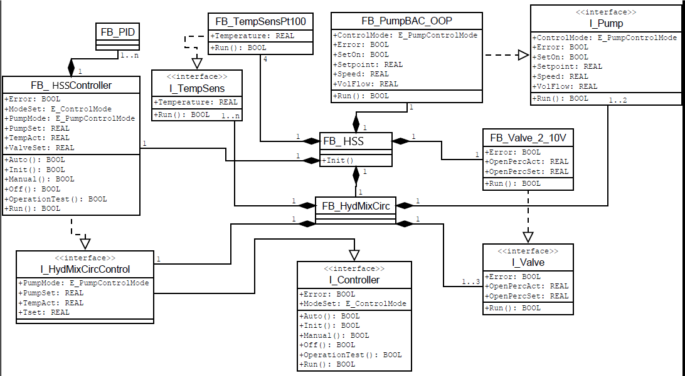

Figure 4 UML Class Diagram

# MAIN

In the MAIN program we will first check the mode and set it to Auto, if the mode is not external ADS.

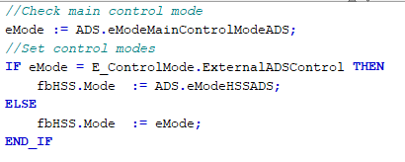

Where eMode is defined as*: eMode : E_ControlMode := E_ControlMode.Auto;*

Then we will generate simulated signals for the sensor temperature, valve position and environmental ambient air through the POUs: SensorData and EnvTemperature. We will save these generated signals in the following variables:

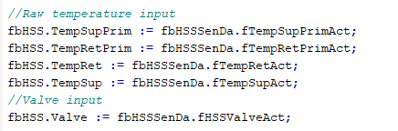

After storing these variables, we will then finally run the function block HSS.

# HSS

In accordance with the heat supply circle, the Function Block “Heating Supply System” consist of a valve, pump, 4 temperature sensors, controller and a hydraulic mixing circuit. These components are declared as below:

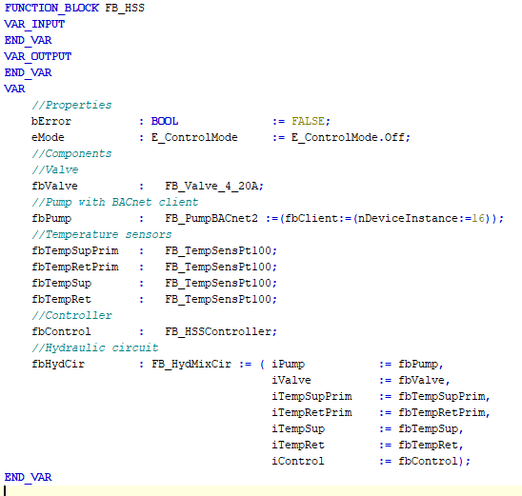

All these components are defined in the POU (program organization unit) “Components” except the controller which is programmed separately. This POU has a method Run in which all the temperature sensor, valve and pump data points are updated from the ADS or GVL, after the function block of hydraulic circuit is executed. The Hydraulic Mixing Circuit takes the valve, pump, temperature sensors and controller values and mixes the fluids to attain the desired temperature for the room. The following lines of code show the fb_HydMixCir.Run() program:

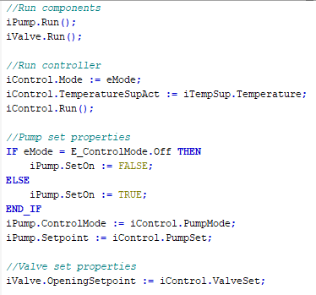

The HSS POU has properties like error, mode, temperatures and valve values that can be accessed from the MAIN function.

# HSSController

The function block HSSController implements the Hydraulic Mixing Control which can be found in the POU “Interfaces”. The input of the controller is the ambient temperature and the outputs are setting value for the valve and pump.

There are different control modes namely: Off, Init, Operation Test, Auto, Manual and External ADS Control in the E_ControlMode. By default, the mode would be Auto. There is also a separate control mode for the pump (EPumpControlMode) which contains the parameters like constant speed and constant difference of the pump.



Figure Modes

In the Auto Mode we use a PID Controller to control the valve. We calculate the setting Temperature using a Heating Curve function with air temperature and heating slope/offset as inputs. The setting temperature and the actual temperature is given in the controller along with constant PID parameters like Kp, Ti, Td etc. and we get the valve setting position as output. The pump is controlled by the separate control mode difference. The code for controller in Auto Mode is given below:

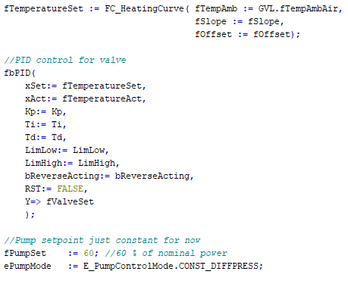

# Components

## Valve

The valve used in the heating supply system uses the function block FB_Valve_4_20A. We decide the percentage of opening of the valve by the amount of current which is between 4mA and 20mA. The valve has local variables like actual opening and opening set point. These real variables are defined by raw integer values. These raw values use the functions current to percentage and percentage to current converter.

## Pump

The pump which is used in the HSS uses the function block FB_BACnet2. This function block utilizes the libraries tc3_BA_Common, tc3_BA2_Common and tc3_BACnetRev14 for defining the parameters of the pump. The control mode for the pump is separately defined as mentioned before. The main parameters for the pump are: control mode, error, operating, power rating, pressure, set point, speed and volume flow.

## Temperature Sensors

There are 4 temperature sensors with the names: TempSup, TempRet, TempSupPrim and TempRetPrim. These sensors use the TempSensPt100 function block form the “Components”. This function block has internal variables raw temperature and actual temperature. The function Pt100Raw_TO_Temperature() is used with raw temperature as input and actual temperature as output. The data of raw temperature is given by the MAIN function which is generated in the POU SensorData.

## Hydraulic Mixing Circuit

The hydraulic circuit updates the temperature and then allows the valve and pump function block to run. Then it uses a hydraulic mixing controller that we programmed as HSS controller to set the pump and valve. This function block uses the “Interface” POU.

## Simulated Input Data

There are two POUs for simulated input data with the name: SensorData and EnvTemperature. The SensorData output is used in the MAIN program whereas the output of the EnvTemperature is directly stored in the GVL.

Sensor Data: The POU Sensor Data generates two ramp signals as input for the temperature sensor and for the actual position of the valve. These both signals are generated with the help of the Engineering POU of OSCAT. This data about the temperature and valve position is stored in variables and used in the MAIN function.

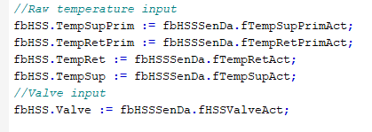

EnvTemperature: The environmental temperature is simulated with the help of the OSCAT library. We generate a sinus wave (ftemp_sin) to represent the Ambient Air. The value of the ambient air is saved in a Global Variable List (GVL.fTempAmbAir) and is used in the HSS Controller block during the simulation of the heating curve.

# OSCAT

The OSCAT or (AixOCAT) library is used to generate signals for the input. In the POUs we find the Engineering folder which again contains the signal generators folder. We use the ramp and sinus function block for the input of the sensor data and environmental temperature. We can set the time period, amplitude, offset and delay. We use the OUT variable which is a real value in this program.

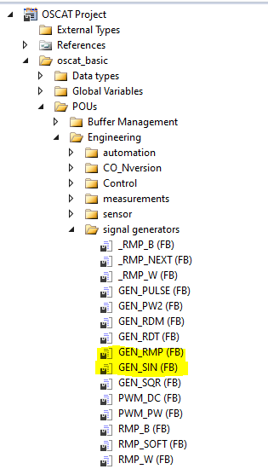

Figure OSCAT

# Interfaces

Along the components we also need the “Interface” POU. In this POU we define the pump, valve, controller, hydraulic mixing control and temperature sensors with the prefix “I”.

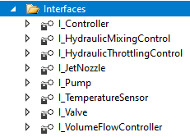

Figure Interfaces