目录

窗体：MainForm 1

代码 2

窗体：ALDTPicker 11

代码 12

## 窗体：MainForm

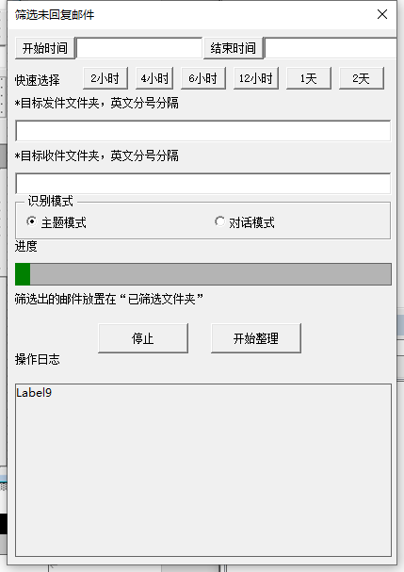

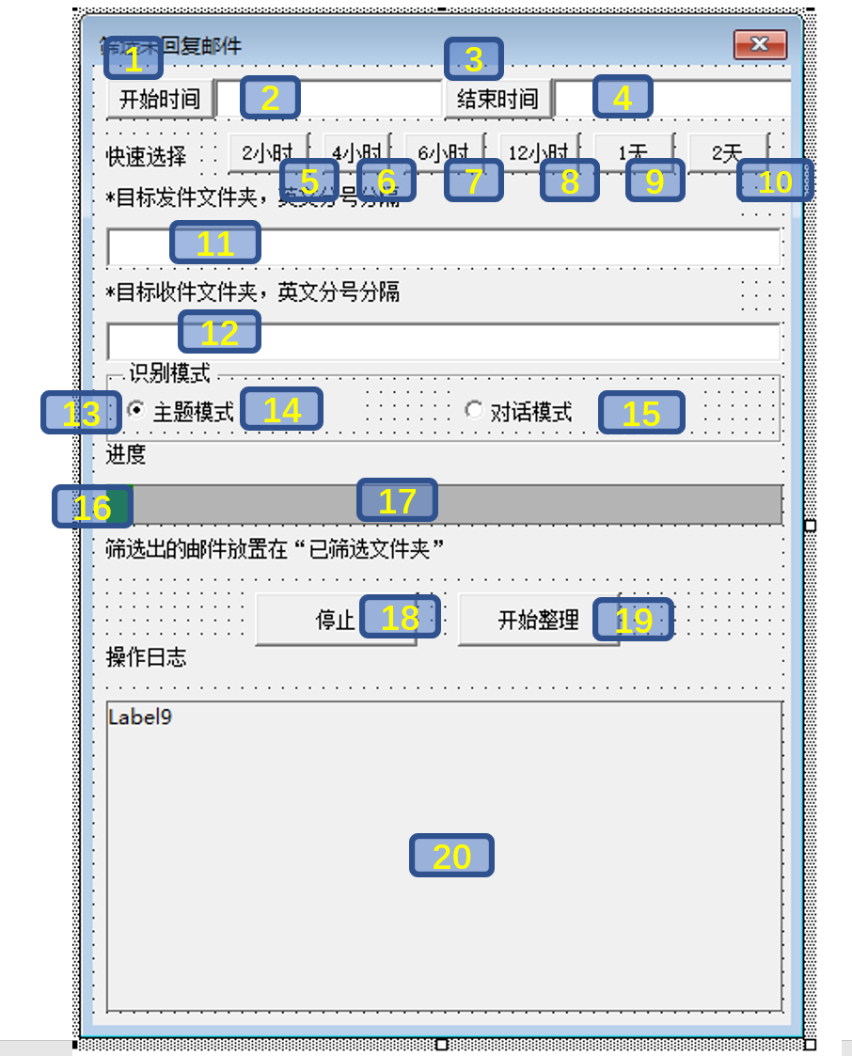

|  |  |  |  |
| --- | --- | --- | --- |
| 位置 | 控件 | 名称 | 备注 |
| 1 | Button | BT_SelST |  |
| 2 | Textbox | T_ST |  |
| 3 | Button | BT_SetET |  |
| 4 | Textbox | T_ET |  |
| 5~10 | Button | s2h、s4h、s6h、s12h、s24h、s48h |  |
| 11 | Textbox | T_TargetFolders |  |
| 12 | Textbox | T_TargetRCFolders |  |
| 13 | Frame | Frame1 | 包含14和15 |
| 14 | OptionButton | O_Subject |  |
| 15 | OptionButton | O_Con |  |
| 16 | Label | L_Progress | 底色绿色 |
| 17 | Label | L_ProgressBG | 底色灰色 |
| 18 | Button | BT_stop |  |
| 19 | Button | BT_Run |  |
| 20 | Label | Label9 |  |

### 代码

'Code written By AntoniotheFuture

'antoniothefuture@qq.com

Public isstop As Boolean

'写日志

Sub Log(logstr)

Me.Label9.Caption = Now() & " " & logstr & Chr(10) & Me.Label9.Caption

End Sub

'清空日志

Sub clearlog()

Me.Label9.Caption = ""

End Sub

Sub ScanMails()

End Sub

'更新进度条的位置

Function SetProgress(PG As Double, n As Integer, M As Integer) As Integer

Me.L_Progress.Width = Me.L_ProgressBG.Width * PG

Me.Label3.Caption = "进度(" & n & "/" & M & ")"

End Function

'-1: 错误

Function GetMails() As Integer

Dim olMail As MailItem

Dim OLF As Folder

Dim MidFolder As Folder

Dim Emails

Dim DoLoad As Boolean

Dim Title As String

Dim Attms As String

Dim AttmArr

Dim MailC As Collection

Dim hit As Boolean

Dim Sh As Shape

Dim SC As Integer

Dim SMails As Collection

Dim RMails As Collection

'时间

Dim ST As String

Dim ET As String

Dim STD As Date

Dim ETD As Date

Dim Folders

Dim RCFolders

Dim OLFolders As Folders

'读取参数

ST = Me.T_ST

ET = Me.T_ET

If ST <> "" Then

If Not IsDate(ST) Then

Log ("开始时间格式错误")

GetMails = -1

Exit Function

Else

STD = CDate(ST)

End If

End If

If ET <> "" Then

If Not IsDate(ET) Then

Log ("结束时间格式错误")

GetMails = -1

Exit Function

Else

ETD = CDate(ET)

End If

End If

Folders = Me.T_TargetFolders

RCFolders = Me.T_TargetRCFolders

If Folders = "" Or RCFolders = "" Then

Log ("目标文件夹为空，无法执行")

GetMails = -1

Exit Function

End If

If ST = "" And ET = "" Then Log ("未选择时间范围，将扫描目标文件夹的所有邮件")

Folders = Split(Folders, ";")

RCFolders = Split(RCFolders, ";")

'判断已筛选文件夹是否存在

On Error Resume Next

Set OLF = Application.GetNamespace("MAPI").Folders(1).Folders("已筛选文件夹")

If TypeName(OLF) = "Nothing" Then

Log ("已筛选文件夹不存在，创建中")

Set OLFolders = Application.GetNamespace("MAPI").Folders

Set OLF = OLFolders(1).Folders.Add("已筛选文件夹")

If TypeName(OLF) = "Nothing" Then

Log ("文件夹创建失败")

GetMails = -1

Exit Function

End If

End If

'清空筛选文件夹

'OLF.Items.Remove

For Each olMail In OLF.Items

olMail.Delete

Next

Dim SFolders As Collection

Dim SSFolders As Collection

Dim RFolders As Collection

Set SFolders = New Collection

Set SSFolders = New Collection

Set RFolders = New Collection

'遍历每个发件文件夹

For Each F In Folders

If F = "" Then GoTo nextF

If Right(F, 2) = "/*" Then

Set MidFolder = GetFolder(Left(F, Len(F) - 2))

Set SSFolders = GetFolders(MidFolder)

For Each F2 In SSFolders

SFolders.Add F2

Next

Else

SFolders.Add GetFolder(CStr(F))

End If

nextF:

Next

'遍历每个收件文件夹

For Each F In RCFolders

If F = "" Then GoTo nextF2

If Right(F, 2) = "/*" Then

Set MidFolder = GetFolder(Left(F, Len(F) - 2))

Set SSFolders = GetFolders(MidFolder)

For Each F2 In SSFolders

RFolders.Add F2

Next

Else

RFolders.Add GetFolder(CStr(F))

End If

nextF2:

Next

Log ("发件文件夹数量：" & SFolders.Count)

Log ("收件文件夹数量：" & RFolders.Count)

Set SMails = New Collection

Set RMails = New Collection

For Each F In SFolders

For Each olMail In F.Items

SMails.Add olMail

Next

Next

For Each F In RFolders

For Each olMail In F.Items

RMails.Add olMail

Next

Next

'邮件去重

For I = SMails.Count - 1 To 0

For ii = SMails.Count - 1 To 0

If I <> ii And SMails(I).Subject = SMails(ii).Subject And SMails(I).ReceivedTime = SMails(ii).ReceivedTime Then

SMails.Remove (I)

Exit For

End If

Next

Next

'Dim olMailR As MailItem

Dim ReplyC As Integer

Dim mlcopy As MailItem

Dim n As Integer

'遍历每一封已发送邮件，找到对应的回复邮件，如果找不到就复制到已筛选文件夹内

n = 0

hitn = 0

For Each olMail In SMails

If isstop Then

Log ("已中止")

GetMails = hitn

Exit Function

End If

ReplyC = 0

hit = True

SetProgress n / SMails.Count, n, SMails.Count

DoEvents

If ST <> "" Then If olMail.LastModificationTime < STD Then hit = False

If ET <> "" And hit Then If olMail.LastModificationTime > ETD Then hit = False

If hit Then

Log ("处理中:" & olMail.Subject)

For Each olMailR In RMails

If olMail.LastModificationTime < olMailR.ReceivedTime Then

If Me.O_Subject.Value Then

'主题匹配模式

If InStr(olMailR.Subject, olMail.Subject) > 0 Then

ReplyC = ReplyC + 1

End If

Else

'对话匹配模式

If olMail.ConversationID = olMailR.ConversationID Then

ReplyC = ReplyC + 1

End If

End If

End If

Next

If ReplyC = 0 Then

Set mlcopy = olMail.Copy

mlcopy.Move OLF

hitn = hitn + 1

End If

End If

n = n + 1

Next

Log ("处理完毕")

SetProgress 1, n, SMails.Count

GetMails = hitn

skip1:

If hitn > 0 Then

Log ("筛选出" & hitn & "封邮件")

Else

Log ("没有符合条件的邮件")

End If

End Function

'递归每一个子文件夹

Function GetFolders(F As Folder) As Collection

Dim C As Collection

Dim C2 As Collection

Dim FF As Folder

Set C = New Collection

Set C2 = New Collection

C.Add F

For Each FF In F.Folders

Set C2 = GetFolders(FF)

For Each FFF In C2

C.Add FFF

Next

Next

Set GetFolders = C

End Function

Private Sub BT_Run_Click()

isstop = False

clearlog

Log ("任务开始")

GetMails

End Sub

Private Sub BT_SelST_Click()

With ALDTPicker

.Show

Me.T_ST = .DateTime

End With

End Sub

Private Sub BT_SetET_Click()

With ALDTPicker

.Show

Me.T_ET = .DateTime

End With

End Sub

Private Sub BT_stop_Click()

isstop = True

End Sub

Private Sub Label7_Click()

End Sub

Private Sub s12h_Click()

SelSTFromNow (12)

End Sub

Private Sub s24h_Click()

SelSTFromNow (24)

End Sub

Private Sub s2h_Click()

SelSTFromNow (2)

End Sub

Function SelSTFromNow(h As Integer) As Integer

Me.T_ST = DateAdd("h", h * -1, Now())

End Function

Private Sub s48h_Click()

SelSTFromNow (48)

End Sub

Private Sub s4h_Click()

SelSTFromNow (4)

End Sub

Private Sub s6h_Click()

SelSTFromNow (6)

End Sub

'这个函数用于从路径定位文件夹

Public Function GetFolder(strFolderPath As String) As MAPIFolder

' strFolderPath needs to be something like

' "Public Folders\All Public Folders\Company\Sales" or

' "Personal Folders\Inbox\My Folder"

Dim objApp 'As Outlook.Application

Dim objNS As NameSpace

Dim colFolders As Folders

Dim objFolder 'As Outlook.MAPIFolder

Dim arrFolders() As String

Dim I As Long

On Error Resume Next

strFolderPath = Replace(strFolderPath, "/", "\")

arrFolders() = Split(strFolderPath, "\")

Set objApp = Application

Set objNS = objApp.GetNamespace("MAPI")

Set objFolder = objNS.Folders.Item(arrFolders(0))

If Not objFolder Is Nothing Then

For I = 1 To UBound(arrFolders)

Set colFolders = objFolder.Folders

Set objFolder = Nothing

Set objFolder = colFolders.Item(arrFolders(I))

If objFolder Is Nothing Then

Exit For

End If

Next

End If

Set GetFolder = objFolder

Set colFolders = Nothing

Set objNS = Nothing

Set objApp = Nothing

End Function

## 窗体：ALDTPicker

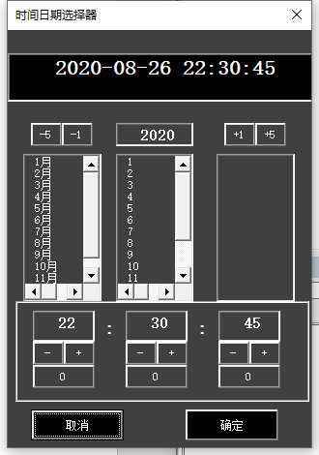

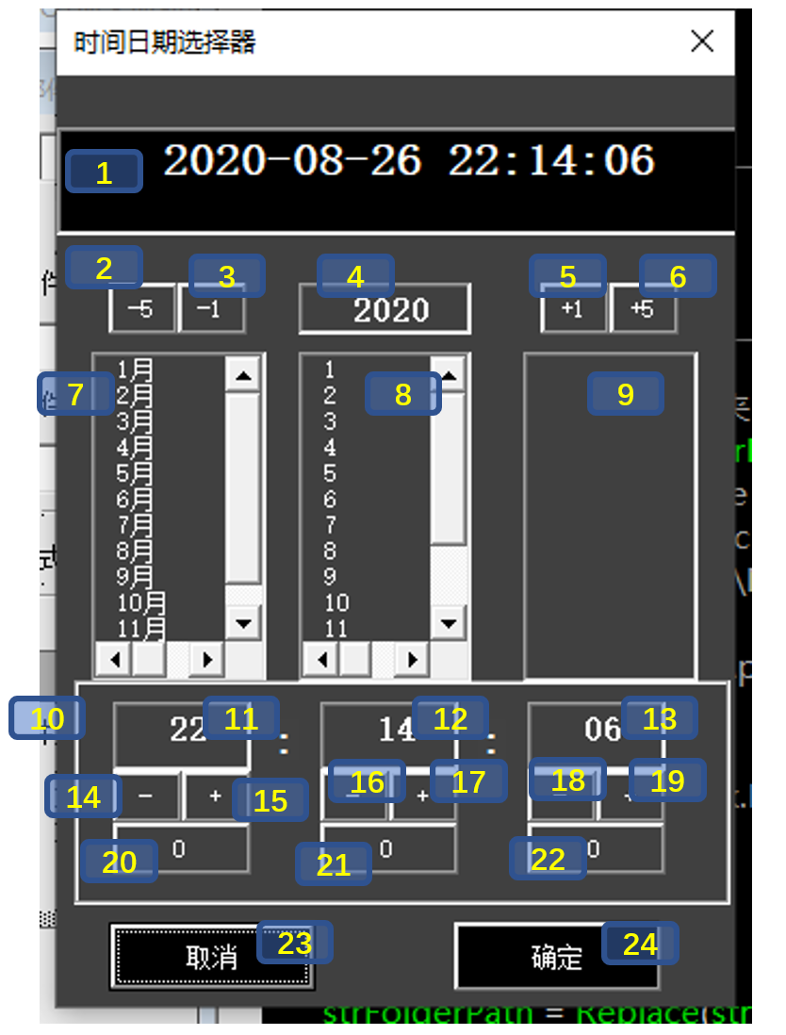

|  |  |  |  |
| --- | --- | --- | --- |
| 序号 | 控件 | 名称 | 备注 |
| 1 | Textbox | T_DateTime |  |
| 2 | Button | BT_YearDownTen |  |
| 3 | Button | BT_YearDown |  |
| 4 | Textbox | T_Year |  |
| 5 | Button | BT_YearUp |  |
| 6 | Button | BT_YearUpTen |  |
| 7 | Listbox | L_NM |  |
| 8 | Listbox | L_UMDs |  |
| 9 | Listbox | L_LMDs |  |
| 10 | Frame | F_Time | 包含11-22 |
| 11 | Textbox | T_H |  |
| 12 | Textbox | T_M |  |
| 13 | Textbox | T_S |  |
| 14 | Button | BT_HCut |  |
| 15 | Button | BT_HAdd |  |
| 16 | Button | BT_MCut |  |
| 17 | Button | BT_MAdd |  |
| 18 | Button | BT_SCut |  |
| 19 | Button | BT_SAdd |  |
| 20 | Button | BT_HZero |  |
| 21 | Button | BT_MZero |  |
| 22 | Button | BT_SZero |  |
| 23 | Button | BT_Cancel |  |
| 24 | Button | BT_OK |  |

### 代码

'Code written By AntoniotheFuture

'antoniothefuture@qq.com

Public OldValue As String

Public DateFormat As String

Public DateTime As String

Public DateType As String

Dim Y As Integer

Dim M As Integer

Dim D As Integer

Dim HH As Integer

Dim MM As Integer

Dim SS As Integer

Private Sub BT_Cancel_Click()

DateTime = OldValue

Me.hide

End Sub

Private Sub BT_HAdd_Click()

If HH = 23 Then

HH = 0

Else

HH = HH + 1

End If

RefreshTextbox

End Sub

Private Sub BT_HCut_Click()

If HH = 0 Then

HH = 23

Else

HH = HH - 1

End If

RefreshTextbox

End Sub

Private Sub BT_HZero_Click()

HH = 0

RefreshTextbox

End Sub

Private Sub BT_MAdd_Click()

If MM = 59 Then

MM = 0

Else

MM = MM + 1

End If

RefreshTextbox

End Sub

Private Sub BT_MCut_Click()

If MM = 0 Then

MM = 59

Else

MM = MM - 1

End If

RefreshTextbox

End Sub

Private Sub BT_MZero_Click()

MM = 0

RefreshTextbox

End Sub

Private Sub BT_SAdd_Click()

If SS = 59 Then

SS = 0

Else

SS = SS + 1

End If

RefreshTextbox

End Sub

Private Sub BT_SCut_Click()

If SS = 0 Then

SS = 59

Else

SS = SS - 1

End If

RefreshTextbox

End Sub

Private Sub BT_SZero_Click()

SS = 0

RefreshTextbox

End Sub

Private Sub BT_OK_Click()

Me.hide

End Sub

Private Sub CommandButton1_Click()

End Sub

Private Sub BT_YearDown_Click()

Y = Y - 1

RefreshTextbox

End Sub

Private Sub BT_YearDownTen_Click()

Y = Y - 5

RefreshTextbox

End Sub

Private Sub BT_YearUp_Click()

Y = Y + 1

RefreshTextbox

End Sub

Private Sub BT_YearUpTen_Click()

Y = Y + 5

RefreshTextbox

End Sub

Private Sub CommandButton5_Click()

End Sub

Private Sub L_LMDs_Click()

D = L_LMDs.Value

RefreshTextbox

End Sub

Private Sub L_NM_Click()

Dim Mstr As String

Mstr = Me.L_NM.Value

M = Left(Mstr, Len(Mstr) - 1)

If Y = 0 Then Y = Year(Date)

Me.L_LMDs.Clear

EndM = DateAdd("M", 1, Format(Y & "-" & M & "-" & "01", "ddddd"))

Ds = Day(DateAdd("D", -1, EndM))

For I = 16 To Ds

Me.L_LMDs.AddItem I

Next

RefreshTextbox

End Sub

Private Sub L_UMDs_Click()

D = L_UMDs.Value

RefreshTextbox

End Sub

Private Sub T_H_Exit(ByVal Cancel As MSForms.ReturnBoolean)

TBH = Me.T_H.Text

If IsNumeric(TBH) And TBH >= 0 And TBH < 24 Then

HH = TBH

Else

Me.T_H.Text = ""

End If

RefreshTextbox

End Sub

Private Sub T_M_Exit(ByVal Cancel As MSForms.ReturnBoolean)

TBH = Me.T_M.Text

If IsNumeric(TBH) And TBH >= 0 And TBH < 60 Then

MM = TBH

Else

Me.T_M.Text = ""

End If

RefreshTextbox

End Sub

Private Sub T_S_Exit(ByVal Cancel As MSForms.ReturnBoolean)

TBH = Me.T_S.Text

If IsNumeric(TBH) And TBH >= 0 And TBH < 60 Then

SS = TBH

Else

Me.T_S.Text = ""

End If

RefreshTextbox

End Sub

Private Sub T_Year_Exit(ByVal Cancel As MSForms.ReturnBoolean)

With Me

If IsNumeric(.T_Year) Then

If Not (.T_Year.Text > 0 And .T_Year = Int(.T_Year.Text)) Then

.T_Year = Year(Date)

End If

Else

.T_Year = Year(Date)

End If

Y = .T_Year

RefreshTextbox

End With

End Sub

Sub RefreshTextbox()

Me.T_Year = Format(Y, "0000")

Me.T_H = Format(HH, "00")

Me.T_M = Format(MM, "00")

Me.T_S = Format(SS, "00")

Me.T_DateTime = Format(Format(Y, "0000") & "/" & Format(M, "00") & _

"/" & Format(D, "00") & " " & Format(HH, "00") & ":" & Format(MM, "00") & ":" & Format(SS, "00"), DateFormat)

DateTime = Me.T_DateTime

End Sub

Sub SetDT(FDateType As String, Optional OldValue As String)

DateType = FDateType

If OldValue = "" Then

Me.T_DateTime = Format(Date & " " & Time(), DateFormat)

DateTime = Me.T_DateTime

Else

DateTime = OldValue

End Sub

Private Sub UserForm_Activate()

If DateFormat = "" Then

DateFormat = "YYYY/MM/DD hh:mm:ss"

End If

If DateType = "" Then

DateType = "D&T"

End If

If DateType = "D" Then

Me.F_Time.Visible = False

ElseIf DateType = "T" Then

Me.F_Time.Visible = False

End If

For I = 1 To 12

Me.L_NM.AddItem I & "月"

Next

For I = 1 To 15

Me.L_UMDs.AddItem I

Next

If Not IsDate(DateTime) Or OldValue = "" Then

DateTime = Date & " " & Time

End If

Y = Year(DateTime)

M = Month(DateTime)

D = Day(DateTime)

HH = Hour(DateTime)

MM = Minute(DateTime)

SS = Second(DateTime)

RefreshTextbox

End Sub