**Pierre Gasly**

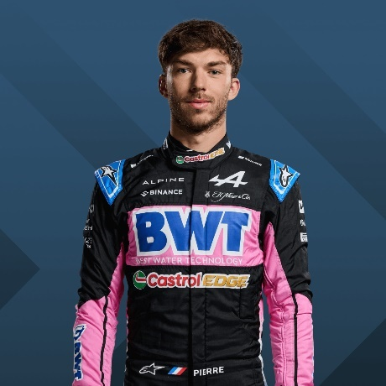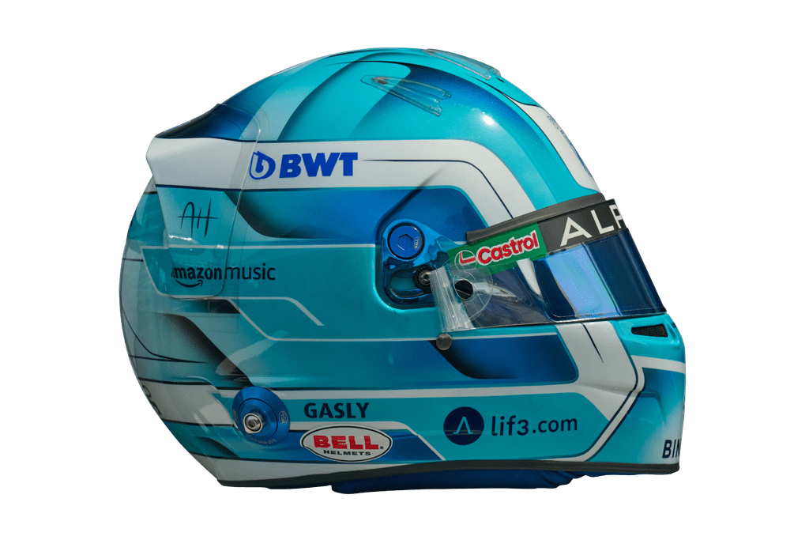

10

* [**Official merchandise**](https://f1store.formula1.com/en/pierre-gasly/a-2328448412+z-940713-2271588191)

**Team**

Alpine

**Country**

France

**Podiums**

4

**Points**

394

**Grands Prix entered**

137

**World Championships**

0

**Highest race finish**

1 (x1)

**Highest grid position**

2

**Date of birth**

07/02/1996

**Place of birth**

Rouen, France

Biography

If there’s one man who knows how big a rollercoaster ride an F1 driver’s career can be, it’s Pierre Gasly!

The flying Frenchman was called up to make his 2017 debut in Malaysia in place of Daniil Kvyat and, after proving his mettle, he was named a Toro Rosso driver the following year. A further 21 races into his fledgling career, Gasly was moved up again – this time to replace Red Bull big gun Daniel Ricciardo.

Gasly seemed to have a knack of being in the right place at the right time – a quality that’s equally handy on track. A series of impressive 2018 performances for Toro Rosso – including a brilliant fourth place in Bahrain – showed exciting promise for what he might do with the ‘A’ team in 2019.

Unfortunately that promise only appeared in flashes – and he quickly suffered from unfavourable comparisons with superstar team mate Max Verstappen. So much so that after the summer break, he was sent back to Toro Rosso, with another young up-and-comer – Alex Albon – being given a shot in the ‘senior’ Red Bull seat.

But Gasly bounced back, as only Gasly can. In the season’s remaining nine races he scored almost as many points as team mate Kvyat managed over the entire year – and secured his best-ever race result with P2 in Brazil. That trajectory continued in 2020, peaking with an emotional maiden win at the renamed AlphaTauri team’s home race in Italy, and didn’t let up in 2021 when he was back on the podium and scored 110 of the squad’s 142 points.

When AlphaTauri’s momentum stalled in 2022, Gasly decided it was time for a change – in the form of French team Alpine, with fellow Frenchman – and old adversary – Esteban Ocon as team mate. The question now is can he regain momentum and get himself another shot at the F1 bigtime…