Contents

Software design patterns 2

UML diagrams Guide 3

A- Creation design patterns 11

1. Singleton design pattern 11

2. Prototype design pattern 11

3. Builder design pattern 13

4. Factory design pattern 13

5. Abstract Factory design pattern 14

B- Structural design patterns 15

1- Proxy 15

2- Decorator 17

3- Adapter pattern 18

4- Façade pattern 19

5- Flyweight 20

6- Bridge 20

7- Composite 22

C- behaviour design patterns 23

1- Visitor 23

2- Observer 26

3- Strategy 29

4- Template Method 30

5- Command 32

# C#

## Compiler

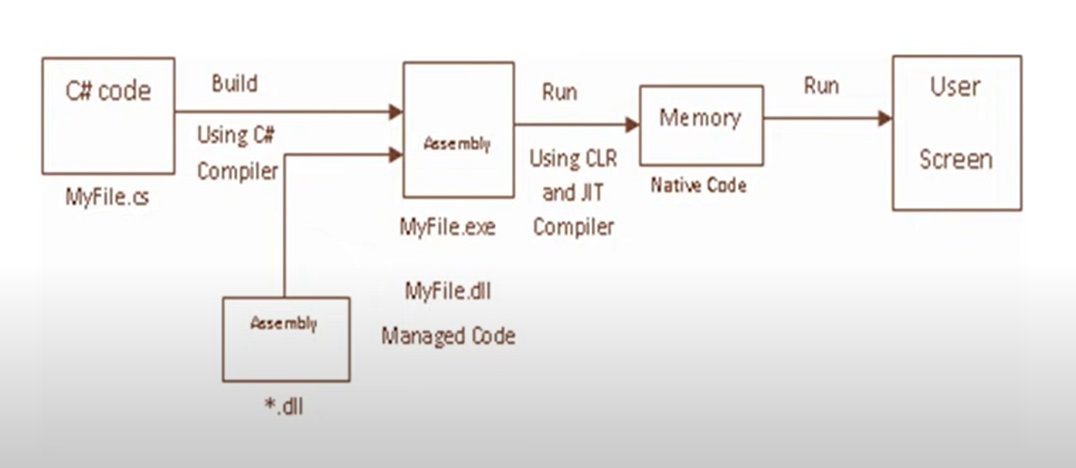

Software design patterns:General solutions to software design problems.

GOF design pattern categories

## UML diagrams Guide