Contents

C# 1

1. What is C#? 1

2. What is an object in C#? 2

# Introduction to microservices

## Service oriented application

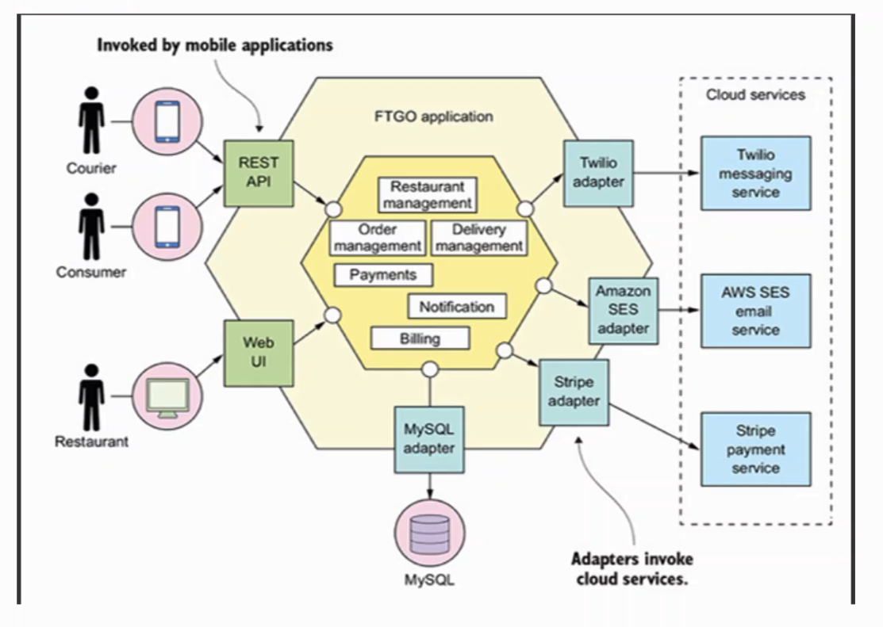

* Use the same data layer
* There are common system in core layer

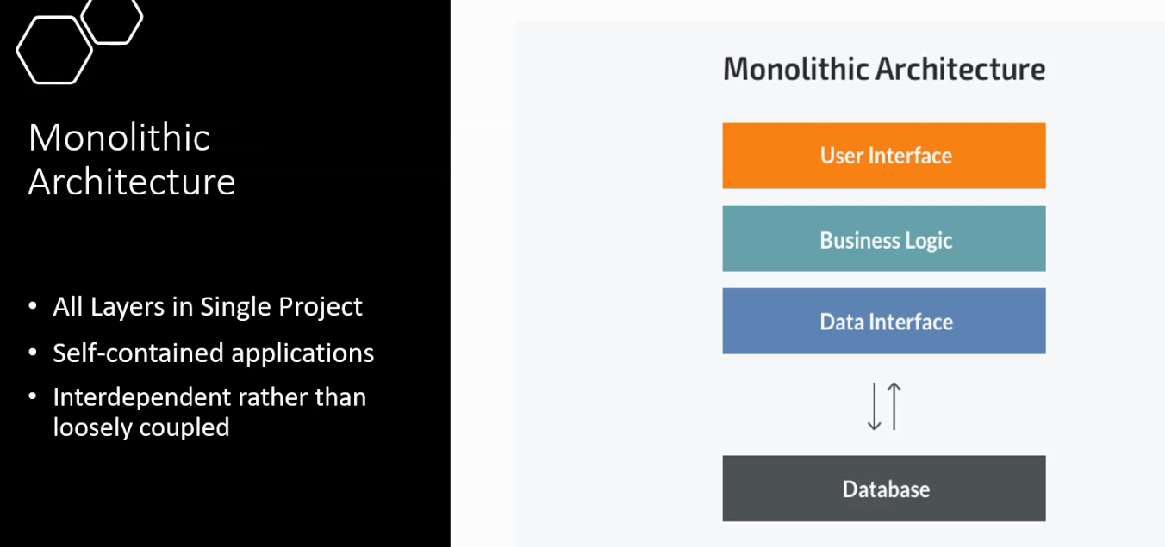

One project

