Contents

A - ASP.NET Core Fundamentals 1

Page rout Razor 1

# A - ASP.NET Core Fundamentals

## Page rout Razor

* Query string

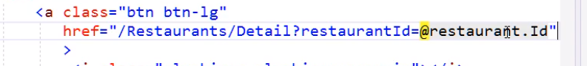

* Asp tag helper

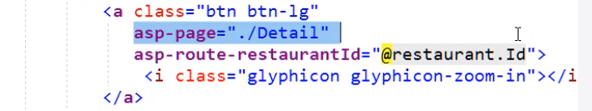

* Page Route

