**PRACTICAL 1**

# Table ACCOUNT

# CREATE TABLE ACCOUNT

# 

## SQL commands:

CREATE TABLE ACCOUNT (

ACC_NO VARCHAR2 (5),

NAME VARCHAR2 (30),

CITY VARCHAR2 (20),

BALANCE NUMBER (10,2),

LOAN_TAKEN VARCHAR2 (5)

);

**Insert The Following Records**

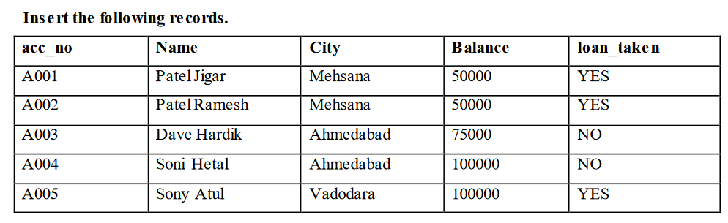

## SQL commands on Records of Table:

INSERT INTO ACCOUNT

(ACC_NO, NAME, CITY, BALANCE, LOAN_TAKEN) VALUES ('A001', 'Patel jigar', 'Mehsana', '50000', 'YES');

INSERT INTO ACCOUNT

(ACC_NO, NAME, CITY, BALANCE, LOAN _TAKEN) VALUES('A002', 'Patel Ramesh', 'Mehsana', '50000', 'YES');

INSERT INTO ACCOUNT

(ACC_NO, NAME, CITY, BALANCE, LOAN _TAKEN)

VALUES('A003', 'Dave hardik', 'Ahmedabad', '75000', 'NO');

INSERT INTO ACCOUNT

(ACC_NO, NAME, CITY, BALANCE, LOAN_TAKEN)

VALUES('A004', 'Sony Hetal', 'Ahmedabad', '100000', 'No');

INSERT INTO ACCOUNT

(ACC_NO, NAME, CITY, BALANCE, LOAN_TAKEN) VALUES('A005', 'Sony Hetal', 'Vododara', '100000', 'YES');

**Output:**

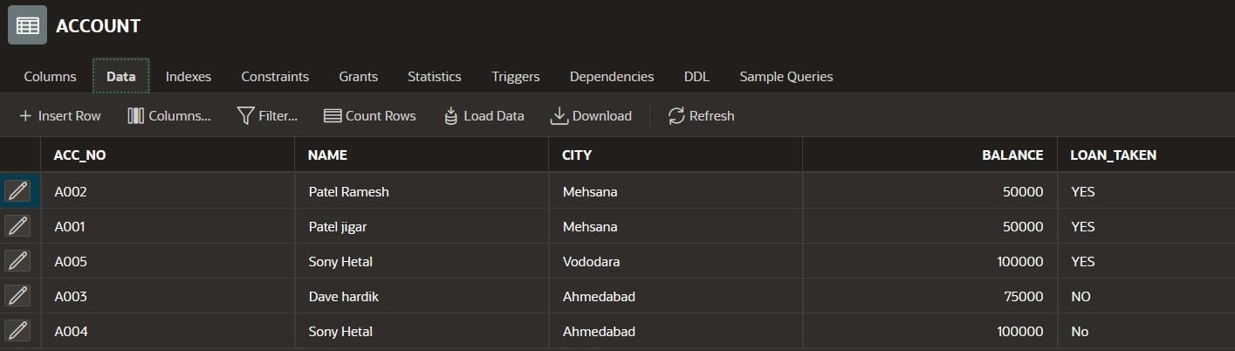



# Table LOAN

**CREATE TABLE LOAN**

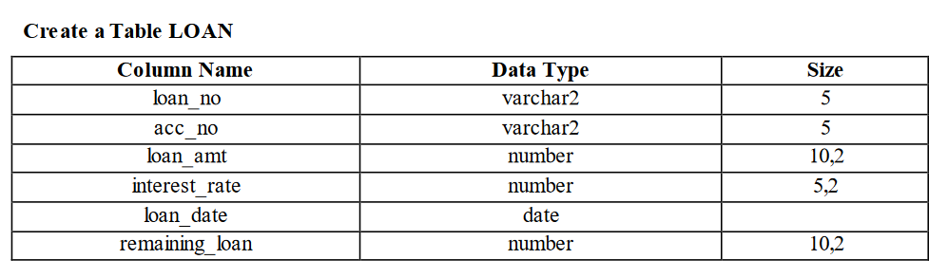

**SQL commands:** CREATE TABLE LOAN (

LOAN_NO VARCHAR2 (5),

ACC_NO VARCHAR2 (5),

LOAN_AMT NUMBER (10,2),

INTEREST_RATE NUMBER (5,2), LOAN_DATE DATE, REMAING_LOAN NUMBER(10,2)

);

**Insert The Following Records**

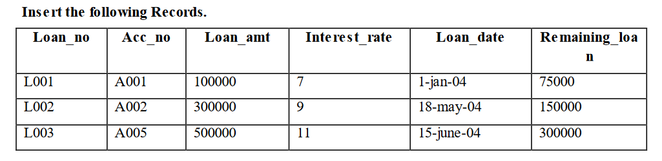

## SQL commands on Records of Table:

INSERT INTO LOAN

(LOAN_NO, ACC_NO, LOAN_AMT, INTEREST_RATE, LOAN_DATE, REMAING_LOAN)

VALUES ('L001','A001','100000','7','1 JAN 04','75000');



INSERT INTO LOAN

(LOAN_NO, ACC_NO, LOAN_AMT, INTEREST_RATE, LOAN_DATE, REMAING_LOAN)

VALUES ('L002','A002','300000','9','18 MAY 04','150000');

INSERT INTO LOAN

(LOAN_NO, ACC_NO, LOAN_AMT, INTEREST_RATE, LOAN_DATE, REMAING_LOAN)

VALUES ('L003','A005','500000','11','15 JUNE 04','350000');

**Output:**

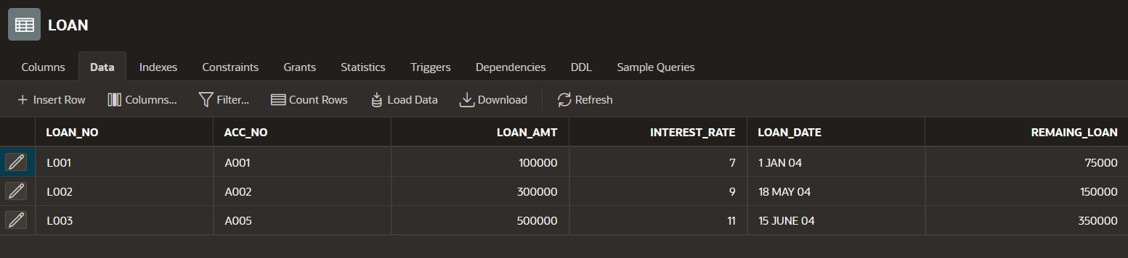

# Table INSTALLEMENT

# CREATE TABLE INSTALLEMENT

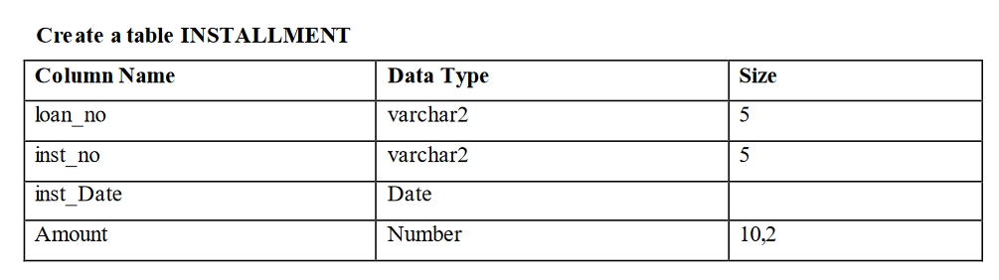

## SQL commands:

CREATE TABLE INSTALLEMENT (

LOAN_NO VARCHAR2(5),

INST_NO VARCHAR2(5),

INST_DATE DATE,

AMOUNT NUMBER(10,2)

);

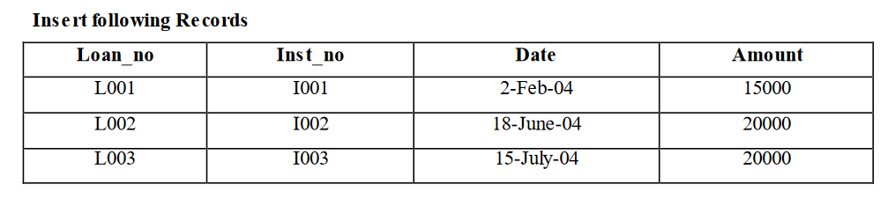

**Insert The Following Records**

## SQL commands on Records of Table:

INSERT INTO INSTALLEMENT

(LOAN_NO, INST_NO, INST_DATE, AMOUNT) VALUES('L001','I001','2 FEB 04','15000');

INSERT INTO INSTALLEMENT

(LOAN_NO, INST_NO, INST_DATE, AMOUNT) VALUES('L002','I002','18 JUNE 04','20000');

INSERT INTO INSTALLEMENT

(LOAN_NO, INST_NO, INST_DATE, AMOUNT)

VALUES('L003','I003','15 JULY 04','20000')



**Output:**

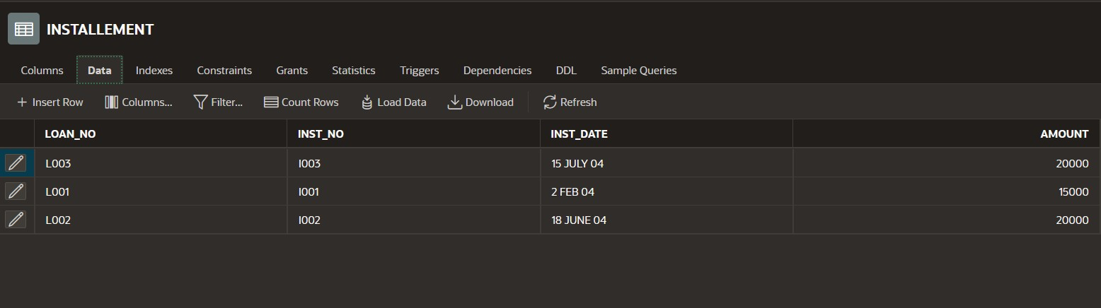

# Table TRANSACTION

# CREATE TABLE TRANSACTION

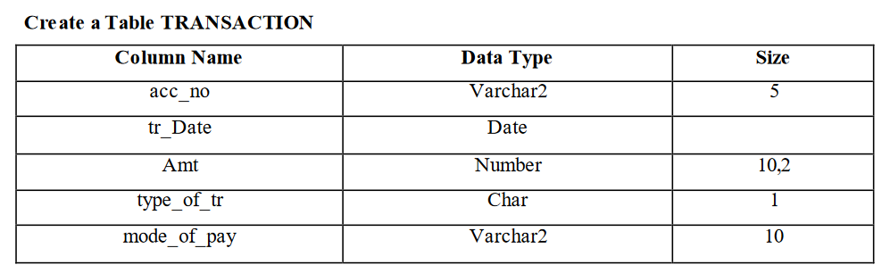

## SQL commands:

CREATE TABLE TRANSACTION (

ACC_NO VARCHAR2(5), TR_DATE DATE,

AMT NUMBER(10,2), TYPE_OF_TR NUMBER(1), MODE_OF_PAY VARCHAR2(10)

);

**Insert The Following Records** 

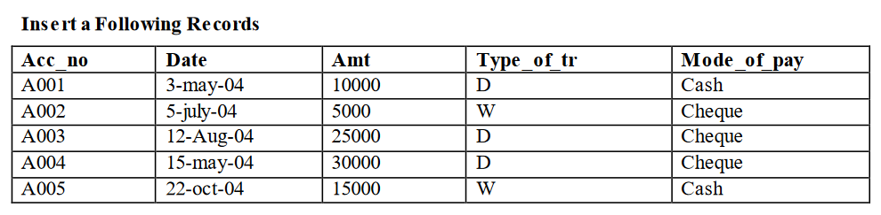

## SQL commands on Records of Table:

INSERT INTO TRANSACTION

(ACC_NO, TR_DATE, AMT, TYPE_OF_TR , MODE_OF_PAY) VALUES('A001','3 MAY 04', '10000', 'D','CASH');

INSERT INTO TRANSACTION

(ACC_NO, TR_DATE, AMT, TYPE_OF_TR , MODE_OF_PAY) VALUES('A002','5 JULY 04', '5000', 'W','CHEQUE');

INSERT INTO TRANSACTION

(ACC_NO, TR_DATE, AMT, TYPE_OF_TR , MODE_OF_PAY) VALUES('A003','12 AUG 04', '25000', 'D','CHEQUE');

INSERT INTO TRANSACTION

(ACC_NO, TR_DATE, AMT, TYPE_OF_TR , MODE_OF_PAY) VALUES('A004','15 MAY 04', '30000', 'D','CHEQUE');

INSERT INTO TRANSACTION

(ACC_NO, TR_DATE, AMT, TYPE_OF_TR , MODE_OF_PAY) VALUES('A005','24 OCT 04', '15000', 'W','CASH');



## Output:

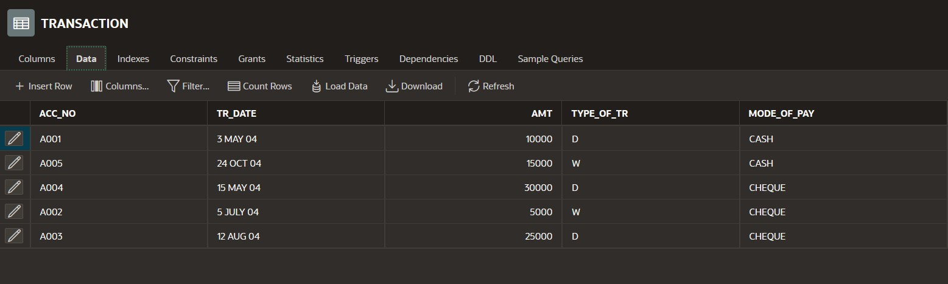

**List of queries**

**1. Display all rows and all columns of table Transaction.**

SELECT * FROM TRANSACTION

**2. Display all rows and selected columns of table Installment.**

SELECT LOAN_NO, INST_NO, INST_DATE, AMOUNT

FROM INSTALLEMENT

**3. Display selected rows and selected columns of table Account.**

SELECT ACC_NO, NAME, CITY FROM ACCOUNT

WHERE LOAN_TAKEN='YES';

**4. Display selected rows and all columns of table loan**

SELECT LOAN_NO, ACC_NO, LOAN_AMT, INTEREST_RATE, LOAN_DATE, REMAING_LOAN

FROM LOAN

WHERE INTEREST_RATE='9';

**5. Show the structure of the table loan, account and transaction.**

DESC LOAN DESC ACCOUNT

DESC TRANSACTION;

