**PRACTICAL 2**

**Table: ACCOUNT.**

**1. Insert the following records if you have not inserted in PRACTIAL - 1**

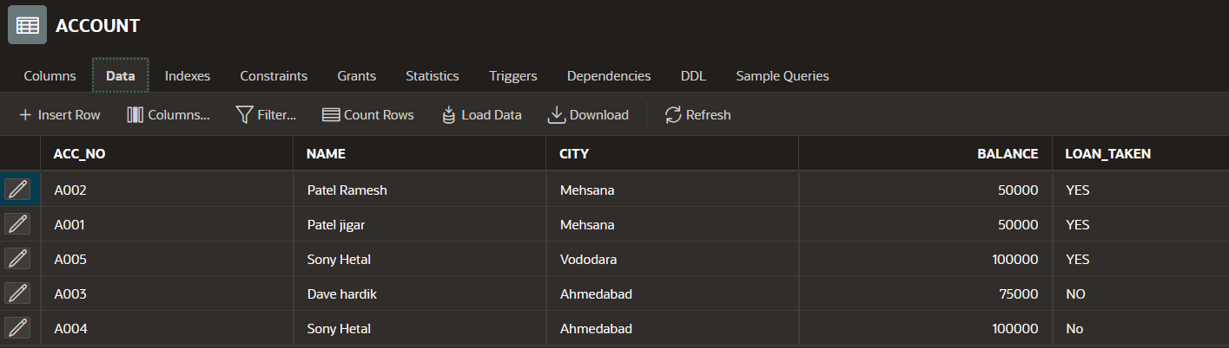

**2. Change the name ‘patel jigar’ to ‘patel hiren’.**

UPDATE ACCOUNT

SET name = 'patel hiren'

WHERE name = 'patel jigar';

**3. Change the name and city where account number is A005. (new name = ‘kothari nehal’ and newcity = ‘patan’).**

UPDATE ACCOUNT

SET name = 'kothari nehal', city = 'patan'

WHERE ACC_NO = 'A005';

**4. Display only those records where loan taken status is ‘YES’.**

**Add the new column (address varchar2 (20)) into table ACCOUNT.**

SELECT * FROM ACCOUNT

WHERE LOAN_TAKEN = 'YES';

ALTER TABLE ACCOUNT

ADD ADDRESS VARCHAR2(20);

**5. Create another table ACCOUNT_TEMP (acc_no, name, balance) from table ACCOUNT.**

CREATE TABLE ACCOUNT_TEMP AS SELECT

ACC_NO ,NAME, BALANCE from ACCOUNT;

**6. Rename the table ACCOUNT to ACCOUNT_MASTER.**

RENAME ACCOUNT to ACCOUNT_MASTER;

**7. Update the column balance for all the account holders.**

**(Multiply the balance by 2 for each account holders)**

UPDATE ACCOUNT_MASTER

SET balance=balance*2;

**8. Describe the structure of table ACCOUNT.**

DESC ACCOUNT;

**9. Delete the records whose account no is A004.**

DELETE from ACCOUNT_MASTER where ACC_NO='A004';

**Table: LOAN.**

**1. Insert the following Records if you have not inserted in PRACTICAL-1**

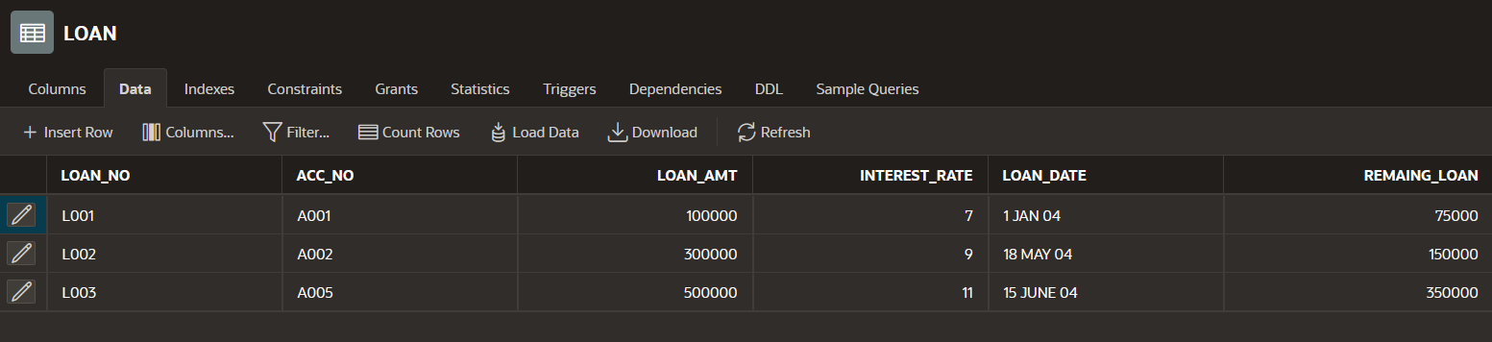

**2. for each loan holders Add 100000 Rs. Amount into the column loan_amt.**

UPDATE LOAN

SET LOAN_AMT=LOAN_AMT+100000;

**3. for each loan holders Increase the interest rate 2%**

UPDATE LOAN

SET INTEREST_RATE = INTEREST_RATE+2;

**4. Create another table LOAN_TEMP (loan_no, Acc_no, loan_amt, loan_date) from the table LOAN**

CREATE TABLE LOAN_TEMP AS

SELECT LOAN_NO, ACC_NO, LOAN_AMT, LOAN_DATE

FROM LOAN;

**5. Display only those records where loan holder taken a loan in month of January.**

SELECT * FROM LOAN WHERE LOAN_DATE='1 JAN 04';

**6. Modify the structure of table LOAN by adding one column credit_no varchar2 (4).**

ALTER TABLE LOAN

ADD CREDIT_NO VARCHAR2(4);

**7. Display the Loan amount*2 of table LOAN.**

SELECT LOAN_AMT*2 FROM LOAN;

**8. Display the records of table LOAN by date wise in ascending order.**

SELECT * FROM LOAN order by LOAN_DATE;

**9. Display the records of table LOAN by account number wise in descending Order.**

SELECT * FROM LOAN order by ACC_NO DESC;

**10. Increase the size 5 to 7 of column acc_no.**

ALTER TABLE LOAN

MODIFY ACC_NO VARCHAR2(7);

**Table: INSTALLMENT.**

**1. Insert following Records if you have not inserted in PRACTICAL-1**

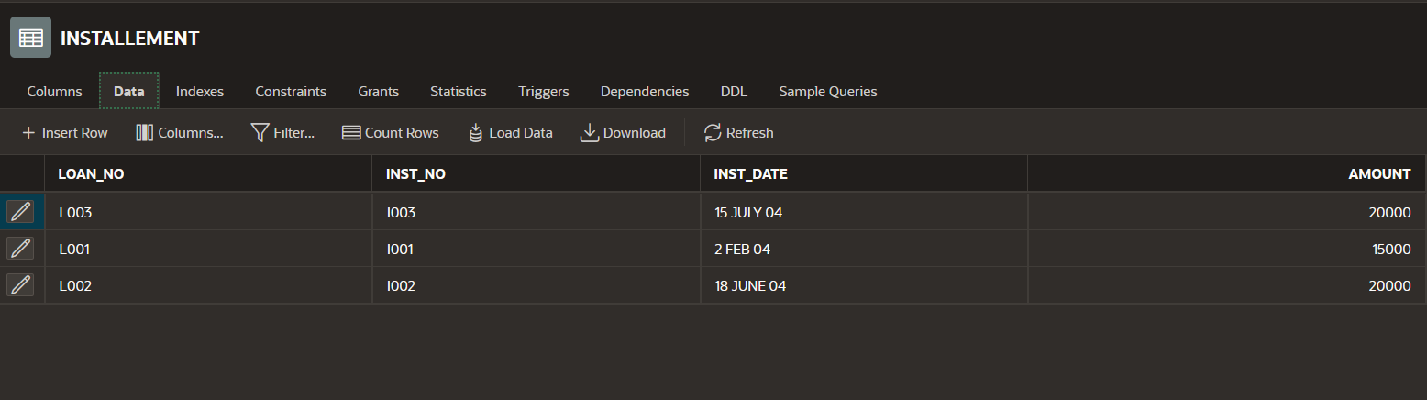

**2. Change the Inst_Date ‘2-Feb-04’ to ’3-Mar-04’.**

UPDATE INSTALLEMENT

SET INST_DATE ='03 MAR 04'

WHERE LOAN_NO ='I001';

**3. Reduce 5000 amount from all Installment holders.**

UPDATE INSTALLEMENT

SET AMOUNT = AMOUNT+5000

**4. Add the amount 5000 where loan no is ‘L003’ and ‘L002’.**

UPDATE INSTALLEMENT

SET AMOUNT = AMOUNT+5000

WHERE LOAN_NO = 'L003' or LOAN_NO ='L002';

**5. Change the column size of 5 to 7 where column name is Loan_no.**

ALTER TABLE INSTALLEMENT

MODIFY LOAN_NO VARCHAR2(7);

**6. Decrease the column size 5 to 4 where column name Inst_no.**

ALTER TABLE INSTALLEMENT

MODIFY INST_NO VARCHAR2(4);

**7. Show the structure of the Table.**

DESC INSTALLEMENT;

**8. Change the amount 15000 to 5000 where loan number is L001**

UPDATE INSTALLEMENT

SET AMOUNT = 5000

WHERE LOAN_NO = 'L001';

**9. Perform delete operation. (Delete only particular one record)**

DELETE FROM INSTALLEMENT

WHERE LOAN_NO = 'L001';

**Table: TRANSACTION**

**1. Insert a Following Records if you have not inserted in PRACTICAL-1**

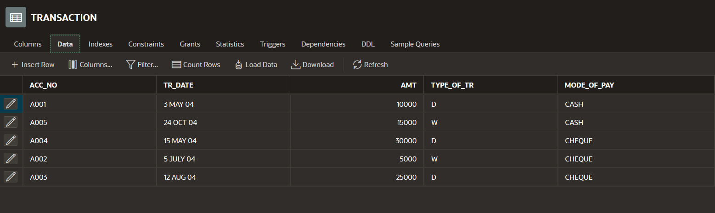

**2. Insert any duplicate value and display all the records without any duplicate rows.**

INSERT INTO TRANSACTION

VALUES ('A001' ,'09 MAY 04',10000,'D','Cash');

SELECT DISTINCT* FROM TRANSACTION;

**3. Select all the records in descending order(account number wise)**

SELECT* FROM TRANSACTION ORDER BY ACC_NO DESC;

**4. Display amt, date, and type of transaction by date wise.**

SELECT AMT , TR_DATE ,TYPE_OF_TR from TRANSACTION

ORDER BY TR_DATE;

**5. Create another table TRANSACTION_TEMP from this table.**

CREATE TABLE TRANSACTION_TEMP

AS SELECT ACC_NO, TR_DATE, AMT, TYPE_OF_TR, MODE_OF_PAY

FROM TRANSACTION;

**6. Create another table TRANS_TEMP by change the column name acc_no to account_no.**

CREATE TABLE TRANS_TEMP (account_no,trans_date,amt,

type_of_tr,mode_of_pay)

AS SELECT ACC_NO, TR_DATE, AMT, TYPE_OF_TR, MODE_OF_PAY

FROM TRANSACTION;

**7. Delete a table TRANSACTION_TEMP**

DROP TABLE TRANSACTION_TEMP;

**8. Rename the table TRANSACTION to TRANS.**

RENAME TRANSACTION to TRANS;

**9. Display account number where type of transaction is ‘D’**

SELECT ACC_NO from TRANSACTION WHERE

TYPE_OF_TR =’D’;