**PRACTICAL 3**

# Table ACCOUNT

# CREATE TABLE ACCOUNT

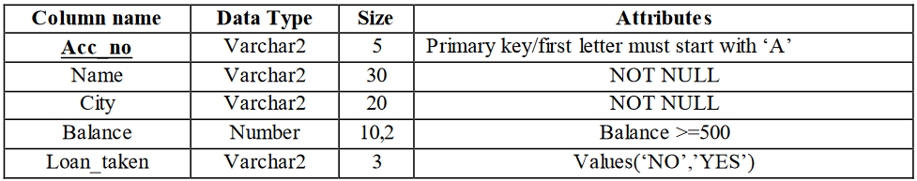

## SQL commands:

CREATE TABLE ACCOUNT

(Acc_no varchar2(5) primary key check (acc_no like 'A%'),

Name varchar2(30),

City varchar2(20),

Balance number(10,2),

Loan_taken varchar2(3)

);

**Insert The Following Records**

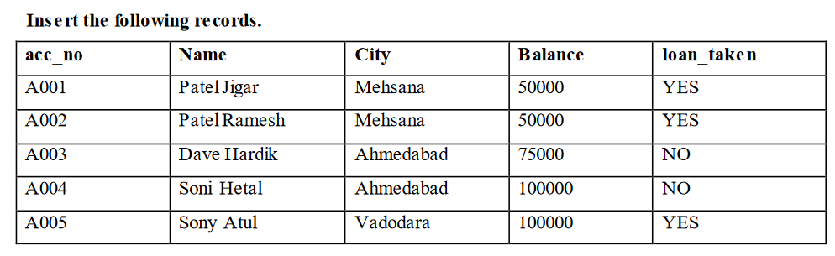

## SQL commands on Records of Table:

INSERT INTO ACCOUNT

(ACC_NO, NAME, CITY, BALANCE, LOAN_TAKEN) VALUES ('A001', 'Patel jigar', 'Mehsana', '50000', 'YES');

INSERT INTO ACCOUNT

(ACC_NO, NAME, CITY, BALANCE, LOAN _TAKEN) VALUES('A002', 'Patel Ramesh', 'Mehsana', '50000', 'YES');

INSERT INTO ACCOUNT

(ACC_NO, NAME, CITY, BALANCE, LOAN _TAKEN)

VALUES('A003', 'Dave hardik', 'Ahmedabad', '75000', 'NO');

INSERT INTO ACCOUNT

(ACC_NO, NAME, CITY, BALANCE, LOAN_TAKEN)

VALUES('A004', 'Sony Hetal', 'Ahmedabad', '100000', 'No');

INSERT INTO ACCOUNT

(ACC_NO, NAME, CITY, BALANCE, LOAN_TAKEN) VALUES('A005', 'Sony Hetal', 'Vododara', '100000', 'YES');

**Output:**

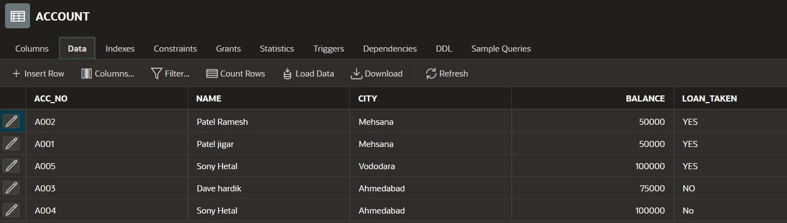

# Table LOAN

**CREATE TABLE LOAN**

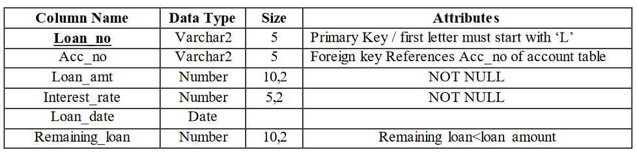

**SQL commands:**

CREATE TABLE LOAN

(

loan_no varchar2(5) primary key check(loan_no like 'L%'),

acc_no varchar2(5) references ACCOUNT,

loan_amt number(10,2) not null,

interest_rate number(5,2) not null,

loan_date date,

remaining_loan number(10,2),constraint check_loan check (remaining_loan<loan_amt)

);

**Insert The Following Records**

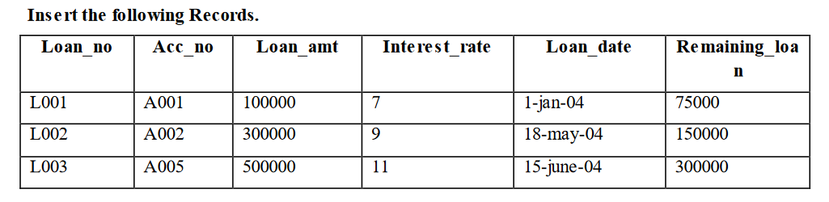

## SQL commands on Records of Table:

INSERT INTO LOAN

values ('L001','A001',100000,7,'01-JAN-04',75000);

INSERT INTO LOAN

values ('L002','A002',300000,9,'18-JAN-04',150000);

INSERT INTO LOAN

values ('L003','A003',500000,11,'15-JUN-04',300000);

**Output:**

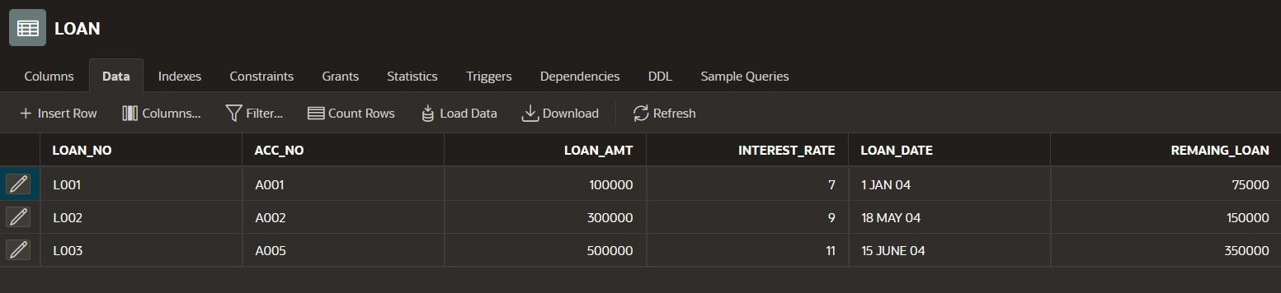

# Table INSTALLEMENT

# CREATE TABLE INSTALLEMENT

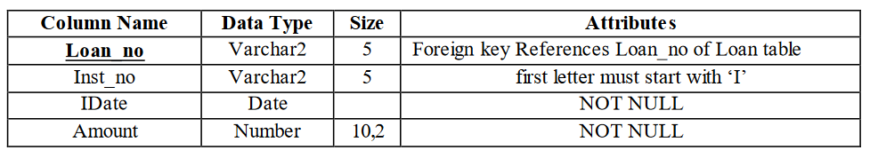

## SQL commands:

CREATE TABLE INSTALLMENT

(

loan_no varchar2(5) references loan,

inst_no varchar2(5) check (inst_no like 'I%'),

idate date not null,

amount number(10,2) not null

);

**Insert The Following Records**

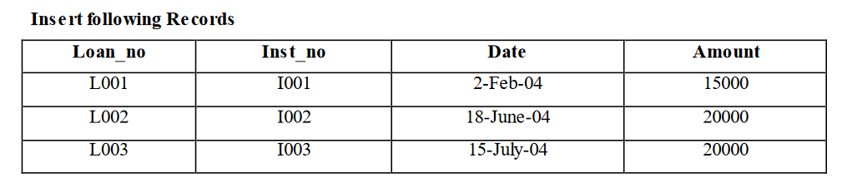

## SQL commands on Records of Table:

INSERT INTO INSTALLMENT

values ('L001','I001','02-FEB-04',15000);

INSERT INTO INSTALLMENT

values ('L002','I002','18-JUN-04',20000);

INSERT INTO INSTALLMENT

values ('L003','I003','15-JUL-04',20000);

**Output:**

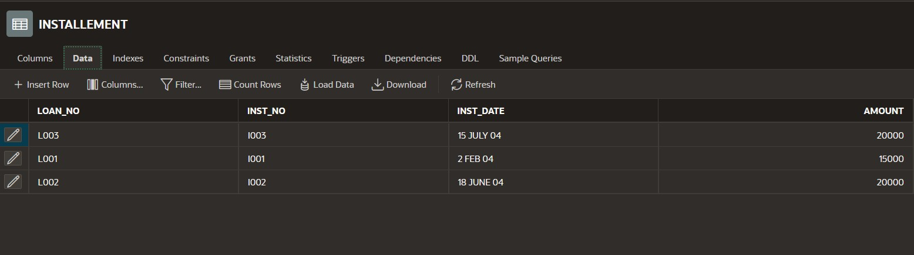

# Table TRANSACTION

# CREATE TABLE TRANSACTION

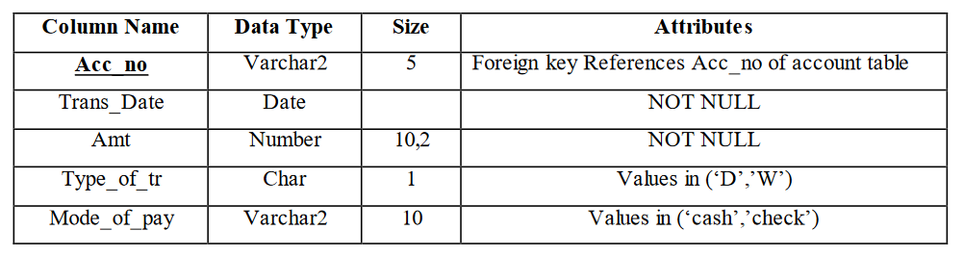

## SQL commands:

CREATE TABLE TRANSACTION

(

acc_no varchar2(5) references account,

trans_date date not null,

amt number(10,2) not null,

type_of_tr char(1) check (type_of_tr in('D','W')),

mode_of_pay varchar2(10) check (mode_of_pay in('cash','check'))

);

**Insert The Following Records**

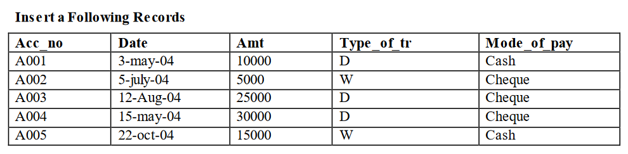

## SQL commands on Records of Table:

## INSERT INTO TRANSACTION

## values ('A001','03-MAY-04',10000,'D','Cash');

## INSERT INTO TRANSACTION

## values ('A002','05-JUL-04',5000,'W','Check');

## INSERT INTO TRANSACTION

## values ('A003','12-AUG-04',25000,'D','Check');

## INSERT INTO TRANSACTION

## values ('A004','15-MAY-04',30000,'D','Check');

## INSERT INTO TRANSACTION

## values ('A005','12-OCT-04',15000,'W','Cash');

**Output:**

## 

## Using Operator: NOT, BETWEEN, NOT BETWEEN, IN, NOT IN

## Retrieve specified information for the account holder who are not in ‘Ahmedabad’.

SELECT * FROM ACCOUNT WHERE NOT CITY='AHEMDABAD';

# Output:

## Retrieve specified information for the account holder who are not in ‘Ahmedabad’ or ‘Vadodara’.

## SELECT * from account

## where city not in ('Ahmedabad','Vadodara');

# Output:

## Retrieve those records of Account holder whose balance between is 50000 and 100000.

SELECT * FROM ACCOUNT

WHERE BALANCE BETWEEN '50000' AND '100000';

# Output:

## Retrieve those records of Account holder whose balance not between is

## 50000 and 100000.

SELECT * FROM ACCOUNT

WHERE BALANCE NOT BETWEEN '50000' AND '90000';

# Output:



1. Display only those records whose amount is 5000, 25000, 30000.

SELECT * FROM TRANSACTION WHERE AMT IN ('5000' , '25000' , '30000');

# Output:

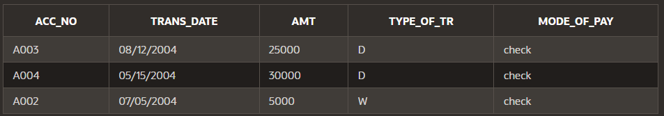

1. Display only those records whose amount not in 5000, 25000, 30000

SELECT * FROM TRANSACTION

WHERE AMT NOT IN ('5000' , '25000' , '30000');

# Output:

# Display System date

# SELECT CURRENT_DATE FROM DUAL

# Output:

# 

1. Find the total transaction amount of account holder from transaction table.

SELECT SUM(AMT) FROM TRANSACTION;

# Output:

1. Find minimum amount of transaction.

SELECT MIN(AMT) FROM TRANSACTION;

# Output:



1. Find maximum amount of transaction.

SELECT MAX(AMT) FROM TRANSACTION;

# Output:

1. Count the total account holders.

SELECT COUNT(NAME) FROM ACCOUNT;

# Output:

1. Count only those records whose made of payment is ‘cash’

SELECT COUNT(MODE_OF_PAY) FROM TRANSACTION WHERE MODE_OF_PAY='CASH';

# Output:

1. Count only those records whose transaction made in the month of ‘MAY’.

SELECT COUNT(TRANS_DATE) FROM TRANSACTION WHERETRANS_DATE BETWEEN '05/03/2004' AND '05/31/2004';

# Output:



1. Find the average value of transaction.

SELECT AVG(AMT) FROM TRANSACTION;

**Output:**



1. Display the result of 4 rest to 4.

SELECT POWER(4, 4) FROM DUAL;

# Output:

1. Find the square root of 25.

SELECT SQRT(25) FROM DUAL;

# Output:

# Write the query for the following Function.

1. **Lower SQL commands:**

SELECT LOWER('brown') FROM Employee;

# Output:



1. **INITCAP SQL commands:**

SELECT INITCAP('brown') FROM Employee;

# Output:

1. **UPPERCASE SQL commands:**

SELECT UPPER('brown') FROM Employee;

# Output:



1. **SUBSTR SQL commands:**

SELECT SUBSTR('alice brown',3,1) FROM Employee;

# Output:



1. **LENGTH SQL commands:**

SELECT LENGTH('alice') FROM Employee;

# Output:

1. **TRIM SQL commands:**

SELECT LTRIM('alice') FROM Employee;

# Output:

