**PRACTICAL 4**

# Table ACCOUNT

# 

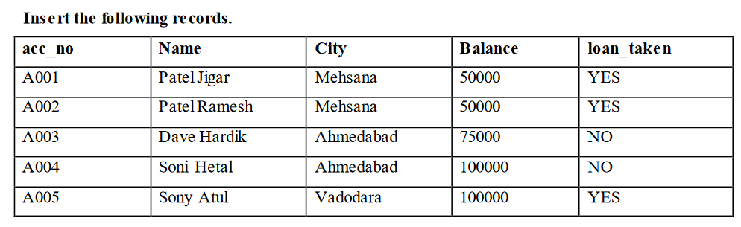

# Table LOAN

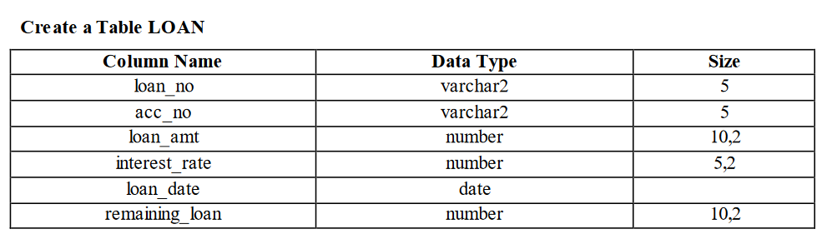

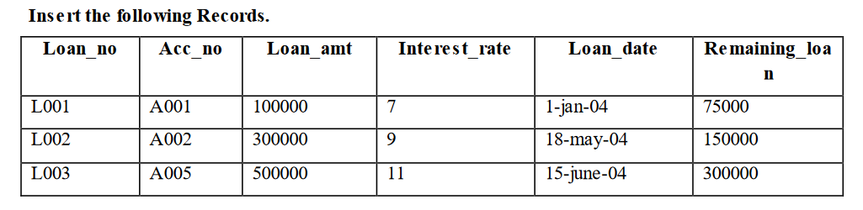

# Table INSTALLEMENT

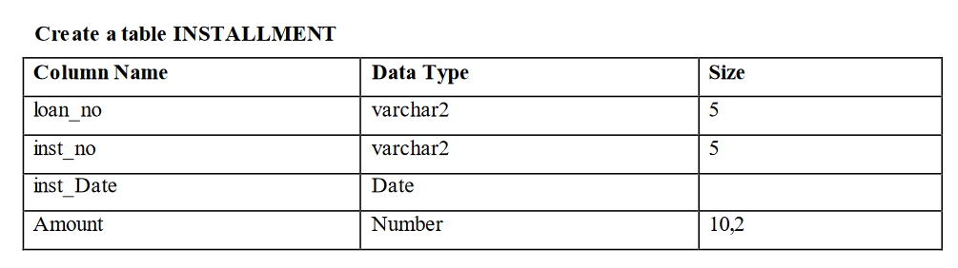

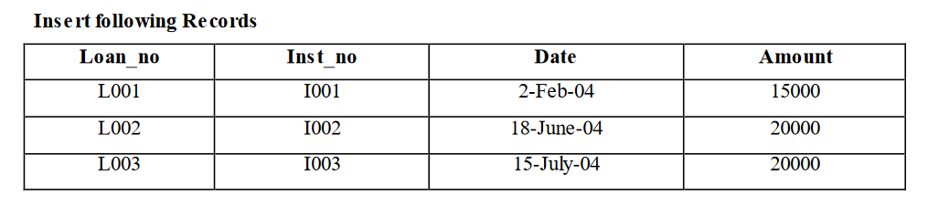

# Table TRANSACTION

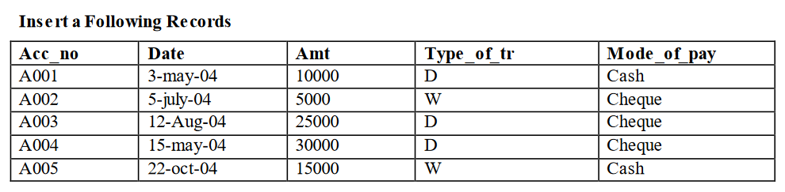

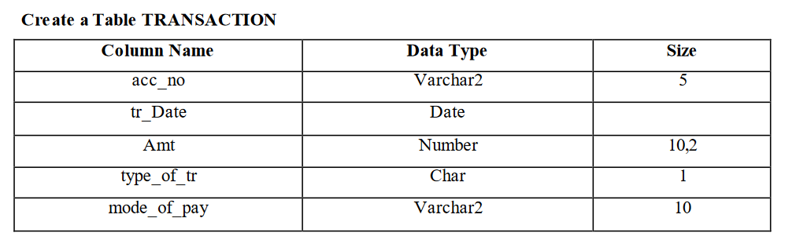

**List of queries**

1. Display the sum of balance of account holders who’s live in same city ‘Mehsana’ using group by clause.

SELECT City, SUM(Balance) AS TotalBalance

FROM ACCOUNT_OLD

WHERE City = 'Mehsana'

GROUP BY City;

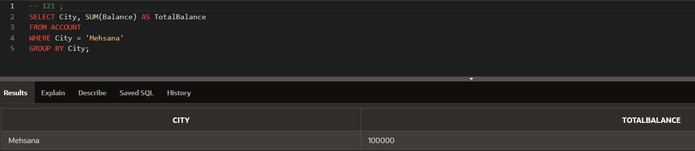

2. Display the information about account where balance is less than total balance of all account holders.

-- 121 ;

SELECT * FROM ACCOUNT_OLD

WHERE Balance < (SELECT SUM(Balance) FROM ACCOUNT_OLD);

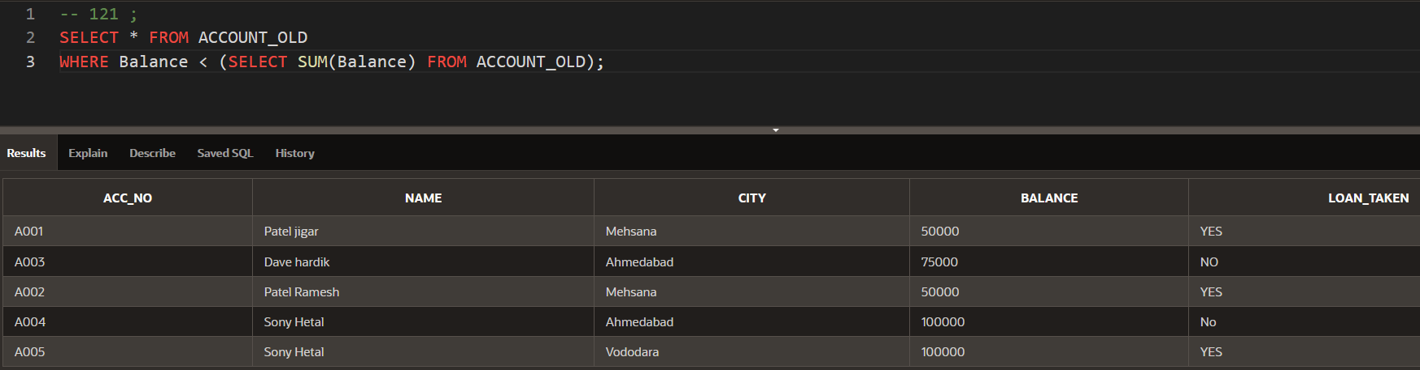

1. Displays the information of account holders whose loan amount and balance both are same.

-- 121 ;

SELECT A.* FROM ACCOUNT_OLD A

INNER JOIN LOAN L ON A.acc_no = L.acc_no

WHERE A.Balance = L.loan_amt;

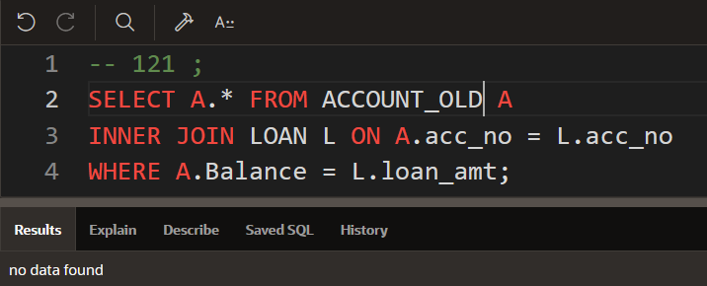

4. Display the name of city, remaining loan amount, account, date of loan and loan number of account holders.

-- 121 ;

SELECT A.City, L.remaining_loan, A.acc_no AS account, L.loan_date AS date_of_loan, L.loan_no

FROM ACCOUNT_OLD A

JOIN LOAN L ON A.acc_no = L.acc_no

JOIN INSTALLMENT I ON L.loan_no = I.loan_no

JOIN TRANSACTION T ON A.acc_no = T.acc_no

WHERE T.type_of_tr = 'D';

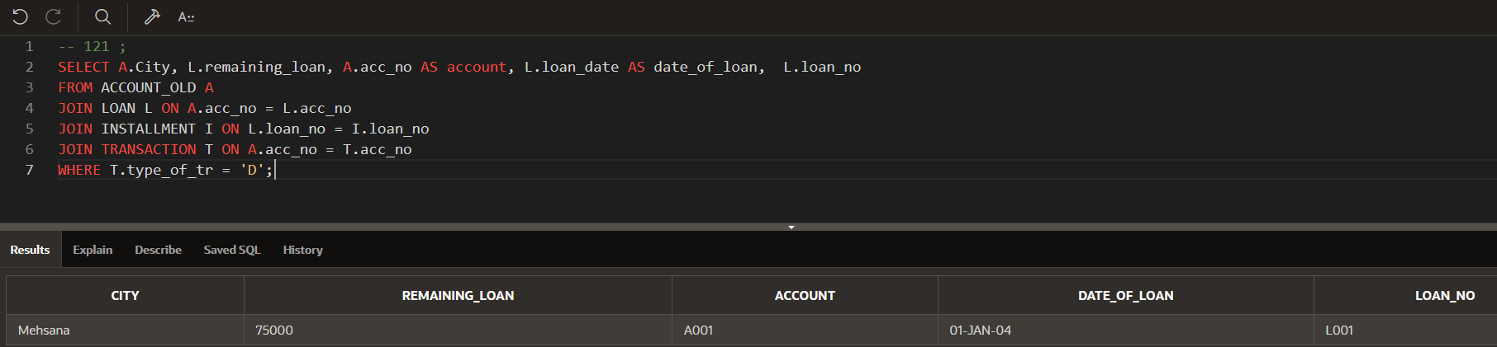

5. Display name of account holder, installment number and installment amount Whose loan number is ‘L001’

-- 121 ;

SELECT

A.Name AS account_holder_name,

I.inst_no AS installment_number,

I.Amount AS installment_amount

FROM ACCOUNT_OLD A

JOIN LOAN L ON A.acc_no = L.acc_no

JOIN INSTALLMENT I ON L.loan_no = I.loan_no

WHERE L.loan_no = 'L001';

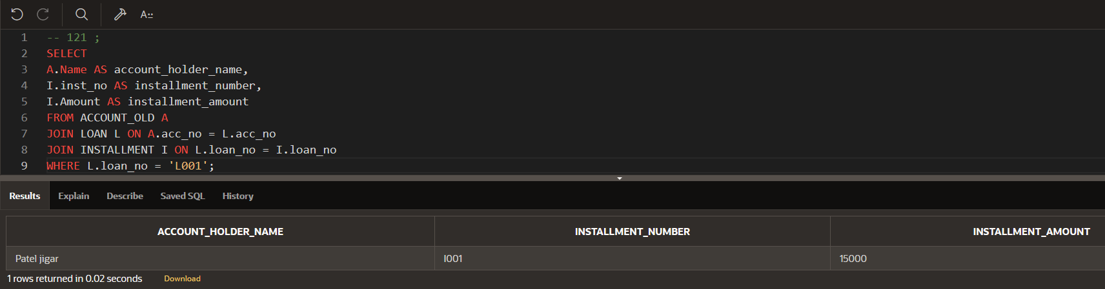

6. Display name of account holder, city, loan amount and installment amount.

-- 121 ;

SELECT

A.Name AS account_holder_name,

A.City,

L.loan_amt AS loan_amount,

I.Amount AS installment_amount

FROM ACCOUNT A

JOIN LOAN L ON A.acc_no = L.acc_no

JOIN INSTALLMENT I ON L.loan_no = I.loan_no;

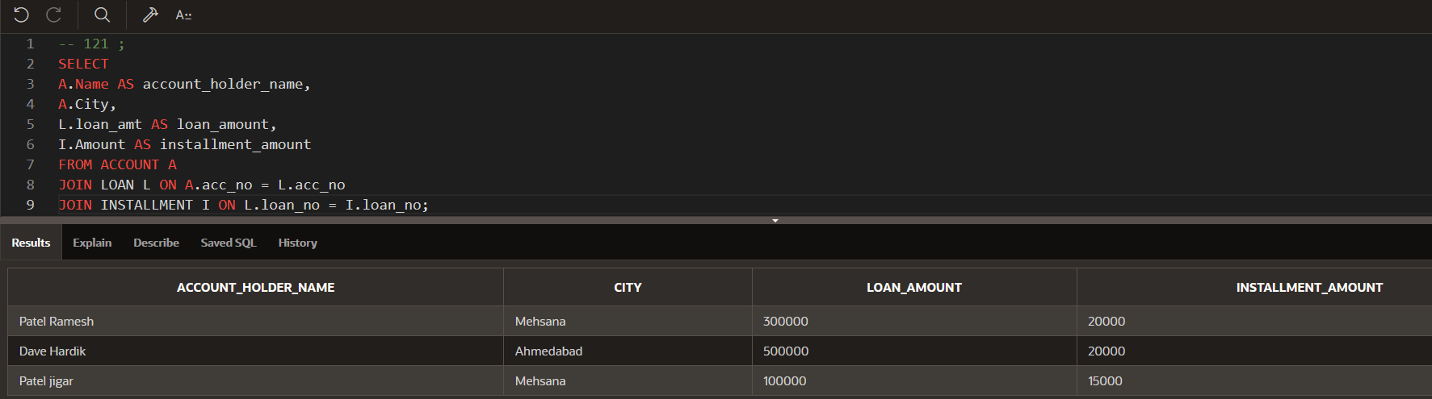

7. Display the balance of account holders whose balance and remaining loan both are same.

-- 121 ;

SELECT A.acc_no, A.Balance

FROM ACCOUNT A

INNER JOIN LOAN L ON A.acc_no = L.acc_no

WHERE A.Balance = L.remaining_loan;

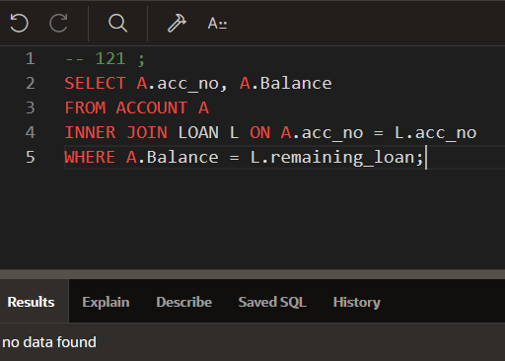

8. List of all account holders’ information whose balance is same as loan amount.

-- 121 ;

SELECT A.acc_no, A.Name, A.City, A.Balance, L.loan_amt

FROM ACCOUNT A

INNER JOIN LOAN L ON A.acc_no = L.acc_no

WHERE A.Balance = L.loan_amt;

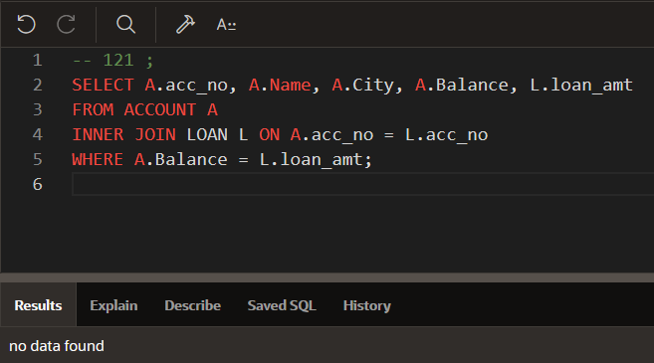

9. Display the amount of transaction, name of account holders, account number and mode

of payment whose mode of payment is ‘CHEQUE’.

-- 121 ;

SELECT T.Amt AS transaction_amount, A.Name AS account_holder_name, A.acc_no, T.mode_of_pay

FROM ACCOUNT A

INNER JOIN TRANSACTION T ON A.acc_no = T.acc_no

WHERE T.mode_of_pay = 'CHEQUE';

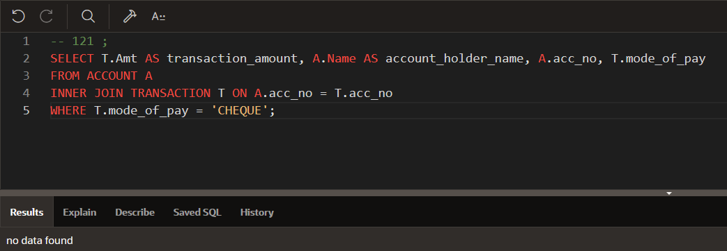

10. Display account no, loan amount, amount of transaction.

-- 121 ;

SELECT A.acc_no, L.loan_amt, T.Amt AS transaction_amount

FROM ACCOUNT_OLD A

LEFT JOIN LOAN L ON A.acc_no = L.acc_no

LEFT JOIN TRANSACTION_OLD T ON A.acc_no = T.acc_no;

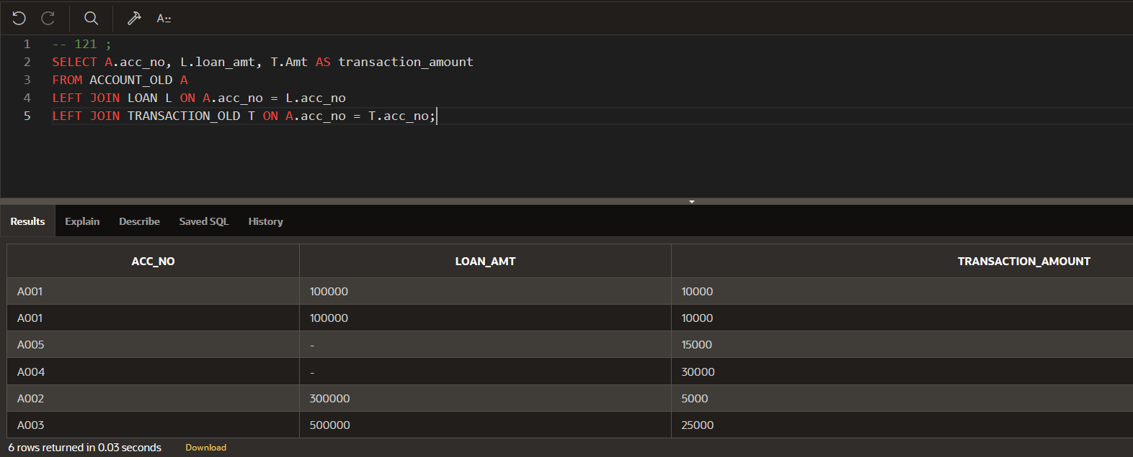

11. List of installment information whose amount is less than average amount of transaction.

-- 121 ;

SELECT I.inst_no, I.Amount AS installment_amount

FROM INSTALLMENT I

WHERE I.Amount < (SELECT AVG(T.Amt) FROM TRANSACTION_OLD T);

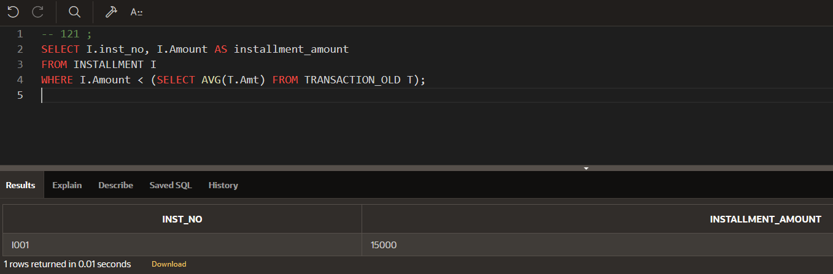

12. Display the sum of installment amount and transaction amount.

-- 121 ;

SELECT

SUM(I.Amount) AS total_installment_amount,

SUM(T.Amt) AS total_transaction_amount

FROM INSTALLMENT I

JOIN TRANSACTION_OLD T ON I.amount = T.amt;

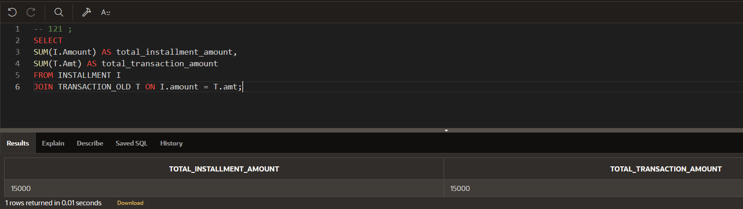

13. Display the balance and amount of transaction group by amount and balance.

-- 121 ;

SELECT

A.Balance AS account_balance,

T.Amt AS transaction_amount

FROM ACCOUNT A

JOIN TRANSACTION_OLD T ON A.acc_no = T.acc_no

GROUP BY A.Balance, T.Amt;

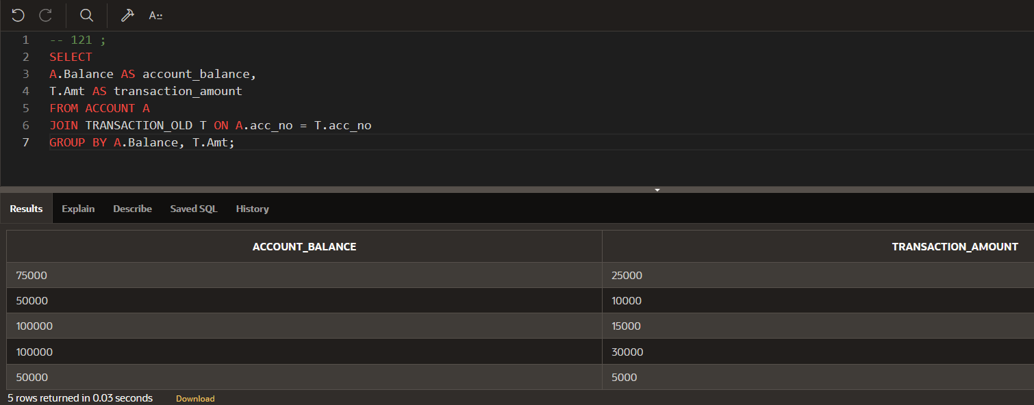

14.List of installment number and account number of account holders.

-- 121 ;

SELECT I.inst_no, A.acc_no

FROM INSTALLMENT I

JOIN LOAN L ON I.loan_no = L.loan_no

JOIN ACCOUNT_OLD A ON L.acc_no = A.acc_no;

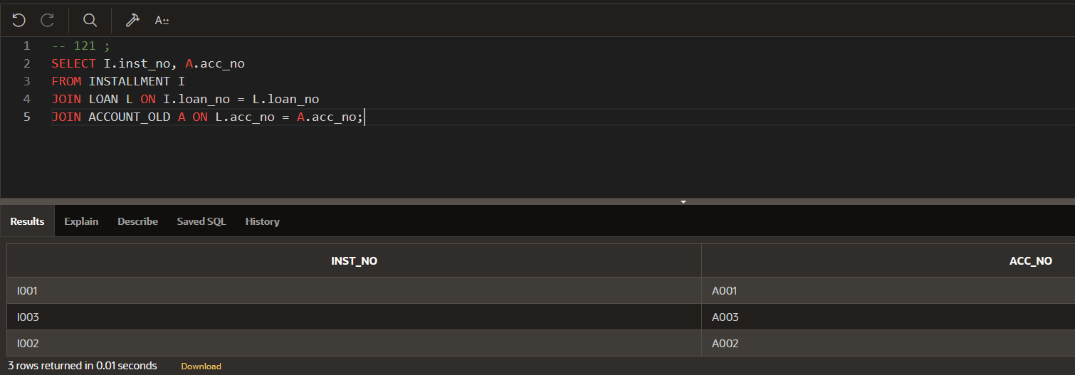

15. Display loan amount, transaction amount and mode of payment where transaction date and loan taken date both are done in month of ‘MAY’.

-- 121 ;

SELECT

L.loan_amt,

T.Amt AS transaction_amount,

T.mode_of_pay

FROM LOAN L

JOIN TRANSACTION T ON L.acc_no = T.acc_no

WHERE TO_CHAR(L.loan_date, 'MON') = 'MAY' AND TO_CHAR(T.tr_Date, 'MON') = 'MAY';

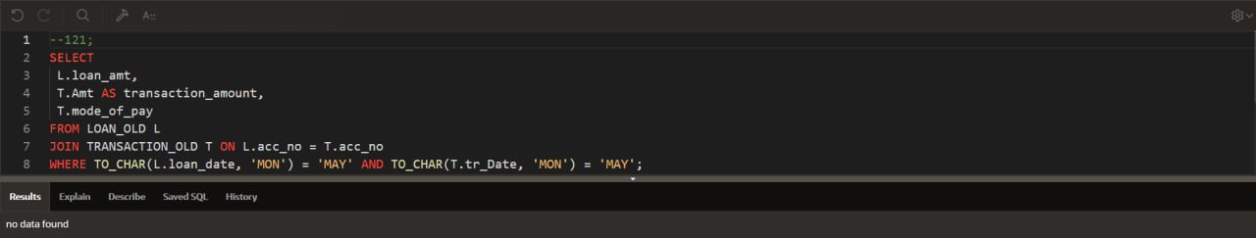

16. Display all the information of installment and transaction where installment date and transaction date both are done in month of ‘JULY’.

-- 121 ;

SELECT I.*, T.*

FROM INSTALLMENT I

JOIN TRANSACTION T ON I.INST_NO = T.ACC_NO

WHERE TO_CHAR(I.inst_Date, 'MON') = 'JUL' AND TO_CHAR(T.tr_Date, 'MON') = 'JUL';

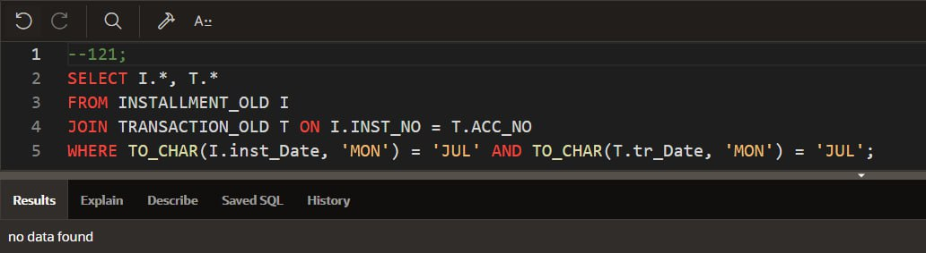

17. Display the last three row of account table.

-- 121 ;

SELECT *

FROM (SELECT * FROM ACCOUNT ORDER BY acc_no DESC)

WHERE ROWNUM <= 3;

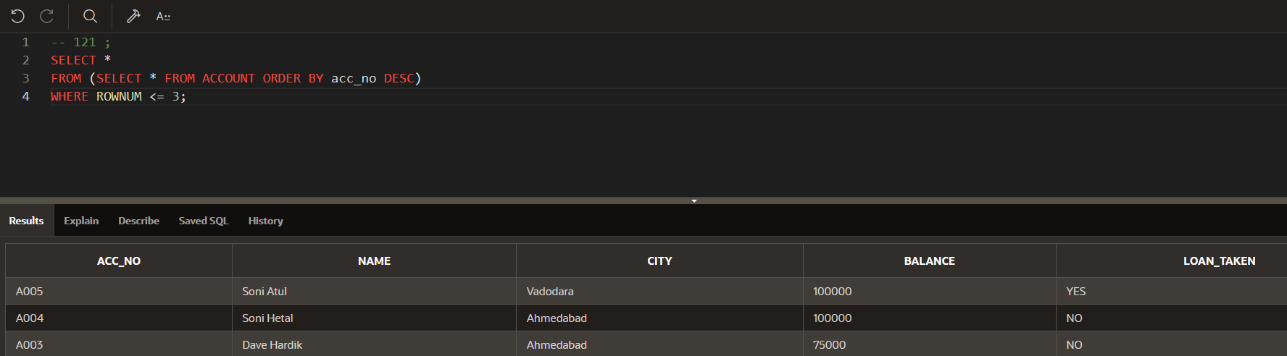

18. Display the balance, mode of payment, loan taken status whose mode of payment is ‘CHEQUE’

and loan taken is ‘YES’.

-- 121 ;

SELECT A.Balance, T.mode_of_pay, A.loan_taken

FROM ACCOUNT_OLD A

JOIN TRANSACTION_OLD T ON A.acc_no = T.acc_no

WHERE T.mode_of_pay = 'CHEQUE' AND A.loan_taken = 'YES'

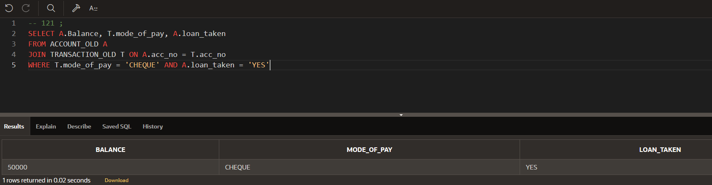

19. Retrieve only rows 2 to 5 from account table.

-- 121 ;

SELECT *

FROM (SELECT a.*, ROWNUM rnum

FROM (SELECT * FROM ACCOUNT_OLD ORDER BY acc_no) a

WHERE ROWNUM <= 5)

WHERE rnum >= 2

