Naming conventions for Antons skafferi - databases

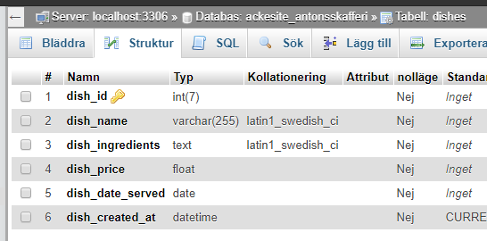
There are some different opinions for naming conventions but the repeating advice from many organizations is the need for consistency when creating databases, tables and attributes. In the project Antons skafferi we will name everything with lower case letters and underscores. You can see the example table dishes in the picture below.

Database name: antonsskafferi

Database tables: <items>

Database attributes: <item_attribute>

We write all SQL queries with commands in upper case and database, tables and attributes in lowercase letter as follows:

CREATE TABLE dishes
(
dish_id int(7) PRIMARY KEY AUTOINCREMENT,
dish_name varchar(255) NOT NULL,
dish_ingredients text NOT NULL,
dish_price float NOT NULL,
dish_date_served date NOT NULL,
dish_created_at datetime CURRENT_TIMESTAMP
)

